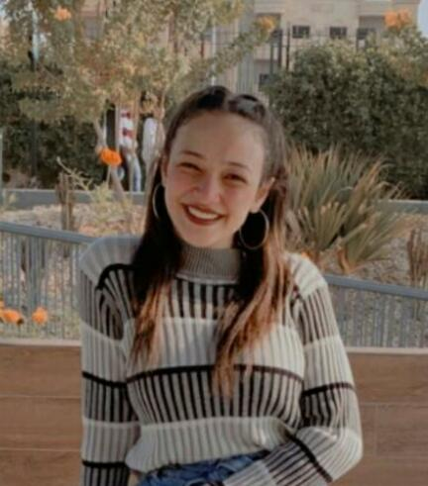c.v

Name: Selvia Adel Eilia Botros

E-mail: selviaadel177@gmail.com

Phone: 01271785695

Address:  **El Minia – maghagha**

**Social** **accounts**: facebook: [selvia.adel251@yahoo.com](mailto:selvia.adel251@yahoo.com) twitter: @sylvia92732912

Instagram: selviaadel177

**Qualifications:** A student at Al-Nahda University, College of Computer Science , I’m Partner in programming team at NUB.

**The objective:** working in highly professional organization so that I will show my work and skill in programming and design web pages

**Courses:**

* Java
* c++ by ACM

**Certificates:**

* I got a certificate in Soft Skills
* I got a certificate fundamental of digital marketing by google

**Skills:**

* I can work for a long and continuous time
* I am using computer skills very well
* I can work under pressure

**Personal** **information**:

date of birth 7_8_2002

Egyptian

Female

Single