**Programming Assignment 3**

JAVA

Programming Assignment #3

PROBLEM:

On most telephone keypads the letters of the alphabet are mapped to various digits as shown in the picture below:

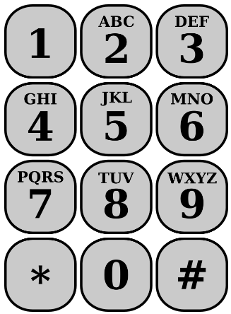

In order to make their phone numbers more memorable, service providers like to find numbers that spell out some word (called a **mnemonic**) appropriate to their business that makes that phone number easier to remember. For example, the phone number for a physician called Smith could be 377 -6484 (DRSMITH). Write a method listMnemonics that will generate all possible letter combinations that correspond to a given number, represented as a string of digits using a recursive function. ***This is a recursive backtracking problem, but you are trying to find all the "solutions", not just one. In fact you are trying to find all possible Strings using the English alphabet, not just Strings that are actual "words".***

For example, if you call the method listMnemonics with the value 623 your method shall generate and return the following 27 possible letter combinations that correspond to that prefix:

**MAD MBD MCD NAD NBD NCD OAD OBD OCD**

**MAE MBE MCE NAE NBE NCE OAE OBE OCE**

**MAF MBF MCF NAF NBF NCF OAF OBF OCF**

Note, the order of these returned strings is unimportant.

Use the GUI depicted above to input required data. (you do not have to input a 7 – 10 digit number. Three digits will suffice)

I will let you decide how you wish to display the output from the inputted string.

Please add comments to your program!