**CHAPTER 1**

**INTRODUCTION**

In recent years, the Internet and especially the Web has enabled a communication revolution: the ability to send and retrieve information everywhere has changed the way we work and live. Internet based access to information and internet Communication means have become ubiquitous. Social networking is the grouping of individuals into specific groups, like small rural communities or a neighbourhood subdivision, if you will. Although social networking is possible in person, especially in the workplace, universities, and high schools, it is most popular online. The term SOCIAL NETWORKING (SN) was first coined by Professor J. A. Barnes in the 1950s, who defined the size of a social network as a group of about 100 to 150 people. When it comes to online social networking, websites are commonly used. These websites are known as social sites. Social networking websites function like an online community of internet users. Depending on the website in question, many of these online community members share common interests in hobbies, religion, or politics. As mentioned, social networking often involves grouping specific individuals or organizations together. While there are a number of social networking websites that focus on particular interests, there are others that do not. The websites without a main focus are often referred to as “traditional" social networking websites and usually have open memberships. This means that anyone can become a member, no matter what their hobbies, beliefs, or views are. According to a report on Nielsen Wire, about two thirds of the world's population participates in some sort of social network. This accounts for close to 10 percent of all time spent on the Internet. The article also states that social networking has become more popular than email as a means of communicating.

**1.1 PURPOSE:**

The purpose of this document is to describe the detailed functionalities of the Social Networking System. It describes all the software and hardware requirements, functional requirements, interfaces and design constraints which are to be considered while designing the system. The document covers all the factors which are necessary to provide clear and complete description of the system.

**1.2 SCOPE:**

This system is intended for online communication and create network between the people belonging to various cultures, countries, backgrounds. It could be used as a platform for promoting business, for political campaigns, marketing, knowledge sharing and various other purposes.

The system provides following feature:

* 1. The system provides log in facility to the users.
  2. Users can edit profile, upload photos, videos, update status, communicate with other users .
  3. The system enables users to deactivate their account, change account password and maintain the security level of their account.
  4. Users can post messages at any time as the website will be available for 24 hours and every day.
  5. The system enables admin to make system announcements, release system updates, monitor user data, send warning or suspend user account and send feedback to the users.

**1.3 DEFINITIONS, ACRONYMS AND ABBREVIATION:**

HTML (Hyper Text Markup Language) : It is used to create static web pages.

XML (Extensible Markup Language) : It is a Markup language that was designed to transport and store data.

Ajax (Asynchronous Java Script and XML) : It is a technique used in JavaScript to create dynamic web pages.

HTTP (Hyper Text Transfer Protocol) : It is a transaction oriented client/ server protocol between a web browser and a web server.

**1.4 REFERENCES:**

www. oracle.com

HTML Black Book

http://www.facebook.com/policy.php/

**1.5 OVERVIEW:**

Social networking is the grouping of individuals into specific groups, like small rural communities or a neighbourhood subdivision, if you will.

Social networking often involves grouping specific individuals or organizations or likeminded people together.

Social networking is a strategy to connect and discuss all sorts of ideas through individuals and communities that may express a primary interest or the comparable pursuits throughout the planet.

Companies like IBM, Microsoft and Google performs to strengthen their networking platforms via social networks like Twitter and Facebook.

**1.6 TECHNOLOGY AND LITERATURE REVIEW**:

We are using ASP.net 4.0 as a front end tool and sql server 2008 as a back end tool. We also use Ajax. Let’s see brief overview of each:

**1.6.1 .NET FRAMEWORK 4.0:**

The .NET Framework is an integral Windows component that supports building and running the next generation of applications and XML Web services. The .NET Framework is designed to fulfill the following objectives:

* To provide a consistent object-oriented programming environment whether object code is stored and executed locally, executed locally but Internet-distributed, or executed remotely.
* To provide a code-execution environment that minimizes software deployment and versioning conflicts.
* To provide a code-execution environment that promotes safe execution of code, including code created by an unknown or semi-trusted third party.
* To provide a code-execution environment that eliminates the performance problems of scripted or interpreted environments.
* To make the developer experience consistent across widely varying types of applications, such as Windows-based applications and Web-based applications.
* To build all communication on industry standards to ensure that code based on the .NET Framework can integrate with any other code.

The .NET Framework has two main components:

* Common language runtime
* .NET Framework class library

The common language runtime is the foundation of the .NET Framework. You can think of the runtime as an agent that manages code at execution time, providing core services such as memory management, thread management and remoting, while also enforcing strict type safety and other forms of code accuracy that promote security and robustness. Code that targets the runtime is known as **managed code**, while code that does not target the runtime is known as **unmanaged code**.

The class library, the other main component of the .NET Framework, is a comprehensive, object-oriented collection of reusable types that you can use to develop applications ranging from traditional command-line or graphical user interface (GUI) applications to applications based on the latest innovations provided by ASP.NET, such as Web Forms and XML Web services.

The .NET Framework can be hosted by unmanaged components that load the common language runtime into their processes and initiate the execution of managed code, thereby creating a software environment that can exploit both managed and unmanaged features. The .NET Framework not only provides several runtime hosts, but also supports the development of third-party runtime hosts.

For example, ASP.NET hosts the runtime to provide a scalable, server-side environment for managed code. ASP.NET works directly with the runtime to enable ASP.NET applications and XML Web services, both of which are discussed later in this topic.

**1.6.2 ASP.NET 4.0:**

ASP.NET is a unified Web development model that includes the services necessary for you to build enterprise-class Web applications with a minimum of coding. ASP.NET is part of the .NET Framework, and when coding ASP.NET applications you have access to classes in the .NET Framework. You can code your applications in any language compatible with the common language runtime (CLR), including Microsoft Visual Basic, C#, Jscript, .NET, and J#. These languages enable you to develop ASP.NET applications that benefit from the common language runtime, type safety, inheritance, and so on.

ASP.NET includes:

* A page and controls framework
* The ASP.NET compiler
* Security infrastructure
* State-management facilities
* Application configuration
* Health monitoring and performance features
* Debugging support
* An XML Web services framework
* Extensible hosting environment and application life cycle management
* An extensible designer environment

**1.6.3 SQL SERVER 2008:**

Microsoft SQL Server 2008 is a comprehensive, integrated data management and analysis software that enables organizations to reliably manage mission-critical information and confidently run today’s increasingly complex business applications. SQL Server 2008 allows companies to gain greater insight from their business information and achieve faster results for a competitive advantage.

* [**Business Intelligence**](http://www.microsoft.com/sqlserver/2005/en/us/business-intelligence.aspx)

Gain deeper insight into your business with integrated, comprehensive analysis and reporting for enhanced decision making.

* [**High Availability**](http://www.microsoft.com/sqlserver/2005/en/us/high-availability.aspx)

Ensure business continuity with the highest levels of system availability through technologies that protect your data against costly human errors and minimize disaster recovery downtime.

* [**Performance and Scalability**](http://www.microsoft.com/sqlserver/2005/en/us/benchmarks.aspx)

Deliver an infrastructure that can grow with your business and has a proven record in handling today's large amounts of data and most critical enterprise workloads.

* [**Security**](http://www.microsoft.com/sqlserver/2005/en/us/security.aspx)

Provide a secure environment to address privacy and compliance requirements with built-in features that protect your data against unauthorized access.

* [**Manageability**](http://www.microsoft.com/sqlserver/2005/en/us/manageability.aspx)

Manage your infrastructure with automated diagnostics, tuning, and configuration to reduce operational costs while reducing maintenance and easily managing very large amounts of data.

* [**Developer Productivity**](http://www.microsoft.com/sqlserver/2005/en/us/developer-productivity.aspx)

Build and deploy critical business-ready applications more quickly by improving developer productivity and reducing project life cycle times.

**CHAPTER 2**

**PROJECT MANAGEMENT**

**2.1 FEASIBILITY STUDY:**

Feasibility study for a system is necessary to know whether the proposed system is feasible technically, economically and functionally. This is important to know as it helps develop a better and efficient system. Feasibility study helps us find out all the negative issues before the system is made and hence, helps us to make changes as required so that there are no issues when the system is halfway through. And thus, Feasibility study is thus, an important part of the SOFTWARE LIFECYCLE MODEL.

There are three feasibility issues are:

* Technical Feasibility
* Time schedule Feasibility
* Operational Feasibility

**2.1.1 TECHNICAL FEASIBILITY**

In this test we will ensure whether the technology used to develop the system can perform all the functions, whether the system is easy to develop, will this system handle more clients at a same time.

Account system is made in ASP.NET framework 4.0 with C# and SQL Server 2012.Both the technologies are efficient to make this system and will perform all the functions like connectivity, authentication etc. without any difficulty.

**2.1.2 TIME SCHEDULE FEASIBILITY**

All the functionalities are designed to team members as per they are best at and project guide is also having knowledge of ASP.NET to guide us. So technically it is feasible to implement the project on time.

**2.1.3 OPERATIONAL FEASIBILITY**

The proposed system provides the functionality based on user characteristics to End user or authorized user.

* 1. **PROJECT PLANNING:**

**2.2.1 PROJECT DEVELOPMENT APPROACH AND JUSTIFICATION:**

The system is developed using the ITERATIVE WATERFALL as it is a small scale project. This approach has the following development phases:

* Feasibility study
* Requirement analysis and specification
* Design
* Coding
* Unit, integration and system testing
* Maintenance

The classical waterfall model is an idealistic one since it assumes that no development error is ever committed by the engineers during any phase of the life cycle phases. However, in practical development environments, the engineers do commit large number of errors in almost every phase of life cycle.

Once a defect is detected, the engineers need to go back to the phase where the defect had occurred and redo some of the work done during that phase and the subsequent phases to correct the defect and its effect on later phases. Therefore any practical software development work, it is not possible to strictly follow the classical waterfall model. Feedback paths are needed in the classical waterfall model from every phase to its preceding phases. As shown in the figure:

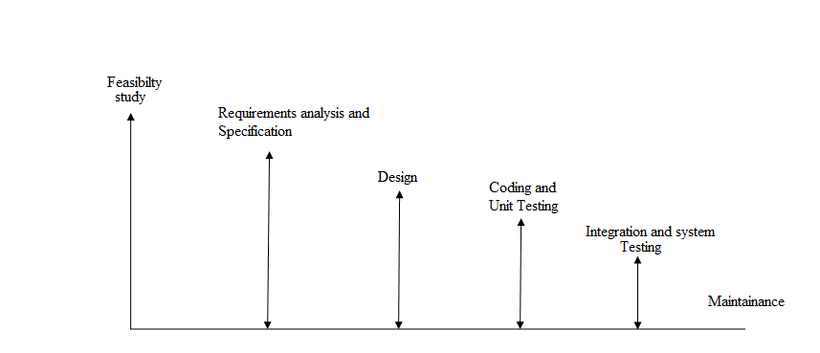

Fig. 2.1 Iterative Waterfall Model Diagram

**2.2.2 PROJECT PLAN:**

In the development of this project, we will first check to see if our project is feasible functionally, technically and economically. Then we **collect the requirements** from the end users and analyze it. We also **analyze** similar systems to get an exact idea of how to create this system. Hence, we gather all the requirements which we need to develop our system. Then, after thoroughly understanding the need of end user, we will develop the **Graphical User Interface (GUI)**.

The GUI is viewed by the user and the user communicates with the system and hence, it should be appealing an attractive. After this comes the **coding part**, which involves handling databases and manages queries and forms etc. There are certain coding standards to be followed so that the flow of program is easily understood.

**Testing** will ensure that our system will work efficiently using all valid values and does not give errors. To test the system we have to perform unit testing, module testing and the finally the system testing.

To **maintain system** up to date with the changes in the organization and ensuring it meets the goals of the organization by implementing changes to the system when necessary.

**2.2.3 MILESTONES AND DELIVERABLES**

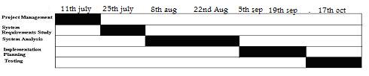

Fig. 2.2 Gantt chart of Project

**2.2.4 ROLES AND RESPONSIBILITIES**

The main responsibility as a developer is to create a consistent and well managed system which helps user to easily generate forms, create a database, and generate code file and tables dynamically. The system should fulfill all the specifications specified by user. It should not have any errors or redundancies. The data store in database should be easy to retrieve.

* 1. **PROJECT SCHEDULING:**

**Project Scheduling chart:**

|  |  |
| --- | --- |
| **Software Life Cycle Phase** | **Duration** |
| System Analysis : Problem Definition and Description | 7 days |
| Hardware Software Requirements | 1 day |
| Constrains\Goals of implementation | 1 day |
| Requirement Gathering | 7 days |
| Requirement Analysis | 7 days |
| Requirement Specification | 7 days |
| System Design : Use case Diagram | 7 days |
| Sequence diagram , Class Diagrams | 7 days |
| DFD , Flow Diagrams | 7 days |
| E-R Diagrams, Database Design | 7 days |
| Component Diagram | 2 days |
| Deployment Diagram | 2 days |
| Coding | 45 days |
| Testing & Deployment | 15 days |

**CHAPTER 3**

**SYSTEM REQUIREMENT STUDY**

**3.1 STUDY OF CURRENT SYSTEM:**

The user must have a valid User ID and password to login to the system. Users, who don’t have their account in this site, can create a new account for signup. Definitely one should not be allowed to have more than one profile. After the valid user logs in his/her account, the user can edit his/her profile and can post his/her views basing on the activities he/she desires. The site is having the features like auto analyze topics, group discussions, auto recommend threads based on searches etc. Ratings should be given according to their posts.

**3.2 PROBLEM AND WEAKNESS OF CURRENT SYSTEM:**

In current system the following problem occurs

* Once user forgets his password, he can’t get back his password as there is no method by which user can get back his password.

No likes and comments are mentioned in my current social networking site.

**3.3 USER CHARACTERISTICS:**

Educational level of Perpal computer software : Low

Experience of Perpal software : None Technical expertise : Little

**3.4 HARDWARE AND SOFTWARE REQUIREMENTS:**

* **Hardware Configuration:**
* **RAM** : 128 MB or above Random Access Memory.
* **Hard disk** : 20 GB or more free space in Hard Disk.
* **Processor** : Pentium III or higher
* **Modem** : 56 kbps / LAN card
* **Software Configuration:**
* **Operating System** : Windows XP, Vista, &7
* **Front End** : Asp.net With C#
* **Back End** : Microsoft SQL Server

**3.5 CONSTRAINTS:**

The Perpal shall be standalone system running in windows environment. It shall be developed using asp.net with c# and SQL database.

* This Website uses only Microsoft SQL Server to store database. The website will not work using some other database management system.
* To view this website must need Web browser (internet explorer 5.0 or above OR Mozilla Firefox).

3.5.1 PARALLEL OPERATIONS

This system is parallel processing so, system is parallel to edit available database and all effect will be shown at a time.

**3.5.2 RELIABILITY REQUIREMENTS**

The application does not demand much reliability. We only need to take care that the Visual studio running perfectly on system.

**3.5.3 SAFETY AND SECURITY CONSIDERATION**

The system is providing basic securities to user’s account. All user’s accounts are secure by password mechanism. Unauthorized user can not login to this system. And it is necessary for the user to login before using this system.

**3.5.4 CRITICALITY OF THE APPLICATION**

If the system is of lower configuration then there may be chances of memory overflow. This problem is mainly related with operating system memory management but we can neglect it for regular operation of software.

**3.6 ASSUMPTIONS AND DEPENDENCIES**

For the existence of this system we need to clarify some of the assumptions and dependency.

* Central server of the system must be able to handle all the incoming requests simultaneously.
* Back up of the databases in case of hardware failure, disaster, natural calamities.
* No data loss in case of handling of the system by the administrators or the system related personal.

**Assumptions** are described as below:

* Only valid user can use the system. Authentication done by the username and password.
* User having basic knowledge of accounting flow.

**Dependencies** are described as below:

* This system is depended upon the user’s valid inputted password. If user inputs wrong password then user will not able to perform any operations of the system.

**CHAPTER 4**

**SYSTEM ANALYSIS:**

**4.1 REQUIREMENT OF SOCIAL NETWORKING WEBSITE:**

* **User Requirement**
* Register Profile
* Edit Profile
* Check User Account
* Delete User Account
* Send / Receive Messages
* Make System Announcement
* Release System Update
* Send User Warning
* Suspend User Account

**4.2 FEATURES OF SYSTEM:**

**Functionality**

Functional requirements define the fundamental actions that system must perform. The functional requirements for system are Signup, login, Edit profile, find friend, Group chat. For further details, refer to use-cases.

**Usability**

This project will help to communicate with the people. Using the different kind of friend kits we can separate the friend’s bye their profession and personality. It may very helpful to communicate each other.

**Reliability**

This project is available anywhere, anytime and it can be used as social networking website to connecting the people.

**Portability**

This project is being develop in Asp.Net. It shall able to run in any Microsoft windows environment that contain .net platform and SQL database.

**Security**

User will be able to access its own account. Administrator will access the whole system with some rules and regulations.

**4.3 SYSTEM ACTIVITY:**

* **Dataflow Diagram**

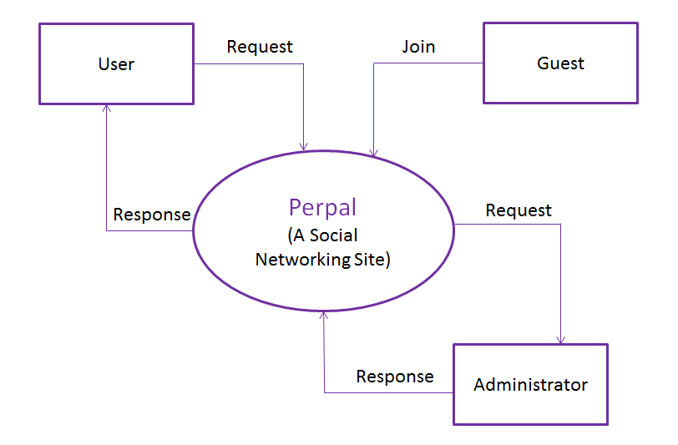

**0-LEVEL DFD:**

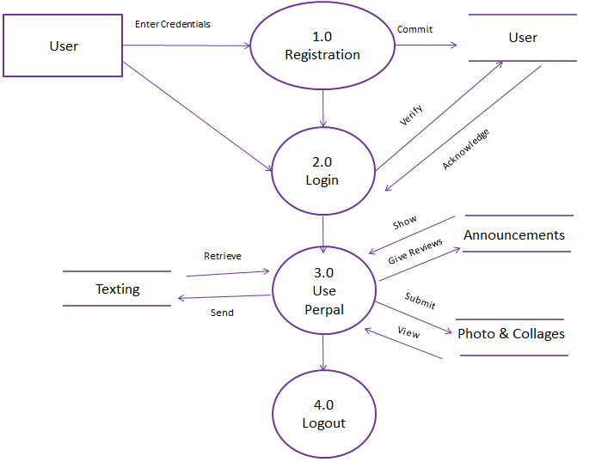

**LEVEL-1 DFD:**

* 1. **CLASS DIAGRAM:**

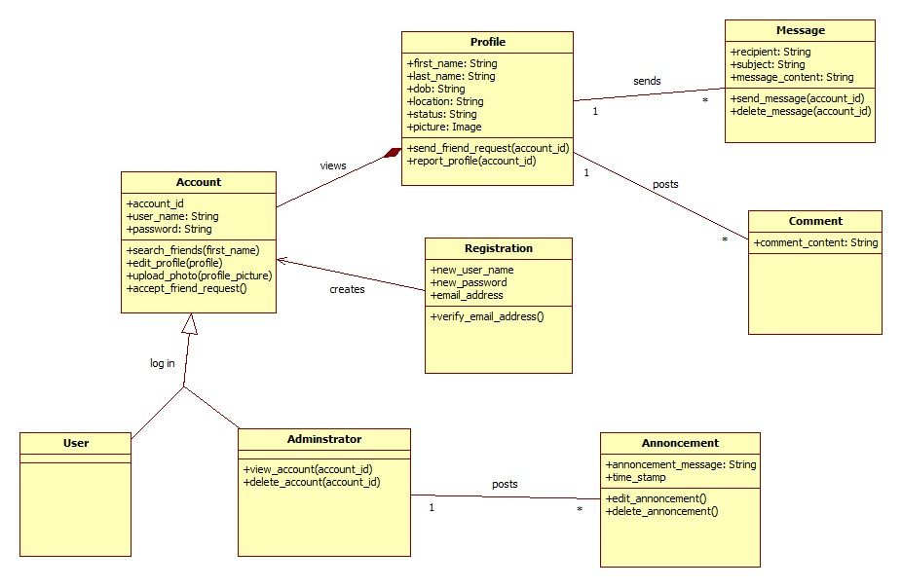

* 1. **USECASE DIAGRAM**

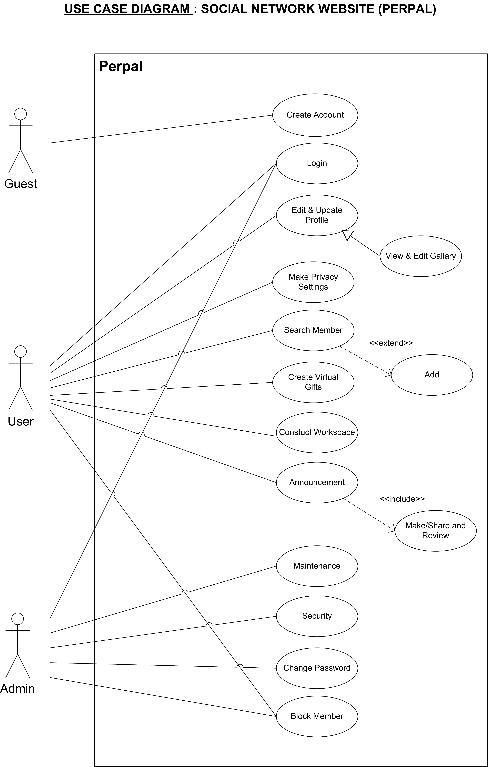

**4.6 DATA MODELING:**

**4.6.1 Data Dictionary**

**1. User**

|  |  |  |
| --- | --- | --- |
| **Field Name** | **Data Type** | **Allow Null** |
| UserId | Bigint | NO |
| Username | varchar(MAX) | Yes |
| Password | varchar(MAX) | Yes |
| FirstName | varchar(100) | Yes |
| LastName | varchar(100) | Yes |
| BirthDay | varchar(50) | Yes |
| Gender | varchar(10) | Yes |
| Relationship | varchar(50) | Yes |
| City | varchar(100) | Yes |
| State | varchar(100) | Yes |
| Country | varchar(100) | Yes |
| Like | varchar(MAX) | Yes |
| Hates | varchar(MAX) | Yes |
| WishOfLike | varchar(MAX) | Yes |
| Tagline | varchar(MAX) | Yes |
| ProfilePicture | varchar(MAX) | Yes |
| IsActive | Bit | Yes |
| VisitedWelcome | Bit | Yes |
| DateOfRegister | varchar(50) | Yes |
| LastLoginDate | varchar(50) | Yes |

1. **Block Id**

|  |  |  |
| --- | --- | --- |
| **Field Name** | **Data Type** | **Allow Null** |
| BlockedMainID | varchar(100) | Yes |
| Date | varchar(50) | Yes |

1. **Quick Announce**

|  |  |  |
| --- | --- | --- |
| **Field Name** | **Data Type** | **Allow Null** |
| AnnID | Bigint | No |
| UserID | Bigint | No |
| Title | varchar(MAX) | Yes |
| Post | varchar(MAX) | Yes |
| Time | varchar(MAX) | Yes |
| Workspace | Int | Yes |

1. **Past School**

|  |  |  |
| --- | --- | --- |
| **Field Name** | **Data Type** | **Allow Null** |
| SchoolId | Bigint | No |
| UserId | Bigint | No |
| SchoolName | varchar(100) | Yes |
| SchoolPic | varchar(MAX) | Yes |
| FinishingYear | varchar(25) | Yes |

1. **Work Space**

|  |  |  |
| --- | --- | --- |
| **Field Name** | **Data Type** | **Allow Null** |
| Personal | Int | Yes |
| Professional | Int | Yes |
| Family | Int | Yes |

**4.6.2 ER DIAGRAM**



**CHAPTER 5**

**SYSTEM DESIGN**

**5.1 Class Diagram**

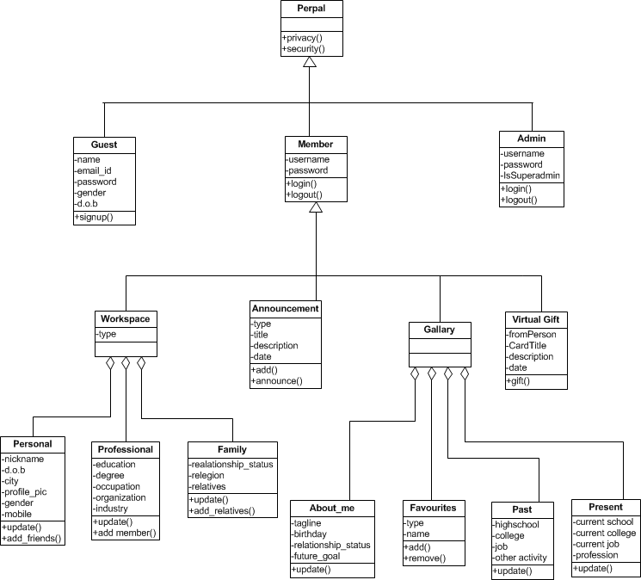

**5.2 ACTIVITY DIAGRAM**

**5.2.1 System Activity Diagram**

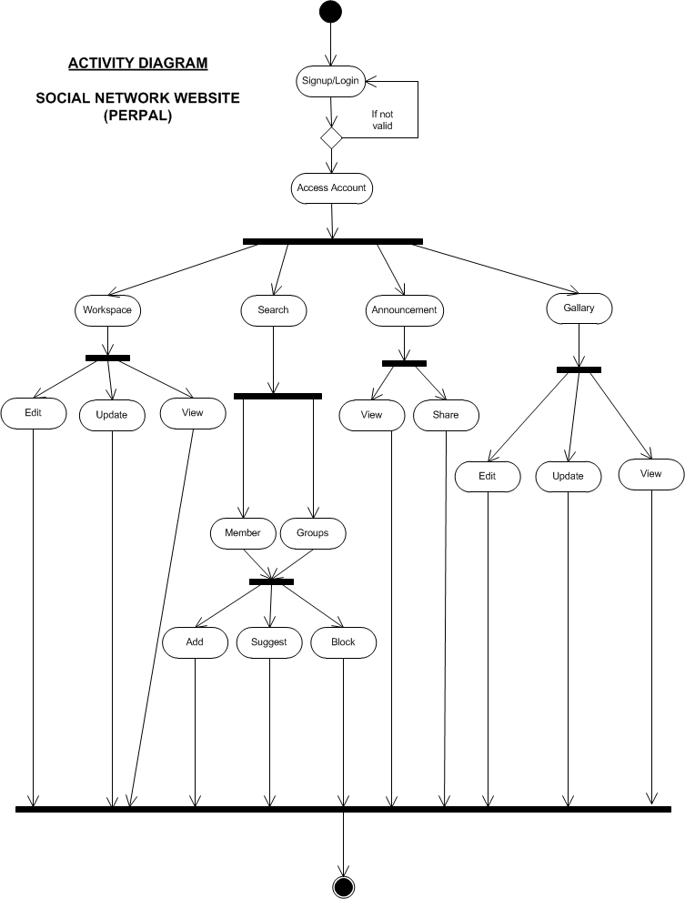

**5.2.2 Announcement Activity Diagram**

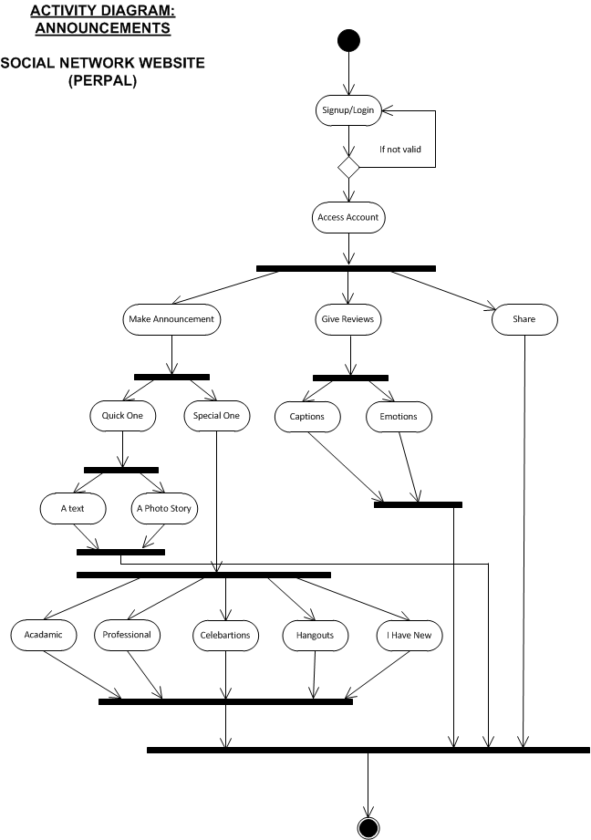

**5.2.3 Virtual Gift Activity Diagram**

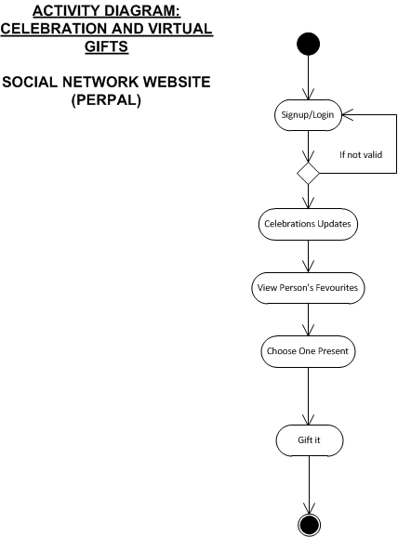

**CHAPTER 6**

**TESTING**

**6.1 TESTING PLAN**

Software testing is the critical element of the software quality assurance and represents the ultimate review of specification, design, and code generation. Once the source code has been generated, software must be tested to uncover as many errors as possible before delivery to the users. This chapter describes some of the testing techniques for designing tests that

* Exercise the internal logic of the software components
* Exercise the input and output domains of the program to uncover errors in program function, behavior and performance.

We carried out testing process in four stages as unit testing, module testing, subsystem testing and system testing.

**The Testing Process**

Unit Testing

Module Testing

Subsystem Testing

System Testing

**Fig 6.1: Testing Process**

The software process activities such as Design, Implementation, and Requirement Engineering were tested. As the design errors are very costly to repair once system has started to operate. Therefore, it is quite obvious to repair them at early stage of the system. So analysis is the most important process of any project.

**6.2 TESTING STRATEGY**

### Requirements Trace ability:

As most interested portion is whether the system is meeting its requirements or not, for that testing should be planned so that all requirements are individually tested. We checked the output of certain combination of inputs, which gives desirable results, or not. Strictly stick to the requirements specifications, gives the path to get desirable results from the system.

**Tested Items:**

Tested items are like sending request to administrator, solving the sent request by the assignee, changing password of assignee and student, sending user feedback, adding new categories, adding new departments etc.

**Testing Schedule:**

Testing has been done for each procedure back-to-back so that errors and omissions can be found as early as possible. Once the system has been developed fully testing procedure is followed on other machines, which differs in configuration.

Software Testing involves executing an implementation of the software with test data and examining the outputs of the software and its operational behavior to check that it is performing as required.

**6.3 TESTING METHODS:**

Different testing techniques are as described below:

**Statistical Testing:**

Statistical Testing is used to test the program’s performance and reliability and to check how it works under operational conditions. Tests are designed to reflect the actual user inputs and their frequency.

The stages involved in the static analysis for this system are follows:

**Defect Testing:**

Defect Testing is intended to find inconsistencies between a program and its specification. These inconsistencies are usually due to the program faults or defects.

**Black-box Testing:**

In Black-Box Testing or Functional Testing, the output of the module and software, is taken into consideration, i.e. whether the software gives proper output as per the requirements or not. In another words, this testing aim to test a program's behavior against it specification without making any reference to the internal structure of the program or the algorithms used. Therefore the source code is not needed, and so even purchased modules can be tested. The program just gets a certain input and its functionality is examined by observing the output.

This can be done in the following way:

* Input Interface
* Processing
* Output Interface

The tested program gets certain inputs. Then the program does its job and generates a certain output, which is collected by a second interface. This result is then compared to the expected output, which has been determined before the test.

**White-box Testing:**

What it does; tests are designed to exercise the code. Code is tested using code scripts, driver etc. White Box testing is used as an important primary testing approach. Here code is inspected to see that are employed to directly interface with and drive the code.

**The tester can analyze the code and use the knowledge about the structure of a component to derive the test data. White box testing methods like control testing, loop testing have been used to make the software of increased reliability.**

**Structural Testing:**

Path testing has been exercised i.e. every independent execution path through a component or program has been tested. If every independent path is executed then all.

Statements in the components must have been executed at least once. The structure of program has also been checked.

**Integration Testing:**

After the individual modules were tested out, the integration procedure is done to create a complete system. This integration process involves building the system and testing the resultant system for problems that arise from component interactions.

The top-down strategy is applied to validate high-level components of a system before design and implementations have been completed. Because, the development process is started with high-level components and work is done down the component hierarchy.

**Performance Testing:**

Performance testing is designed to test the runtime performance of the system within the context of the system. These tests were performed as module level as well as system level. Individual modules were tested for required performance.

**6.4 TEST CASES:**

By definition, a test case is a set of data that the system will process as a normal input the philosophy behind testing is to find errors. We devised the test cases with this purpose in mind.

**Test Case 1:**

* **Purpose:** The purpose of this test case is to find out whether the rendering functionality is working perfectly or not.
* **Required Input:** Request of any particular department.
* **Expected Output:** The output of the test case was that the required solution is fetched.

#### Test Case 2:

* **Purpose:** The purpose of this test case is to check whether website is working properly when database is being manipulated by user.
* **Required Input:** It must have a website to deal complain along with requests.
* **Expected Output:** A Proper working solution along with all facility was found.

Table 6.1 Login into User Account

|  |  |  |  |  |
| --- | --- | --- | --- | --- |
| **Sr. No** | **Test Case** | **Expected Output** | **Actual Output** | **Test Case Status** |
| 1 | In login Enter Email Id and Password | Redirect to user home page | Redirect to user home page | Pass |
| 2 | Keep one of the required field empty | Website Should Give Error Message | Website Gives Error Message : “Require field is missing” | Pass |
| 3 | In Login Enter Invalid Email Id or Password | Website Should Give Error Message | Website Gives Error Message : “Incorrect Email Id or Password” | Pass |

Table 6.2 Sign in New User

|  |  |  |  |  |
| --- | --- | --- | --- | --- |
| **Sr. No** | **Test Case** | **Expected Output** | **Actual Output** | **Test Case Status** |
| 1 | Enter All Inputs which are valid | Website should give message | Website shows message “New User Joined successfully” | Pass |
| 2 | Keep one field empty | Website should give error message. | Website give message: “Require field is missing” | Pass |
| 3 | Enter invalid date and invalid contact number | Website should give error message | Website give message: “Invalid format” | Pass |

Table 6.3 Delete User Account

|  |  |  |  |  |
| --- | --- | --- | --- | --- |
| **Sr. No** | **Test Case** | **Expected Output** | **Actual Output** | **Test Case Status** |
| 1 | Enter User Id | Website should give message | Website shows message: “User Account has been successfully deleted” | Pass |
| 2 | Keep field empty | Website should give error message. | Website give message: “Email Id is missing” | Pass |
| 3 | Enter Invalid Id | Website should give error message. | Website give message: “Email Id is invalid” | Pass |

Table 6.4 Change Password

|  |  |  |  |  |
| --- | --- | --- | --- | --- |
| **Sr. No** | **Test Case** | **Expected Output** | **Actual Output** | **Test Case Status** |
| 1 | Enter all inputs which are valid | Website should give message | Website shows message “Password change successfully” | Pass |
| 2 | Keep at least one field empty | Website should give error message. | Website give message: “Require field is missing” | Pass |
| 3 | Enter current password invalid | Website should give error message. | Website give message: “Current password didn’t match” | Pass |
| 4 | Enter confirm password and new password different | Website should give error message. | Website give message: “New password didn’t match” | Pass |

**CHAPTER 7**

**USER MANUAL**

1. **Sign Up for New Account**

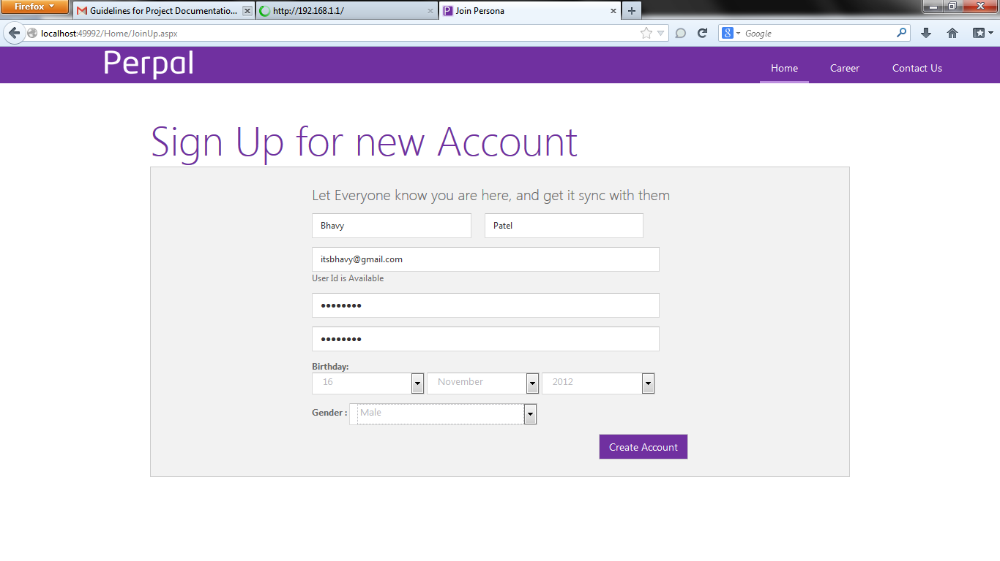

1. **Login Page**

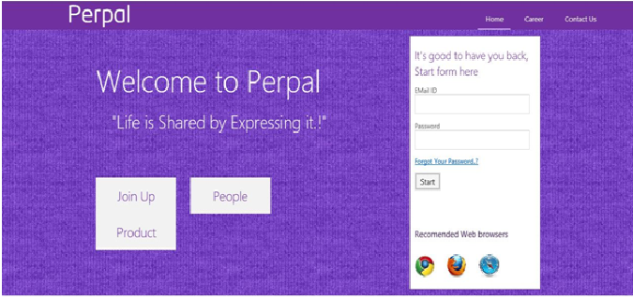

1. **Invalid Username or Password**

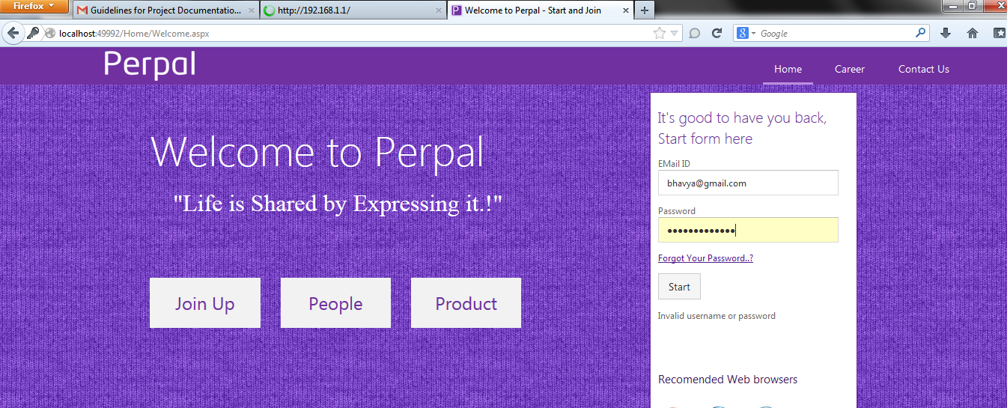

1. **Validation or Error Page**

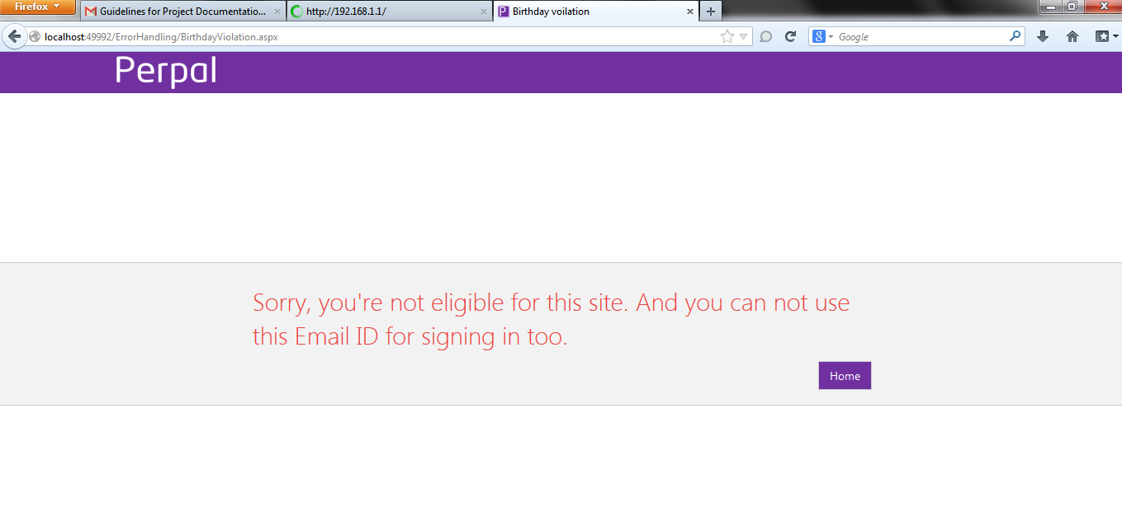

* In perpal social networking site, this screenshot is describe that under sixteen years user can’t join this account.

1. **Home Page of Your Profile**

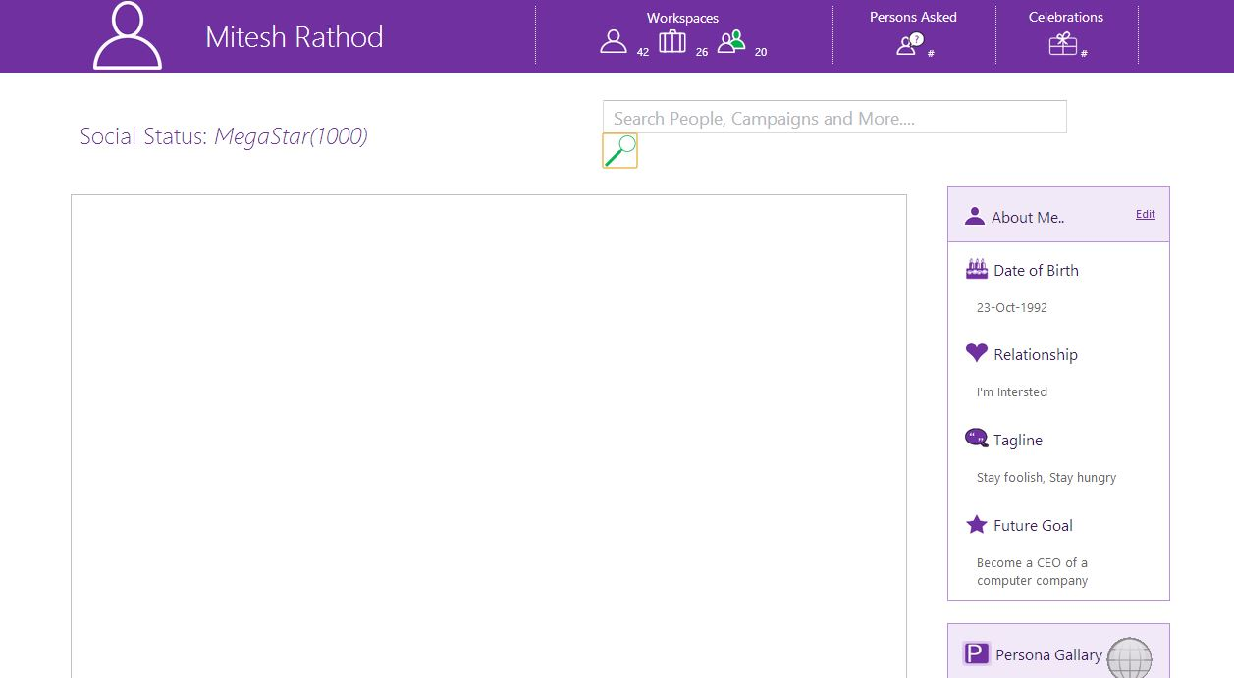

* This is user home page, in which user can show the current and past status or announcement, any uploaded photos etc.

1. **Editing Your Profile**

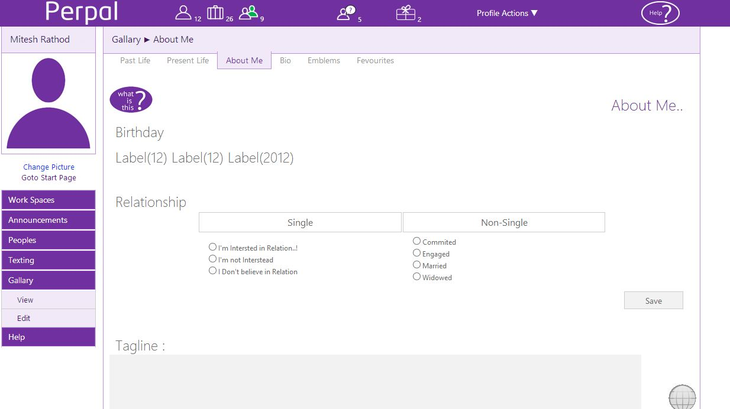

* This screenshot mentioned that the user can change or upload new photos, user’s whole profile like birth date, his first name, last name also nick name.
* User can also change the school profile like past school name, current school name, past or current college name and user can also upload the school or college photos.
* User can also mention the family relationship and he or she married or not.

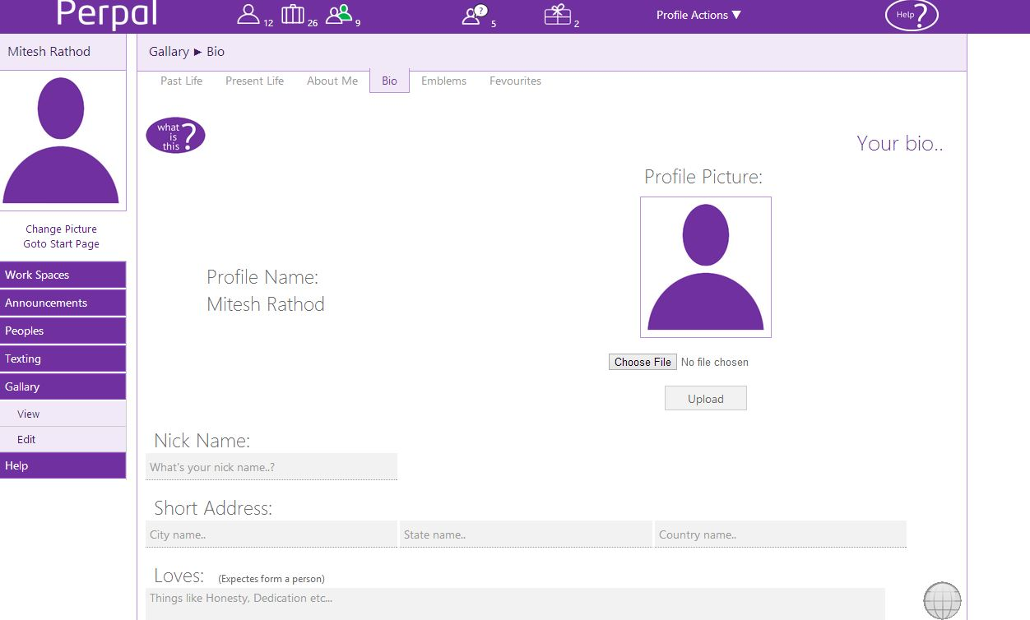

1. **Announcement View Page**

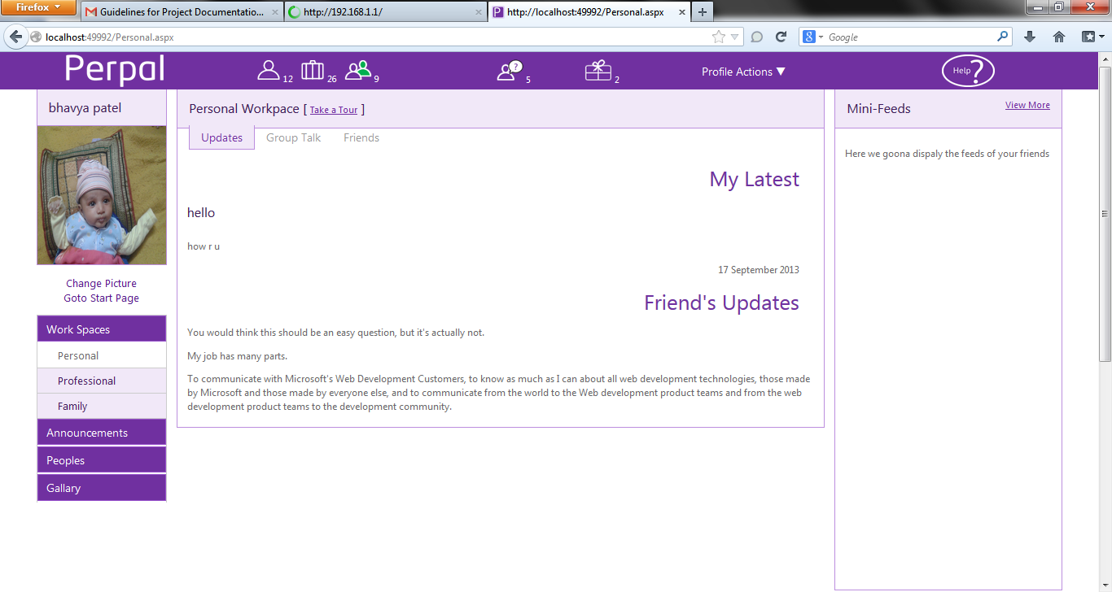

1. **Announcement Update Page**

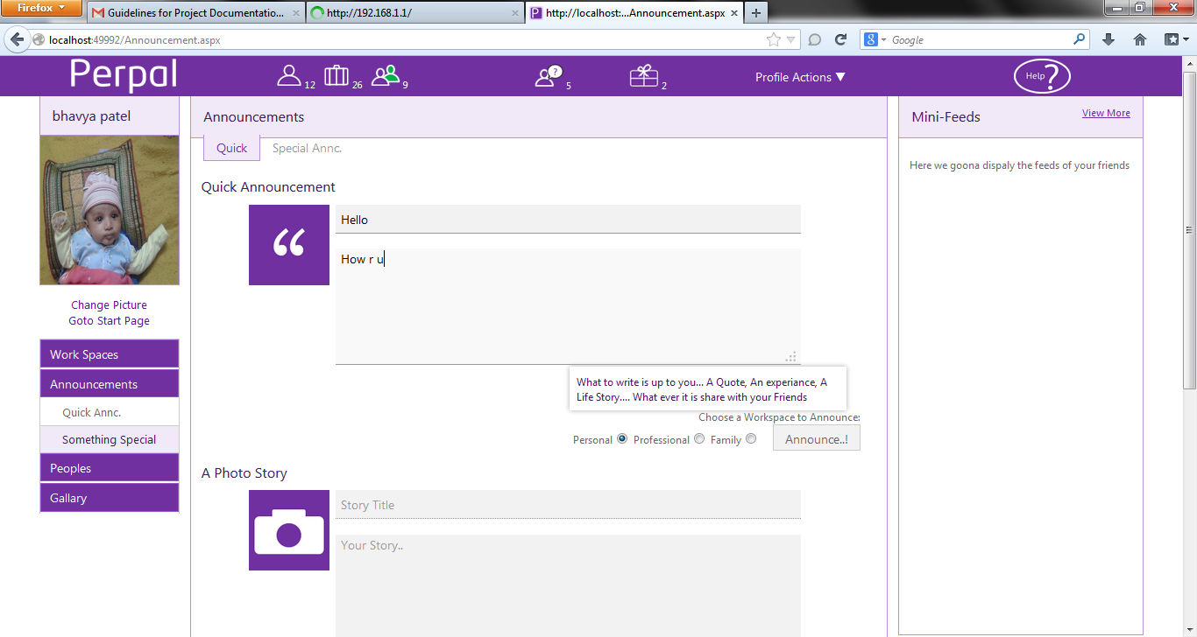

* In this Page, User can write or post the announcement or status update which can be shown in the user home page.

1. **Change Profile Picture**

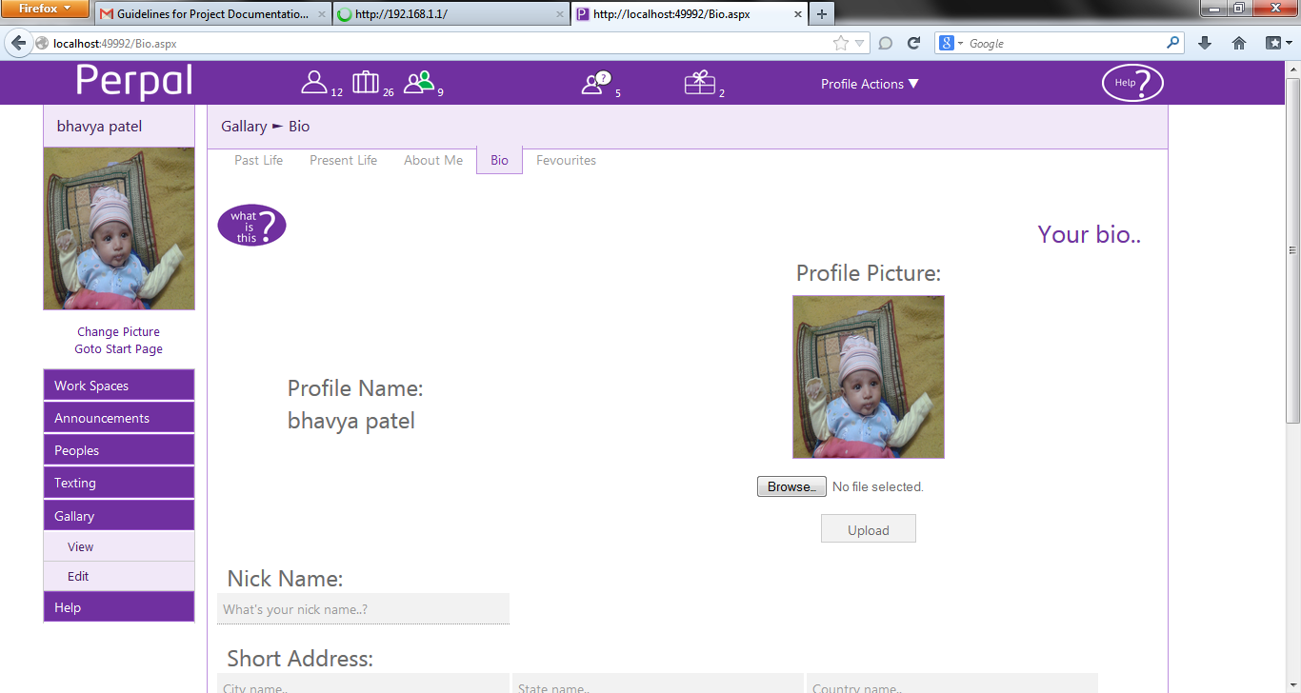

* This screenshot described that in which user can change the profile picture.

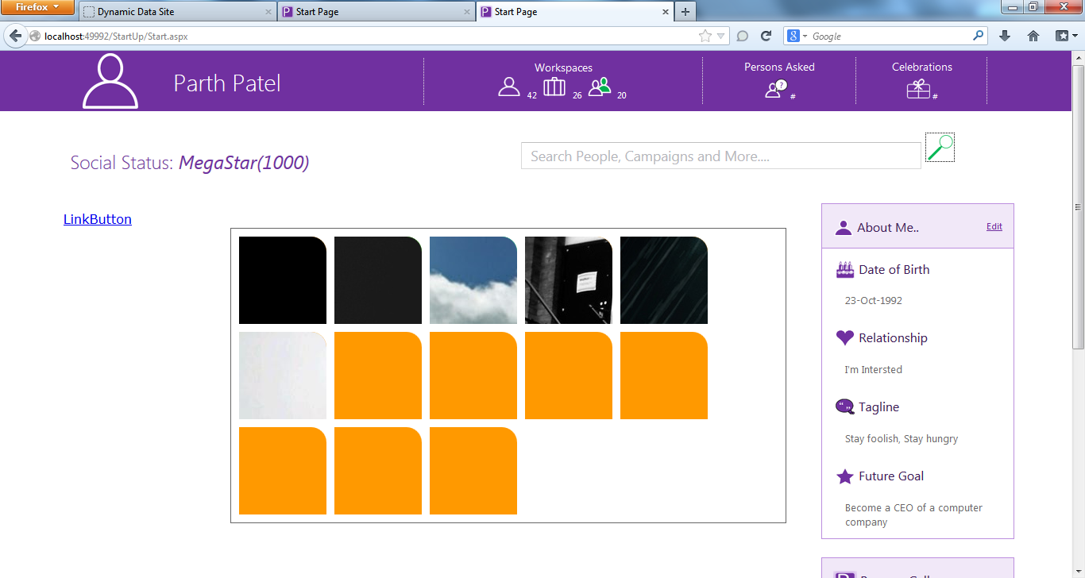

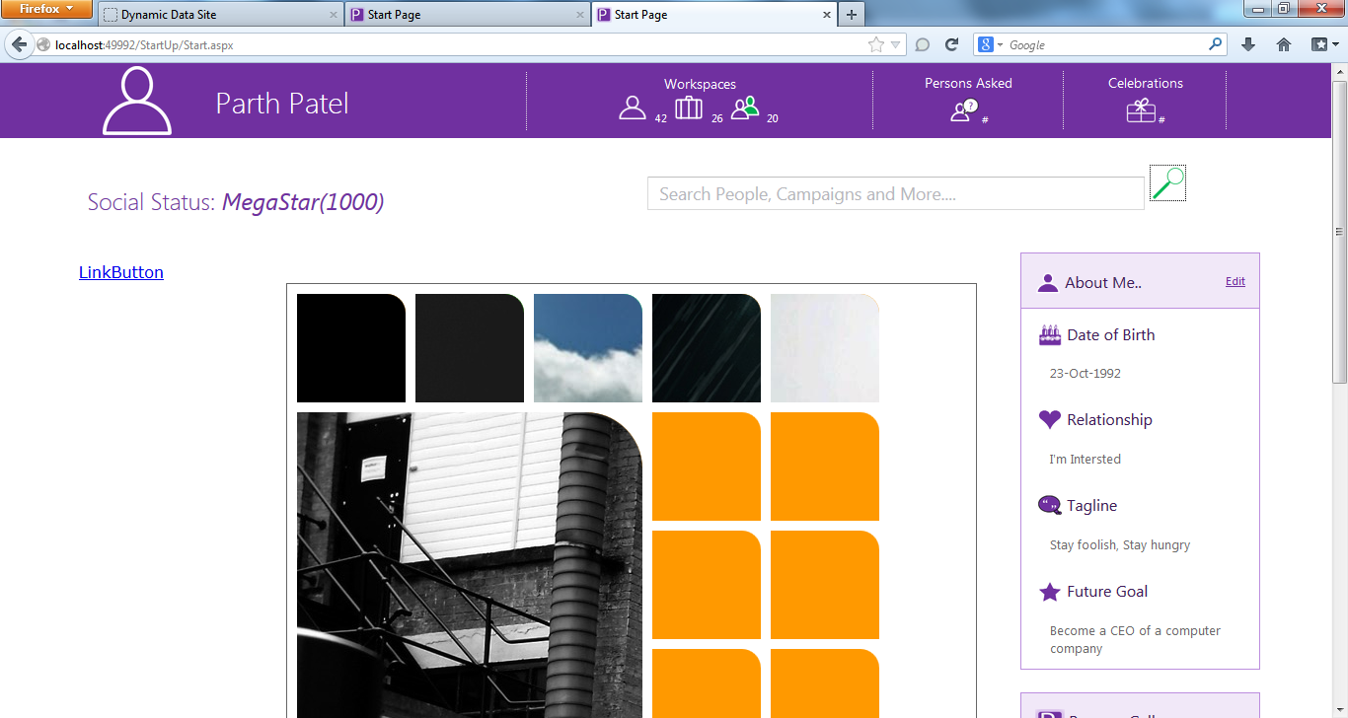

**CHAPTER 8**

**LIMITATION AND FUTURE ENHANCEMENT**

**Limitation:**

Once the user forgot his/her password, then he/she is not allowed to get password back.

It is not possible to admin to deal with each and every user directly here.

**Future Enhancement:**

In future we will first try to overcome our limitations, such as blocking unknown friend of a user from viewing his/her profile, scribble, album etc. Apart from that we would add some modules for both admin as well as client part

**CHAPTER 9**

**CONCLUSION AND DISCUSSION:**

**9.1 : CONCLUSION:**

1. It is online application in which user can share his thought, status update and announcement with professional, family, personally. The user can upload new profile picture, and also change his past or current co-curricular activities.
2. It is a GUI based project so user can work friendly with it.
3. The complexity is less and performance is high.

**9.2: DISCUSSION:**

I achieve lots of support from our organization. My external guide and as well as his members are always ready to provide any kind of support when and where required. I also grasp some minor thing but which is very major part of the project development like to put comment wherever and when necessary, use special naming convention for coding, how to optimized coding which required less memory and provide fast processing, how to debug code for different bugs etc… which are very useful for me and I have follow it during my project.

**9.2.1: SELF ANALYSIS OF PROJECT VIABILITIES**

* The given project Social Networking Site is known for me and viable for fulfilling the specific requirement of the institute that is share the new announcement and status update and also communicate between two or more users and also passing messages between the users.

**9.2.2: PROBLEM ENCOUNTERED AND POSSIBLE SOLUTIONS**

* It is done by AJAX control.
* In designing of website, there are so many problems arrived for management all parts. In error solving lot many error take time to solve.
* I have solved them by .Net framework documentation, MSDN or with the help of project guide.

**9.2.3: SUMMARY OF PROJECT WORK**

* When we got project from our company, we tried to understand the project concept and different areas related to this project. Then we planned out whole project according to planning management.
* We also scheduled whole Software Engineering activities that are related with our software and allocated days to complete particular activities.
* Then we tried to strictly follow those scheduled activities also we calculated risks that are related to our project.
* According to our schedule we have prepared different milestones and deliverables and also achieved those milestones and deliverables.
* Also on each week we tried to show our work using weekly report and also we made the discussion with our internal guide.
* First of all we made our mind clear for what we were going to develop by collecting all the information related to our project.
* Next was the analysis phase. In that we collect the entire requirement from our company. We have also studied on functional requirement. We analyze the requirements and make dataflow for our system.
* After designing, we come to fix our database and decided different modules that would work for our system.
* After completion of designing and analysis, we started coding for application. We used ASP.NET as a development tool and SQL Server as a database.
* Then we started testing out application. There were many deficiencies in that but we tried to solve them and were successful most of the times.

**CHAPTER 10**

**BIBLIOGRAPHY**

**Websites Referred:**

* msdn.microsoft.com
* http://www.asp.net
* "http://www.w3schools.com" _http://www.w3schools.com
* "http://www.learnsqlserver.com" _http://www.learnsqlserver.com
* http://css3playground.com/
* <http://www.facebook.com>
* [www.orkut.com](http://www.orkut.com)
* www.linkedin.com

**Books Referred:**

Apress Beginning, ASP.NET 2.0 in C#,(2005)

Wrox Beginning, ASP.NET 2.0 with C#,(2008)

Wrox Beginning, AJAX with ASP.Net 2.0,(2010)