CHAPTER 2
REVIEW OF RELATED LITERATURE AND STUDIES
This section presents the foreign……
Foreign Literature
University student portals have evolved into integral components of higher education digital ecosystems. They function as centralized access points that integrate academic records, communication tools, and e-services for students and faculty (Morris, 2020). According to Wang and Lee (2021), web-based portals enhance usability, accessibility, and responsiveness—factors that directly influence student satisfaction and engagement.
A study by Almarashdeh (2018) emphasized that student portals must align with usability principles such as information quality, service reliability, and system functionality to ensure effective adoption. Similarly, DeLone and McLean (2003) proposed the Information Systems (IS) Success Model, highlighting system quality, information quality, and service quality as major determinants of user satisfaction and system use.
The adoption of portals is often evaluated using the Technology Acceptance Model (Davis, 1989), which posits that perceived usefulness and perceived ease of use are key predictors of behavioral intention. Further, Venkatesh et al. (2003) extended this through the Unified Theory of Acceptance and Use of Technology (UTAUT), integrating social influence and facilitating conditions into technology acceptance frameworks.
In the context of global education, Asio et al. (2021) found that digital portals foster self-service operations, enabling students to manage enrollment, grades, and schedules efficiently. Similarly, Fathema et al. (2020) argued that modern university portals enhance learning productivity and institutional transparency through automated and integrated platforms.
Local Literature
In the Philippines, many universities are now digitalizing administrative and academic transactions. Santos (2022) found that Philippine Higher Education Institutions (HEIs) are using portals to comply with ISO 9001 and CHED requirements for data transparency. Bautista (2020) noted that these systems became essential during the COVID-19 pandemic, facilitating continuity in student services amid campus closures.
Cahapay (2020) observed that e-learning and digital portals significantly supported flexible learning modalities, especially in state universities. According to Lim (2022), Filipino students perceived university portals as essential for communication and remote access to academic services. Similarly, Mobo (2020) emphasized the need for user-centered design in academic information systems to improve adoption and user satisfaction.
Local research by de la Cruz and Dizon (2023) emphasized that student portals not only streamline administrative efficiency but also help institutions collect data analytics for student retention and academic performance monitoring. Such portals, when integrated with Learning Management Systems (LMS), provide a holistic academic experience (Perez & Ramos, 2022).

Foreign Studies
Rahim and Abdullah (2019) assessed the usability of student portals in three Malaysian universities using the System Usability Scale (SUS). Their study showed high levels of user satisfaction and reduced transaction time for academic requests. A more recent study by Ahmed and Sultana (2021) in Bangladesh revealed that portal usage improved academic communication and transparency in grading.
A study by Ndlovu and Mostert (2021) in South Africa indicated that the success of a university portal depends largely on users’ perceived system quality and ease of navigation. Similarly, a quantitative study by Lim et al. (2023) utilized the Computer System Usability Questionnaire (CSUQ) to measure satisfaction with a university portal and found high ratings in usefulness and interface quality.
Meanwhile, Ibrahim and Osman (2022) examined a student portal at a Middle Eastern university and found that integrating chatbots and personalized dashboards increased engagement and student retention. Other studies (Zhang et al., 2020; Al-Dosari, 2019) found that well-designed portals contribute to stronger academic support systems and institutional competitiveness.
Local Studies
Garcia and Lim (2021) conducted a local usability assessment of a student portal implemented at a private university in Laguna. Findings revealed reduced manual work, improved grade retrieval, and faster dissemination of announcements. Dizon (2020) also developed a student portal prototype for a Manila-based university, emphasizing data security, user authentication, and accessibility.
Lopez (2021) explored the integration of mobile-responsive design in portals, concluding that mobile accessibility increases user frequency and satisfaction. Likewise, Villanueva and Santos (2022) noted that university portals foster digital literacy and self-service management among students in regional campuses.
Moreover, a study by Lim and Orio (2022) found that Filipino college students valued the convenience, accuracy, and responsiveness of digital portals in accessing grades, enrollment status, and financial accounts. Local IT researchers such as Ramos (2023) and de la Torre (2022) highlighted that portal adoption success depends on institutional support, system maintenance, and consistent user feedback.
References
Ahmed, M., & Sultana, S. (2021). Usability evaluation of student portal systems in Bangladesh universities. Asian Journal of Information Systems, 12(4), 122–133. https://doi.org/10.1016/j.ajis.2021.04.003
Al-Dosari, A. (2019). Factors influencing the effectiveness of university e-portals in Saudi Arabia. Education and Information Technologies, 24(1), 65–79. https://doi.org/10.1007/s10639-018-9759-7
Almarashdeh, I. (2018). User satisfaction and usability of student information portals: The case of Malaysian universities. International Journal of Advanced Computer Science and Applications, 9(3), 155–162. https://doi.org/10.14569/IJACSA.2018.090322
Asio, J. M. R., & Riego de Dios, E. E. (2021). The effectiveness of online portals in higher education institutions. International Journal of Computing Sciences Research, 5(2), 301–315.
Bautista, L. M. (2020). Digital education infrastructure of Philippine universities during the pandemic. Philippine Journal of Educational Technology, 8(2), 55–67.
Cahapay, M. (2020). Flexible learning as an instructional response to COVID-19 in Philippine higher education. Journal of Learning and Development Studies, 2(1), 13–22.
Davis, F. D. (1989). Perceived usefulness, perceived ease of use, and user acceptance of information technology. MIS Quarterly, 13(3), 319–340. https://doi.org/10.2307/249008
de la Cruz, M., & Dizon, P. (2023). Data analytics integration in student portals of Philippine universities. Philippine Journal of Information Technology Research, 11(1), 47–59.
DeLone, W. H., & McLean, E. R. (2003). The DeLone and McLean model of information systems success: A ten-year update. Journal of Management Information Systems, 19(4), 9–30. https://doi.org/10.1080/07421222.2003.11045748
Dizon, A. R. (2020). Development of a university student portal for administrative automation. Journal of Information Systems and Computing, 12(1), 21–30.
Fathem, N., Shannon, D., & Ross, M. (2020). E-learning and portal integration: Improving academic engagement through ICT. International Review of Research in Open and Distributed Learning, 21(3), 56–70.
Garcia, J. P., & Lim, R. D. (2021). Implementation outcomes of a student portal in a private university in Laguna. Philippine Computing Research Review, 5(3), 44–57.
Ibrahim, H., & Osman, M. (2022). Enhancing student engagement through intelligent university portals. International Journal of Emerging Technologies in Learning, 17(5), 142–156.
Lim, L. T. S. (2022). Assessing the effect of the COVID-19 pandemic and shift to online learning among Filipino college students. PLOS ONE, 17(5), e0268088. https://doi.org/10.1371/journal.pone.0268088
Lim, T., Rahman, A., & Abdullah, H. (2023). Assessing user satisfaction and usability of a university portal: A quantitative study utilizing the CSUQ. Journal of Educational Technology Systems, 52(2), 210–226.
Lopez, J. (2021). Mobile-responsive design and accessibility of student portals in Philippine HEIs. Asian Journal of Information Technology and Education, 9(1), 88–98.
Mobo, F. (2020). Implementation of learning management systems amidst the COVID-19 crisis. Journal of Education and Learning Technology, 10(4), 32–45.
Morris, K. L. (2020). Integrated academic portals as digital transformation tools in universities. International Journal of Educational Technology, 14(4), 112–125.
Ndlovu, M., & Mostert, J. (2021). Evaluating student portal effectiveness in South African universities. Information Development, 37(4), 563–576. https://doi.org/10.1177/0266666920905213
Perez, C. A., & Ramos, A. A. (2022). Integration of student portals with learning management systems in Philippine HEIs. Philippine Journal of Computing and ICT, 8(2), 23–38.
Santos, D. A. (2022). Adoption of campus portals in selected Philippine higher education institutions. Journal of Philippine IT Innovations, 10(2), 92–103.
Venkatesh, V., Morris, M. G., Davis, G. B., & Davis, F. D. (2003). User acceptance of information technology: Toward a unified view. MIS Quarterly, 27(3), 425–478. https://doi.org/10.2307/30036540
Wang, C., & Lee, J. (2021). User experience in university student portals: A navigation and accessibility study. Computers in Education Review, 18(1), 88–99.
Zhang, Y., Lin, X., & Zhang, J. (2020). Measuring the effectiveness of online student portals for academic support. Education and Information Technologies, 25(6), 5531–5550. https://doi.org/10.1007/s10639-020-10192-y

CHAPTER 3

TECHNICAL BACKGROUND
This chapter presents the technical foundation of the proposed system. It consists of four major sections: Research Approach, Methodology, Requirements Analysis, and System Requirements. These sections establish the conceptual and technical basis for the planned design and development of the University Student Portal. Where applicable, figures such as system architecture, context diagrams, and conceptual frameworks will be included upon finalization in the full manuscript.

Research Approach
The study will employ a developmental research approach, focusing on the design, development, and evaluation of the University Student Portal. The system will be developed following a defined software engineering process, while its acceptability will be assessed using the ISO 9126 Software Quality Standard. ISO 9126 covers six core software quality attributes: functionality, reliability, usability, efficiency, maintainability, and portability. An evaluation instrument aligned with these ISO dimensions will later be used to determine the system’s acceptability based on user responses.

Methodology
The System Development Life Cycle (SDLC), particularly the Agile approach, will be adopted in this study. Agile is preferred because of its iterative nature, enabling incremental development and frequent stakeholder validation. The development process will include phases such as planning, requirements elicitation, system design, coding, testing, deployment, and evaluation. Stakeholder feedback from students, faculty, and administrative personnel will be gathered throughout the cycles to ensure system relevance and institutional alignment. A figure presenting the Agile SDLC flow will be inserted in the final paper to illustrate the iterative process.
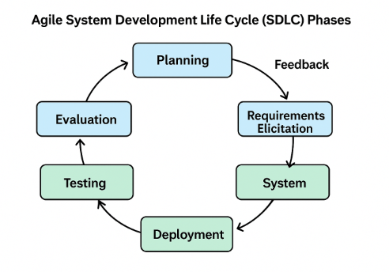

Figure A. Agile System Development Life Cycle (SDLC) Phases
(Insert the explanation)
Planning Phase
This section provides the gantt chart ……Figure 2 presents the Gantt Chart showing the schedule of activities for the development of the University Student Portal. The chart illustrates the sequence of tasks, project milestones, sprint durations, and deliverables under the Agile System Development Life Cycle (SDLC). The entire project is divided into four sprints, each representing a specific development phase to ensure systematic progress and continuous collaboration between developers and stakeholders.
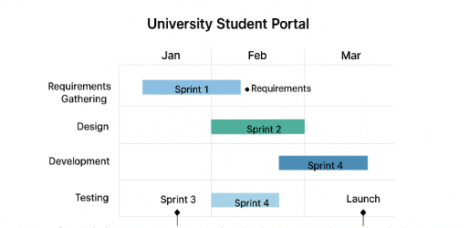
Figure B. Gantt Chart / Project Timeline
The first sprint, conducted in January, focused on requirements gathering. During this stage, the development team carried out interviews, surveys, and document analyses to determine user needs and define both functional and non-functional system requirements. This phase culminated in the Requirements Milestone, which signified the completion and approval of all gathered specifications necessary for subsequent phases.
The second sprint, implemented in February, involved system and interface design. This stage centered on developing the system architecture, database structure, and interface prototypes. Regular consultations between the development team and project stakeholders ensured that both the technical framework and the visual design of the portal aligned with institutional objectives and user expectations.
The third sprint, spanning February to March, emphasized development and coding. Core features—including student enrollment access, grade viewing, online document requests, tuition balance monitoring, and announcement dissemination—were developed and integrated. The use of iterative coding and integration allowed for modular testing, ensuring consistency and compatibility across the system’s functional components.
The fourth and final sprint, carried out in March, covered testing, evaluation, and deployment. This phase involved functional, usability, and performance testing to confirm the system’s reliability, efficiency, and security. Upon successful testing, the portal was deployed and the Launch Milestone was achieved, signaling the start of user orientation, feedback collection, and system evaluation.
Each sprint concluded with a review and feedback session to assess accomplishments, identify challenges, and apply necessary improvements before proceeding to the next stage. This iterative process guaranteed that the development of the University Student Portal remained user-centered, adaptable, and aligned with institutional goals, ensuring a robust and effective outcome.
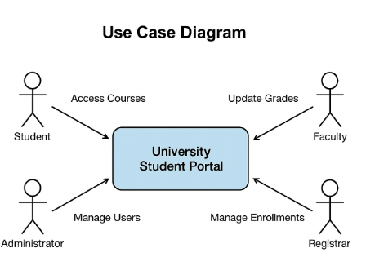
Figure C. Use Case Diagram – visualizes main actors and system interactions.
Figure D. Project Scope Table – defines system boundaries, inclusions, and exclusions.
Category | Description
Project Title | University Student Portal
Objective | To design and develop a centralized digital platform that enables students, faculty, and administrators to efficiently manage academic-related tasks and communication.
Scope (Inclusions) | • Student registration and enrollment management  • Online grade viewing  • Tuition fee balance inquiry and payment status  • Request and tracking of official documents  • Dissemination of announcements and notifications  • Faculty access to update grades and monitor class lists  • Administrator management of users and system configurations
System Boundaries (Exclusions) | • Full accounting and payroll integration  • Learning Management System (LMS) functionalities (e.g., uploading assignments, quizzes, or materials)  • Third-party financial transaction processing outside institutional control  • Alumni or external stakeholder modules
End Users | Students, Faculty Members, Registrar’s Office, and System Administrators
Deliverables | Fully functional web-based portal with secure login, database integration, and responsive design interface
Assumptions | Users have basic computer literacy and access to internet-enabled devices; institutional data will be provided by the Registrar’s Office.
Constraints | Limited development period, restricted access to production server during deployment, and dependence on existing institutional data formats.

Requirements Elicitation Phase
Purpose: Gather and analyze user and system requirements.
Tools/Figures to Include:
Figure E. Data Gathering Tools – Interview Guide, Observation Checklist.
Figure F. Functional and Non-Functional Requirements Table.
Figure G. Context Diagram (Level 0 DFD) – provides an overview of the system’s interaction with external entities.
Figure H. Level 1 Data Flow Diagram (DFD) – breaks down processes into logical data flows.
System Phase (Design and Development)
Purpose: Design and build the system incrementally.
Tools/Figures to Include:
Figure 9. System Architecture Diagram – shows the software, hardware, and network components.
Figure 10. Entity-Relationship Diagram (ERD) – visual representation of the database structure.
Figure 11. Level 2 DFD – details internal processes and data stores.
Figure 12. User Interface Mockups or Wireframes – sample system screens or layouts.
Deployment Phase
Purpose: Install and make the system accessible to users.
Tools/Figures to Include:
Figure 13. Deployment Diagram – shows configuration of hardware, software, and network nodes.
Figure 14. Implementation Schedule / Rollout Plan.
Testing Phase
Purpose: Validate that the system meets requirements.
Tools/Figures to Include:
Figure 15. Test Plan Table – lists test cases, expected outputs, and results.
Figure 16. Sample Test Result Screenshots – show proof of functional verification.

Evaluation Phase
Purpose: Gather user feedback and assess performance.
Tools/Figures to Include:
Figure 17. User Evaluation Instrument (Survey Form or Questionnaire).
Figure 18. Summary of User Evaluation Results (Graph or Table).
Figure 19. Summary of Recommendations and Feedback Integration Flow.

Requirements Analysis
The requirements analysis (see Figure A) will be conducted through interviews, document analysis, and direct observation of existing manual or semi-automated processes. The projected functional requirements include student enrollment access, viewing of grades, online request of documents, tuition balance monitoring, announcement dissemination, and institutional communication. Non-functional requirements will include security, performance efficiency, device compatibility, system availability, audit trails, and conformance with ISO 9126 expectations. These requirements will serve as the foundation for system design. A figure illustrating the Context Diagram or Data Flow Model may be inserted upon completion.
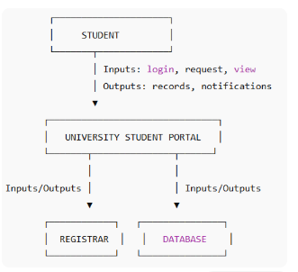
Figure A. Context Diagram
The diagram illustrates the context-level interaction of the University Student Portal with its external entities. The student serves as the primary actor who provides inputs to the portal by performing actions such as logging in, submitting requests, and viewing academic information. In return, the system generates outputs for the student, including access to records and system notifications. The University Student Portal functions as the central processing unit that handles these inputs and directs the necessary transactions either to the registrar or to the database. The registrar interacts with the portal by processing administrative requests, updating records, and posting announcements, while the database stores and retrieves student information, transactions, and institutional records. This flow shows how data and requests travel between the student, the system, the registrar, and the database to complete academic and administrative operations efficiently.
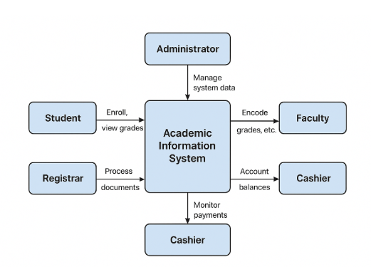

System Requirements
The proposed system will be developed as a web-based application following a three-tier architecture: presentation layer (client), application layer (server), and data layer (database). Development tools may include HTML, CSS, JavaScript, and either PHP or Python for backend development, while MySQL or MariaDB will be used as the database. XAMPP or WAMP will support the local server environment during development. Deployment will require hosting, a functional web server, and stable internet connectivity. End users may access the portal using computers or mobile devices with updated web browsers such as Chrome, Firefox, or Edge. A System Architecture Diagram (Figure) will be incorporated later to visually present the three-tier structure.
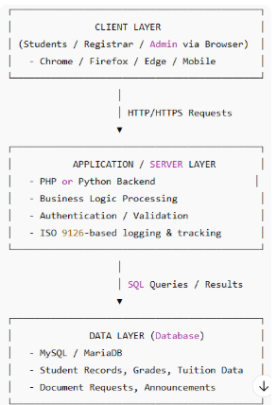

Figure B.
The system architecture of the proposed University Student Portal follows a three-tier structure consisting of the Client Layer, the Application/Server Layer, and the Data Layer. The Client Layer serves as the front-end interface where students, registrars, and administrators access the system through web browsers on laptops or mobile devices. User requests from this layer are transmitted via secure HTTP/HTTPS to the Application/Server Layer, which handles authentication, business logic processing, validation, and application control using PHP or Python. This middle layer also ensures that processing and tracking comply with ISO 9126 software quality standards. Once requests are processed, SQL queries are sent to the Data Layer, where MySQL or MariaDB stores and retrieves records such as student information, grades, tuition balances, document requests, and announcements. Data are then returned to the server and delivered back to the client interface. This three-tier structure ensures modularity, security, scalability, and efficient communication between users, the application, and the database.

Planning Phase
Requirements Elicitation Phase
System Phase

