KLE Society's

KLE Technological University



**Open Ended (OE) Assessment Report**

**On**

**THERMAL POWERPLANT MANAGEMENT**

**Object Oriented Programming (20ECSC204)  
Object Oriented Programming Lab (20ECSP203)**

Submitted by

| Name | Roll no | SRN |
| --- | --- | --- |
| Prajwal N Shavi | 343 | 01FE20BCS166 |
| Neha T Patil | 344 | 01FE20BCS167 |
| Team Number: 19 | | |

Faculty In-charge:

Prof. Manas Kumar Panda

SCHOOL OF COMPUTER SCIENCE & ENGINEERING

Academic year 2021-22

1. **Introduction:**
   1. **Overview of the problem statement:**

Thermal powerplant management system simplifies the need of database management that is a major problem faced in this domain.

Through this application, all the database can be stored in txt file like form that is user readable also. This application also simplifies the calculation of the input and output transmitted power easily that can be tedious to calculate otherwise. Updates can also be made on the existing database so that data can be managed efficiently.

We have accomplished this application using some of the concepts of object-oriented programming in C++.

* 1. **Features of Application:**

The following features have been implemented in this project:

* All the data will be read from the files. So, the user need not to enter every data manually.
* All the data in files will be read automatically once we run the program.
* The number of lines in each file can be displayed using appropriate choice.
* The detailed information of each class can be printed if the user chooses to see the entries.
* Employee database can be updated along with handling the error. Error here can be caused due to entering negative value when asked.
* Similarly, power transmission can be updated. If output power is more than input power, error will be encountered.
* The total power produced and total power transmitted can be calculated automatically.
* The updated contents will automatically be updated into the respective files.

1. **Design:**
   1. **Class Diagram:**

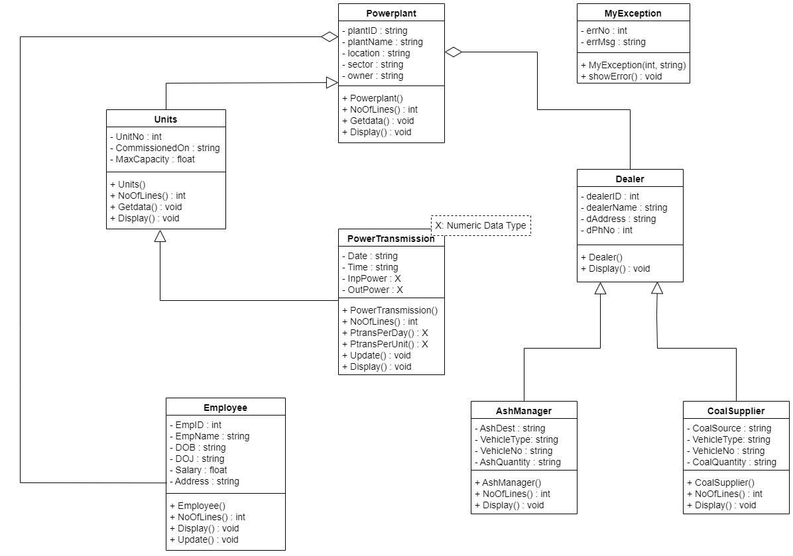

1. **Implementation:**
   1. **Test Plans:**

|  |  |  |  |  |
| --- | --- | --- | --- | --- |
| Sl No. | Test Case | Input | Output | Status |
| 1 | To display number of lines in all the files | Enter your choice: 1 | Number of lines in the PowerPlant.txt file are: 1  Number of lines in the Units.txt file are: 8  Number of lines in the PowerTransmission.txt file are: 12  Number of lines in the Dealer.txt file are: 5  Number of lines in the CoalSupplier.txt file are: 4  Number of lines in the AshManager.txt file are: 5  Number of lines in the Employee.txt file are: 22 | **PASS** |
| 2 | To display Powerplant database | Enter your choice: 2 | Plant Details:  Plant ID: RTPS  Plant Name: RAICHUR_THERMAL_POWERSTATION  Plant location: Shaktinagar  Sector: State  Plant Owner: KarnatakaPowerCorporation(KPC) | **PASS** |
| 3 | To display Units database. | Enter your choice: 3 | Unit ID: 1  Commissioned On: 29-03-1985  Max Capacity: 210  Unit ID: 2  Commissioned On: 02-03-1986  Max Capacity: 210  Unit ID: 3  Commissioned On: 30-03-1991  Max Capacity: 210  Unit ID: 4  Commissioned On: 29-09-1994  Max Capacity: 210  Unit ID: 5  Commissioned On: 31-01-1999  Max Capacity: 210  ……… | **PASS** |
| 4 | To display power trans -mission database. | Enter your choice: 4 | Unit No: 1  Date: 15-12-2021  Time: 08:00  Input Power: 141  Output Power: 130  Unit No: 2  Date: 15-12-2021  Time: 12:30  Input Power: 80  Output Power: 75  Unit No: 3  Date: 15-12-2021  Time: 13:00  Input Power: 132  Output Power: 125  ……… | **PASS** |
| 5 | To display Dealer database. | Enter your choice: 5 | Power Plant ID:RTPS  Dealer Id: 101  Dealer Name: Rajesh  Dealer Address: Cashutec,Building.Centre,Shaktinagar  Dealer Phone No: 8563214696  Power Plant ID:RTPS  Dealer Id: 102  Dealer Name: Mahesh  Dealer Address: Vasavadatta.Cement.Kesoram.Industries.Limited  Dealer Phone No: 9563241563  Power Plant ID:RTPS  Dealer Id: 103  Dealer Name: Raam  Dealer Address: Cashutec.Building.Centre,Shaktinagar  Dealer Phone No: 9902555645  ………. | **PASS** |
| 6 | To display Coal Supplier database. | Enter your choice: 6 | Coal Source:Western.Coal.FieldsLimited,Nagpur  Vehicle Type: Train  Vehicle No: KA35F1065  Coal Quantity: 6300  Coal Source:Mandakini.Coal.FieldsLimited,Odisha  Vehicle Type: Lorrey  Vehicle No: 22356783241  Coal Quantity: 73000  Coal Source:Singareni.Collieries.CompanyLimited,Telengana  Vehicle Type: Train  Vehicle No: 45267893421  Coal Quantity: 80000  ………. | **PASS** |
| 7 | To display Ash Manager database. | Enter your choice: 7 | Fly Ash Destination:Cashutec.Cement.Factory  Fly Vehicle Type: Lorrey  Vehicle No: KA12F1069  Ash Quantity: 4800  Fly Ash Destination:Sedam.Vasavadatta.Cement.Factory  Fly Vehicle Type: Lorrey  Vehicle No: KA01E1889  Ash Quantity: 3800  Fly Ash Destination:Cashutec.Cement.Factory  Fly Vehicle Type: Railway  Vehicle No: 2563941256  Ash Quantity: 68000  …………. | **PASS** |
| 8 | To display Employee database. | Enter your choice: 8 | Employee ID: 1  Employee Name: Moinuddin.Khan.H.N  Date of Birth: 10-12-1980  Date of Joining: 01-01-1999  Sex: m  Role: EE  Salary: 163360  Address: #23,Type-1,Shaktinagar  Employee ID: 2  Employee Name: Keshava.Egappa.Naik  Date of Birth: 11-10-1984  Date of Joining: 01-09-2000  Sex: m  Role: SE  Salary: 153185  Address: #25,Type-1,Shaktinagar  Employee ID: 3  Employee Name: Prabhakara.N.K  Date of Birth: 15-01-1981  Date of Joining: 14-11-2002  Sex: m  Role: CE  Salary: 146654  Address: #24,Type-2,Shaktinagar  ……………. | **PASS** |
| 9 | To update Employee database(Add a new Employee). | Enter your choice: 9  Enter the following details:  Employee ID: 23  Employee Name : Abhishek  Employee DOB: 19-05-1984  Employee DOJ: 25-10-2000  Employee sex: m  Employee Role: Senior.Engg  Employee salary: 45000  Employee address: #24,Type-2,Shaktinagar | Database Updated Successfully | **PASS** |
| 10 | To update Employee database(Add a new Employee). | Enter your choice: 9  Enter the following details:  Employee ID: 24  Employee Name : Kavita  Employee DOB: 15-10-1994  Employee DOJ: 24-02-2004  Employee sex: f  Employee Role: Helper  Employee salary: **-25000** | Error:404 Salary Cannot Be Negative | **Fail** |
| 11 | To update the database (refresh after update). | Enter your choice: 10 | Number of lines in the PowerPlant.txt file are: 1  Number of lines in the Units.txt file are: 8  Number of lines in the PowerTransmission.txt file are: 12  Number of lines in the Dealer.txt file are: 5  Number of lines in the CoalSupplier.txt file are: 4  Number of lines in the AshManager.txt file are: 5  Number of lines in the Employee.txt file are: 23 | **PASS** |
| 12 | To update power trans -mission | Enter your choice: 11  Enter the following details:  Unit No: 9 | Error:456 Please select from the available 8 units | **Fail** |
| 13 | To update power trans -mission | Enter your choice: 11  Enter the following details:  Unit No: 4  Date 18-12-2021  Time: 12:00  Input Power: 120  Output Power: 140 | Error:123 Output power cannot be more than Input power | **Fail** |
| 14 | To update power trans -mission | Enter your choice: 11  Enter the following details:  Unit No: 4  Date 18-12-2021  Time: 12:00  Input Power: 120  Output Power: 80 | Database Updated Successfully | **PASS** |
| 15 | Total input | Enter your choice: 12 | Total Input Power Transmission Per Day:2039 | **PASS** |
| 16 | Total output | Enter your choice: 13 | Total Output Power Transmission Per Day:1899 | **PASS** |
| 17 | Error | Enter your choice:15 | Please Enter a valid choice | **Fail** |

* 1. **Results:**

**1.**

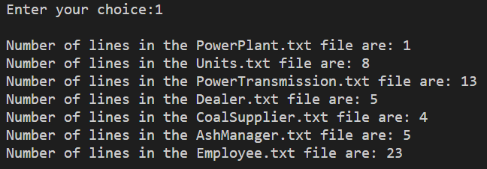

**2.**

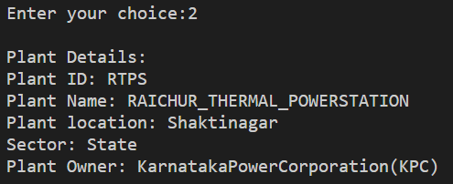

**3.**

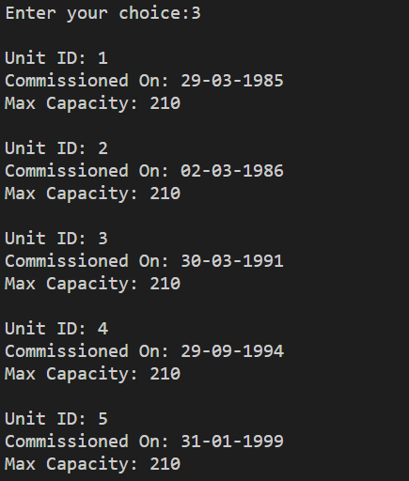

**4.**

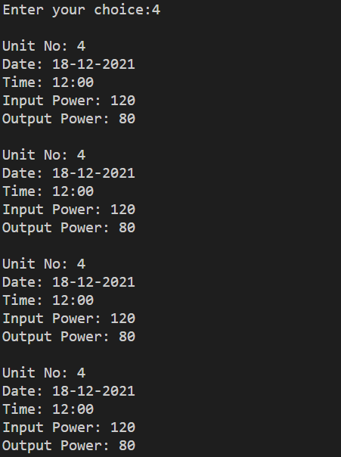

**5.**

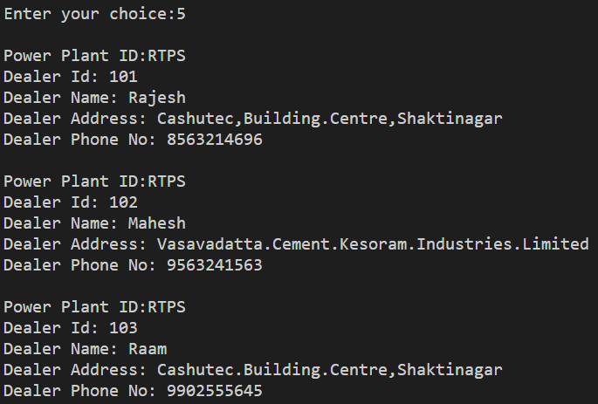

**6.**

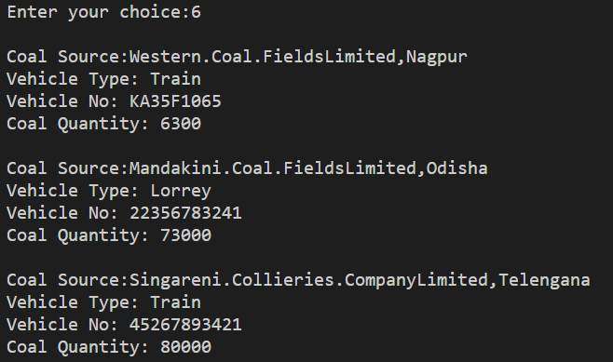

**7.**

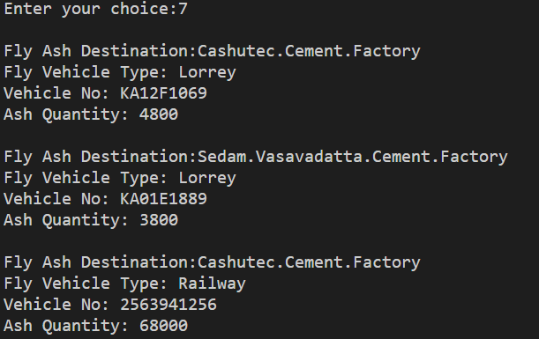

**8.**

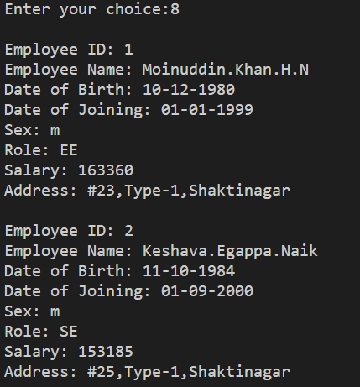

**9.**

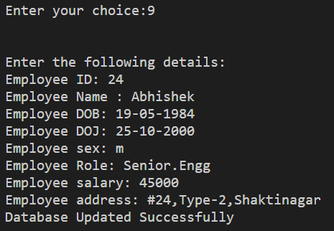

**10.**

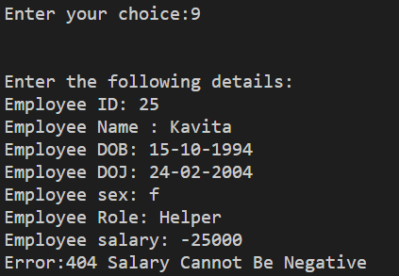

**11.**

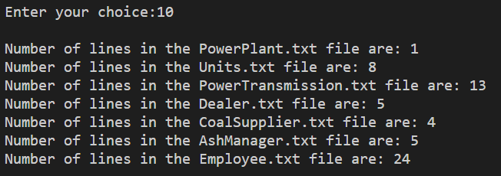

**12.**

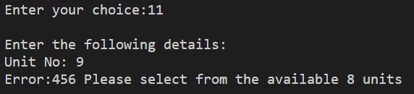

**13.**

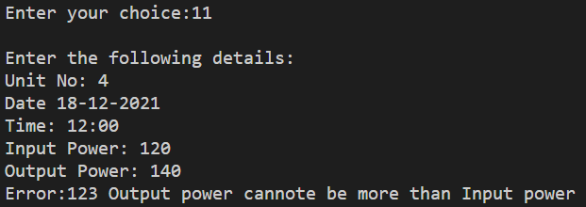

**14.**

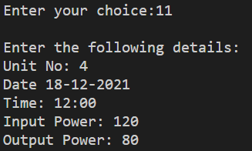

**15.**

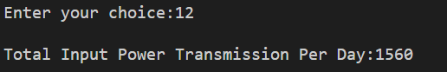

**16.**

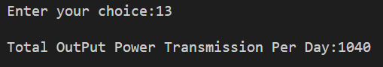

**17.**

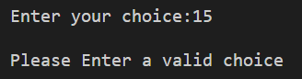

**Thank-you**