1.Given that an EMPLOYEE class contains following members: Employee Number, Employee Name, Basic, DA, IT, Net Salary. Member functions: to read the data, to calculate Net Salary and to print data members. Write a C++ program to read the data of N employees and compute Net Salary of each employee. (Dearness Allowance (DA) = 52% of Basic and Income Tax (IT) = 30% of the gross salary. Net Salary = Basic + DA – IT) ?

ANS:

#include<iostream>
using namespace std;

class employee{
int num;
string name;
float basic, da, it,net_salary, gross_salary;
public:
void read()
{
cout<<"Enter the employee number: ";
cin>>this->num;
cout<<"Enter the employee name: ";
cin>>this->name;
cout<<"Enter the basic: ";
cin>>this->basic;
}

void calculate()
{
da = (52.0/100.0*basic);
gross_salary = da + basic;
it = (0.30*gross_salary);
net_salary = basic + da - it;
}

void display()
{
cout<<"employee-id: "<<num<<endl;
cout<<"Employee-nmae: "<<name<<endl;
cout<<"basic: "<<basic<<endl;
cout<<"DA: "<<da<<endl;
cout<<"Gross Salary: "<<gross_salary<<endl;
cout<<"IT :"<<it<<endl;
cout<<"Net Salary :"<<net_salary<<endl;
}
};

int main()
{
employee e1[10];
int n;
cout<<"Enter the number of students: ";
cin>>n;
for(int i=0;i<n;i++)
{
e1[i].read();
e1[i].calculate();
e1[i].display();
}
}

OUTPUT:
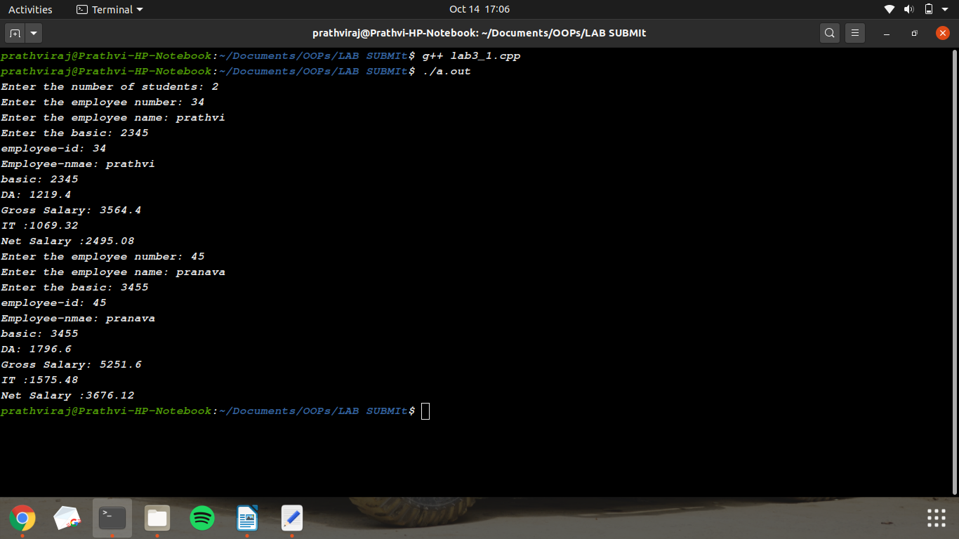

2. Write a C++ program to Create array of objects of class student with data members for storing his USN marks of six subjects for three tests and member functions to input display and calculate the avg marks for each subject taking best two of three marks. Write a tester program to test these classes ?

ANS:

#include<iostream>
using namespace std;

class student{
private:
string USN;
int test[3][6];
float best[6];
public:
void read();
void display();
void best_of_2();
void display_avg();
};

void student::read(){
printf("Enter the USN: ");
cin>>this->USN;
for(int i=0; i<3;i++)
{
cout<<"\nTEST "<<i+1<<endl;
for(int j=0; j<6;j++)
{
cout<<"Enter the marks in subject-"<<j+1<<": ";
cin>>test[i][j];
}
cout<<endl;
}
}
void student::display(){
cout<<"\nUSN: "<<this->USN;
for(int i=0; i<3;i++)
{
cout<<"\nTEST "<<i+1<<endl;
for(int j=0; j<6;j++)
{
cout<<"Marks in subject-"<<j+1<<" is :"<<test[i][j]<<endl;
}
cout<<endl;
}
}
void student::best_of_2()
{
for(int j=0; j<6; j++)
{
int small = test[0][j];
best[j] = 0;
for(int i=0; i<3; i++)
{
best[j] += test[i][j];
if (test[i][j]<small)
small = test[i][j];

}
best[j] - = small;
best[j] /= 2;
}
}
void student::display_avg()
{
cout<<endl;
for(int j=0; j<6;j++)
{
cout<<"Avg marks in subject-"<<j+1<<" is :"<<best[j]<<endl;
}
cout<<endl;
}

int main()
{
student s;
s.read();
s.display();
s.best_of_2();
s.display_avg();
return 0;
}

OUTPUT:
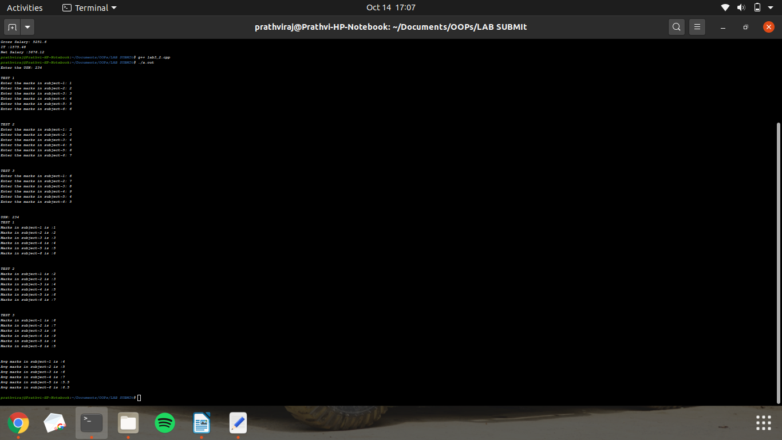

3. Write a C++ program to create a class called COMPLEX and implement the following overloading functions ADD that return a COMPLEX number. i. ADD (a, s2) – where a is an integer (real part) and s2 is a complex number. ii. ADD (s1, s2) – where s1 and s2 are complex numbers?

ANS:

#include<iostream>
using namespace std;
class complex{
int real;
int imaginary;
public:
void read(int, int);
void display();
friend complex add(int, complex);
friend complex add(complex, complex);
};

void complex::read(int x,int y)
{
this->real = x;
this->imaginary = y;
}
void complex::display()
{
cout<<this->real<<"+"<<this->imaginary<<"i"<<endl;
}

complex add(complex b, complex a)
{
complex res;
res.real = a.real + b.real;
res.imaginary = a.imaginary + b.imaginary;
return res;
}
complex add(int a, complex b)
{
complex res;
res.real = a + b.real;
res.imaginary = b.imaginary;
return res;
}

int main()
{
complex a,b,r,d;
int i,j;
cout<<"Enter real and imaginary number of 1st complex: ";
cin>>i>>j;
a.read(i,j);
cout<<"Enter real and imaginary number of 2nd complex: ";
cin>>i>>j;
b.read(i,j);
r = add(a,b);
r.display();
cout<<"Enter an integer: ";
cin>>i;
d = add(i, a);
d.display();
}

OUTPUT:
