1.Write a program to find the transpose of a matrix using friend function and with member functions to read and display the matrix ?

ANS:

#include<iostream>
using namespace std;

class matrix
{
int n,m;
int a[10][10];
public:
void read()
{
int i,j;
cout<<"Enter the no of rows:"<<endl;
cin>>n;
cout<<"Enter the no of column:"<<endl;
cin>>m;
cout<<"Enter the Elements"<<endl;
for(i=0;i<n;i++)
{
for(j=0;j<m;j++)
{
cin>>a[i][j];
}
}
}
void display()
{
cout<<"MATRIX"<<endl;
for(int i=0;i<n;i++)
{
for(int j=0;j<m;j++)
{
cout<<a[i][j]<<" ";
}
cout<<endl;
}
}
friend void transpose(matrix);
};

void transpose(matrix d)
{
cout<<"TRANSPOSE OF MATRIX"<<endl;
for(int i=0;i<d.m;i++)
{
for(int j=0;j<d.n;j++)
{
cout<<d.a[j][i]<<" ";
}
cout<<endl;
}
}

int main()
{
matrix d;
d.read();
d.display();
transpose(d);
}

OUTPUT:

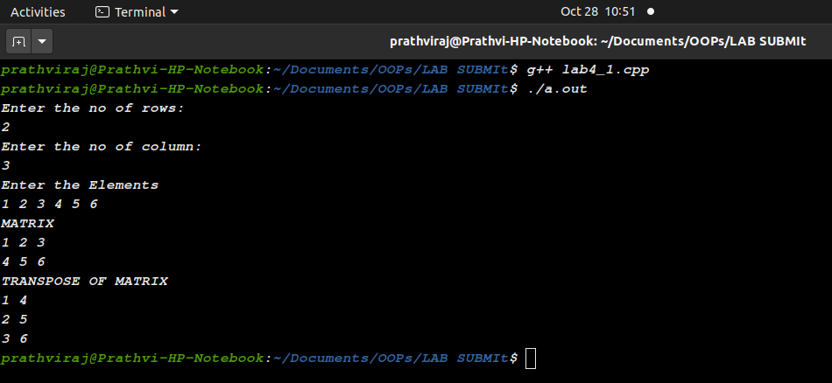

2.Create a vehicle having a non-static data member registration number and a static data member count. Non-static member functions setregno() and getregno() are used to get and set the registration number. A static member function getVehiclecount() is used to return the number of vehicles in the garage.

ANS:

#include<iostream>
using namespace std;

class vehicle{
int register_no;
static int count;
public:
vehicle()
{
count++;
}
void setregno()
{
cout<<"Enter Registration no:";
cin>>register_no;
}
void getregno()
{
cout<<"\n REGISTER NO: "<< register_no;
}

static void getVehiclecount()
{
cout<<"\n Number of vehicle: "<< count<<endl;
}
};
int vehicle::count;

int main()
{
cout<<"VEHICLE INSURANCE COOPERATION:\n";
vehicle a;
a.setregno();
a.getregno();
a.getVehiclecount();
vehicle b;
b.setregno();
b.getregno();
b.getVehiclecount();
}

OUTPUT:
