1.wap to demonstrate all types of constructors?

#include<iostream>
using namespace std;
class go
{
int x;
int y;
int *ptr;
int *ptr1;
public:
go()
{
x=10;
y=15;
ptr=new int;
ptr1=new int;
*ptr=13;
*ptr1=20;
}
go(int a,int b)
{
this->x=a;
this->y=b;
ptr=new int;
ptr1=new int;
*ptr=a;
*ptr1=b;
}
void display()
{
cout<<"X="<<x<<endl<<"Y="<<y<<endl;
}
void display1()
{
cout<<"X="<<*ptr<<endl<<"Y="<<*ptr1<<endl;
}
~go()
{
cout<<"Destructor Called"<<endl;
free(ptr);
free(ptr1);
}
};
int main()
{
cout<<"Default Constructor"<<endl;
go x1;//Default
x1.display();
cout<<"Paramatrized Constructor"<<endl;
go x2(100,150);//Paramatrized
x2.display();
cout<<"Copy Constructor"<<endl;
go x3(x2);//Copy
x3.display();
cout<<"Copy Constructor"<<endl;
go x4=x2;//Copy
x4.display();
int p, q;
cout<<"Paramatrized Constructor with Dynamic Initialization"<<endl;
cout<<"Enter two Values = ";
cin>>p>>q;
go ex5(p,q);//Dynamic Initialization
ex5.display();
cout<<"Dynamic Constructor"<<endl;
go ex6;//Dynamic Constructor
ex6.display1();
cout<<"Dynamic Constructor"<<endl;
go ex7(25,67);
ex7.display1();
return 0;
}

OUTPUT:
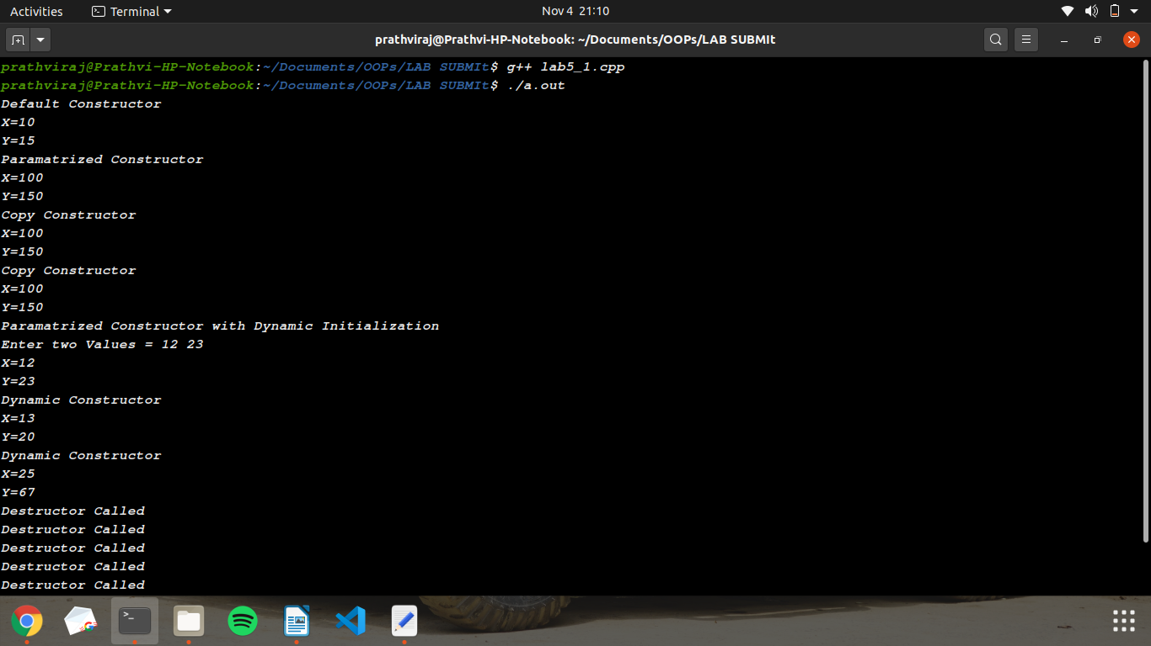
2.Wap to create a class string with two member variables char*name and len create name array dynamically and display the name.?

#include<iostream>
#include<cstring>
using namespace std;
class stringss
{
char *name;
public:
stringss()
{
name=new char[strlen("prathvi")];
strcpy(name,"prathvi");
}
stringss(char *a)
{
name=new char[strlen(a)];
strcpy(name,a);
}
void display()
{
cout<<"Name="<<name<<endl<<"Length="<<strlen(name)<<endl;
}
};
int main()
{
stringss x1;
x1.display();
char a[20];
stringss x2("prathvi");
x2.display();
cout<<"Enter the name="<<endl;
cin.getline(a,20);
stringss x3(a);
x3.display();
return 0;
}

OUTPUT:
