4.Design a class named PersonData with the following member variables lastName, firstName, address, city, state and phone. Write the appropriate constructor, accessor and mutator functions for these member variables. Next, design a class named CustomerData, which is derived from the PersonData class. The CustomerData class should have the following member variables: customerNumber, email id. The customerNumber variable will be used to hold a unique integer for each customer. Write appropriate constructors, accessor and mutator functions for these member variables. Demonstrate an object of the CustomerData class in a simple program.

5. A retail store has a preferred customer plan where customers may earn discounts on all their purchases. The amount of a customer’s discount is determined by the amount of the customer’s cumulative purchases in the store. When a preferred customer spends $500, he or she gets a 5% discount, 6% discount when he spends $1000 and $2,000 or more, he or she gets a 10% discount. Design a class named PreferredCustomer, which is derived from the CustomerData class of Exercise 7. The PreferredCustomer class should have the following member variables purchasesAmount, discountLevel. The purchasesAmount variable holds the total of a customer’s purchases. The discountLevel variable should be set to the correct discount percentage, according to the store’s preferred customer plan. Write appropriate member functions for this class and demonstrate it in a simple program.?
ANS:
#include<iostream>
using namespace std;

class persondata
{
string lastname,firstname,address,city,state;
int phone;
public:
persondata()
{
lastname='c';
firstname='b';
address='a';
city='y';
state='x';
phone=10;
}
void setLastname()
{
cout<<"Enter Last Name\n";
cin>>lastname;
}
void setFirstname()
{
cout<<"Enter First Name\n";
cin>>firstname;
}
void setAddress()
{
cout<<"Enter Address\n";
cin>>address;
}
void setCity()
{
cout<<"Enter city\n";
cin>>city;
}
void setState()
{
cout<<"Enter State\n";
cin>>state;
}
void setPhone()
{
cout<<"Enter Phone Number\n";
cin>>phone;
}

string getLastname()
{
return lastname;
}
string getFirstname()
{
return firstname;
}
string getAddress()
{
return address;
}
string getCity()
{
return city;
}
string getState()
{
return state;
}
int getPhone()
{
return phone;
}
};
class customerData : public persondata
{
int custo_num;
string email;
public:
customerData(int p,string q):persondata()
{
custo_num=p;
email=q;
}
void setCusto_num()
{
cout<<"Enter Customer Number: "<<endl;
cin>>custo_num;
}
void setEmail()
{
cout<<"Enter EMAIL: "<<endl;
cin>>email;
}
int getCusto_num()
{

return custo_num;
}
string getEmail()
{
return email;
}
};

class prefferedCustomer: public customerData
{

int discount;
int total_amount;
public:

prefferedCustomer(int p,string q,int purchase):customerData(p,q)
{
total_amount=purchase;
}

void cal(){
if(total_amount>=500 && total_amount<1000)
discount=5;
else if(total_amount>=1000 && total_amount<2000)
discount=6;
else if(total_amount>=2000)
discount=10;
}
int getDiscount()
{
return discount;
}
};

int main()
{
int p,z;
string q;
persondata obj;

cout<<"Enter customer number and email\n";
cin>>p>>q>>z;
prefferedCustomer obj1(p,q,z);
obj1.setLastname();
obj1.setFirstname();
obj1.setAddress();
obj1.setCity();
obj1.setState();
obj1.setPhone();

cout<<"Details \n";
cout<<obj1.getLastname()<<endl;
cout<<obj1.getFirstname()<<endl;
cout<<obj1.getAddress()<<endl;
cout<<obj1.getCity()<<endl;
cout<<obj1.getState()<<endl;
cout<<obj1.getPhone()<<endl;
cout<<obj1.getCusto_num()<<endl;
cout<<obj1.getEmail()<<endl;

//obj1.setCusto_num();
//obj1.setEmail();
obj1.cal();
cout<<"Discount = "<<obj1.getDiscount()<<"%";
return 0;
}
output:

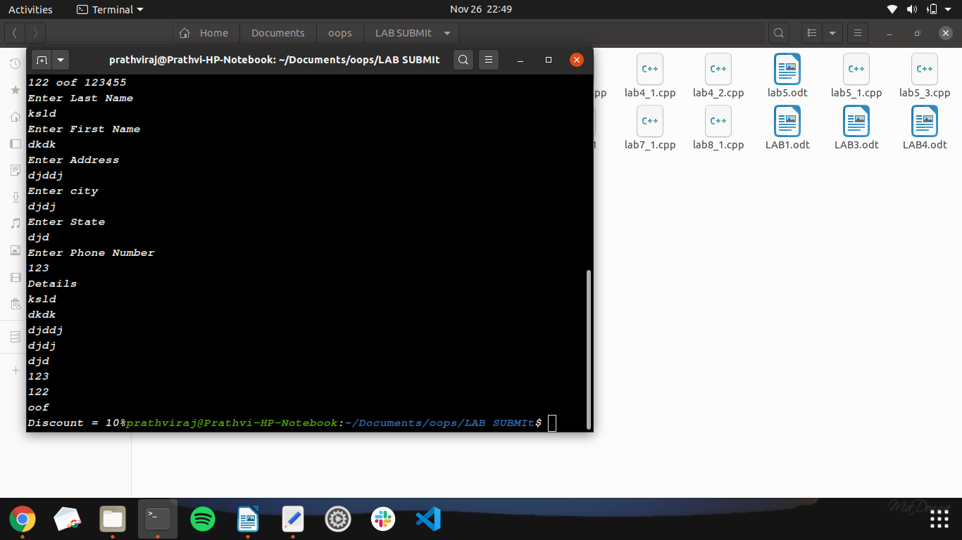
3.Write a C++ program to create a class called MATRIX using a two-dimensional array of integers. Implement the following operations by overloading the operator = = which checks the compatibility of two matrices m1 and m2 to be added and subtracted. Perform the addition and subtraction by overloading the operators + and – respectively. Display the results (sum matrix m3 and difference matrix m4).

ANS:
#include<iostream>
using namespace std;

class mat{
int n,m;
int **ptr;
public:
mat()
{
m=2;
n=2;
ptr = new int*[m];
for(int i=0;i<m;i++)
{
ptr[i]=new int[n];
}
for(int i=0;i< m;i++)
for(int j=0; j<n; j++)
{
ptr[i][j]=0;
}
}
mat(int x, int y)
{
m=x;
n=y;
ptr = new int*[m];
for(int i=0;i<m;i++)
ptr[i]= new int[n];
for(int i=0;i<m;i++)
for(int j=0; j<n; j++)
ptr[i][j]=0;
}

void read();
void display();
friend mat operator*(int a, mat b);
friend istream& operator>>(istream &input , mat &m);
friend ostream& operator<<(ostream &output , mat &m);
friend mat operator+(mat &m1, mat &m2);
friend mat operator*(mat &m1, mat &m2);
};

void mat::read()
{
for(int i=0;i < m;i++)
for(int j=0; j<n; j++)
{
cout<<"Enter the "<<i<<" "<<j<<" :";
cin>>ptr[i][j];
}
}

void mat::display()
{
for(int i=0;i < m;i++)
{
for(int j=0; j<n; j++)
{
cout<<ptr[i][j]<<" ";
}
cout<<endl;
}
}
mat operator*(mat &m1, mat &m2)
{
mat res(m1.m, m2.n);
int i,j,k;
for(i = 0; i < m1.m; i++)
for(j = 0; j < m2.n; j++)
for(k = 0; k < m1.n; k++)
{
res.ptr[i][j] += m1.ptr[i][k] * m2.ptr[k][j];
}
return res;
}
mat operator*(int a, mat b)
{
mat res(b.m, b.n);
for(int i=0;i < b.m;i++)
{
for(int j=0; j<b.n; j++)
{
res.ptr[i][j]= a * b.ptr[i][j];
}
cout<<endl;
}
return res;
}

istream& operator>>(istream &input , mat &m)
{
for(int i=0;i < m.m; i++)
for(int j=0; j<m.n; j++)
{
cout<<"Enter the "<<i<<" "<<j<<" :";
input>> m.ptr[i][j];
}
return input;
}

ostream& operator<<(ostream &output , mat &m)
{
for(int i=0;i < m.m;i++)
{
for(int j=0; j<m.n; j++)
output<<m.ptr[i][j]<<" ";
output<<endl;
}
return output;
}

mat operator+(mat &m1, mat &m2)
{
mat res(m1.m,m2.n);
if(m1.m == m2.m && m1.n == m2.n)
{
for(int i=0;i < m1.m;i++)
for(int j=0; j<m1.n; j++)
res.ptr[i][j] = m1.ptr[i][j] + m2.ptr[i][j];
return res;
}
}

int main()
{
int m,n, m2, n2;
cout<<"Enter the number of rows and colm: ";
cin>>m>>n;
mat a(m,n);
cin>>a;
cout<<"Enter the number of rows and colm: ";
cin>>m2>>n2;
mat b(m2, n2);
cin>>b;
cout<<"A:\n"<<a;
cout<<"\nB:\n"<<b;
if (m==n2 && m2 == n)
{
mat r = a*b;
cout<<"\nA*B\n"<<r;
}
else
{
cout<<"Cant multiply matrix:\n";
}
int k;
cout<<"enter the no. to be multiplied: ";
cin>>k;
mat res = k*b;
cout<<k<<"*B: \n"<<res;
}

output:

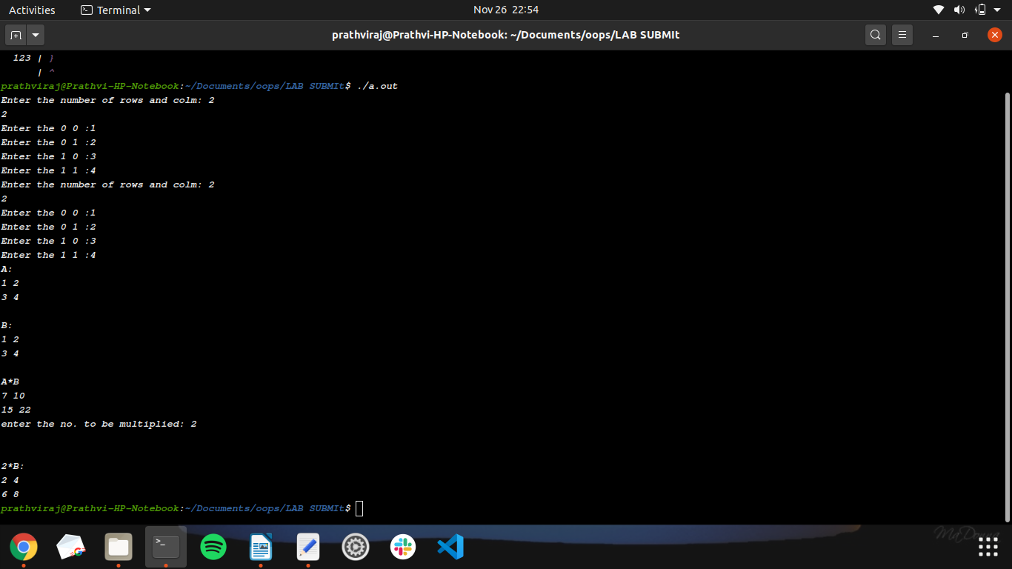
1.Write a program to find the transpose of a matrix using friend function and with member functions to read and display the matrix.

ANS:
#include<iostream>
using namespace std;
class mat
{
int m,n;//rows and cols
int **a;// pointer for 2d array
public:
mat()
{
m=2;
n=2;
a= new int*[m];
for(int i=0;i<m;i++)
{
a[i]=new int[n];
}
for(int i=0;i<m;i++)
{
for(int j=0;j<n;j++)
{
a[i][j]=0;
}
}
}
mat(int r,int c)
{
m=r;
n=c;
a= new int*[m];

for(int i=0;i<m;i++)
{
a[i]=new int [n];
}
for(int i=0;i<m;i++)
{
for(int j=0;j<n;j++)
{
a[i][j]=0;
}
}
}
void read();
void display();
mat add(mat mat1); //member function
mat sub(mat mat1);
friend mat add(mat mat1,mat mat2);

};
void mat::read()
{
for(int i=0;i<m;i++)
{
for(int j=0;j<n;j++)
{
cin>>a[i][j];
}
cout<<"\n";
}
}
void mat::display()
{
for(int i=0;i<m;i++)
{
for(int j=0;j<n;j++)
{
cout<<a[i][j]<<"\t";
}
cout<<"\n";
}
}
mat mat::add(mat mat1)
{
mat res(m,n);
// res.m=m;
// res.n=n;
for(int i=0;i<m;i++)
{
for(int j=0;j<n;j++)
{
res.a[i][j]=a[i][j]+mat1.a[i][j];
}
}
return(res);
}
mat mat::sub(mat mat1)
{
mat res(m,n);
// res.m=m;
// res.n=n;
for(int i=0;i<m;i++)
{
for(int j=0;j<n;j++)
{
res.a[i][j]=a[i][j]-mat1.a[i][j];
}
}
return(res);
}
mat add(mat a, mat b)
{
mat res(a.m,a.n);
for(int i=0; i<a.m; i++)
{
for(int j=0; j<a.n ; j++)
{
res.a[i][j] = a.a[i][j] + b.a[i][j];
}
}
return res;
}
int main()
{
int r,c;
cout<<"enter the row and column\n";
cin>>r>>c;
mat m1(r,c);
mat m2(r,c);
mat m3(r,c);

m1.display();
m2.display();
cout<<"enter the matrix1 elements\n";
m1.read();
cout<<"enter the matrix2 elements\n";
m2.read();
m3=m1.add(m2); //Member function
cout<<"matrix are \n";
m1.display();
cout<<"matrix are \n";
m2.display();
cout<<"resultant matrix is\n";
m3.display();
m3=add(m1,m2); //friend function
cout<<"resultant matrix is\n";
m3.display();
cout<<"resultant matrix after subtraction is\n";
m3=m1.sub(m2); //Member function
m3.display();
}
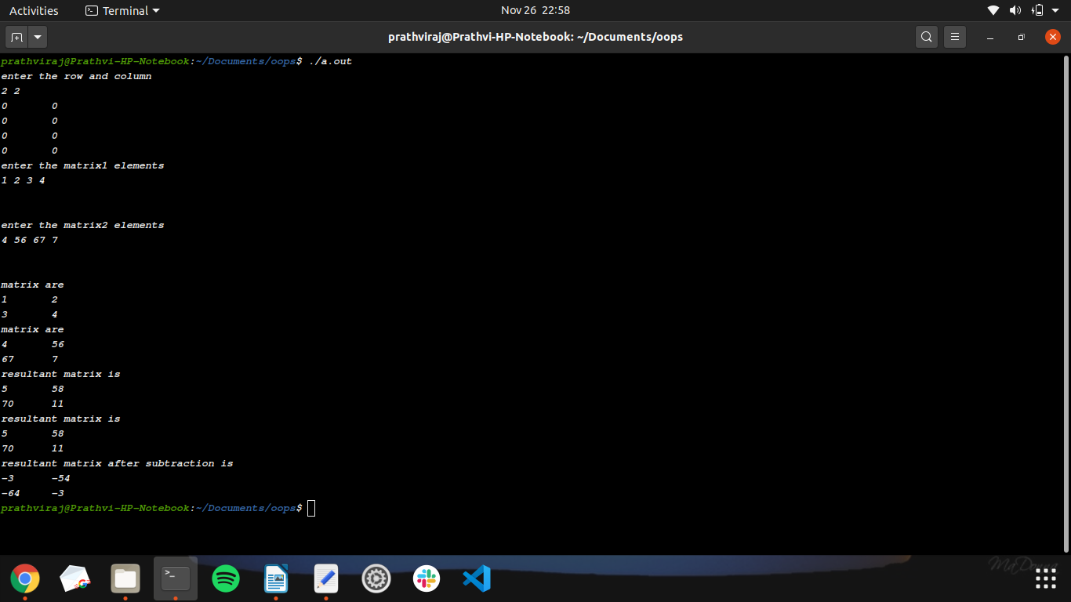
2.Create a vehicle having a non-static data member registration number and a static data member count. Non-static member functions setregno() and getregno() are used to get and set the registration number. A static member function getVehiclecount() is used to return the number of vehicles in the garage. Use a constructor to increment the vehicle count when a vehicle is created and the destructor to decrement the count when the vehicle is destroyed.

ANS:
#include<iostream>
using namespace std;

class vehicle{
int register_no;
static int count;
public:
vehicle()
{
count++;
}
void setregno()
{
cout<<"Enter Registration no:";
cin>>register_no;
}
void getregno()
{
cout<<"\n REGISTER NO: "<< register_no;
}

static void getVehiclecount()
{
cout<<"\n Number of vehicle: "<< count<<endl;
}
};
int vehicle::count;

int main()
{
cout<<"VEHICLE INSURANCE COOPERATION:\n";
vehicle a;
a.setregno();
a.getregno();
a.getVehiclecount();
vehicle b;
b.setregno();
b.getregno();
b.getVehiclecount();
}

OUTPUT:
