LAB INTERNALS-1
NAME : PRATHVIRAJ PRABHU
USN : 1BM19IS118
DATE : 23/12/2020
SECTION : ISE-C

Programme 10 :

#include<iostream>
using namespace std;

class person
{
string name;
int age;
public:
void getdata(string p,int q)
{
name=p;
age=q;
}
string setname()
{
return name;
}
int setage()
{
return age;
}
};

class student : virtual public person
{
public:
string usn;
void getusn(string r)
{
usn=r;
}
string setusn()
{
return usn;
}
};

class faculty : virtual public person
{
public:
int id;
void getid(int s)
{
id=s;
}
int setid()
{
return id;
}
};

class TA :public student,public faculty
{
public:
string course;
void getcourse(string t)
{
course=t;
}
string setcourse()
{
return course;
}
};

int main()
{
TA d;
d.getdata("Prathviraj Prabhu",19);
d.getusn("1BM19IS118");
d.getid(11882299);
d.getcourse("maths");
cout<<"NAME : "<<d.setname()<<endl;
cout<<"AGE : " <<d.setage()<<endl;
cout<<"USN : "<<d.setusn()<<endl;
cout<<"ID : "<<d.setid()<<endl;
cout<<"COURSE : "<<d.setcourse()<<endl;
return 0;

}

OUTPUT :
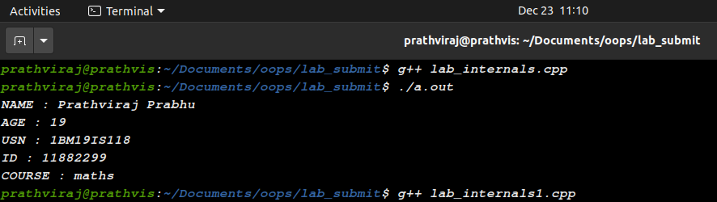
Modifications 1:

#include<iostream>
using namespace std;

class person
{
protected:
string name;
int age;
public:
void getdata(string a,int b)
{
name=a;
age=b;
}
string setname()
{
return name;
}
int setage()
{
return age;
}
};

class student : virtual protected person
{
protected:
string usn;

public:
void getusn(string r)
{
usn=r;
}

string setusn()
{
return usn;
}
};

class faculty : virtual protected person
{
protected:
int id;
public:
void getid(int s)
{
id=s;
}

int setid()
{
return id;
}
};

class TA :protected student,protected faculty
{
protected:
string course;
public:
void getcourse(string t)
{
course=t;
}
string setcourse()
{
return course;
}
};

int main()
{
TA d;
d.getdata("Prathviraj Prabhu",19);
d.getusn("1BM19IS118");
d.getid(11882299);
d.getcourse("maths");
cout<<"NAME : "<<d.setname()<<endl;
cout<<"AGE : " <<d.setage()<<endl;
cout<<"USN : "<<d.setusn()<<endl;
cout<<"ID : "<<d.setid()<<endl;
cout<<"COURSE : "<<d.setcourse()<<endl;
return 0;

}

OUTPUT :

We will get error that we cant access the member variables in main function because we declared member variables in Protected.

Error Occured :

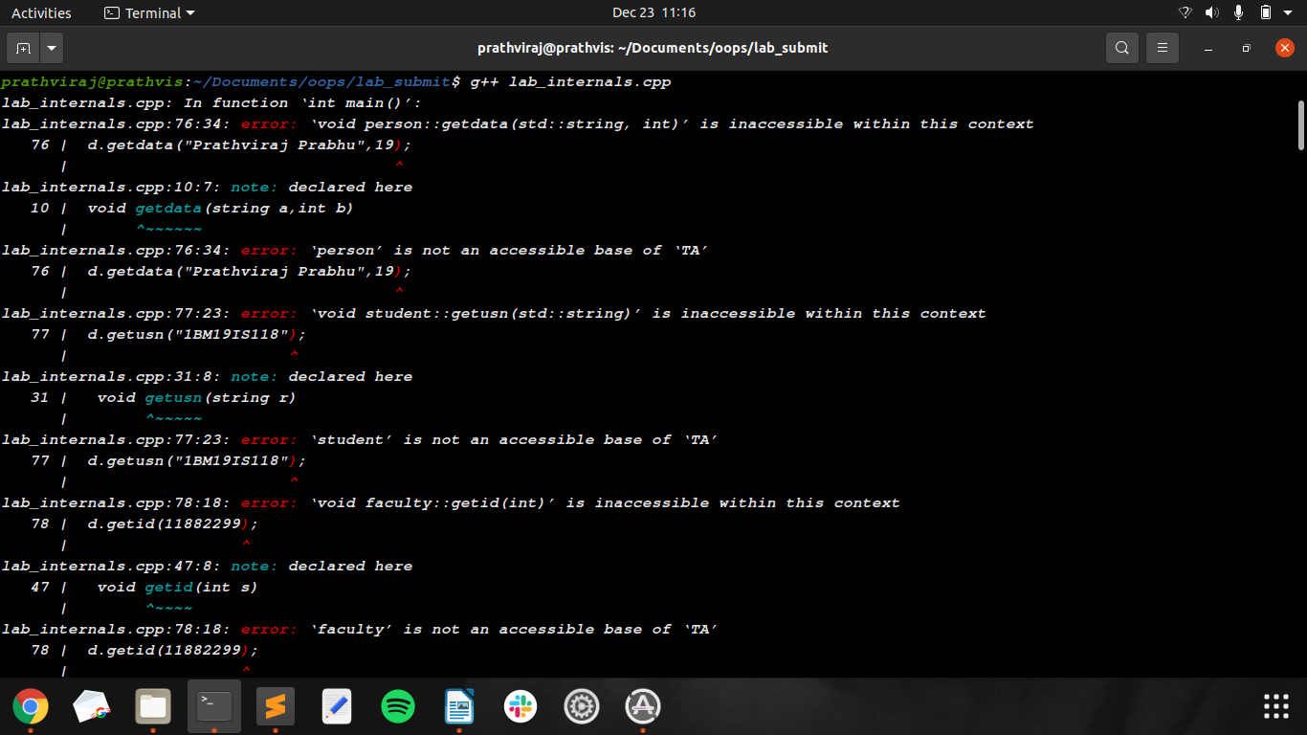
Modifications 2:

file Name : lab_internals1.cpp

#include<iostream>
using namespace std;
#include "sub1.h"
#include "sub2.h"
#include "sub3.h"

int main()
{
TA d;
d.getdata("Prathviraj Prabhu",19);
d.getusn("1BM19IS118");
d.getid(11882299);
d.getcourse("maths");
cout<<"NAME : "<<d.setname()<<endl;
cout<<"AGE : " <<d.setage()<<endl;
cout<<"USN : "<<d.setusn()<<endl;
cout<<"ID : "<<d.setid()<<endl;
cout<<"COURSE : "<<d.setcourse()<<endl;
return 0;

}

file Name : sub1.h

#include<iostream>
using namespace std;

class person
{
string name;
int age;
public:
void getdata(string a,int b)
{
name=a;
age=b;
}
string setname()
{
return name;
}
int setage()
{
return age;
}
};

file Name : sub2.h

#include<iostream>
using namespace std;

class student : virtual public person
{
public:
string usn;
void getusn(string r)
{
usn=r;
}

string setusn()
{
return usn;
}
};

class faculty : virtual public person
{
public:
int id;
void getid(int s)
{
id=s;
}

int setid()
{
return id;
}
};

file Name : sub3.h

#include<iostream>
using namespace std;

class TA :public student,public faculty
{
public:
string course;
void getcourse(string t)
{
course=t;
}
string setcourse()
{
return course;
}
};

OUTPUT:
