STUDENT PERFORMANCE PREDICTION SYSTEM USING MACHINE LEARNING

Vishal Singh
Batch : 01 | Section : C

ABSTRACT
Student performance prediction has become an important area of research in educational data mining and learning analytics. Educational institutions generate large volumes of student-related data, including attendance records, internal assessment marks, assignment scores, and study habits. Analyzing these factors can help educators identify students who may require academic support and improve overall learning outcomes.
This project presents a Student Performance Prediction System that utilizes machine learning techniques to predict students' final examination marks. The system uses academic indicators such as attendance percentage, internal test scores, assignment performance, and daily study hours to estimate final exam performance. The project follows the complete machine learning lifecycle including data collection, preprocessing, exploratory data analysis, feature engineering, model development, evaluation, and deployment.
The dataset consists of 2000 student records containing academic and behavioral attributes. Various regression algorithms including Linear Regression and Random Forest Regressor were trained and evaluated. Model performance was assessed using Mean Absolute Error (MAE), Mean Squared Error (MSE), Root Mean Squared Error (RMSE), and R² Score. The best-performing model was deployed using Streamlit to provide an interactive web interface for real-time predictions.
Keywords: Machine Learning, Educational Data Mining, Student Performance Prediction, Regression, Random Forest, Streamlit.

CHAPTER 1: INTRODUCTION
1.1 Background
The rapid growth of educational technologies has resulted in the generation of vast amounts of student data. Educational institutions continuously collect information related to attendance, assignments, examinations, and learning activities. Such data can be leveraged to gain meaningful insights into student behavior and academic performance.
Machine Learning provides powerful tools for analyzing historical data and generating predictions. By identifying patterns in student records, predictive models can assist educators in making informed decisions regarding student support and intervention strategies.
Student performance prediction is particularly important because academic success is influenced by multiple factors including attendance, assessment scores, study habits, and engagement levels. Early prediction allows institutions to provide targeted support to students before final examinations.
1.2 Problem Statement
Educational institutions often face challenges in identifying students who are at risk of poor academic performance. Traditional methods rely heavily on manual evaluation and observation, which may not always be efficient or accurate. Therefore, there is a need for an automated system capable of predicting student performance based on available academic indicators.
1.3 Objectives
The main objectives of this project are:
• To analyze factors affecting student performance.
• To develop a machine learning model for predicting final examination marks.
• To compare multiple regression algorithms.
• To evaluate model performance using standard metrics.
• To deploy the best-performing model through a web application.
1.4 Scope of the Project
The project focuses on academic performance prediction using historical student data. The developed system can be extended to educational institutions for identifying students requiring additional academic support.

CHAPTER 2: LITERATURE REVIEW
2.1 Educational Data Mining
Educational Data Mining (EDM) is a research field that focuses on developing methods for exploring educational datasets. EDM aims to improve learning experiences by identifying hidden patterns and relationships within educational data.
2.2 Learning Analytics
Learning analytics involves measuring and analyzing learner data to understand and optimize learning processes. It enables institutions to track student progress and predict academic outcomes.
2.3 Machine Learning in Education
Machine learning techniques have been widely applied in educational settings. Regression and classification algorithms are commonly used to predict student grades, dropout risks, and learning achievements.
2.4 Existing Research Studies
Several researchers have applied machine learning techniques for academic prediction:
• Linear Regression for grade forecasting.
• Decision Trees for academic classification.
• Random Forest for educational data analysis.
• Support Vector Machines for student success prediction.
• Neural Networks for learning outcome prediction.
2.5 Research Gap
Most traditional systems provide only descriptive analysis. There remains a need for predictive systems capable of providing accurate performance forecasts using multiple academic indicators.

CHAPTER 3: DATASET DESCRIPTION AND METHODOLOGY
3.1 Dataset Overview
The dataset contains 2000 student records and includes academic performance indicators.
3.2 Dataset Attributes
- Student_ID
- Attendance (%)
- Internal Test 1 (out of 40)
- Internal Test 2 (out of 40)
- Assignment Score (out of 10)
- Daily Study Hours
- Final Exam Marks (out of 100)
3.3 Target Variable
Final Exam Marks (out of 100)
3.4 Machine Learning Lifecycle
The project follows the standard machine learning lifecycle:
- Data Collection
- Data Cleaning
- Exploratory Data Analysis
- Feature Engineering
- Model Development
- Model Evaluation
- Deployment
3.5 Tools and Technologies
• Python
• Pandas & NumPy
• Streamlit
• Matplotlib
• Seaborn
• Scikit-Learn
CHAPTER 4: DATA PREPROCESSING AND EXPLORATORY DATA ANALYSIS
4.1 Data Cleaning
The dataset was examined for missing values and duplicate records.
Activities performed:
• Missing value detection
• Duplicate removal
• Data type verification
4.2 Feature Engineering
Two new features were created:
Average Internal Marks
Average_Internal_Marks = (Test1 + Test2)/2
Overall Academic Score
Overall_Academic_Score = Attendance + Assignment Component + Study Hours Component
4.3 Exploratory Data Analysis
The following visualizations were generated:
• Histograms
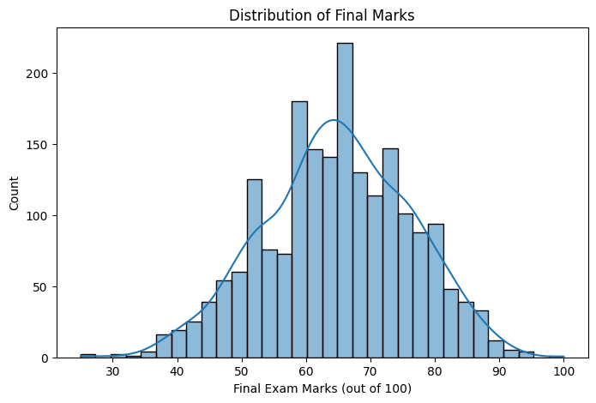
The histogram shows the distribution of students' final examination marks. The marks approximately follow a normal distribution with most students scoring between 55 and 80 marks. The highest concentration of students is observed around 65 marks, indicating that the average academic performance of the dataset lies in the mid-range. Very few students scored below 40 or above 90 marks, suggesting that extreme performances are relatively uncommon.

• Boxplots
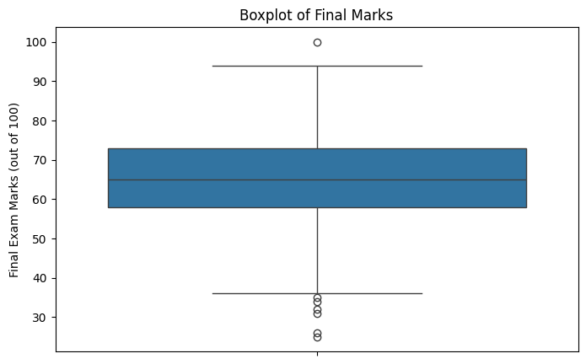

The boxplot provides a summary of the distribution of final examination marks. The median score is approximately 65 marks, indicating the central tendency of the dataset. The interquartile range shows that the middle 50% of students scored between approximately 58 and 73 marks. A few outliers are visible at both the lower and upper ends, representing students with exceptionally low or high academic performance. However, the dataset does not exhibit severe skewness, suggesting a balanced distribution of marks.

• Scatter Plots
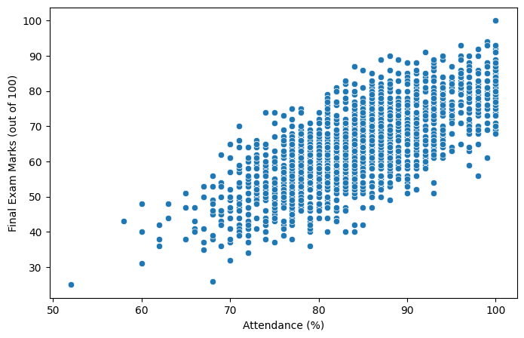
The scatter plot demonstrates a strong positive relationship between attendance percentage and final examination marks. Students with higher attendance generally tend to achieve better academic results. The upward trend indicates that attendance is an important predictor of student performance. Students with attendance levels above 90% frequently scored above 70 marks, whereas lower attendance is associated with relatively weaker performance.

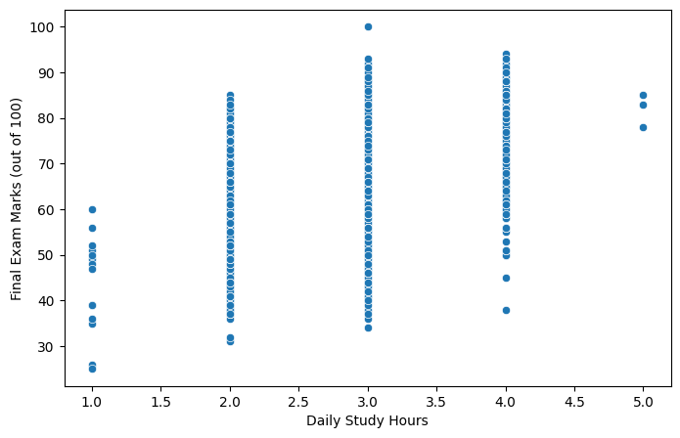
The relationship between daily study hours and final examination marks is positively correlated. Students who spend more time studying each day generally achieve higher scores. Although some variation exists among students with similar study durations, the overall trend suggests that increasing study hours contributes positively to academic achievement. Students studying 4–5 hours daily tend to obtain higher marks than those studying only 1–2 hours per day.

• Correlation Heatmap
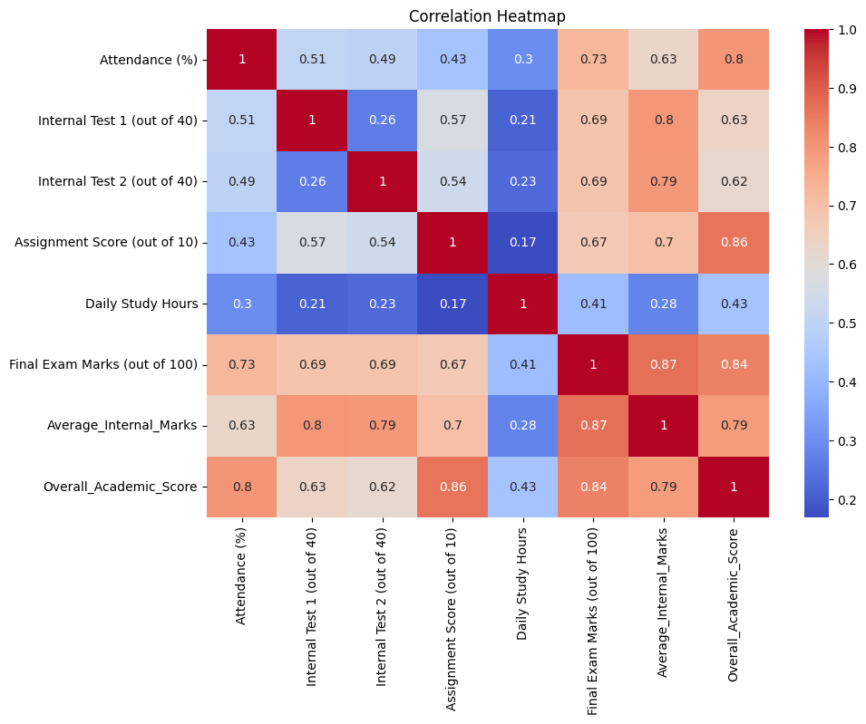
The correlation heatmap illustrates the strength of relationships among all numerical variables in the dataset.
Key observations include:
- Average_Internal_Marks has the strongest correlation with Final Exam Marks (0.87), indicating that internal assessments are highly predictive of final performance.
- Overall_Academic_Score also exhibits a strong positive correlation (0.84) with final marks.
- Attendance (%) shows a strong positive relationship (0.73) with final examination performance.
- Internal Test 1 and Internal Test 2 both demonstrate substantial correlations (0.69) with final marks.
- Assignment Score has a moderate-to-strong positive correlation (0.67).
- Daily Study Hours shows the weakest but still positive correlation (0.41), suggesting that study habits contribute to performance but are less influential than assessment-related factors.
Overall, the heatmap confirms that academic indicators such as attendance, internal assessments, and assignments play significant roles in determining student success.

4.4 Summary of Exploratory Data Analysis
The exploratory data analysis revealed several important patterns within the dataset. The distribution of final examination marks was approximately normal, indicating a balanced representation of students across performance levels. Attendance, internal assessment scores, and assignment performance exhibited strong positive relationships with final examination marks. Feature engineering further enhanced the dataset by creating Average Internal Marks and Overall Academic Score, both of which demonstrated high correlations with the target variable. These findings suggest that academic engagement and continuous assessment performance are significant indicators of student achievement and justify their inclusion in the machine learning models developed in this project.

4.5 Observations
Attendance showed a positive relationship with final marks.
Students with higher study hours generally achieved better examination scores.
Internal assessment scores demonstrated strong correlations with final performance.

CHAPTER 5: MODEL DEVELOPMENT
5.1 Train-Test Split
The dataset was divided into:
• Training Set: 80%
• Testing Set: 20%
5.2 Linear Regression
Linear Regression was selected as a baseline model.
Advantages:
• Simple implementation
• Easy interpretation
• Fast training
5.3 Random Forest Regressor
Random Forest is an ensemble learning algorithm that combines multiple decision trees.
Advantages:
• Handles non-linear relationships
• Robust against overfitting
• High predictive performance
5.4 Model Training Process
The models were trained using the training dataset and evaluated using the testing dataset.

CHAPTER 6: RESULTS AND DISCUSSION
6.1 Evaluation Metrics
The following metrics were used:
Mean Absolute Error (MAE)
Measures average prediction error.
Mean Squared Error (MSE)
Measures squared prediction error.
Root Mean Squared Error (RMSE)
Represents prediction error in original units.
R² Score
Measures how well the model explains variance in the target variable.
6.2 Model Comparison
Create a table using your actual notebook output:
Model | MAE | RMSE | R² Score
Linear Regression | 3.674 | 4.617 | 0.829
Random Forest | 4.043 | 5.122 | 1.790
6.3 Discussion
Random Forest demonstrated superior predictive performance compared to Linear Regression. The model effectively captured complex relationships among attendance, internal marks, assignment scores, and study hours.

CHAPTER 7: DEPLOYMENT
7.1 Streamlit Application
A web-based application was developed using Streamlit.
Features:
• User-friendly interface
• Real-time prediction
• Easy deployment
7.2 User Inputs
The user enters:
• Attendance
• Internal Test Scores
• Assignment Score
• Daily Study Hours

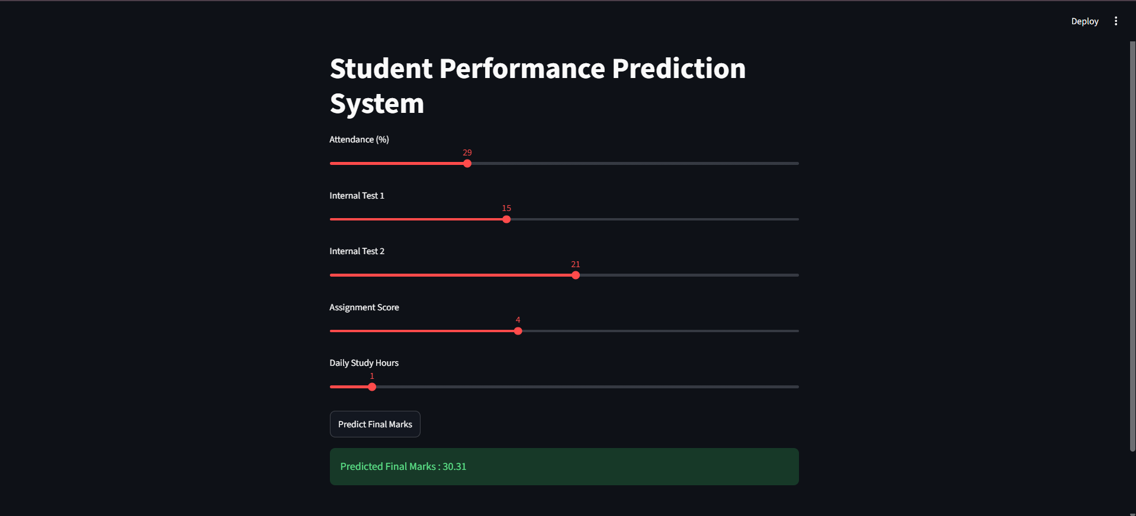
The application predicts the expected final examination marks.
CHAPTER 8: CONCLUSION AND FUTsURE SCOPE
8.1 Conclusion
This project successfully developed a machine learning-based Student Performance Prediction System. The developed model predicts final examination marks using multiple academic indicators. The results demonstrate the effectiveness of machine learning techniques in educational analytics.
The deployment of the model through Streamlit enables practical usage and provides an intuitive interface for end users.
8.2 Future Scope
Future enhancements may include:
• Deep Learning models
• Real-time academic monitoring
• Mobile application integration
• Attendance tracking systems
• Early warning systems for at-risk students
• Cloud deployment

REFERENCES
[1] Ian Goodfellow, Deep Learning, MIT Press.
[2] Aurélien Géron, Hands-On Machine Learning with Scikit-Learn, Keras and TensorFlow.
[3] Pedro Domingos, The Master Algorithm.
[4] Scikit-Learn Documentation.
[5] Streamlit Documentation.
[6] Research papers on Educational Data Mining and Student Performance Prediction from Google Scholar.

