**1) Write a new method for the ArrayIntList class called learnIndexOf that returns the**

**index of a particular value in the list. The method should return the index of the first**

**occurrence of the target value in the list. If the value is not in the list, it should return**

**-1. For example, if a variable called list stores the following values:**

**[42, 7, -9, 14, 8, 39, 42, 8, 19, 0]**

**Then the call list.learnIndexOf(8) should return 4 because the index of the first**

**occurrence of the value 8 in the list is at index 4.**

**CODE:**

import java.util.Scanner;  
import java.util.ArrayList;  
public class Main {  
  
 static int learnIndexOf(ArrayList<Integer> arraylist, int value){  
 for(int i = 0; i < arraylist.size();i++){  
 if(arraylist.get(i) == value){  
 return i;  
 }  
 }  
 return -1;  
 }  
  
 public static void main(String[] args) {  
 Scanner inputs = new Scanner(System.*in*);  
 ArrayList<Integer> arrayList = new ArrayList<Integer>();  
 int N = 0;  
 System.*out*.println("Enter N value: ");  
 N = inputs.nextInt();  
  
 for(int j = 0;j<N;j++){  
 System.*out*.println("Enter value " + (j+1) +" :");  
 int num = inputs.nextInt();  
 arrayList.add(num);  
  
 }  
  
 System.*out*.println("Enter value to get index of : ");  
 int value = inputs.nextInt();  
  
 int result = *learnIndexOf*(arrayList,value);  
 System.*out*.println(result);  
 }  
}

**OUTPUT:**

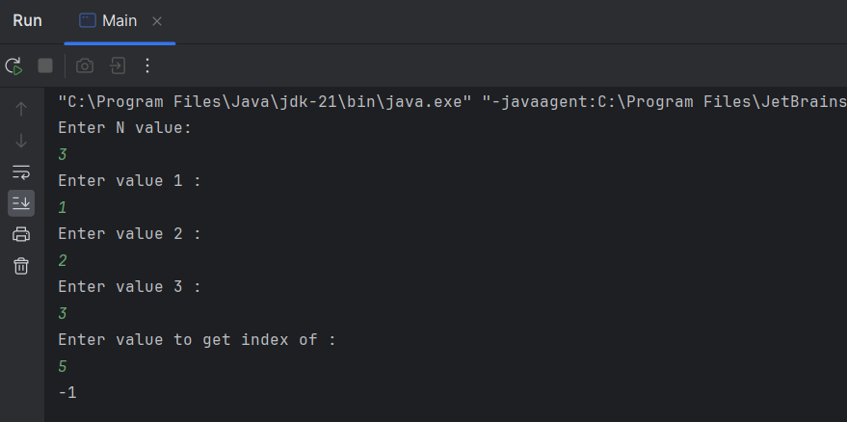

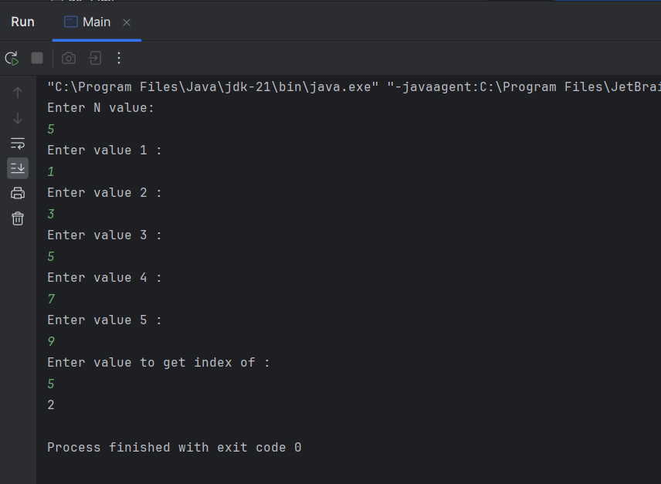

**2) Given the following Integer ArrayList scores_list of student exam scores: [84, 70, 90,**

**67, 77, 94, 92, 71, 80, 95], write some lines of code that remove all the odd-valued**

**scores, i.e. 67, 77, 71 and 95**

**CODE:**

import java.util.Scanner;  
import java.util.ArrayList;  
 class Main {  
 public static void main(String[] args) {  
 Scanner inputs = new Scanner(System.*in*);  
 ArrayList<Integer> arrayList = new ArrayList<Integer>();  
 int N = 0;  
 System.*out*.println("Enter N value: ");  
 N = inputs.nextInt();  
  
 for(int j = 0;j<N;j++){  
 System.*out*.println("Enter value " + (j+1) +" :");  
 int num = inputs.nextInt();  
 arrayList.add(num);  
  
 }  
  
 //printing the original array list  
 for(int k=0;k<arrayList.size();k++){  
 System.*out*.print(arrayList.get(k) + " ");  
 }  
 System.*out*.println();  
  
 //removing the odd numbered values  
 for(int j=arrayList.size()-1;j>=0;j--){  
 if(arrayList.get(j) % 2 != 0){  
 arrayList.remove(j);  
 }  
 }  
  
 //printing the modified array list  
 for(int k=0;k<arrayList.size();k++){  
 System.*out*.print(arrayList.get(k) + " ");  
 }  
  
 }  
}

**OUTPUTS:**

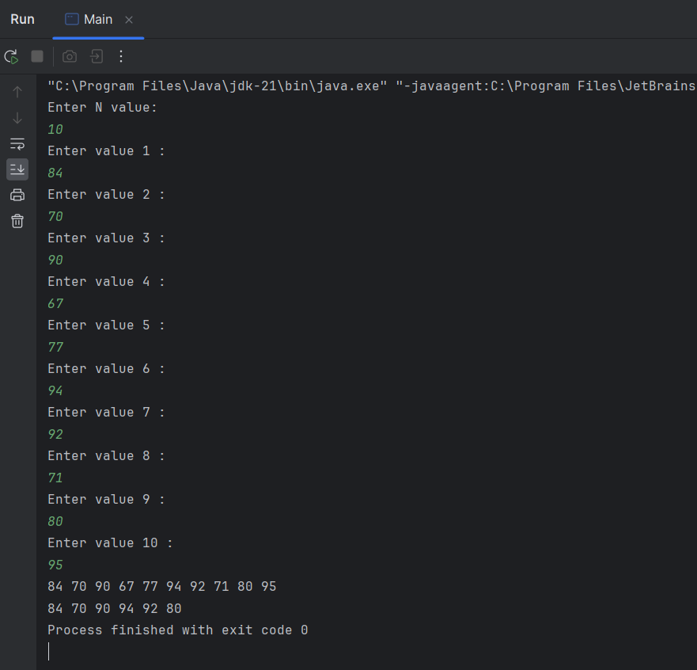

**3) Write a method that receives an ArrayList of names of fruits and sorts them in**

**alphbetical order.**

**CODE:**

import java.util.ArrayList;  
import java.util.Scanner;  
import java.util.Arrays;  
public class Main {  
 public static void main(String[] args) {  
 Scanner inputs = new Scanner(System.*in*);  
 ArrayList<String> arrayList = new ArrayList<String>();  
 int N = 0;  
 System.*out*.println("Enter N value: ");  
 N = inputs.nextInt();  
 inputs.nextLine();  
  
 for(int j = 0;j<N;j++){  
 System.*out*.println("Enter string " + (j+1) +" :");  
 String fruit = inputs.next();  
 arrayList.add(fruit);  
  
 }  
  
 String[] array = arrayList.toArray(new String[0]);  
 Arrays.*sort*(array);  
  
   
 System.*out*.println("Array elements:");  
 for (String element : array) {  
 System.*out*.print(element + " ");  
 }  
  
  
  
  
 }  
}

**OUTPUTS:**

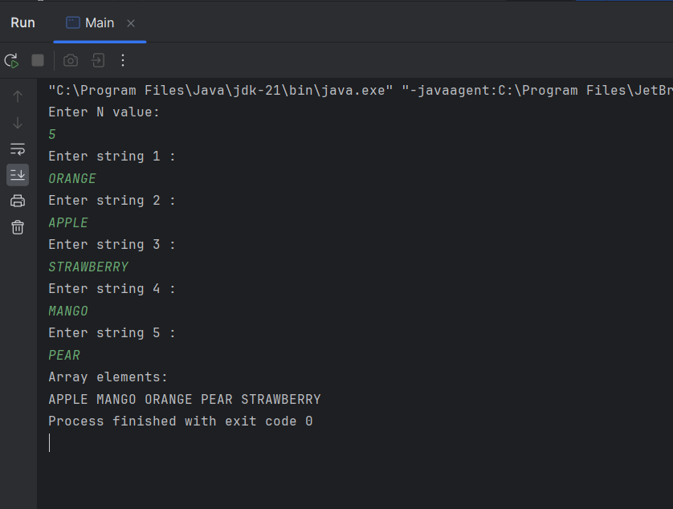

**4) Write a method which can reverse an array_list. First, create a new empty ArrayList**

**called temp. Then iterate through array_list backwards, and within each loop cycle,**

**retrieve an element from array_list using get(), and use add() to insert it into temp.**

**Use the method size() to get the size of an ArrayList**

**CODE:**

import java.util.Scanner;  
import java.util.ArrayList;  
  
public class Main {  
 public static void main(String[] args) {  
 Scanner inputs = new Scanner(System.*in*);  
 ArrayList<Integer> arrayList = new ArrayList<Integer>();  
 int N = 0;  
 System.*out*.println("Enter N value: ");  
 N = inputs.nextInt();  
  
 for(int j = 0;j<N;j++){  
 System.*out*.println("Enter value " + (j+1) +" :");  
 int num = inputs.nextInt();  
 arrayList.add(num);  
  
 }  
  
 ArrayList<Integer> temp = new ArrayList<Integer>();  
  
 for(int j=arrayList.size()-1;j>=0;j--){  
 int value = arrayList.get(j);  
 temp.add(value);  
 }  
  
 for(int k = 0;k<temp.size();k++){  
 System.*out*.print(temp.get(k) + " ");  
 }  
  
 }  
}

**OURP**