

Big Data Analytics for Job Market Trends, In-Demand Skills, and Salary Insights

Big Data Project Report

Submitted by:
Aryam Monshi, 444001593
Rawan Alharthi, 444001029
Nora Alshibi, 444002730
Taghreed Alzahrani, 443007366

Introduction
The job market is rapidly evolving, so nowadays, many students and job seekers require more transparency regarding companies' requirements. Students might learn that certain skills are essential; however, lacking data, they cannot determine how popular such skills can be in job descriptions. Job seekers may also find it difficult to identify job titles, which are in demand more, what locations provide more positions or if there are any differences in salaries between remote positions and others.
The objective of our project was to build a Big Data analytics solution, which would analyze the LinkedIn job postings' dataset. Specifically, we aimed to explore the trends in the job market, necessary skills, salary level, remote work possibility, and job engagement. As the provided dataset had over 123,000 job postings, it was appropriate for a Big Data solution as it required organized ingestion, storage, processing, analytics, machine learning, and visualization.
It is important to note that we did not design a project which simply allows building some visualizations based on the analysis of a CSV file. On the contrary, the project is a full-fledged data pipeline. It starts with the ingestion of dataset files followed by storing the original data in a raw folder. Further, the data is cleaned using PySpark technology, stored as Parquet files, analyzed, a salary level prediction model is developed, and a Streamlit dashboard with all output results is generated.

Problem Definition and Motivation
Students, graduates, job hunters have troubles to comprehend how their desired field looks like on the job market. Even though people know about required skills and their significance, they lack a solid data-driven understanding of skills that are highly demanded by companies, common job titles, or aspects that affect salary level.
For instance, if a student is interested in a position of a data analyst, he or she might be uncertain regarding the prioritization between such skills as SQL, Python, Excel, Power BI, communication, and project management competences. Moreover, job hunters do not necessarily have comprehensive knowledge about geolocations where they might expect more positions, companies where they will find job vacancies, or peculiarities in salaries offered for remote positions against on-site positions.
Thus, the presented problem is crucial to solve since career-related decisions must be evidence-driven rather than intuitive and speculative. In other words, after analyzing LinkedIn postings' database, we might contribute significantly towards gaining

valuable insights to assist students, job hunters, educational institutions, and businesses to get a deeper understanding of their job markets.
Therefore, we developed a Big Data analytics solution that processes job postings collected from LinkedIn, detects job market trends, analyzes in-demand skills, investigates salary indicators, and represents visual insights in an interactive dashboard format.

Dataset Description
The dataset used in this project is a LinkedIn job postings dataset from Kaggle. It contains job posting information collected from LinkedIn, including job titles, companies, locations, salary fields, work types, remote availability, views, applications, and required skills. The dataset is suitable for our project because it allows us to analyze the job market from different sides, such as job demand, skill demand, salary patterns, work type distribution, and engagement.
The dataset is not stored in one file only. It contains a main job postings file and supporting files that help us connect each job with its related skills. In this project, we mainly used three files:
- postings.csv
- job_skills.csv
- skills.csv

Main Dataset File: postings.csv
The main file is postings.csv. It contains 123,849 job postings and includes the main information about each job. This file is considered the core dataset of the project because most of the analysis depends on it.
Column Name | Description
job_id | Unique identifier for each job posting
company_name | Name of the company that posted the job
title | Job title
description | Full job description
min_salary | Minimum salary value, if available
med_salary | Median salary value, if available
max_salary | Maximum salary value, if available
pay_period | Salary period such as hourly, monthly, or yearly
location | Job location

views | Number of views received by the job posting
applies | Number of applications submitted
remote_allowed | Indicates whether the job allows remote work
formatted_work_type | Work type such as full-time, part-time, contract, or  internship
formatted_experience_level | Experience level required for the job
normalized_salary | Salary value converted into a normalized format for  comparison
The initial data check showed that the dataset contains 24,428 unique companies, 8,526 unique locations, and 72,521 unique job titles. This shows that the dataset is rich and diverse enough to support useful job market analysis.
Figure 1: Showing the main job posting information such as job title, company, location, salary fields, work type, and remote availability.

Job Skills File: job_skills.csv
The second file is job_skills.csv. This file connects job postings with their required skills. It contains 213,768 rows, which means that one job can be linked to more than one skill.
Column Name | Description
job_id | The job posting identifier
skill_abr | The abbreviation of the required skill
For example, the same job can appear more than once if it requires multiple skills. This is useful because it allows us to analyze which skills are most commonly required in the job market.
The initial check showed that 122,096 jobs from postings.csv have at least one related skill, while only 1,753 jobs do not have skill information..
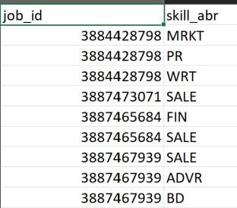
Figure 2: showing how each job posting is connected to one or more skill abbreviations.

Skills Mapping File: skills.csv
The third file is skills.csv. This file explains the meaning of each skill abbreviation used in job_skills.csv. It contains 35 unique skills.
Column Name | Description
skill_abr | Skill abbreviation
skill_name | Full skill name
For example, abbreviations such as ENG, SALE, FIN, and PRJM can be mapped to full skill names such as Engineering, Sales, Finance, and Project Management.
This file is important because it makes the analysis easier to understand. Instead of showing only skill codes, we can display readable skill names in the results and dashboard.
The initial check showed that all 35 skill abbreviations in job_skills.csv were successfully mapped to skills.csv, and there were no missing skill mappings.
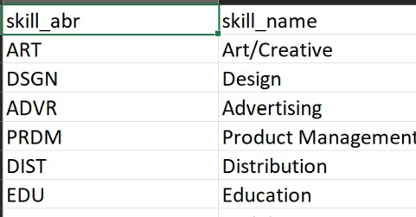
Figure 3: Showing the mapping between skill abbreviations and full skill names

Initial Dataset Summary
The following table summarizes the main dataset statistics after the initial data understanding step.
Item | Value
Number of rows in postings.csv | 123,849
Number of loaded columns from postings.csv | 17
Number of rows in job_skills.csv | 213,768
Number of unique job IDs in job_skills.csv | 126,807
Number of rows in skills.csv | 35
Number of unique skills | 35
Number of unique companies | 24,428
Number of unique locations | 8,526
Number of unique job titles | 72,521

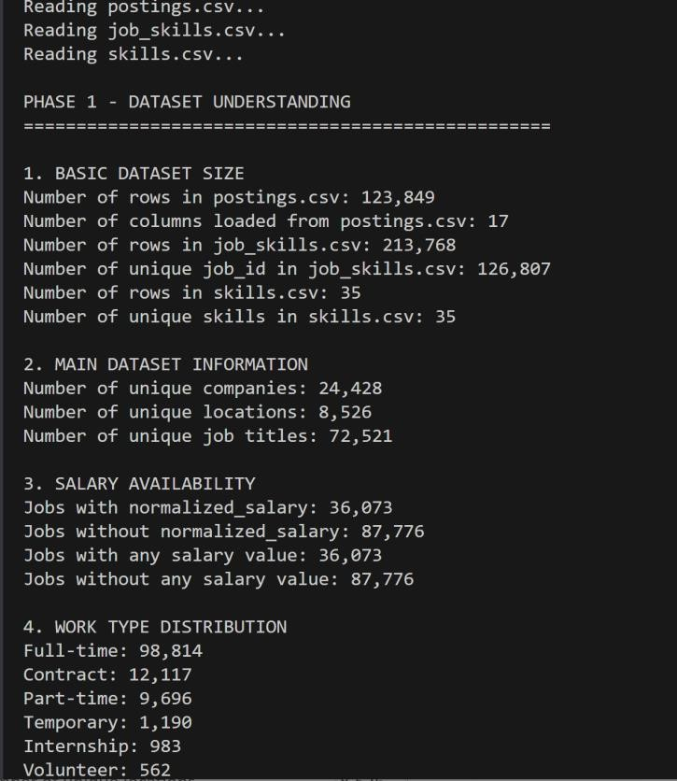
Figure 4: Dataset profile output showing the number of rows, columns, unique companies, unique locations, and unique job titles

Salary Data Availability
Salary information is important for the salary insights and machine learning parts of this project. However, not all job postings include salary values.
Salary Availability | Count
Jobs with normalized_salary | 36,073
Jobs without normalized_salary | 87,776
Jobs with any salary value | 36,073
Jobs without any salary value | 87,776
This means that salary analysis and salary level prediction were based only on jobs that contain salary information. However, the remaining jobs were still useful for general analysis such as job titles, companies, locations, work types, remote jobs, and skills demand.

Architecture Design
We designed the system as a Big Data ecosystem for analyzing LinkedIn job posting data. The architecture starts with the data source, which includes postings.csv, job_skills.csv, and skills.csv. These files provide job posting details, job-skill relationships, and readable skill names.
The data ingestion layer uses Python scripts to read the files, validate the required columns, and prepare the data for the next steps. After ingestion, the original files are stored in a raw storage folder without modification. This gives us a clean separation between original data and processed data.
The processing layer uses PySpark to clean and transform the data. In this part, we removed duplicates, handled missing values, prepared salary fields, converted remote work values into clear labels, created salary_level, and joined job postings with the skills data.
After processing, we saved the cleaned outputs as Parquet files in the processed storage folder. These files were then used for analytics, machine learning, and the Streamlit dashboard.
The final output layer is the dashboard. It allows users to interact with the results, filter the data, explore charts, and test the salary level prediction model.
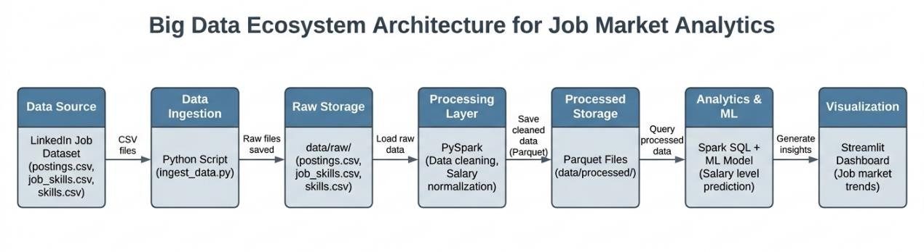
Figure 5: System architecture showing the flow from LinkedIn job dataset files to ingestion, raw storage, PySpark processing, processed storage, analytics, machine learning, and Streamlit dashboard.

Tool–Layer Justification Table

Layer | Tool Used | Why It Is Appropriate | Alternative  Considered
Data Source | LinkedIn Job Postings Dataset | The dataset contains real job posting data from LinkedIn, including job titles, companies, locations, salaries, work types, views, applications,  and required skills. | A direct LinkedIn API was considered, but it was not selected because it may require access permissions, API limits, and additional  restrictions.
Data Ingestion | Python Script | Python is suitable for reading the dataset files, checking required columns, and preparing  files before processing. | Manual file handling was not selected because it is less organized and harder to  repeat.
Raw Storage | Local Raw Data Lake Folder | The raw storage folder keeps the original CSV files without modification and separates raw data  from processed data. | MongoDB was not selected as raw storage because it is more suitable for processed or  query-ready data.
Processing Layer | PySpark | PySpark is suitable for scalable processing, cleaning, joins, aggregation, and feature engineering. | Pandas alone was not selected as the main processing tool because it does not show scalable Big Data  processing clearly.
Processed Storage | Parquet Files | Parquet is efficient, structured, and works well with Spark and Python analytics tools. | CSV was considered, but it is less efficient for repeated analytical queries and does not preserve schema as  well.

Analytics | PySpark / Python Analytics | These tools are suitable for generating insights such as top jobs, skills, salaries, and engagement  summaries. | Excel was not selected because it is not suitable as the main analytics tool in a Big Data  pipeline.
Machine Learning | Spark MLlib / Python ML | These tools are suitable for building a salary level prediction model using processed job features. | Manual rule-based prediction was not selected because it would not represent real  predictive analytics.
Visualization | Streamlit + Plotly | Streamlit is suitable for building an interactive dashboard, and Plotly supports hover, zoom, treemaps, donuts, bubbles,  and heatmaps. | Power BI was considered, but Streamlit was easier to integrate with the Python-based pipeline.
- Implementation
This section explains how we implemented the system. It includes the main workflow, important code snippets, and screenshots that show execution evidence.

Data Ingestion
We started by loading the dataset files into the project and checking that the required files and columns existed. The ingestion script was implemented in: ingestion/ingest_data.py
The script reads the three files:
    - postings.csv
    - job_skills.csv
    - skills.csv
It checks the file structure, counts the rows, validates required columns, and saves a summary output.
One of the simple helper functions we used was:

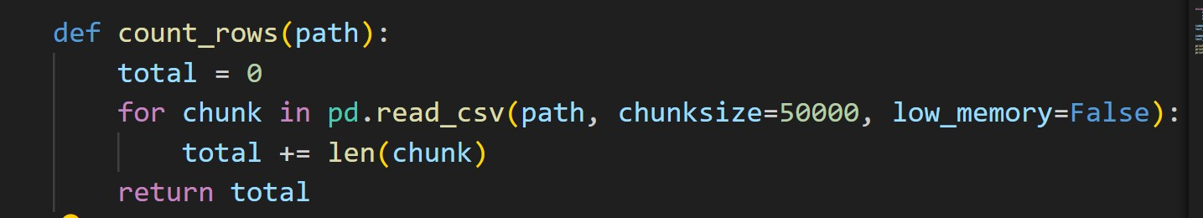
This function was useful because postings.csv is large, so we counted rows in chunks instead of loading everything at once.
We also used a column validation function:
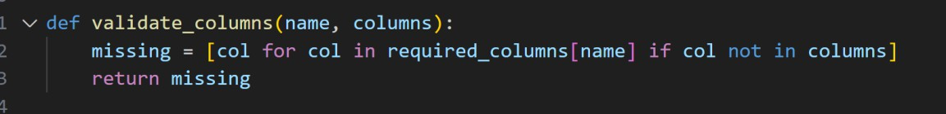
This helped us confirm that the files contained the columns needed for analysis.

Raw Storage
After ingestion, we stored the original files in the raw storage folder:
data/raw/
The raw folder contains:
data/raw/postings.csv data/raw/job_skills.csv data/raw/skills.csv
We kept these files unchanged. This is important because we can always return to the original data if we need to rerun the pipeline or fix a processing issue.

PySpark Processing
We used PySpark as the main processing engine. The processing script was implemented in:
processing/spark_processing.py
This script reads the raw files, cleans the data, prepares salary values, creates salary levels, and saves the processed outputs.
The main cleaning function was:

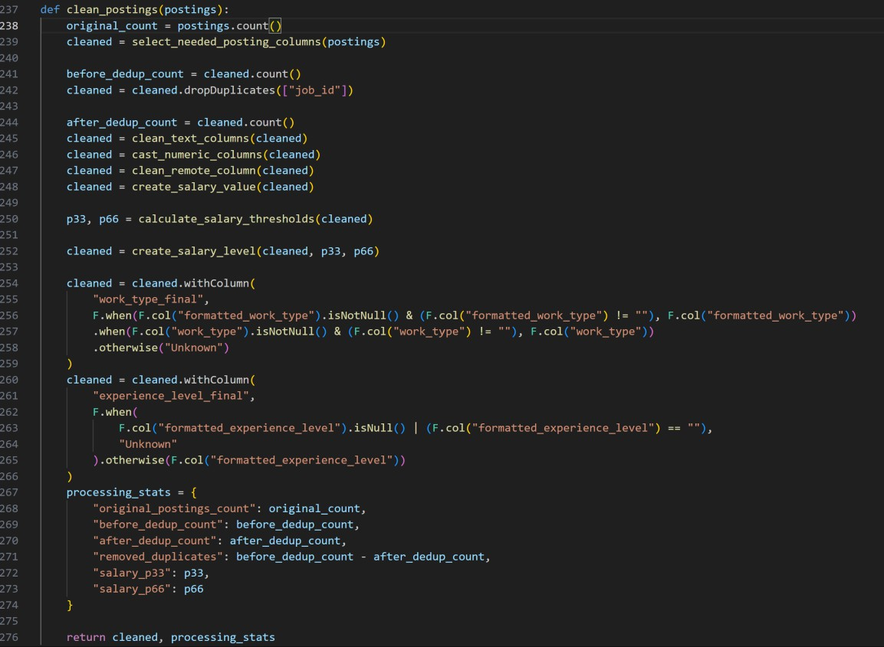
This function represents the main workflow for cleaning postings.csv. It selects important columns, removes duplicate jobs, cleans text columns, converts numeric values, prepares remote status, and creates the salary level.
For salary preparation, we used normalized_salary first because it is the most suitable field for comparison. If it was missing, the script could use med_salary, or the average of min_salary and max_salary.
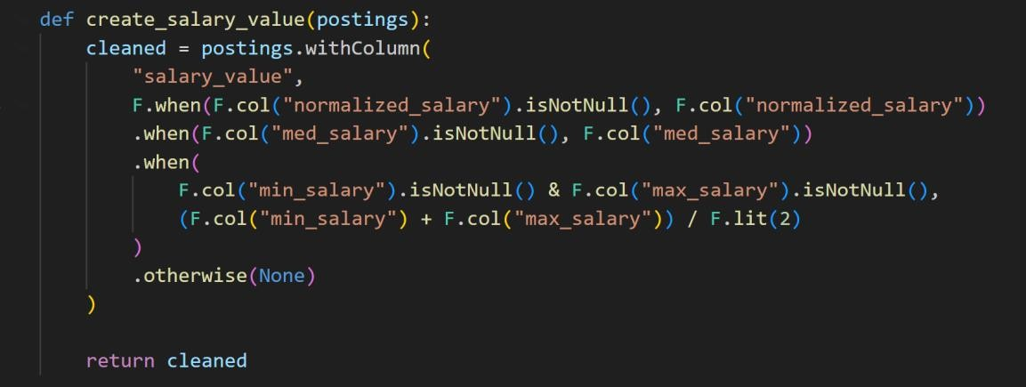
We also created a new column called salary_level. This column classifies salaries into Low, Medium, High, or Unknown.

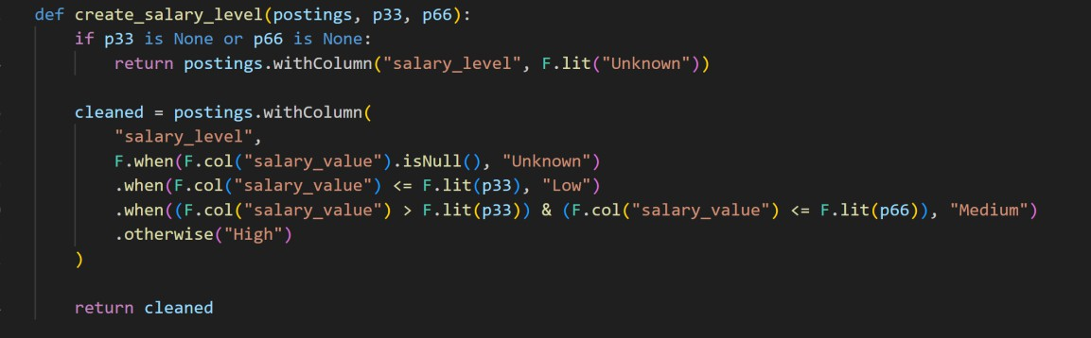
The salary levels were based on percentiles. The 33rd percentile was 59,750, and the 66th percentile was 106,000.
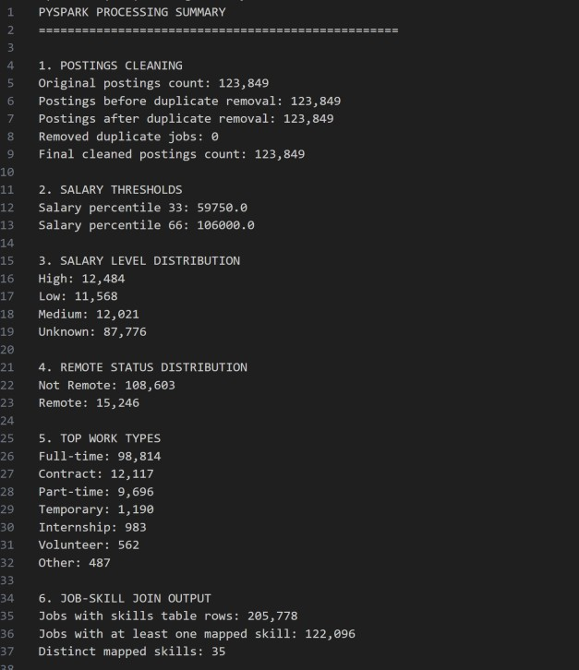
Figure 6: : PySpark processing summary showing cleaned postings, salary levels, remote status, and work type distribution.
The high number of Unknown salary levels happened because many job postings did not include salary information.

Processed Storage
After processing, we saved the cleaned and transformed data in the processed storage folder:
data/processed/
The processed storage layer contains three main Parquet files:

File | Description
cleaned_postings.parquet | Contains cleaned job posting records after cleaning,  salary preparation, and salary level creation.

jobs_with_skills.parquet | Contains job postings joined with their related  skills.
job_skill_summary.parquet | Contains summarized skill-level information such  as job counts, salary indicators, views, and applications.
We selected Parquet because it is more efficient than CSV for processed analytical data. It also keeps the schema and works well with Spark and Python tools.
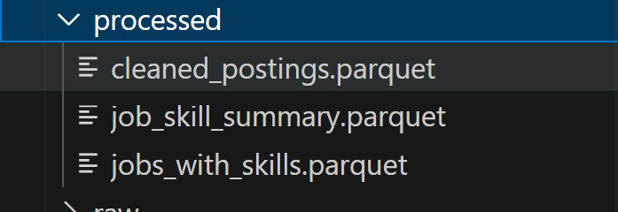
Figure 7: Processed storage folder showing the cleaned and query-ready Parquet files

Analytics
After preparing the processed data, we generated the analytical outputs using: analytics/run_analytics.py
Before salary analysis, we applied a salary filter to remove unrealistic salary values: For example if salary was:
10,000 <= salary_value <= 500,000
We call The function used for salary filtering:
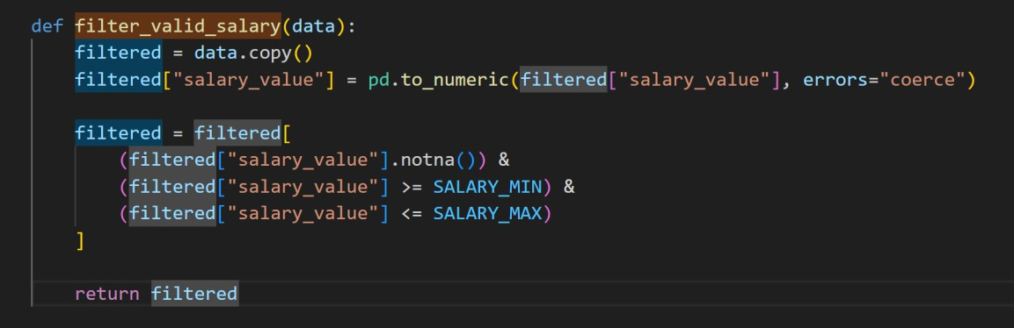
This filter removed 513 invalid or outlier salary records. After filtering, 35,560 salary records remained for salary analysis.
The analytics script generated outputs such as:
- top_job_titles.parquet
- top_companies.parquet
- top_locations.parquet

- top_skills.parquet
- salary_by_title.parquet
- salary_by_skill.parquet
- salary_by_location.parquet
- remote_salary_comparison.parquet
- engagement_summary.parquet
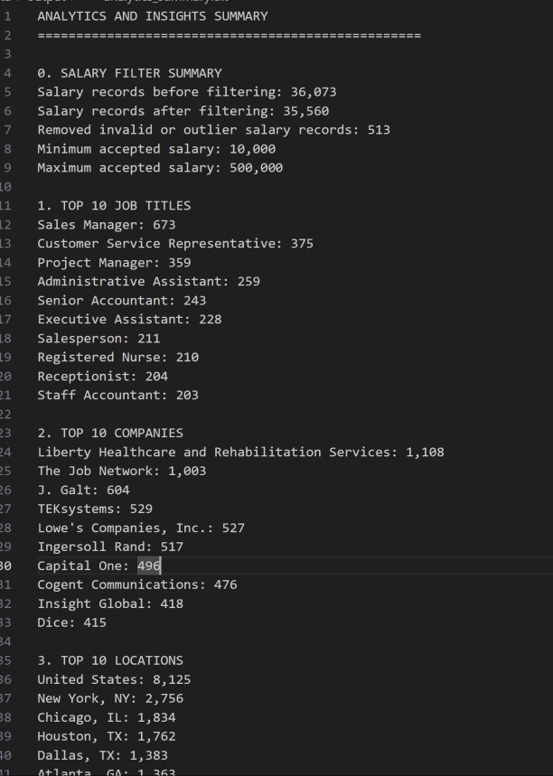
Figure 8: Analytics output folder containing Parquet and CSV files used for charts and dashboard visualization

Machine Learning
We added a machine learning model to predict the salary level of job postings. The target variable was:
salary_level
The classes were:
    - Low
    - Medium
    - High
We did not include jobs with unknown salaries in model training. Only jobs with valid salary values were used.
The machine learning script was:

ml/salary_level_prediction.py
The model used was a Random Forest Classifier implemented with Spark MLlib. The model used the following features:
Feature | Description
title_group | Grouped job title
location_group | Grouped job location
work_type_final | Work type
remote_status | Remote or not remote
views | Number of views
applies | Number of applications
experience_level_final | Experience level
skills_array | Required skills
The dataset was split into training and testing data:

Dataset Part | Number of Records
Training records | 28,596
Testing records | 6,964
Total records used | 35,560
The class distribution was reasonably balanced.

Salary Level | Training Records | Testing Records
High | 9,944 | 2,444
Medium | 9,717 | 2,304
Low | 8,935 | 2,216

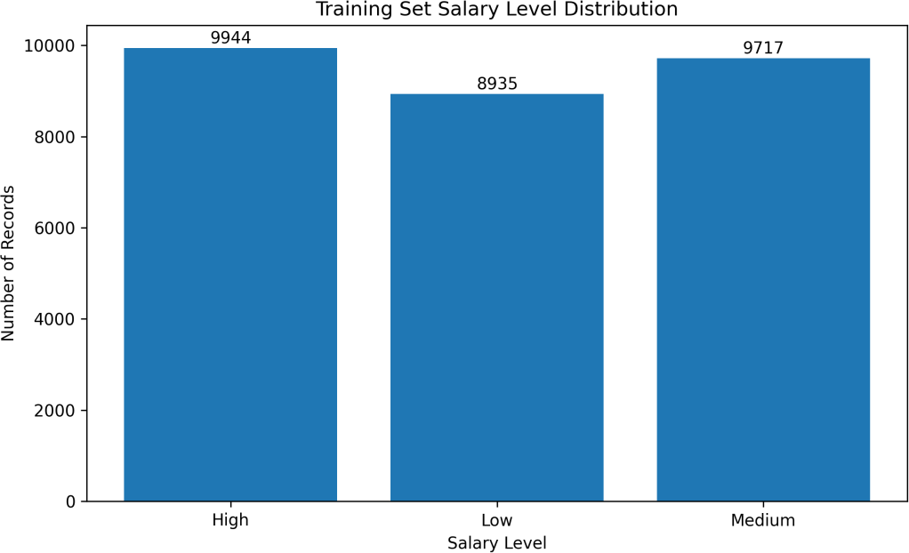

Figure 9: Distribution of salary level classes in the training data.
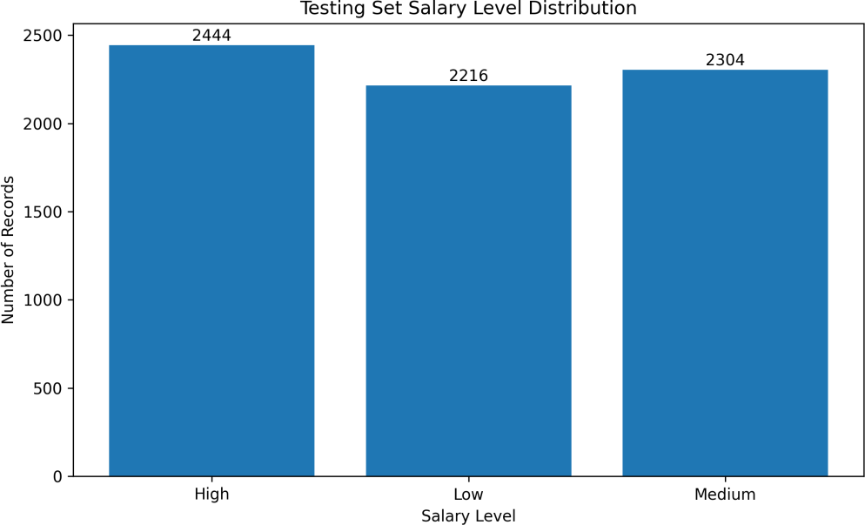

Figure 10: Distribution of salary level classes in the testing data.
The model performance was:

Metric | Value
Accuracy | 0.5836
F1-score | 0.5767

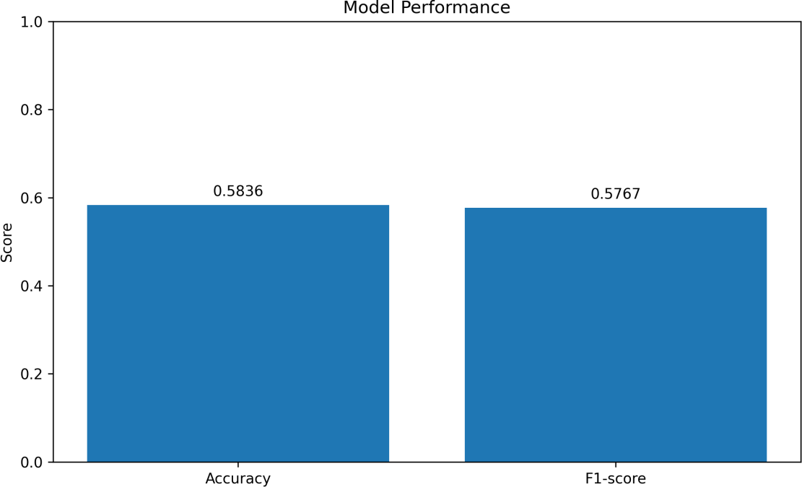

Figure 11: Model performance showing the accuracy and F1-score of the salary level prediction model.
The confusion matrix gives detail about how the model predicted each salary class.

Actual Salary Level | Predicted High | Predicted Medium | Predicted Low
High | 1,760 | 490 | 194
Medium | 898 | 871 | 535
Low | 223 | 560 | 1,433
The model performed better on the High and Low classes. The Medium class was more difficult because medium salaries are often close to both low and high salary ranges.
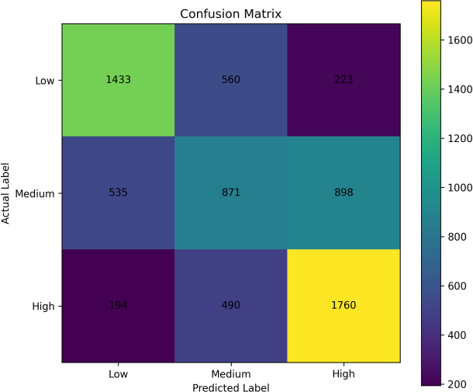

Figure 12: Confusion matrix of the Random Forest classifier for predicting salary levels.

The model also generated sample predictions to show actual and predicted salary levels.
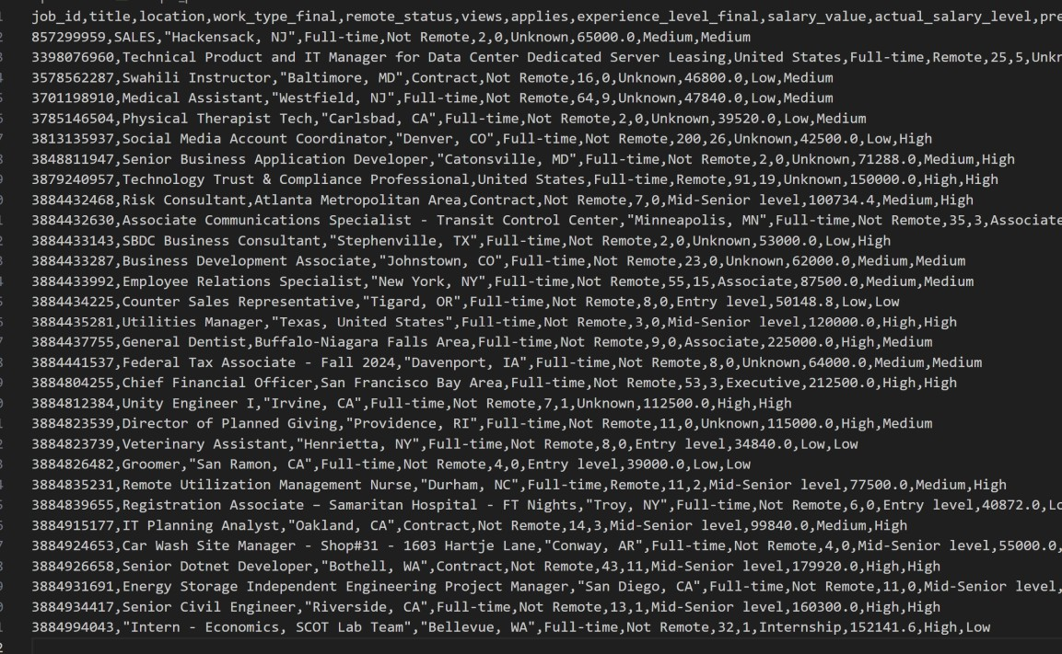
Figure 13: Sample salary level predictions generated by the machine learning model.

Dashboard
The dashboard uses the processed Parquet files and the machine learning output files. It includes filters for work type, remote status, skill, and salary range. These filters allow the user to explore the job market data in different ways.
We selected Streamlit instead of Tableau because our dashboard is not only for showing charts. It also includes an interactive salary level prediction form connected directly to the machine learning model. The user can enter job details such as job title, location, work type, remote status, experience level, expected views, expected applications, and required skills. Then, the dashboard predicts whether the expected salary level is Low, Medium, or High.
Tableau is strong for business dashboards and visual reporting, but Streamlit was more suitable for our project because it works directly with Python, Pandas, Plotly, and machine learning models. Since our whole pipeline was built using Python tools, Streamlit allowed us to connect the processed data, analytics results, and prediction model in one application.
We used Plotly inside Streamlit because it provides interactive visuals such as hover details, zooming, legends, treemaps, donut charts, bubble charts, and heatmaps.

The dashboard contains several tabs, and each tab focuses on a different part of the project.

Overview Tab
The Overview tab shows the main KPIs, including total job postings, total companies, total locations, total skills, and average salary. It also includes donut charts for work type and salary level distribution, plus a treemap for top skills.
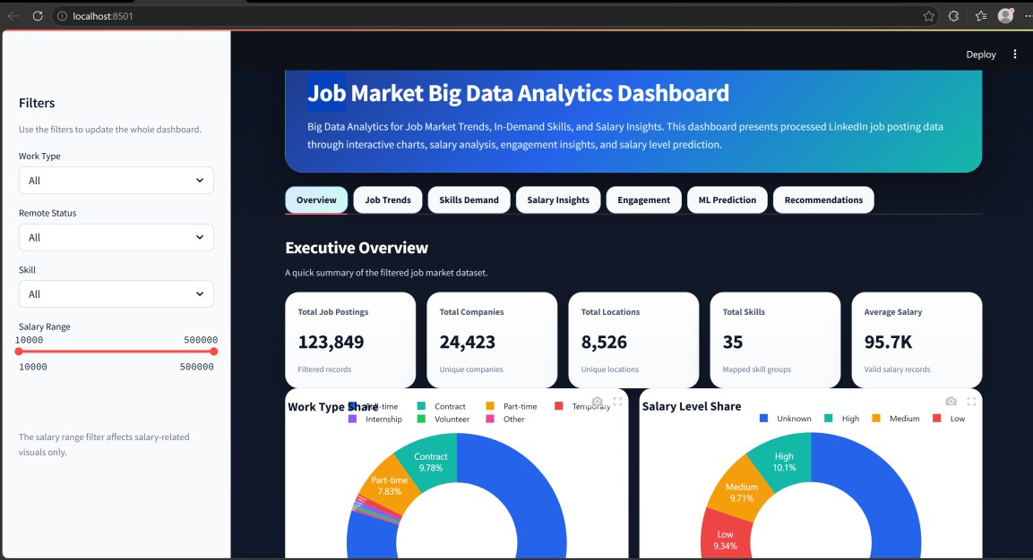
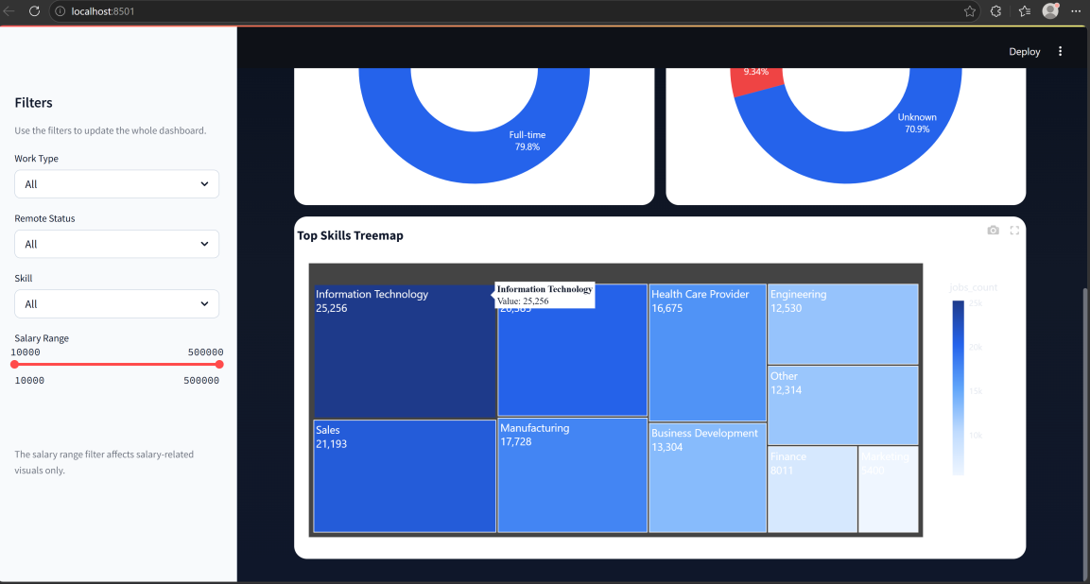

Job Trends Tab
The Job Trends tab shows the most common job titles, top companies, top locations, and jobs by work type. This tab helps users understand the general structure of the job market in the dataset.
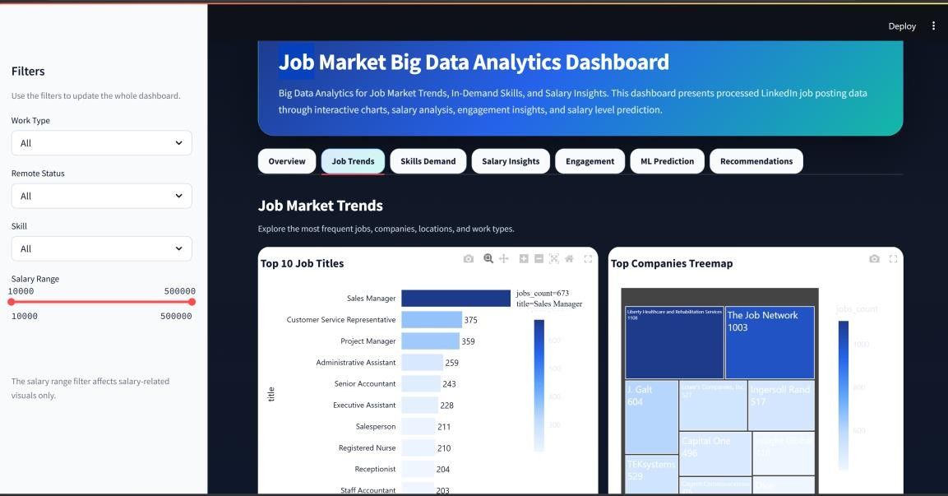
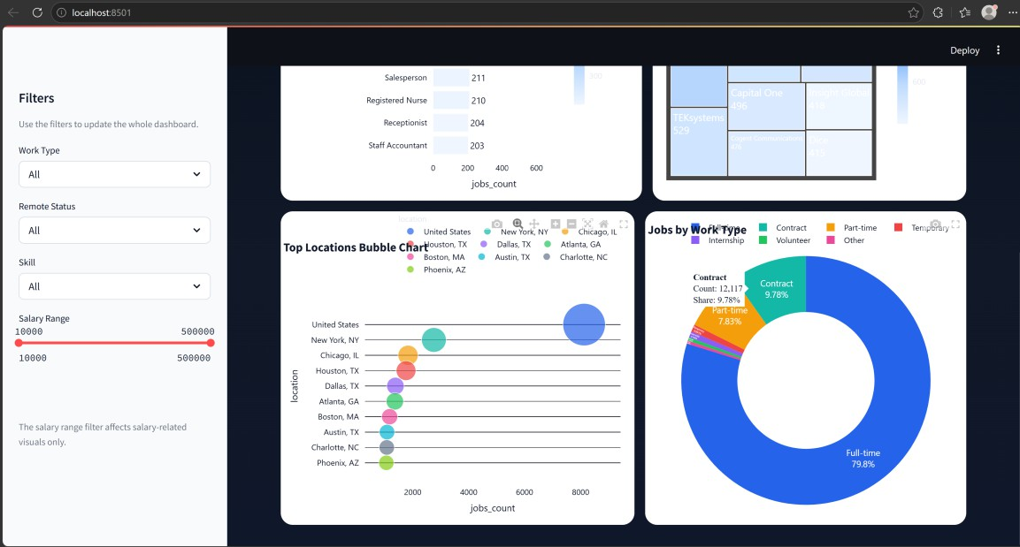

Skills Demand Tab
The Skills Demand tab shows the top in-demand skills, skills related to high-salary jobs, skills common in remote jobs, and skills by selected job title. This tab is useful for students and job seekers because it shows what skills appear most often in job postings.
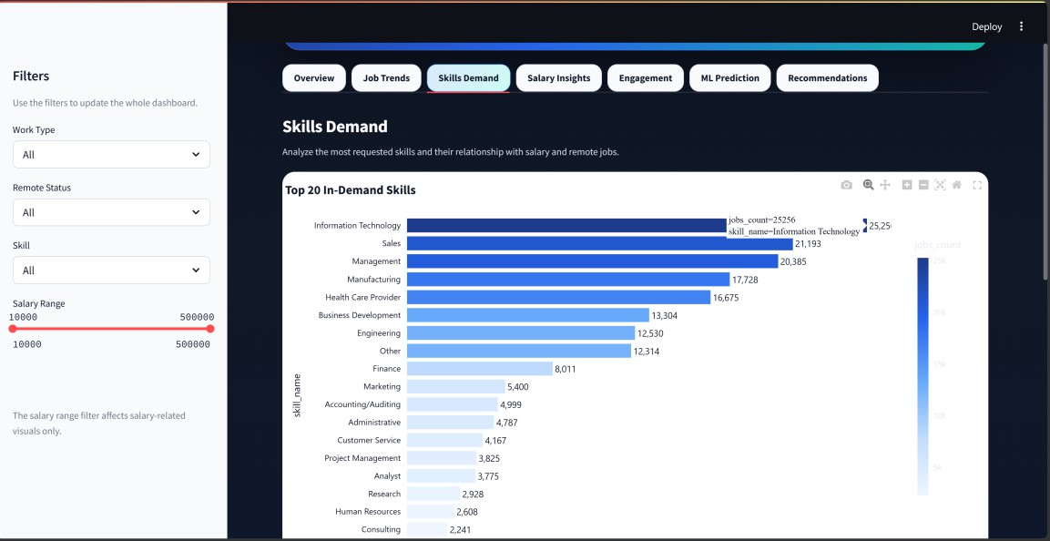
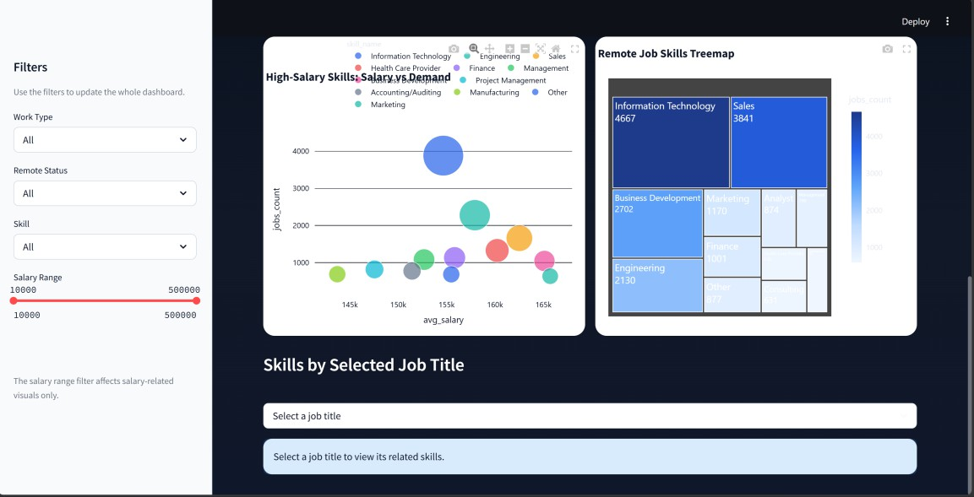

Salary Insights Tab
The Salary Insights tab shows salary analysis by job title, skill, location, salary level, and remote status. The salary range filter can be used to control which salary values appear in the charts.
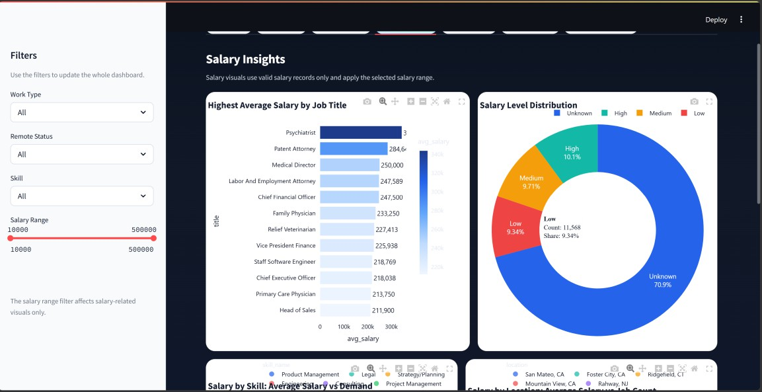
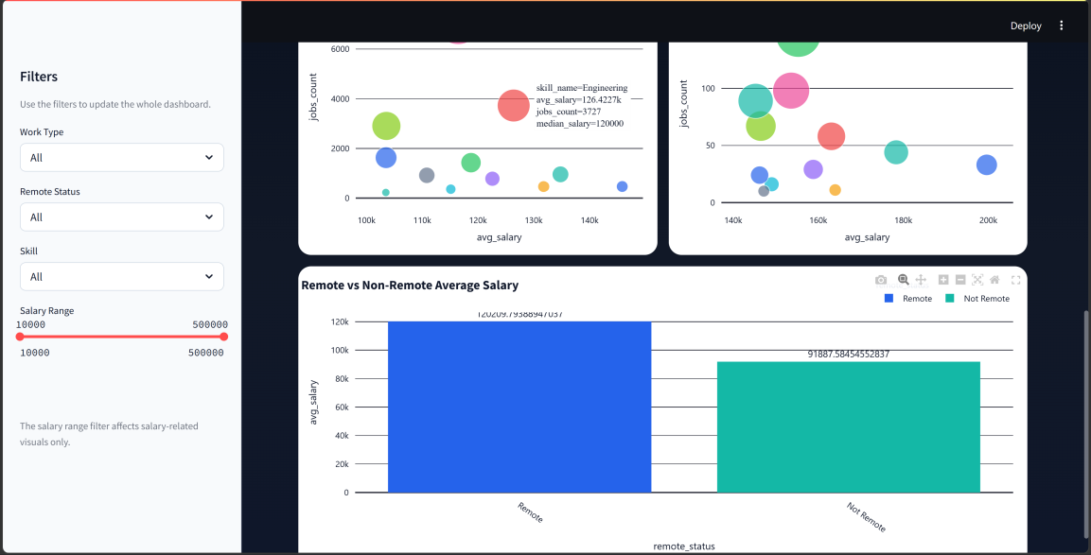

Engagement Tab
The Engagement tab analyzes views and applications. It includes total views, total applies, average views, average applies, correlation, a scatter chart, top viewed jobs, top applied jobs, and engagement by skill.
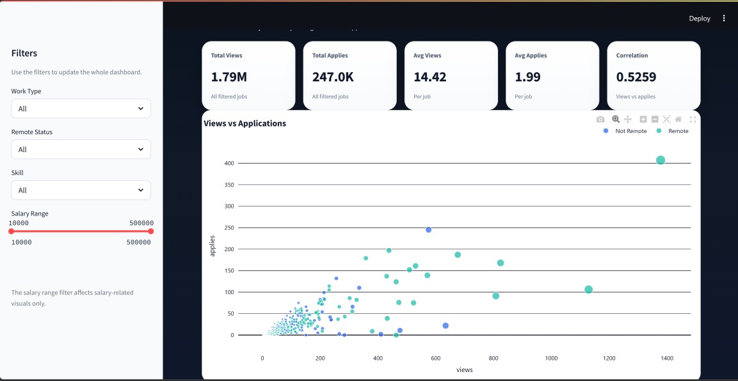
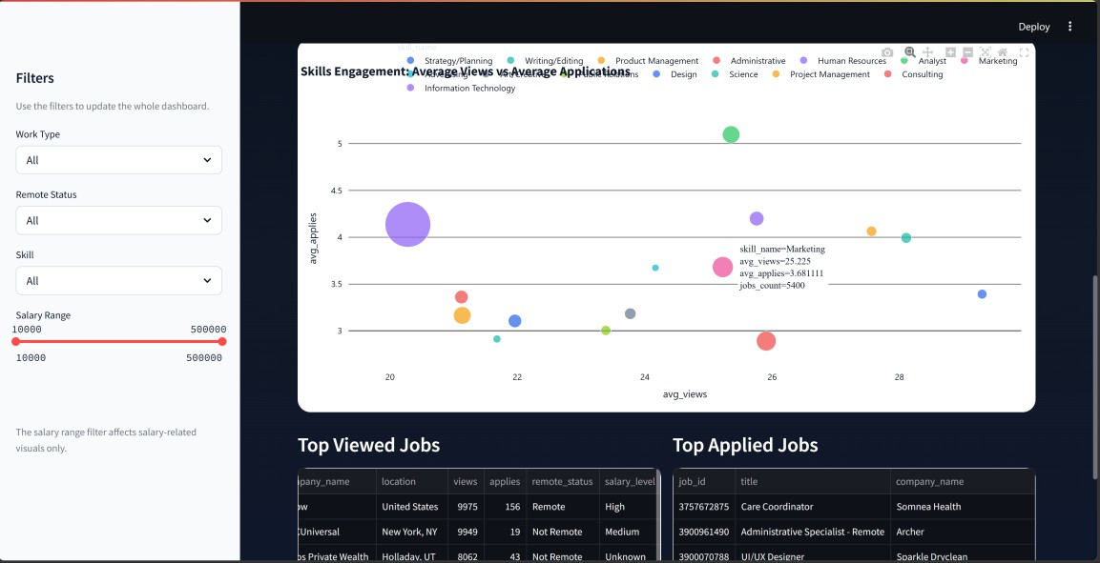

Machine Learning Prediction Tab
The Machine Learning Prediction tab shows t the interactive prediction section that allows the user to choose job title, location, work type, remote status, experience level, expected views, expected applications, and required skills. After clicking the prediction button, the dashboard displays the predicted salary level and prediction probabilities.
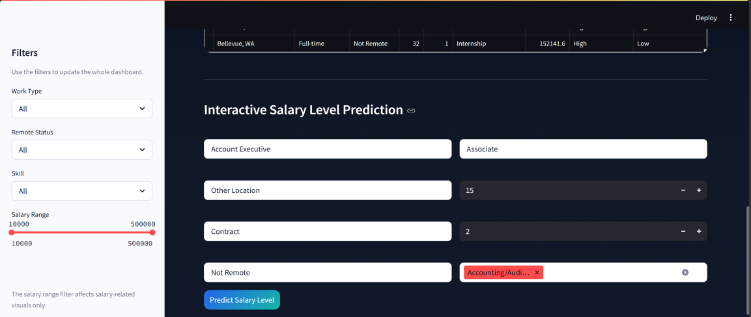
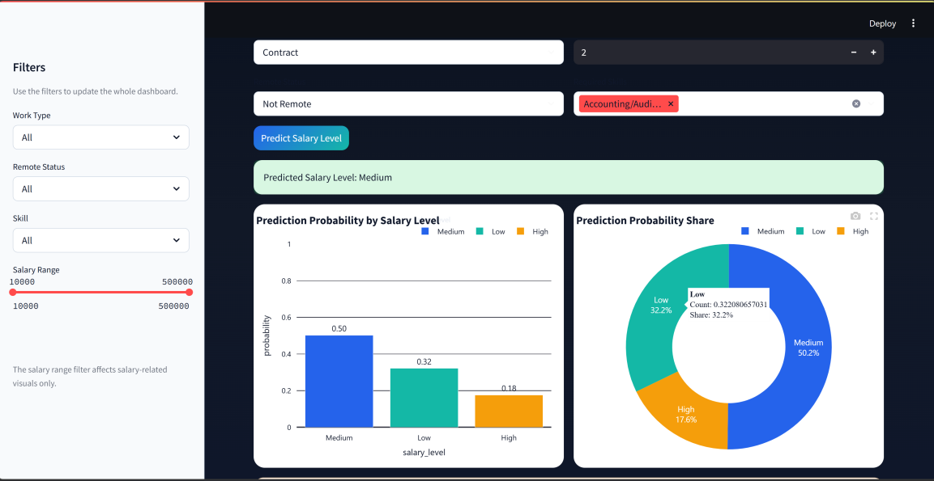

Recommendations Tab
The Recommendations tab provides simple data-based recommendations. It shows the most in-demand skills, skills associated with higher salaries, and skills common in remote jobs based on the current filters.
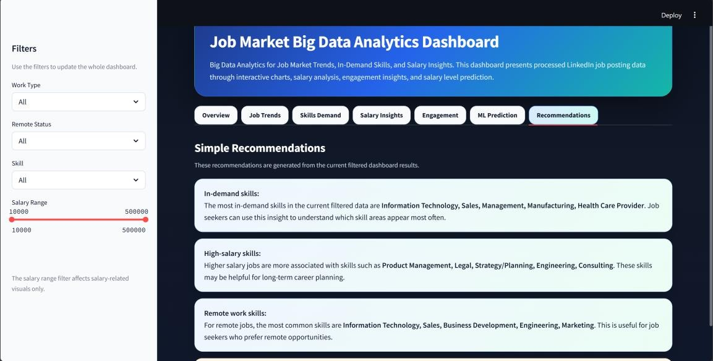

Results and Insights
The analytics results helped us understand job market trends, skills demand, salary differences, remote work patterns, and engagement indicators.

Job Market Trends
The first result focuses on the most common job titles.

Rank | Job Title | Number of Jobs
1 | Sales Manager | 673
2 | Customer Service Representative | 375
3 | Project Manager | 359
4 | Administrative Assistant | 259
5 | Senior Accountant | 243
6 | Executive Assistant | 228
7 | Salesperson | 211
8 | Registered Nurse | 210
9 | Receptionist | 204
10 | Staff Accountant | 203
Sales Manager was the most common job title in the dataset. We also noticed that customer service, project management, administrative, and accounting roles appeared frequently.

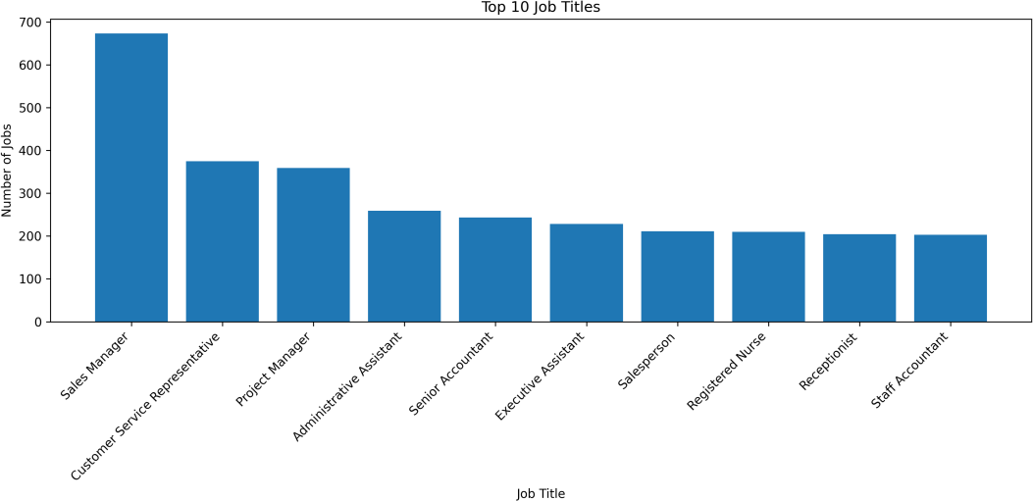

The next result shows the companies with the highest number of job postings.

Rank | Company | Number of Jobs
1 | Liberty Healthcare and Rehabilitation Services | 1,108
2 | The Job Network | 1,003
3 | J. Galt | 604
4 | TEKsystems | 529
5 | Lowe’s Companies, Inc. | 527
6 | Ingersoll Rand | 517
7 | Capital One | 496
8 | Cogent Communications | 476
9 | Insight Global | 418
10 | Dice | 415
This result helps identify the most active employers or job networks in the dataset.
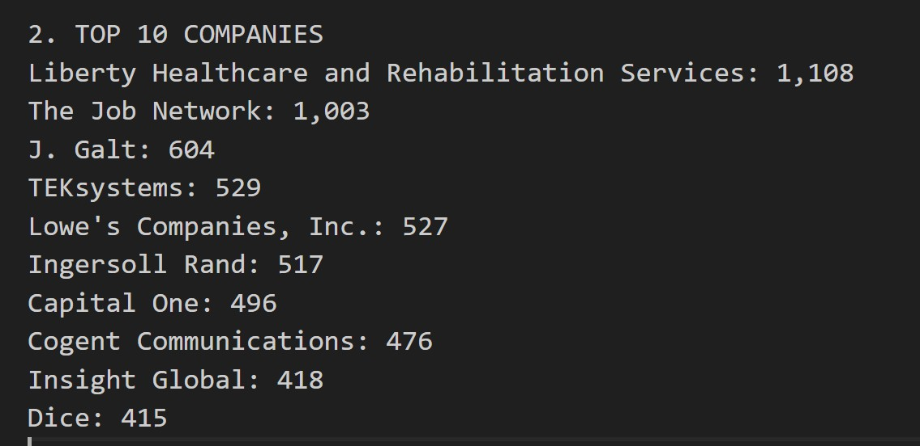

The location analysis shows where job postings are more concentrated.

Rank | Location | Number of Jobs
1 | United States | 8,125
2 | New York, NY | 2,756
3 | Chicago, IL | 1,834
4 | Houston, TX | 1,762
5 | Dallas, TX | 1,383
6 | Atlanta, GA | 1,363
7 | Boston, MA | 1,176
8 | Austin, TX | 1,083
9 | Charlotte, NC | 1,075
10 | Phoenix, AZ | 1,059
Major cities such as New York, Chicago, Houston, and Dallas appeared strongly in the dataset.
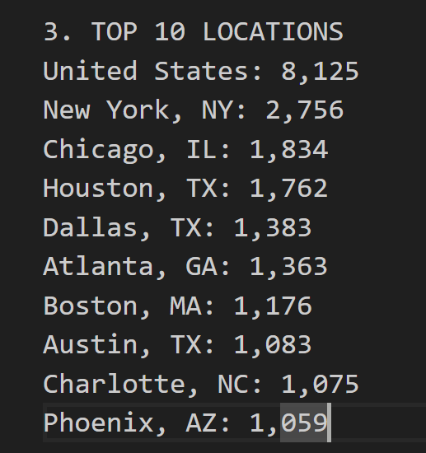
The work type distribution shows that full-time jobs dominate the dataset.

Work Type | Number of Jobs
Full-time | 98,814
Contract | 12,117
Part-time | 9,696
Temporary | 1,190
Internship | 983
Volunteer | 562
Other | 487

Skills Demand
The skill analysis shows the most frequently required skills.

Rank | Skill | Number of Jobs
1 | Information Technology | 25,256
2 | Sales | 21,193
3 | Management | 20,385
4 | Manufacturing | 17,728
5 | Health Care Provider | 16,675
6 | Business Development | 13,304
7 | Engineering | 12,530
8 | Other | 12,314
9 | Finance | 8,011
10 | Marketing | 5,400
11 | Accounting/Auditing | 4,999
12 | Administrative | 4,787
13 | Customer Service | 4,167
14 | Project Management | 3,825
15 | Analyst | 3,775
16 | Research | 2,928
17 | Human Resources | 2,608
18 | Consulting | 2,241
19 | Legal | 2,229
20 | Education | 2,217

Information Technology was the most common skill category, followed by Sales, Management, Manufacturing, and Health Care Provider.
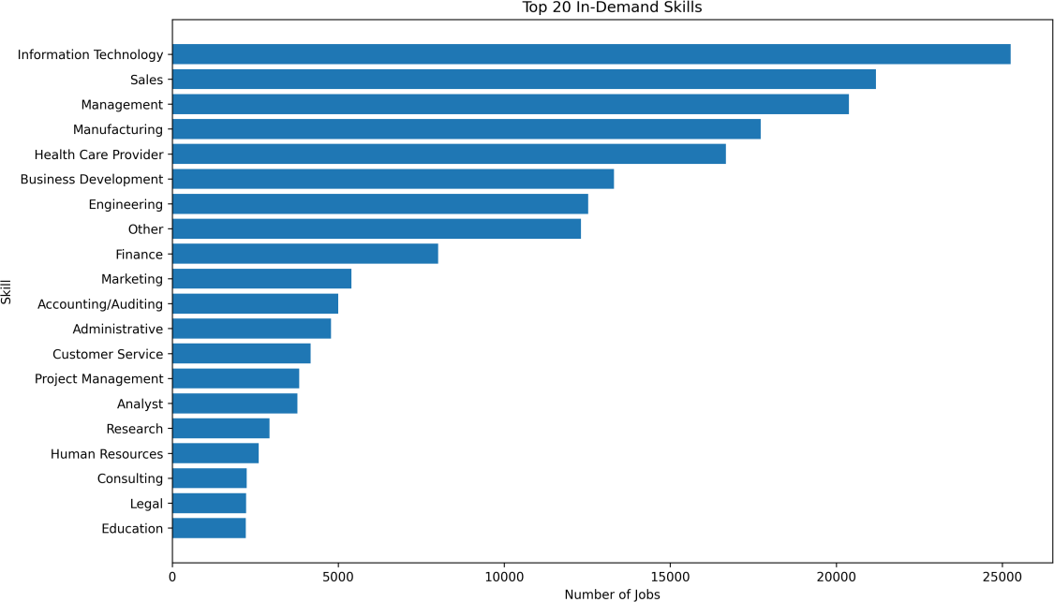
Figure 14: Top 20 in-demand skills based on job-skill mapping.
For remote jobs, the most common skills were:

Rank | Skill | Number of Remote Jobs
1 | Information Technology | 4,667
2 | Sales | 3,841
3 | Business Development | 2,702
4 | Engineering | 2,130
5 | Marketing | 1,170
6 | Finance | 1,001
7 | Other | 877
8 | Analyst | 874
9 | Management | 790
10 | Health Care Provider | 638
This result shows that technology and business-related skills are common in remote opportunities.

Salary Insights
The following table shows the highest average salaries by skill.

Rank | Skill | Average Salary | Median Salary | Jobs
1 | Product Management | 145,857.46 | 142,500.00 | 471
2 | Legal | 134,769.20 | 120,000.00 | 960
3 | Strategy/Planning | 131,787.37 | 122,000.00 | 468
4 | Engineering | 126,422.67 | 120,000.00 | 3,727
5 | Consulting | 122,602.21 | 115,000.00 | 784
6 | Project Management | 118,760.90 | 114,400.00 | 1,430
7 | Information Technology | 116,457.45 | 112,500.00 | 7,090
8 | Science | 115,131.43 | 93,600.00 | 363
9 | Research | 110,826.57 | 93,600.00 | 921
10 | Finance | 103,569.57 | 92,500.00 | 2,906
Product Management, Legal, Strategy/Planning, Engineering, and Consulting were associated with higher average salaries.
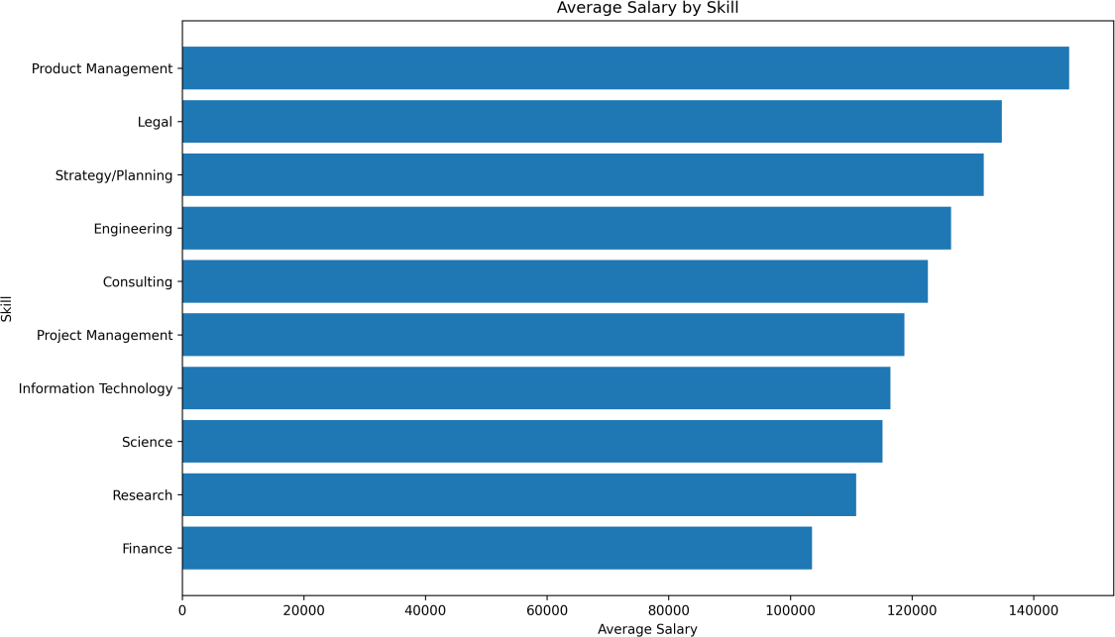
Figure 15: Average salary by skill category after filtering unrealistic salary values

Remote salary comparison showed the following:

Remote Status | Average Salary | Median Salary | Jobs
Remote | 120,209.79 | 113,250.00 | 4,777
Not Remote | 91,887.58 | 77,677.60 | 30,783
Remote jobs had a higher average and median salary in the available salary records. However, we interpreted this carefully because many job postings do not include salary information.
Average salary by skill category after filtering unrealistic salary values
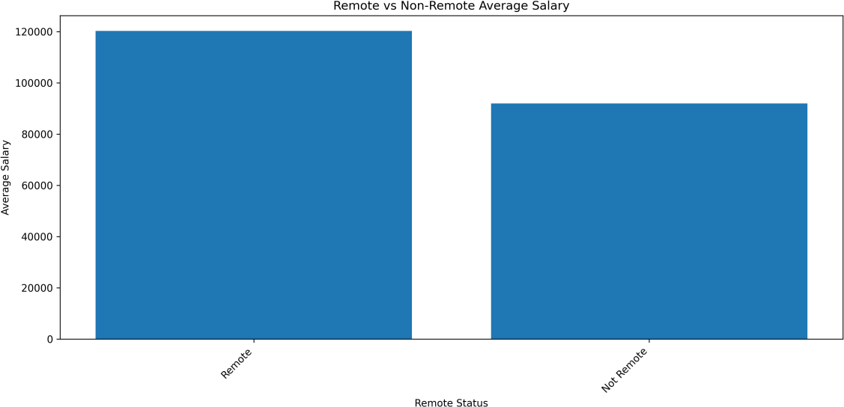
Figure 16:Salary comparison between remote and non-remote jobs

Engagement Insights
The engagement analysis used views and applies.

Metric | Value
Total Views | 1,785,765
Total Applies | 247,005
Average Views | 14.42
Average Applies | 1.99
Views-Applies Correlation | 0.5259
The correlation between views and applications was 0.5259, which means there is a moderate positive relationship. In simple words, jobs with more views usually receive more applications, but views are not the only factor.

Discussion
This project successfully built a Big Data analytics workflow for analyzing job market trends, in-demand skills, salary insights, and salary level prediction. We were able to process a large LinkedIn job postings dataset, clean the data, join multiple files, generate useful insights, build a machine learning model, and present the results through an interactive dashboard.
One of the main strengths of this project is that it does not depend on one simple analysis file only. Instead, it follows a complete workflow starting from data ingestion, raw storage, PySpark processing, processed storage, analytics, machine learning, and visualization. This made the project more organized and closer to a real Big Data solution.
Another strength is that the dataset contains a large number of job postings and useful fields such as job title, company name, location, work type, salary, views, applications, and skills. The existence of job_skills.csv and skills.csv also made the skill analysis stronger because we did not depend only on extracting skills manually from job descriptions.
However, the project also has some limitations. The first limitation is that many job postings do not include salary information. Because of this, salary analysis and salary level prediction were performed only on records that had valid salary values. Jobs without salary values were still useful for general analysis, such as job titles, companies, locations, work types, and skills demand.
Another limitation is that some company names are missing. These missing values were handled during processing by replacing them with Unknown Company, but this still means that company-based analysis may not be fully complete.
Also, the dataset comes from LinkedIn only. This means the results represent the job postings available in this dataset, but they do not fully represent the entire job market. Other platforms such as Indeed, Glassdoor, company career pages, or government job portals may show different results.
The skill mapping in the dataset is useful, but it is still general. For example, skills such as Information Technology, Management, Sales, and Engineering are broad categories. They are helpful for high-level analysis, but they do not always show detailed technical skills such as Python, SQL, Java, AWS, or Power BI.

Big Data Justification
This project is considered a Big Data solution because it is not limited to reading a CSV file and creating simple charts. We implemented a complete workflow that includes ingestion, storage, scalable processing, processed storage, analytics, machine learning, and visualization.
Component | Description
Data Ingestion | Reading and validating the dataset files before processing
Raw Storage | Storing the original files separately without modification
PySpark  Processing | Cleaning the data, handling missing values, preparing salaries,  and joining files
Multi-file Joins | Joining postings.csv, job_skills.csv, and skills.csv
Processed  Storage | Saving cleaned and query-ready data using Parquet files
Analytics | Generating job market trends, skills demand, salary insights,  and engagement insights
Machine  Learning | Building a salary level prediction model
Visualization | Presenting the results through an interactive Streamlit  dashboard
The dataset also contains a large number of records. The main job postings file contains 123,849 job postings, and the job-skill file contains more than 200,000 job- skill relationships. This makes the dataset suitable for scalable processing techniques.
PySpark was used because it is designed for large-scale data processing. In this project, Spark was used to clean the data, remove duplicates, prepare salary fields, create salary levels, and join the job postings with skill mapping files. This shows that the project uses a scalable processing approach instead of depending only on small- scale tools.
Another reason this project fits the Big Data concept is that it separates the data into different layers. The raw data is stored in data/raw/, while the cleaned and processed data is saved in data/processed/. This separation makes the workflow repeatable and easier to maintain.

The project also produces outputs that support analysis and decision-making. For example, the dashboard shows the most common job titles, top skills, salary differences, remote job patterns, engagement indicators, and salary level prediction. Therefore, this project is more than traditional data analysis. It follows a Big Data ecosystem structure by using ingestion, raw storage, scalable processing, processed storage, analytics, machine learning, and visualization in one complete solution.

Ethics and Privacy
This project uses a public job postings dataset for educational purposes. The goal of the project is to analyze job market trends and provide general insights about jobs, skills, salaries, and work types.
The project does not analyze individual job applicants or personal profiles. The analysis is done at the level of job postings, companies, locations, skills, and salary categories. Because of this, the project does not make decisions about specific people or candidates.

Use of AI Tools
AI tools were used during the project as a support tool, not as a replacement for our work. The final project decisions, implementation, testing, and report review were done by us.
Task | AI Tool  Used | How It Was Used | Student Contribution
Idea refinement | ChatGPT | Helped compare possible project ideas and select a suitable  Big Data topic | We selected the final project idea and approved the dataset
Tool comparison | ChatGPT | Helped explain why tools such as PySpark, Parquet, Streamlit, and Spark MLlib are  suitable | We made the final tool decisions and used them in the project
Debugging | ChatGPT | Helped identify and fix code issues during PySpark and  Windows execution | We tested the solutions, ran the scripts, and verified the outputs

Dashboard improvement | ChatGPT | Helped suggest dashboard structure, chart types, and  design improvements | We implemented the dashboard and captured screenshots from the  working system
Machine learning explanation | ChatGPT | Helped explain model results such as accuracy, F1-score,  and confusion matrix | We trained the model, generated results, and interpreted the outputs
Dashboard implementation and design | ChatGPT | Helped build and improve the Streamlit dashboard structure | We implemented the dashboard, tested it locally, fixed visual issues, and captured screenshots from the  working system

Conclusion
In our project, we have created a solution for analysis of job market trends, skills demand, salary information, and salary level prediction using Big Data analytics. We used a linkedin_job_postings dataset with more than 123,000 job postings and files for creating job-skill connections.
We have created a full-fledged workflow consisting of the following stages. Firstly, we loaded and validated the datasets. Secondly, we put the source files into a raw storage folder. Thirdly, we have performed data processing (including salary cleaning, creation of salary levels, join of job postings and required skills) using PySpark libraries and created a DataFrame with salaries represented in a certain format.
Finally, we stored the DataFrame in a Parquet file.
Analytics of the job market data resulted in many useful insights concerning job titles, companies, location preferences, job types, skills in demand, average salaries, remote working, and engagement. Moreover, the machine learning model has made possible predicting salary levels. Specifically, each salary can now be marked as Low, Medium, or High. As a result, there is also the possibility to use a Streamlit-based application with visualizations for interacting with the results and testing salary predictions.

References
- Kaggle. LinkedIn Job Postings (2023–2024) Dataset. https://www.kaggle.com/datasets/arshkon/linkedin-job-postings?resource=download
- Apache Spark Documentation. Used as a reference for PySpark processing and Spark MLlib.
- Streamlit Documentation. Used as a reference for building the interactive dashboard.
- Plotly Documentation. Used as a reference for interactive charts and dashboard visualizations.

