Power BI – Module End Evaluation
Dataset : SalesData_1000Rows_WithIssues_copy.csv
RESHMA V M

Data Cleaning and Loading:
- Import the dataset into Power BI using Power Query Editor

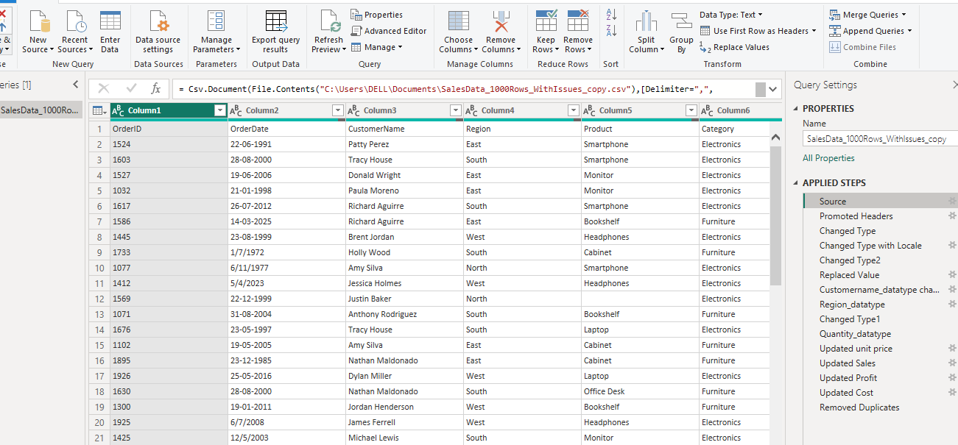

- Perform the necessary data cleaning steps to prepare it for analysis, including:
i) Handling missing values in columns.
Numeric Columns (UnitPrice, Sales, Cost, Profit): If UnitPrice/ Sales/ Cost/Profit is missing, add a Custom Column under Add Column tab using the formulas:
- Updated Unit Price= if [UnitPrice] = if [ Unit Price] = null then [Sales] / [Quantity] else [UnitPrice])
- Updated Sales= if [Sales]=null then [Quantity]*[UnitPrice] else [Sales])
- Updated Profit= if [Profit] = null then [Sales] - [Cost] else [Profit])
- Updated Cost= if [Cost] = null then [Sales]-[Profit]else [Cost])
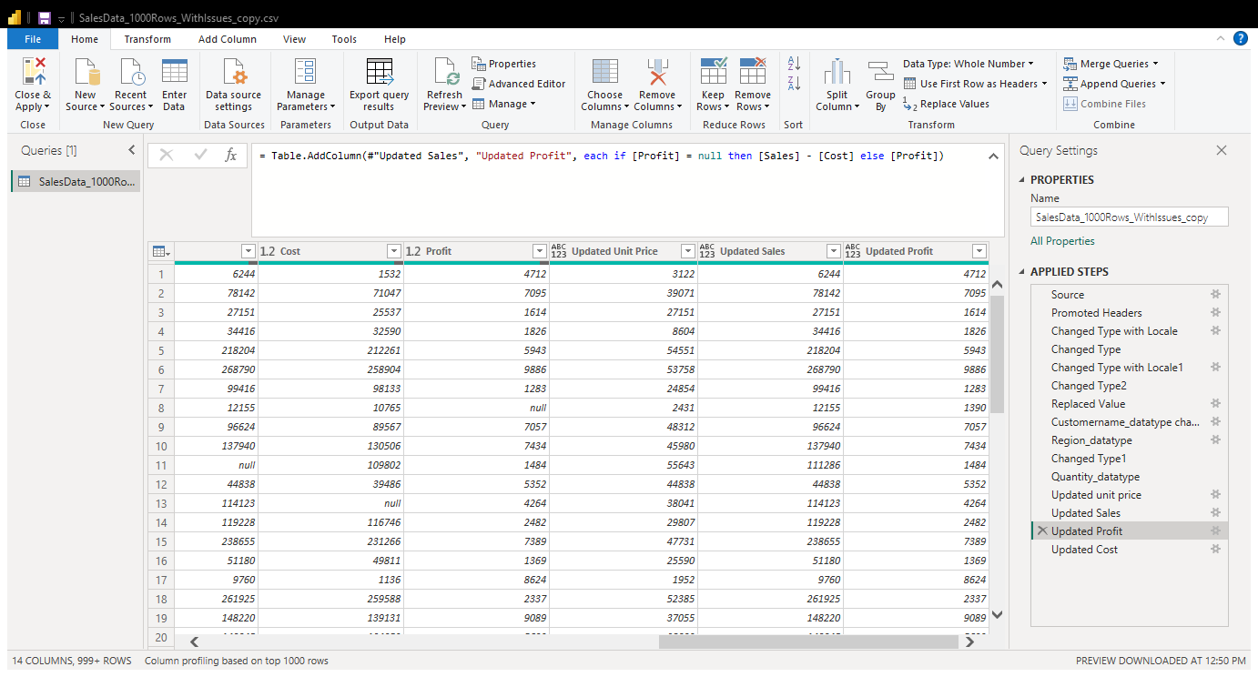
Pic : Handling missing values in columns.

ii) Removing duplicate rows.
iii) Standardizing the OrderDate column to a consistent date format.

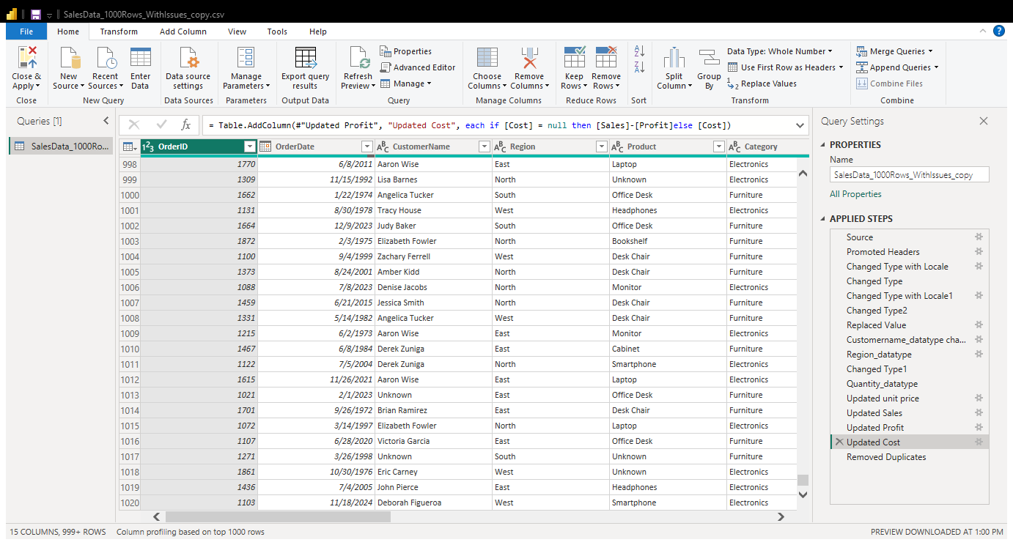Pic : Before removing duplicates with date
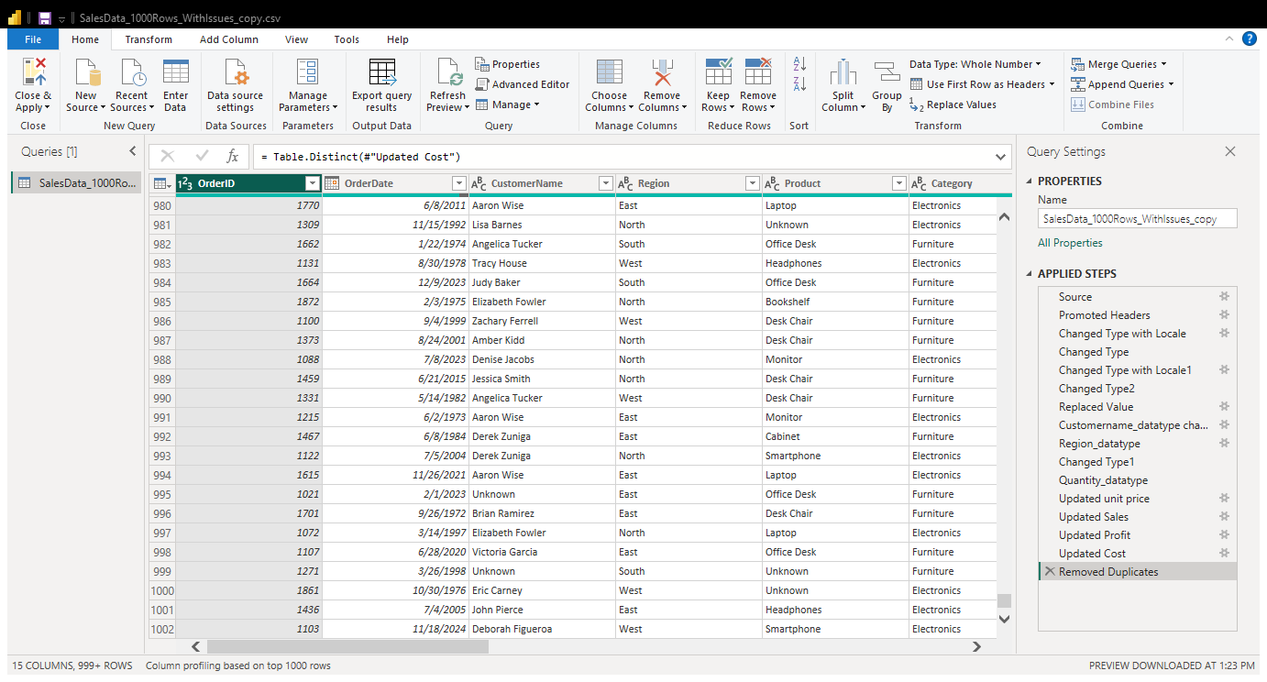
Pic: After removing duplicates with date

Visualizations and Insights
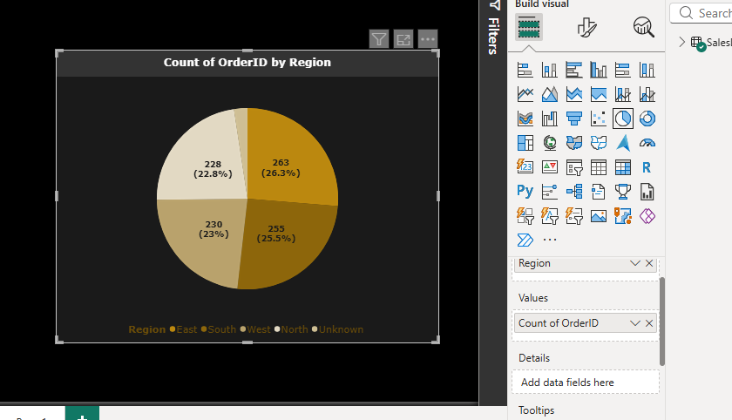
- Create a Pie Chart showing order distribution across different regions.
Pic : Pie chart- Count of orderID by Region

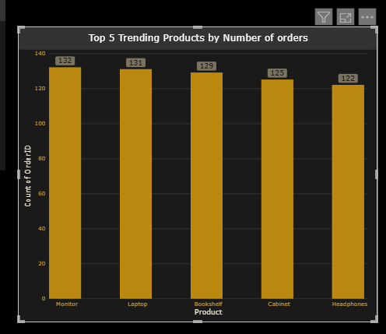
b) Create a Column Chart to display the top 5 trending products based on the number of times each product was ordered.

Pic: Column chart – Top 5 trending products by number of orders

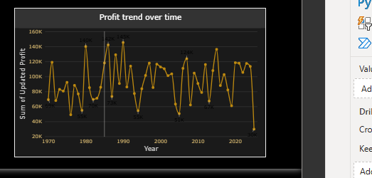
c) Create a Line Chart to show the profit trend over time.

DAX Calculations:
- Create a Calculated Table named EastRegionOrders that filters and displays only the orders from the East region.
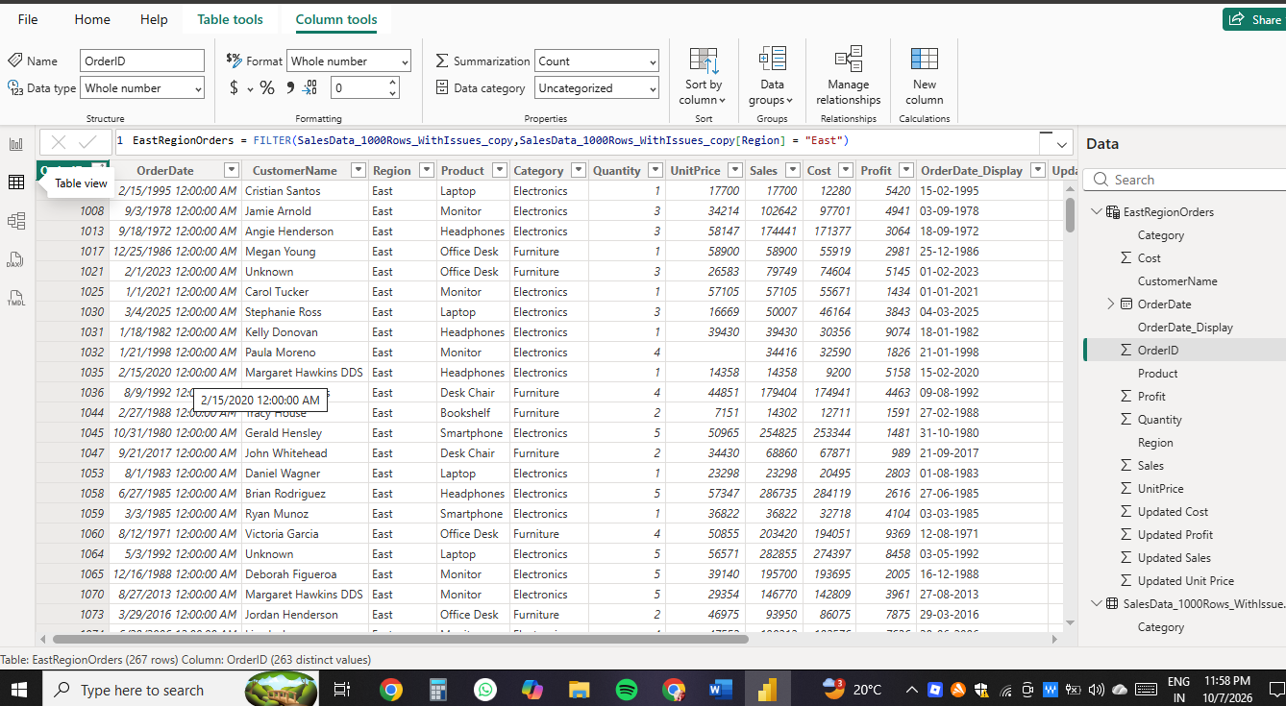
Pic : Table for East region orders

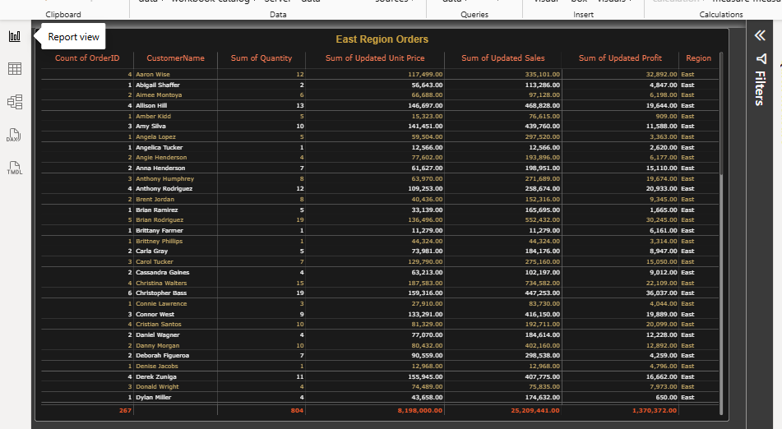
Pic : Table view in Power BI
- Create a Calculated Column to compute the difference between the Profit and Cost columns. Name it ProfitCostDifference.

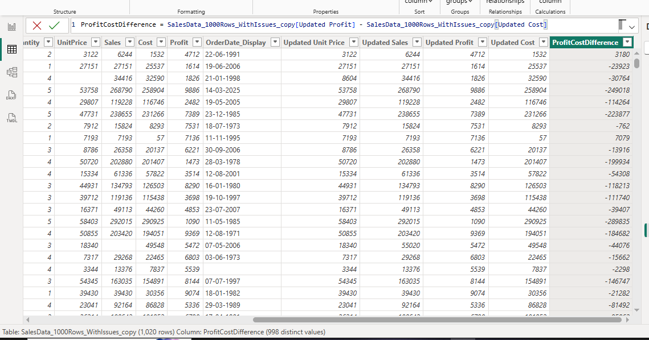

- Create a Calculated Measure to find the total profit earned. Name it TotalProfit.
TotalProfit = sum(SalesData_1000Rows_WithIssues_copy[Updated Profit])


This project analyzed customer sales data from SalesData_1000Rows_WithIssues_copy.csv using Power BI to evaluate revenue, costs, and regional order trends. Power Query was used to clean missing values, remove duplicates, and format dates. DAX logic was then applied to compute key metrics like total sales, costs, and profits, which were displayed in an interactive dashboard highlighting regional performance and top products

