Codeschool - bootstrap

3 basic components of a website

**Structure - html**

**Style - CSS**

**Behaviour - JS**

**Bootstrap**  is a framework which is simply a library of tools that assists us with style and behaviour of the page

## Container class

It adds the margin, and center the content

Applied to a div

## Container fluid class

Instead of margin, it adds a padding so that the content can stretch across the whole width of the page

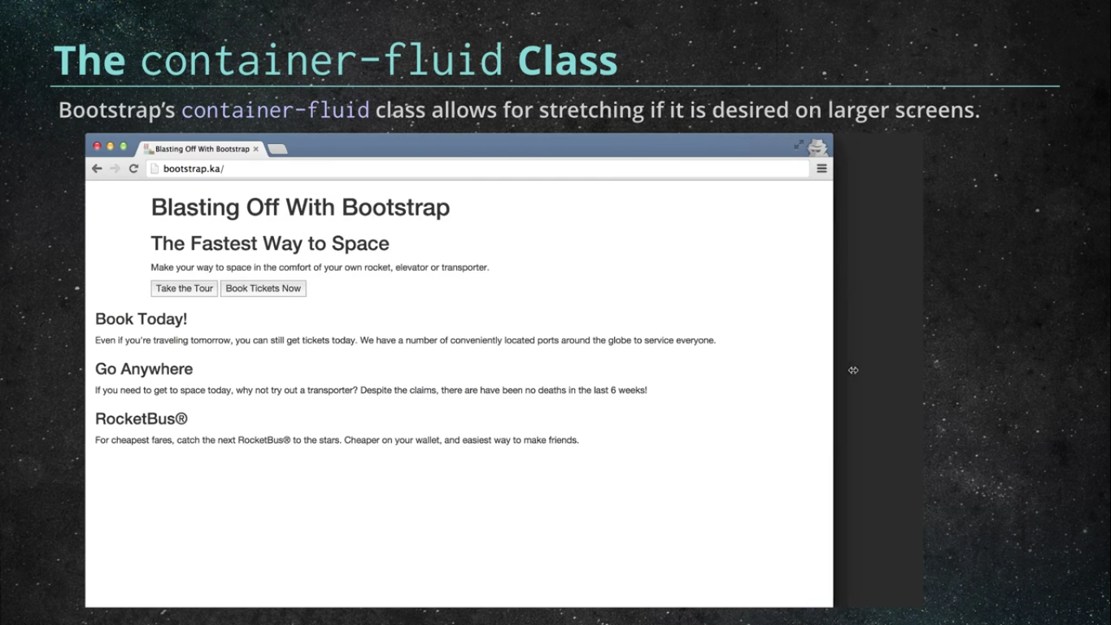

## The grid system:

It consists of rows and columns. The maximum number of columns for the largest viewport is 12.

As the viewport decreases in size, they adjust responsively.

Example:

<div class='container'>

<div class='row'> #columns resides inside of a row

<div class='col-lg-6'> # a div of size of 6 columns

col-lg-6

</div>

<div class='col-lg-6'> # a div of size of 6 columns

col-lg-6

</div>

</div>

</div>

### Column offsets:

Shifts the element to the right by a certain number of columns

<div class='col-lg-6 col-lg-offset-2'> # a div of size of 6 columns with an offset of 2

col-lg-6

</div>

### 

### 

### Nesting:

Defining the rows inside of column width maximum width of 12 columns

<div class='col-lg-6'> # a div of size of 6 columns with an offset of 2

Level -1

<div class=’row’>

<div class=’col-lg-6’>

Level -2

</div>

<div class=’col-lg-6’>

Level-2

</div>’

</div>’

</div>

### Viewport size definition:

Xs - smartphone

Sm - tablets

Md - medium sized desktops

Lg - large sized desktops

Defined in the class being used

col-lg -6 : large viewport size

Col-sm-6: small viewport size

Defines how the element appears at a particular viewport size and any above that breakpoint.

I.e. md is applicable for both medium and large and xs is applicable for all the viewport sizes unless overrided.

### Multiple configurations:

<div class=’col-sm-12 col-md-6’> # entire screen width for sm and half for the med

</div>

## Button classes:

* btn btn-default
* btn btn-primary
* Btn btn-info
* btn btn-warning
* btn btn-danger
* btn btn-success

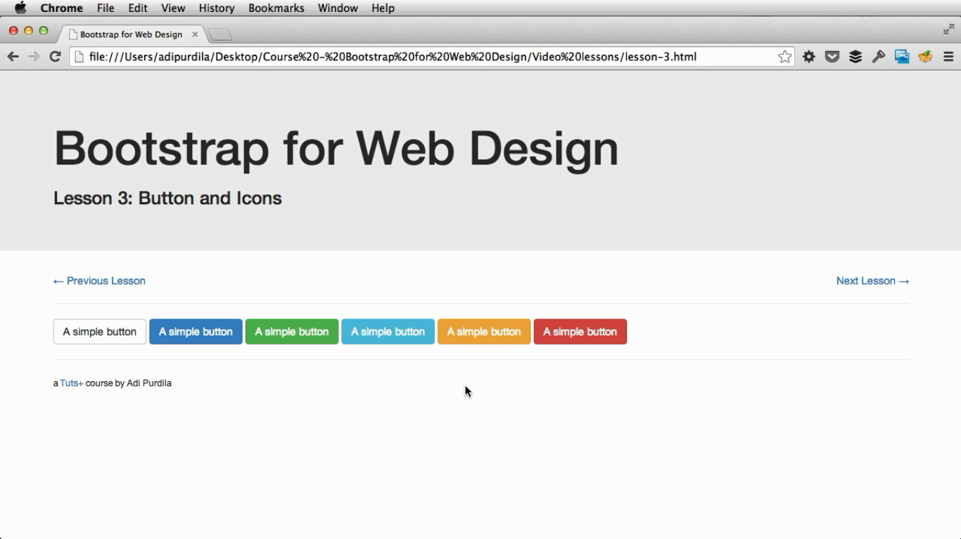

And for a link, that aligns perfectly:

**btn btn-link**

Syntax:

**<a href=’’ class=’btn btn-primary’> a Simple button</a>**

Sizes:

<a href=’’ class=’btn btn-primary **btn-lg**’> a Simple button</a>

<a href=’’ class=’btn btn-primary **btn-sm**’> a Simple button</a>

<a href=’’ class=’btn btn-primary **btn-xs**’> a Simple button</a>

Block - btn:

Spans the entire width of it’s parent

<a href=’’ class=’btn btn-primary **btn-block**’> a Simple button</a>

These classes can be applied to button, a, input type submit

## Glyphicons:

Added using span elements,

**<span class=’glyphicon glyphicon-search’></span>**

**or**

<button type="button" class="btn btn-default btn-lg">  
 <span class="glyphicon glyphicon-star" aria-hidden="true"></span> Star  
</button>

And the normal css is applicable,

<span class=’glyphicon glyphicon-search**’ style=’font-size:5em; color: red’**></span>

## Form control:

Example:

<form class=**"form-horizontal"**>  
 <div class="**form-group**">  
 <label for="inputEmail3" class="**col-sm-2 control-label**">Email</label>  
 **<div class="col-sm-10">**  
 <input type="email" class="**form-control**" id="inputEmail3" placeholder="Email">  
 </div>  
 </div>  
 <div class="**form-group**">  
 <label for="inputPassword3" class="col-sm-2 control-label">Password</label>  
 <div class="col-sm-10">  
 <input type="password" class="form-control" id="inputPassword3" placeholder="Password">  
 </div>  
 </div>  
 <div class="form-group">  
 <div class="col-sm-offset-2 col-sm-10">  
 **<div class="checkbox">  
 <label>  
 <input type="checkbox"> Remember me  
 </label>** </div>  
 </div>  
 </div>  
 <div class="form-group">  
 <div class="col-sm-offset-2 col-sm-10">  
 <button type="submit" class="btn btn-default">Sign in</button>  
 </div>  
 </div>  
</form>