INTERNSHIP REPORT
on
LEAP Coach — AI-Enhanced Learning Management System
Visit www.leapcoach.in

Submitted to
Indian Institute of Management Ahmedabad
(IIM Ahmedabad)

Under the guidance of
Prof. Vishal Gupta

Submitted by
Durgesh Verma
B.Tech Computer Engineering, 2nd Year
Institute of Infrastructure, Technology, Research and Management (IITRAM)

Internship Period: 26th May 2026 – 23rd July 2026

CERTIFICATE

This is to certify that Durgesh Verma, a student of B.Tech Computer Engineering (2nd Year) at the Institute of Infrastructure, Technology, Research and Management (IITRAM), Ahmedabad, has successfully completed the Summer Internship at Indian Institute of Management Ahmedabad (IIM Ahmedabad) during the period of 26th May 2026 to 23rd July 2026.

During the internship, they worked on the project titled "LEAP Coach — AI-Enhanced Learning Management System" under the guidance of Prof. Vishal Gupta. The project involved the design, development, and deployment of a full-stack web application serving as an AI-powered learning management system for leadership and executive coaching education, along with building LEAP AI, a semi-RAG-based approach powered by Gemini that enables context-aware learning and supports the student through each session.

During the internship, I studied and learned about Quantitative finance and Algorithmic trading, and the applied version of Probability and Statistics, in building Quant Strategies, using the resources of the Vikram Sarabhai Library along with PGP students.

Their work has been found satisfactory and is hereby approved for submission.

Prof. Vishal Gupta
Faculty, Organizational Behaviour Area
Indian Institute of Management Ahmedabad

ACKNOWLEDGEMENTS

I would like to express my sincere gratitude to all those who have supported me throughout this internship and made this project possible.
First and foremost, I extend my heartfelt thanks to Prof. Vishal Gupta, Indian Institute of Management Ahmedabad, for providing me with the opportunity to work on this project. Their vision for LEAP Coach and continuous guidance were instrumental in shaping the project from concept to deployment. Their mentorship helped me understand the intersection of technology and education in a practical, industry-relevant context.
I am grateful to the Indian Institute of Management Ahmedabad (IIM Ahmedabad) for hosting me as an intern and providing an enriching academic and professional environment that fostered learning and innovation.
I would also like to thank the Institute of Infrastructure, Technology, Research and Management (IITRAM), Ahmedabad, and the Department of Computer Engineering for encouraging students to pursue industry internships and for supporting my participation in this program.
Finally, I am thankful to my family and peers for their unwavering encouragement and support throughout the duration of this internship.

Durgesh Verma
B.Tech Computer Engineering, 2nd Year
IITRAM, Ahmedabad

TABLE OF CONTENTS

ACKNOWLEDGEMENTS 3
TABLE OF CONTENTS 4
1. INTRODUCTION 6
1.1 Background 6
1.2 Objective of the Internship 6
1.3 Scope of Work 6
2. ABOUT THE ORGANIZATION 8
2.1 Indian Institute of Management Ahmedabad 8
2.2 Project Mentor — Prof. Vishal Gupta 8
3. TECHNOLOGY STACK 9
3.1 Architecture Overview 9
4. APPLICATION FLOW & USER JOURNEY 11
4.1 User Registration & Authentication 11
4.2 Learner Dashboard 11
4.3 Course Catalog & Topic Details 12
4.4 Learning Player 13
4.5 Assignments & Credit System 13
5. ADMIN PANEL & CONTENT MANAGEMENT 16
5.1 Admin Modules 16
5.2 Sub-Admin Permission System 18
6. TELEGRAM CHATBOT INTEGRATION 19
6.1 Architecture 19
6.2 Features 19
7. DATABASE DESIGN 21
7.1 Key Tables 21
7.2 Row-Level Security (RLS) 21
8. SECURITY IMPLEMENTATION 23
8.1 API Security 23
8.3 Server-Only Guards 23
9. EMAIL & NOTIFICATION SYSTEM 25
9.1 Email Broadcasting 25
9.2 In-App Notifications 25
10. DEVELOPMENT METHODOLOGY & TIMELINE 26
10.1 Development Approach 26
10.2 Key Metrics 26
11. CHALLENGES & LEARNINGS 28
11.1 Technical Challenges 28
11.2 Key Learnings 28
12. CONCLUSION & FUTURE SCOPE 30
12.1 Conclusion 30
12.2 Future Scope 30

1. INTRODUCTION

1.1 Background
The education technology (EdTech) industry has experienced significant growth globally, driven by the increasing demand for accessible, high-quality learning experiences. Traditional education models are being transformed by digital platforms that leverage artificial intelligence, video streaming, and interactive content delivery to enhance the learning experience.
In this context, Prof. Vishal Gupta of IIM Ahmedabad envisioned LEAP Coach — a specialized AI-enhanced Learning Management System (LMS) designed to deliver leadership, executive coaching, and management education to three distinct learner personas: Students, Working Professionals, and Entrepreneurs. LEAP stands for "Leadership, Education, and Professional" growth, reflecting the platform's mission to scale human wisdom through technology.

1.2 Objective of the Internship
The primary objective of this internship was to design, develop, and deploy a production-ready, full-stack web application that serves as a comprehensive learning management system with the following goals:
• Build a responsive, mobile-friendly web application with an intuitive user interface
• Implement AI-powered tutoring using Google Gemini for contextual, transcript-grounded learning assistance
• Develop a comprehensive admin panel for content management, user management, and analytics
• Implement role-based access control and per-topic/category pricing with coupon support
• Build a Telegram chatbot for learner support and engagement
• Ensure security hardening with rate limiting, input validation, and HMAC-verified webhooks
• Deploy the application on Vercel for production use

1.3 Scope of Work
The internship spanned approximately 10 weeks (26th May 2026 to 23rd July 2026) and covered the entire software development lifecycle — from requirements gathering and architecture design through implementation, testing, security hardening, and deployment preparation. The project was built from scratch with no pre-existing codebase, resulting in over 19,800 lines of TypeScript code across 157 source files, 43+ pages, and 17 API route handlers.

3. TECHNOLOGY STACK
The application was built using a modern JavaScript/TypeScript stack chosen for performance, developer experience, and production readiness. The following table summarizes the key technologies used:

Category | Technology
Frontend Framework | Next.js 16 (App Router) with React 19
Language | TypeScript 5.6
Styling | Tailwind CSS 3, Framer Motion
Authentication | Clerk (Next.js SDK v6)
Database | Supabase (PostgreSQL) with Row-Level Security
AI Integration | Google Gemini 2.5 Flash (REST API)
Video Streaming | Mux Player (HLS, on-demand CDN)
Telegram Bot | grammY framework, long polling
Email | Resend (primary) + Gmail SMTP (fallback)
Charts & Analytics | Recharts 3
PDF Generation | jsPDF 4
Validation | Zod 4
Deployment | Vercel (serverless)
Version Control | Git + GitHub

The project uses a dual-mode architecture: a mock data layer (with seeded data) for rapid prototyping and demonstration, and a real Supabase + Clerk backend for production. The mode is automatically determined by the presence of environment variables, allowing seamless switching without code changes.

3.1 Architecture Overview
The application follows a modern serverless architecture pattern:
• Client Layer: React 19 components with server-side rendering (SSR) for SEO and performance. The App Router provides file-system-based routing with nested layouts.
• API Layer: 17 Next.js Route Handlers (serverless functions) handle payments, AI chat, email broadcasts, Telegram linking, admin operations, and webhook processing.
• State Management: A centralized React Context provider (AppProvider) manages all application state with localStorage persistence and automatic Supabase synchronization.
• Database Layer: Supabase PostgreSQL with 35 tables, comprehensive Row-Level Security policies, and server-side service-role access for privileged operations.
• External Services: Clerk (auth), Gemini (AI), Razorpay (payments), Mux (video), Resend/Gmail (email), Telegram Bot API.

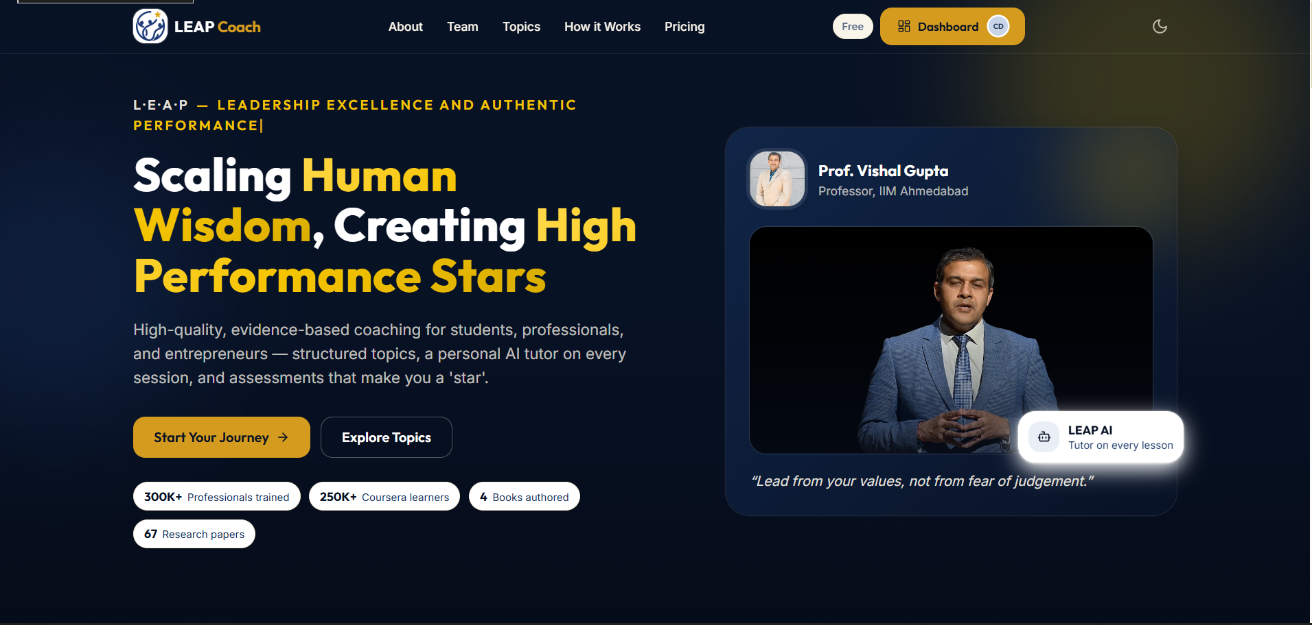
Figure 3.1: Landing Page

4. APPLICATION FLOW & USER JOURNEY

4.1 User Registration & Authentication
The application supports multiple authentication methods through Clerk: email/password sign-up, Google OAuth (SSO), and LinkedIn OAuth. Upon first sign-up, users are directed to a role selection page where they choose their persona — Student, Professional, or Entrepreneur. This role determines the content catalog, pricing, and announcements they receive. An admin login flow is separate, accessible via a dedicated /admin/login route.

4.2 Learner Dashboard
After authentication and role selection, learners land on a personalized dashboard that displays:
• A welcome message with the learner's name and their current plan badge (Free / Pro / Pro+ / Max)
• A "Continue Learning" section showing in-progress topics with completion percentages
• Credit score display with a badge tier indicator (Aspirant / Learner / Advanced / Star)
• Latest announcements and upcoming live sessions relevant to the learner's role
• Quick-access navigation to the course catalog, notifications, and account settings

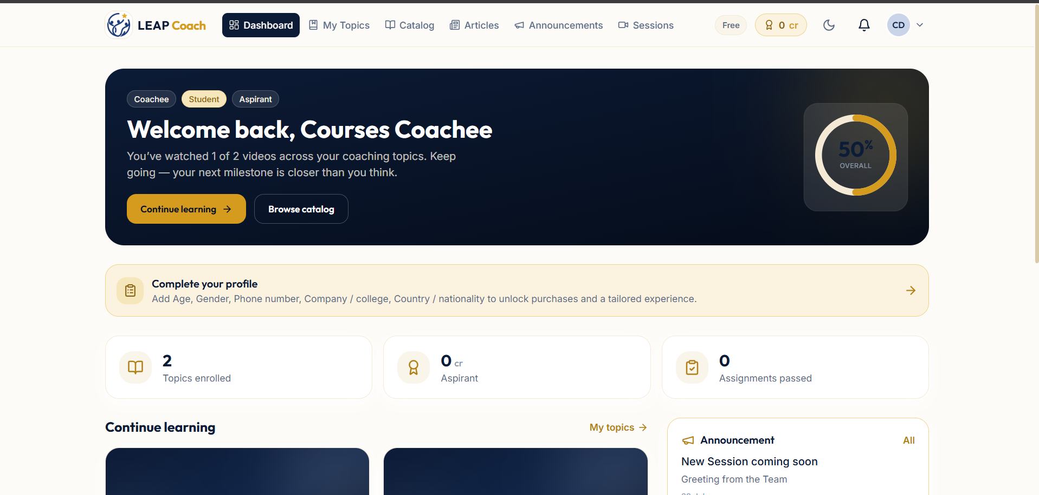
Figure 4.3: Learner Dashboard

4.3 Course Catalog & Topic Details
The catalog page displays all published coaching topics, filterable by category (Student / Professional / Entrepreneur). Each topic card shows the title, category tag, instructor, video count, and price. Clicking a topic opens its detail page featuring:
• Topic overview with a roadmap of all videos and assignments
• Prerequisites and learning outcomes
• Purchase/enrollment options with coupon code support
• Performance report card (after enrollment) showing completion percentage, quiz scores, and earned credits
• Access expiry information (1-year window from purchase date)
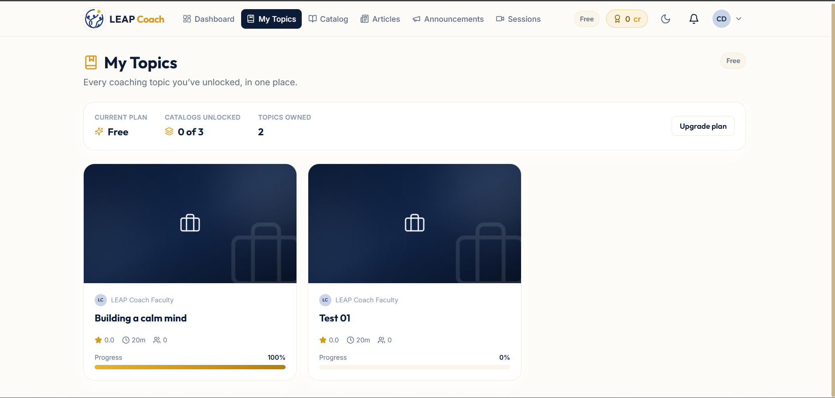
Figure 4.4: Course Catalog Page

4.4 Learning Player
The learn player is the core learning experience, consisting of four tabs:
• Video Player: Mux-powered HLS video streaming with progress tracking. Completion is marked automatically when a video finishes playing.
• LEAP AI Tutor: An AI chat interface powered by Google Gemini 2.5 Flash. The AI is grounded strictly in the video's transcript and provides contextual help with quick actions — Summarize, Quiz Me, and Go Deeper.
• Notes & Resources: Private note-taking per video with PDF export (jsPDF), downloadable resource links, and auto-generated transcript display.
• Discussion: Per-video discussion threads with @mentions and reply notifications.

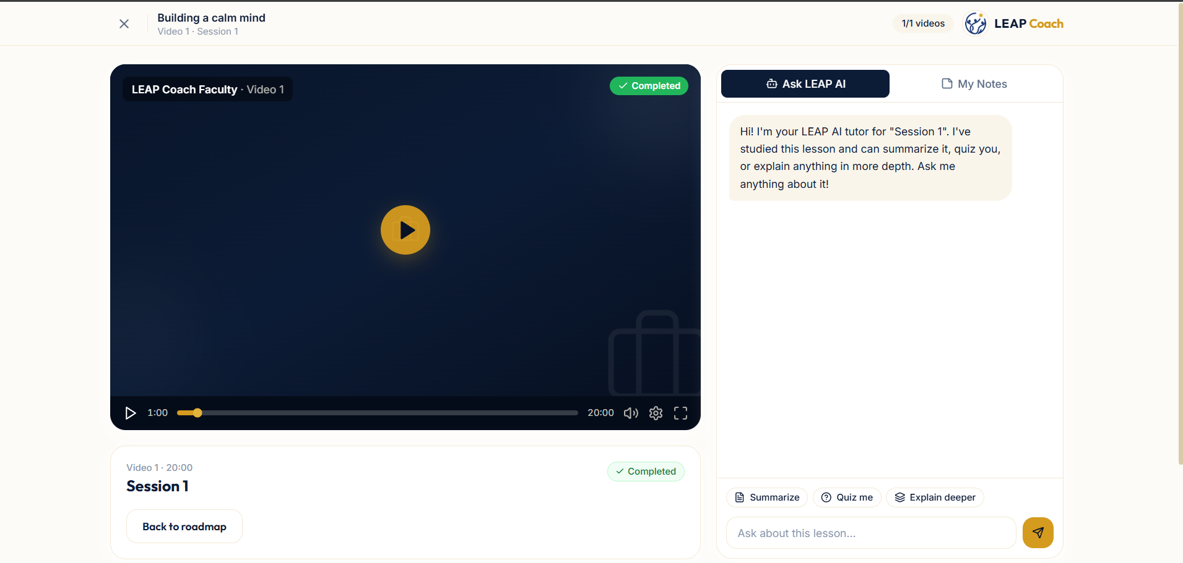
Figure 4.6: Learning Player — Video + AI Tutor

4.5 Assignments & Credit System
Each topic can have multiple assignments (checkpoints) consisting of multiple-choice questions. The credit system is per-topic and attempt-weighted:
• Questions are weighted by the attempt on which they were first answered correctly: 1st attempt = 1.0, 2nd = 0.7, 3rd = 0.4, 4th+ = 0
• A weighted percentage is calculated across all topic questions
• Credits are awarded on a ladder: >85% = 100 credits, >75% = 90, >65% = 80, and so on down to a floor of 40 credits for completion with 0% score
• Credits finalize only when a topic is fully completed (all videos watched + all checkpoints attempted)
• Badge tiers: Aspirant (0–500), Learner (501–1000), Advanced (1001–1999), Star (2000+)

5. ADMIN PANEL & CONTENT MANAGEMENT
The admin panel is a comprehensive content management and operations dashboard accessible only to authorized administrators. It features owner-level access control with delegatable sub-admin permissions.

5.1 Admin Modules
The admin panel consists of the following modules, each accessible via the admin navigation sidebar:
Module | Description
Overview | Dashboard with real course purchase activity feed and platform statistics
Content Studio | 7-step course creation wizard (details, videos with Mux IDs, assignments, questions, roadmap, preview, publish)
Question Bank | Centralized view of all assignment questions across topics
Analytics | Visual charts (Recharts) for enrollment trends, revenue, user demographics, and engagement
Users | User list with search, sort, detailed profiles, sub-admin management, ban/delete controls
Plans & Coupons | Editable pricing tiers, coupon CRUD (percentage, category, expiry, max redemptions)
Announcements | Role-targeted announcements with email broadcast, per-recipient delivery tracking, retry
Live Sessions | Schedule sessions with Google Meet links, instructor, role targeting, email invitations
Articles | Blog/resource articles with publish/archive workflow
FAQ | Reorderable FAQ management with publish toggle
Privacy Policy | Admin-editable privacy policy page
Homepage | Homepage content configuration
Team | Team member profiles displayed on the public /team page

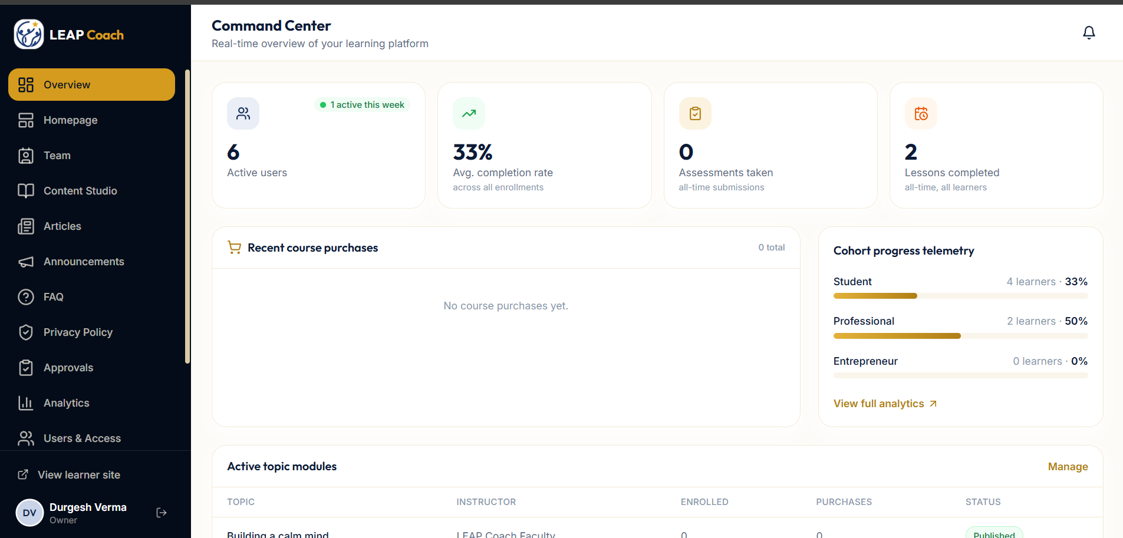
Figure 5.1: Admin Overview Dashboard

5.2 Sub-Admin Permission System
The platform supports a granular sub-admin permission system. The owner (primary administrator) can grant specific permissions to other users, such as content management, user management, announcements, sessions, articles, FAQ, homepage, and approvals. Sub-admin actions that modify privileged database columns (is_admin, permissions, banned) are routed through a server-side API endpoint using the Supabase service role, bypassing a PostgreSQL trigger that protects these columns from direct client writes.

6. TELEGRAM CHATBOT INTEGRATION
A standalone Telegram chatbot (@LeapCoachbot) was developed as an additional engagement channel for learners. The bot operates as a separate Node.js process alongside the main web application.

6.1 Architecture
• Built with the grammY framework using long polling (no public URL required)
• Reads learner data from Supabase via the service-role key (read-only over LMS data)
• Uses a separate Google Gemini API key for AI-powered responses
• Linked to individual learner accounts via a secure one-time token handshake

6.2 Features
• Pull-based Q&A: answers questions about announcements, live sessions, trending topics, FAQs, and pricing
• First-person persona: speaks as Prof. Vishal Gupta (warm mentor voice)
• Smart scoping: academic/coaching questions are redirected to the website; payment queries are directed to the support email
• Account commands: /start (link), /me (account snapshot), /help, /unlink
• Website integration: Account page shows a Telegram Connect card for linking/unlinking

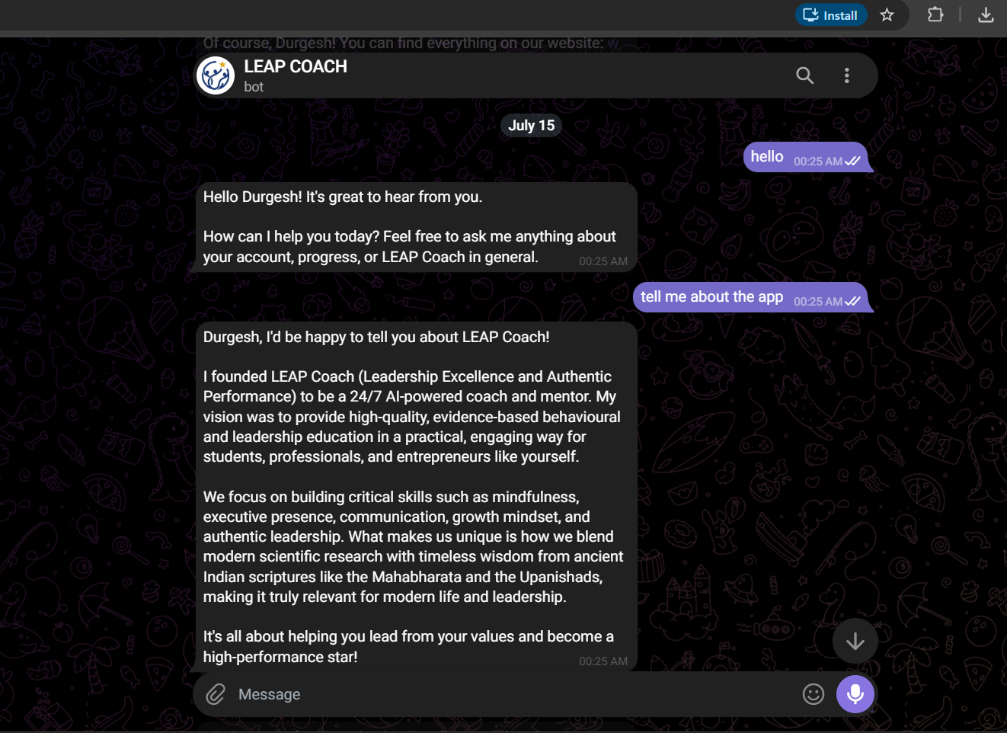
Figure 6.1: Telegram Bot Chat Interface

7. DATABASE DESIGN
The application uses Supabase (PostgreSQL) with a comprehensive schema of 35 tables organized into logical sections. The entire schema is maintained in a single, idempotent database.sql file that can be re-run safely.

7.1 Key Tables
Table Group | Tables & Purpose
Identity | profiles (user data, plan, credits, permissions), telegram_links, telegram_link_tokens
Content | courses, videos (with Mux playback IDs, transcripts), assignments, questions
Commerce | course_purchases, category_passes, payments, coupons, pricing_tiers
Learner | enrollments, video_progress, submissions, user_notes, notifications
Community | video_comments, comment_likes
CMS | announcements, live_sessions, articles, faqs, site_pages, team_members, site_content

7.2 Row-Level Security (RLS)
Every table has Row-Level Security enabled with carefully designed policies:
• Public read access for published content (courses, videos, articles, FAQs)
• Owner-only read/write for personal data (notes, progress, submissions)
• Admin-only access for management tables (coupons, pricing, team, announcements)
• Service-role bypass for server-side operations (payment grants, admin writes)
• A protect_privileged_cols trigger prevents client-side modification of is_admin, permissions, banned, subscription_plan, and subscription_valid_until columns
All RLS policies use the Supabase initplan optimization — wrapping auth.jwt() and is_admin() calls in (select ...) so they evaluate once per query rather than per row, significantly improving performance on large tables.

8. SECURITY IMPLEMENTATION
Security was treated as a first-class concern throughout the project. A comprehensive security hardening pass was conducted covering the OWASP Top 10 and platform-specific risks.

8.1 API Security
• Zod validation: Every API route validates input with Zod schemas, rejecting malformed requests with 400 responses
• Rate limiting: Sliding-window rate limiter on all 17 routes (tiered: AI 20/min, payment 12/min, admin 30/min, email 6/min) with 429 + Retry-After headers
• Authentication: All routes verify Clerk session tokens server-side; admin routes additionally check is_admin and specific permissions
• IDOR prevention: Actor identity is always derived from the session token, never from client-submitted data

8.3 Server-Only Guards
Critical server modules are protected with import "server-only" guards, ensuring they can never be accidentally imported into client-side bundles:
• lib/supabase/admin.ts (service-role client)
• lib/payments/server.ts, lib/payments/grant.ts (pricing logic, grant operations)
• lib/email/send.ts, lib/email/unsubscribe.ts (email infrastructure)
• lib/ai/config.ts (Gemini API key)

9. EMAIL & NOTIFICATION SYSTEM
The platform includes a multi-provider email broadcast system and a real opt-out mechanism compliant with email best practices.

9.1 Email Broadcasting
• Dual-provider architecture: Resend (batch API, primary) with Gmail SMTP fallback
• Per-recipient sending: Email addresses are never leaked between recipients
• Delivery tracking: Per-recipient delivery ledger stored as JSONB, showing delivered vs. pending
• Retry capability: Admin can retry emails to only those recipients who haven't received them yet
• Role-targeted: Announcements and live session invites are sent only to eligible learners matching the target role
• RFC 8058 compliant one-click unsubscribe with HMAC-tokenized unsubscribe links

9.2 In-App Notifications
A dedicated notifications page aggregates three sources: discussion reply/mention notifications (with deep links to the relevant video), upcoming live sessions, and recent announcements. The notification bell in the header shows an unread count badge.

10. DEVELOPMENT METHODOLOGY & TIMELINE

10.1 Development Approach
The project followed an iterative, prototype-first development methodology:
• Phase 1 (Week 1–2): Requirements analysis, architecture design, mock prototype with complete UI for all 43+ pages, seed data, and the full admin panel. The mock layer allowed the complete product to be demonstrated and validated before any backend integration.
• Phase 2 (Week 3–4): Supabase integration (database schema, RLS, auth), Clerk authentication, real Gemini AI tutor, Mux video player integration, and Razorpay payment gateway (test mode).
• Phase 3 (Week 5–6): Coupon system, category-bundle, course access expiry (1-year windows), community discussions, FAQ/privacy CMS, and the Telegram chatbot.
• Phase 4 (Week 7–8): Email broadcast system, notification infrastructure, learner profiles, admin user management hardening, per-topic credit system redesign, and UI polish.
• Phase 5 (Week 9–10): Security hardening (rate limiting, Zod validation, server-only guards, IDOR audit), Next.js 14→16 upgrade (React 19), payment workflow hardening (capture guarantee, refund sync, reconciliation), database consolidation, and production deployment.

10.2 Key Metrics
Metric | Value
Total Lines of Code | ~19,850 (TypeScript/TSX)
Source Files | 157
Pages / Routes | 43+ pages, 17 API routes
Database Tables | 35 with full RLS
Framework Versions | Next.js 16, React 19
External Integrations | 6 (Clerk, Supabase, Gemini, Razorpay, Mux, Telegram)
Development Duration | 9 weeks (26 May – 23 July 2026)
Build Status | All 53 routes compile clean
11. CHALLENGES & LEARNINGS

11.1 Technical Challenges
• Next.js 14 to 16 Migration: Upgrading across two major versions (14→15→16) with React 18→19 required careful handling of the async params breaking change, middleware→proxy file rename, and dependency compatibility checks for Clerk, Recharts, and jsPDF.
• Supabase RLS + Client Writes: Privileged database columns (is_admin, permissions, banned, subscription_plan) are protected by a PostgreSQL trigger, which silently no-ops client-side writes. This required routing all admin operations through server-side API endpoints using the service role.
• Payment Edge Cases: Handling the gap between payment authorization and capture, preventing double purchases, syncing external refunds, and building a reconciliation system for missed webhook grants required deep understanding of payment lifecycle.
• Git History Rewrite: A 35 MB video file embedded in git history caused persistent push failures. Resolving this required git-filter-repo to rewrite history and reduce the pack size from 36 MB to 1.7 MB.
• Dual Dev Server Conflicts: Running two Next.js dev servers sharing the same .next directory caused chunk-load errors and stale build artifacts — a subtle issue that manifested as random page reload failures.

11.2 Key Learnings
• Full-stack ownership: Gained end-to-end experience from database schema design to UI implementation to deployment configuration
• Security-first development: Learned to implement rate limiting, HMAC verification, server-only guards, and IDOR prevention as integral parts of feature development
• AI integration patterns: Implemented grounded AI tutoring with transcript context, preventing hallucination by constraining the model to lesson-specific content
• Production hardening: Experienced the difference between a working prototype and production-ready software — handling edge cases, failure modes, and concurrent access
• Working with a domain expert: Collaborated with a non-technical stakeholder (Prof. Gupta) to translate educational requirements into technical features
12. CONCLUSION & FUTURE SCOPE

12.1 Conclusion
This internship at IIM Ahmedabad provided an exceptional opportunity to build a production-grade, AI-enhanced learning management system from the ground up. Over the course of 10 weeks, the LEAP Coach platform evolved from a conceptual product requirement document to a fully functional web application with 43+ pages, 17 API endpoints, 35 database tables, a Telegram chatbot, and integrations with six external services.
The project demonstrated that modern web technologies — particularly the Next.js App Router, Supabase, and serverless deployment — enable a single developer to build and ship a feature-rich, secure, and performant application in a compressed timeline. The mock-first approach proved especially valuable, allowing the complete product to be validated with the stakeholder before investing in backend integration.
The experience of working at IIM Ahmedabad, under the mentorship of Prof. Vishal Gupta, was invaluable. It provided exposure to the intersection of technology and education, reinforcing the belief that thoughtfully designed software can meaningfully scale access to high-quality learning.

12.2 Future Scope
• Certificate generation: Automated PDF certificates upon topic completion with verifiable QR codes
• Advanced analytics: Learner engagement heatmaps, cohort analysis, and predictive dropout alerts
• Mobile application: React Native companion app for offline video access and push notifications
• Multi-language support: Hindi and regional language translations for broader reach
• Redis rate limiting: Replace the in-memory rate limiter with Upstash Redis for multi-instance consistency
• AI improvements: Personalized learning path recommendations based on learner progress and quiz performance
• Live class integration: Real-time video classes with attendance tracking (beyond Google Meet links)

— End of Report —

