LEAP Coach — Work Report
Summary of changes made to the LEAP Coach platform: a real idea of the day, leaderboard, stamps and credits; topic-wide video thumbnails; cross-device video resume; faster page loading; and interactive About and Pricing pages.

1. Idea of the Day
- Admins and sub-admins plan 3–5 ideas at a time from a new Admin → Idea of the Day page; each goes on the next free date.
- The learner dashboard switches to the new idea automatically at the learner's midnight. When the schedule runs out, earlier ideas rotate so the card is never empty.
- Each learner's answer is saved, and after answering they see how everyone else answered.
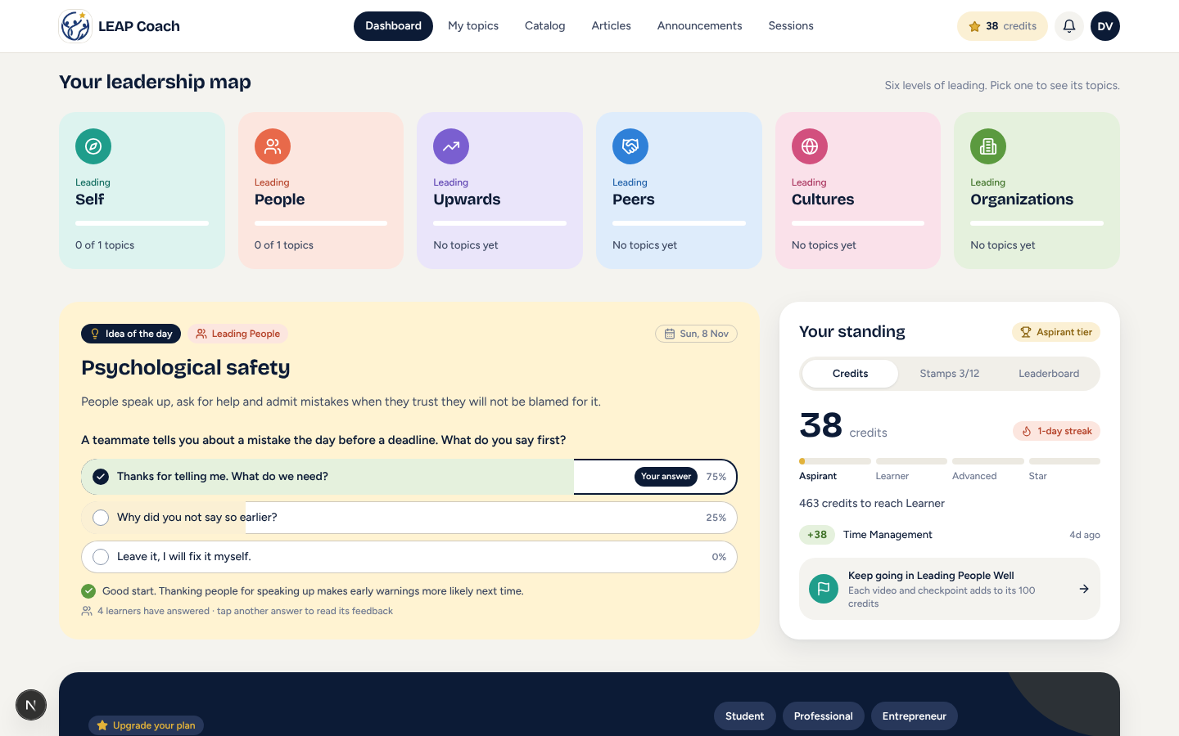
Learner dashboard: idea of the day with saved answer and class results
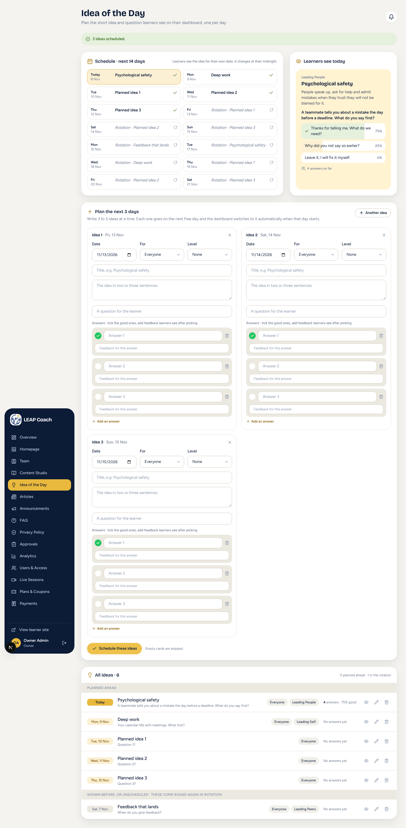
Admin planner: 14-day schedule, today's preview and all ideas

2. Leaderboard, Stamps and Credits
- Credits are now calculated by the database (learners can no longer edit their own number) and grow as the learner progresses through a topic, up to 100 per topic, weighted by checkpoint performance.
- A real leaderboard ranks learners this month or all time, within their path or across everyone.
- 12 stamps (first video, perfect score, 7-day streak, etc.) are awarded by the database with the date earned and shown on public profiles.
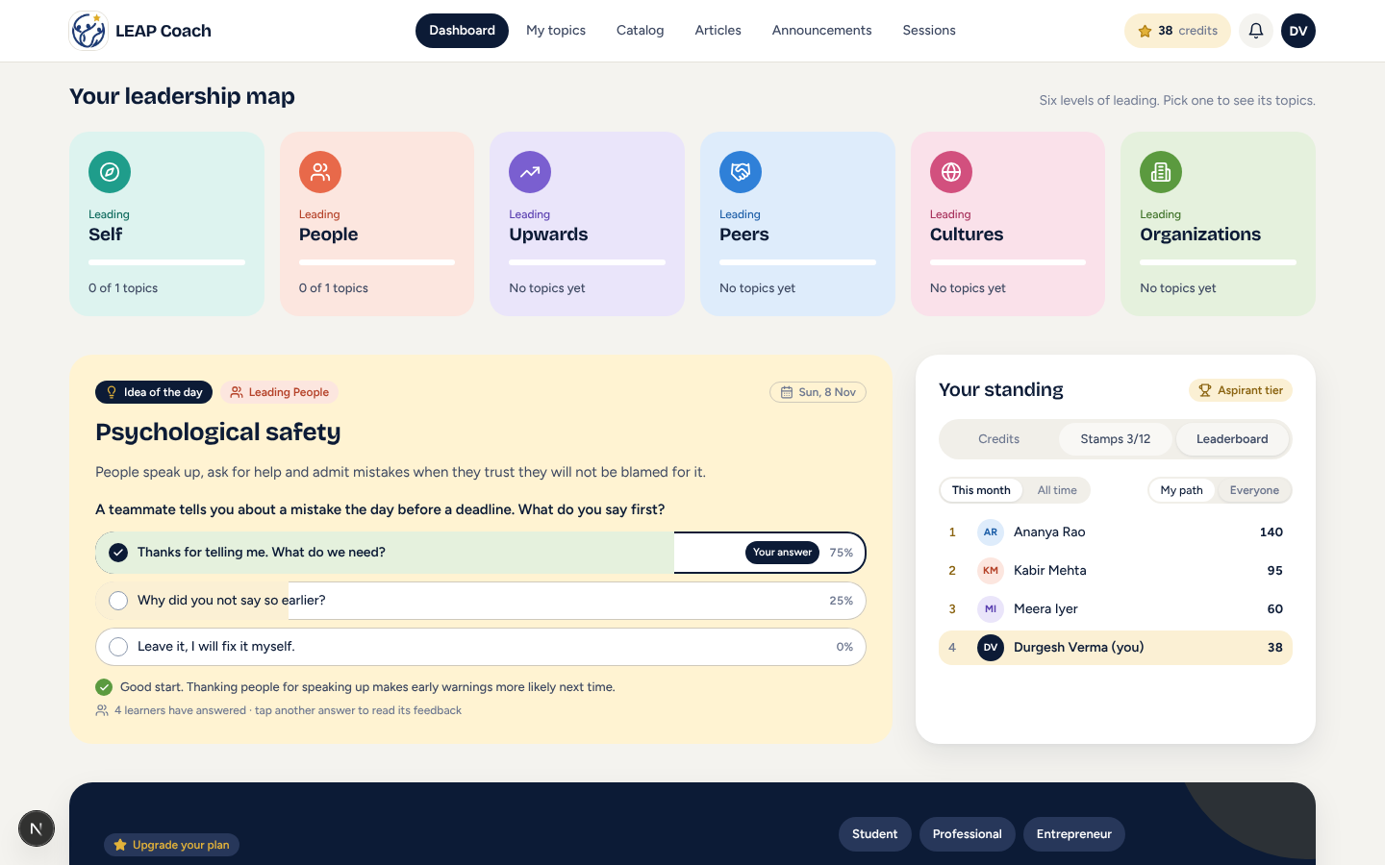
Real leaderboard
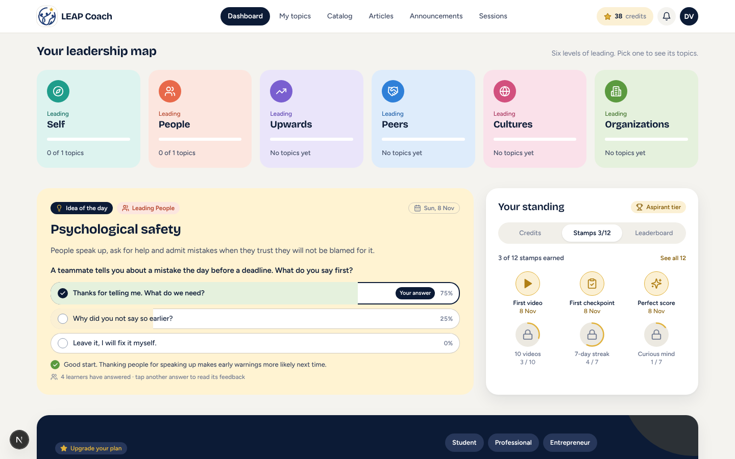
Stamps with progress and earned dates

3. Video Thumbnail for a Whole Topic
- Admins upload one thumbnail in the topic editor's Sessions step; it appears on every video in that topic and in the 'Up next' list.
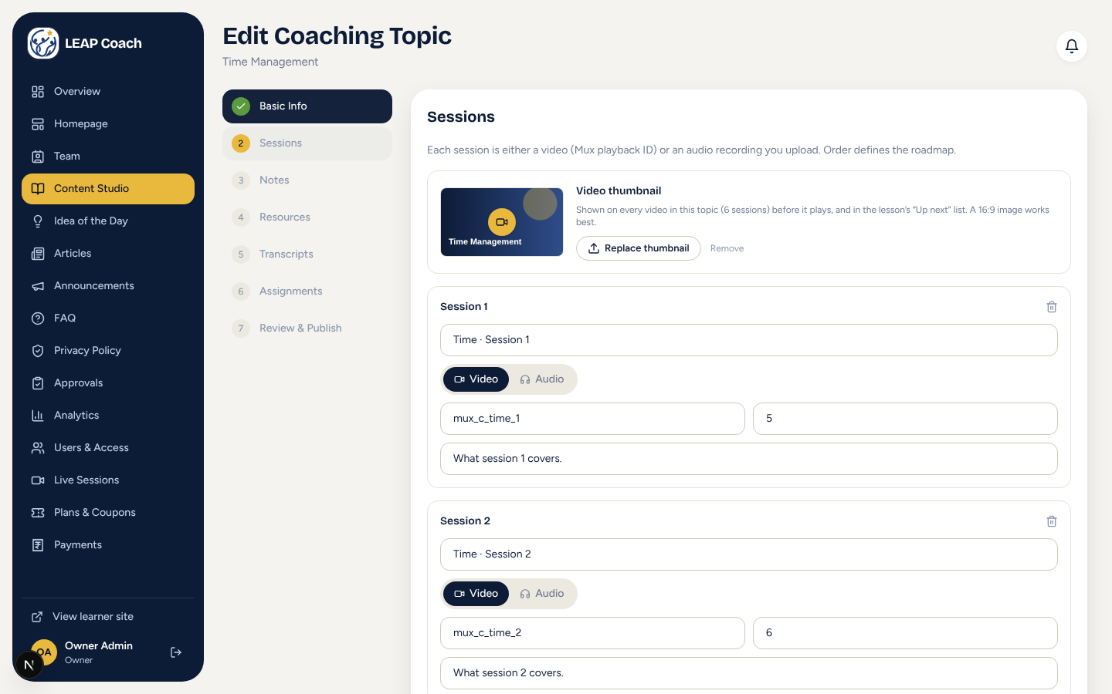
Thumbnail upload in the topic editor
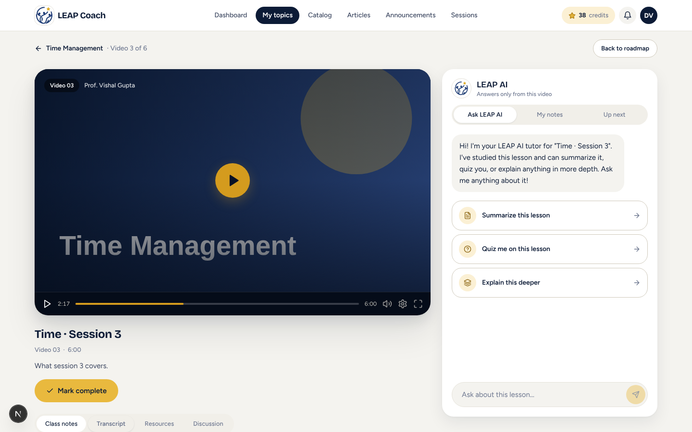
Thumbnail shown on the lesson player

4. Resume Where You Left Off
- The video position is saved to the database (every 20 seconds, on pause and when leaving), so it follows the learner to any device.
- The dashboard shows the topic touched most recently first, even when the learner switched between topics, with a 'Resume at m:ss' button.
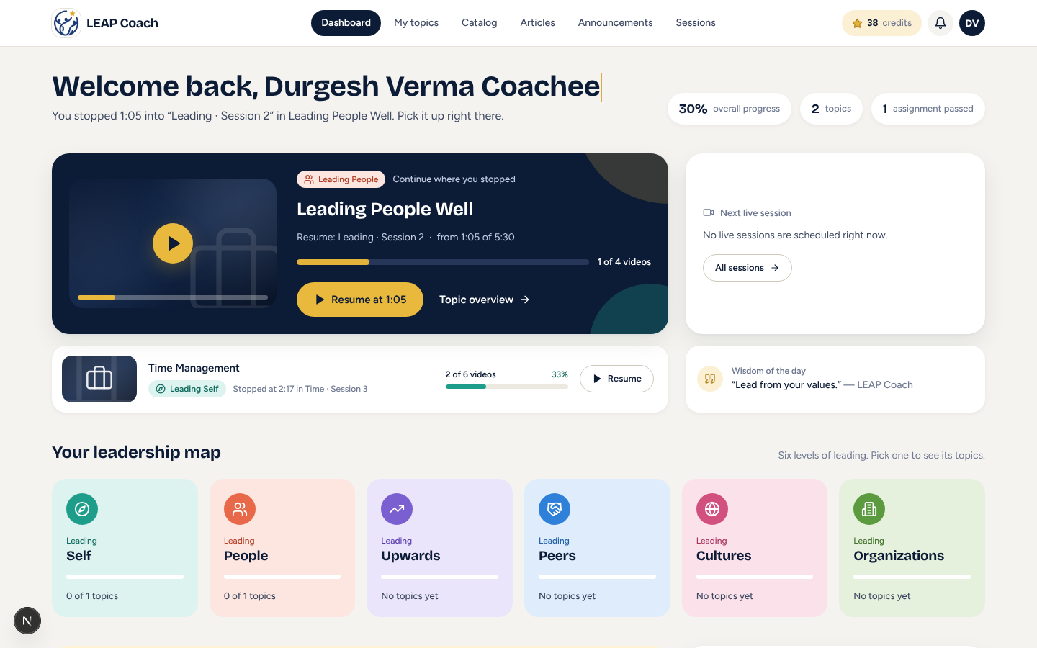
Dashboard resumes the most recent topic at the exact second
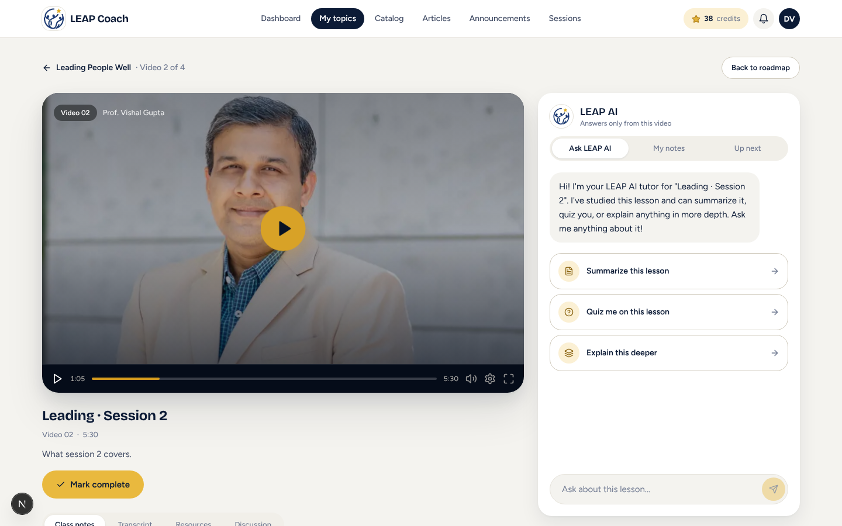
Player opens at the saved position

5. Faster Loading
- Visitors load only public content; learners load only their own data plus shared content; admins load lighter versions of large tables.
- Transcripts, comments and other users' profiles are fetched only when a screen needs them. In-browser lookups now use indexes instead of repeated full scans.

6. Interactive About and Pricing Pages
- About: clickable L·E·A·P letters, coaching domains and learner journeys, animated statistics and scroll animations.
- Pricing: animated prices with savings, a plan finder comparing per-topic and category passes, a plan comparison table and an FAQ accordion.
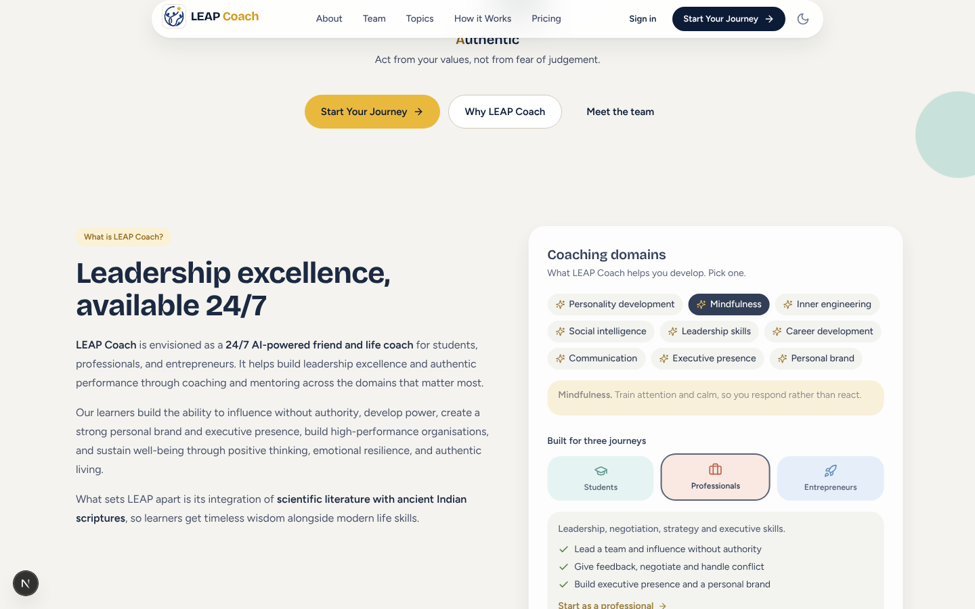
Interactive About page
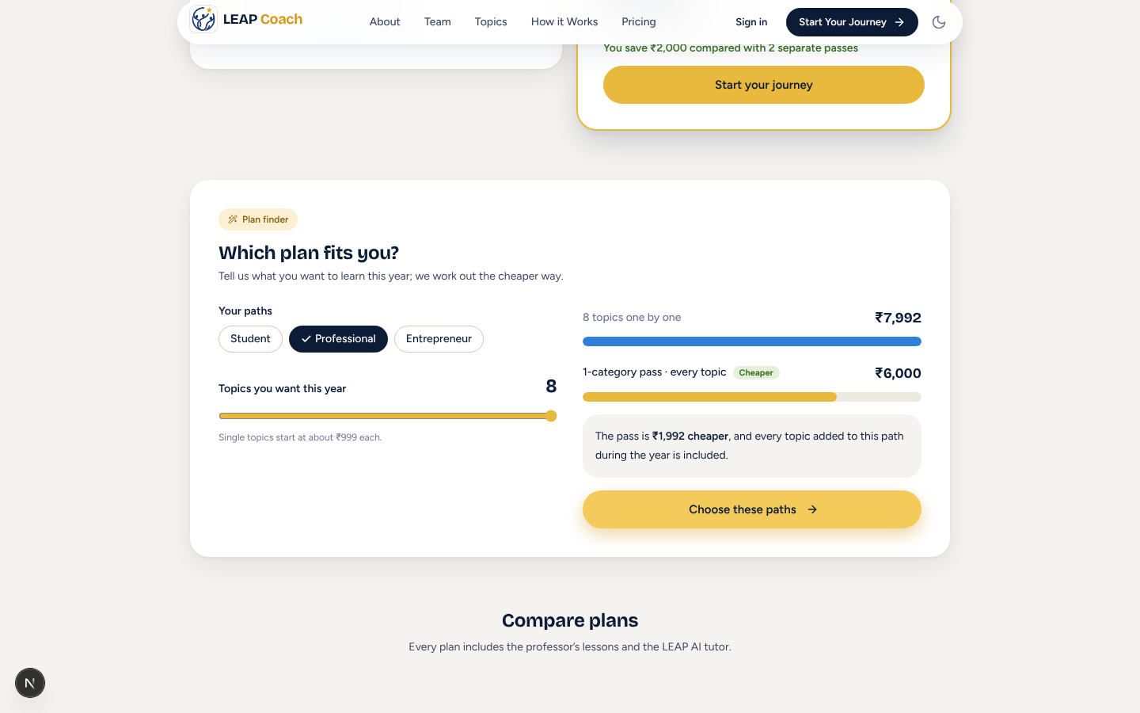
Pricing plan finder
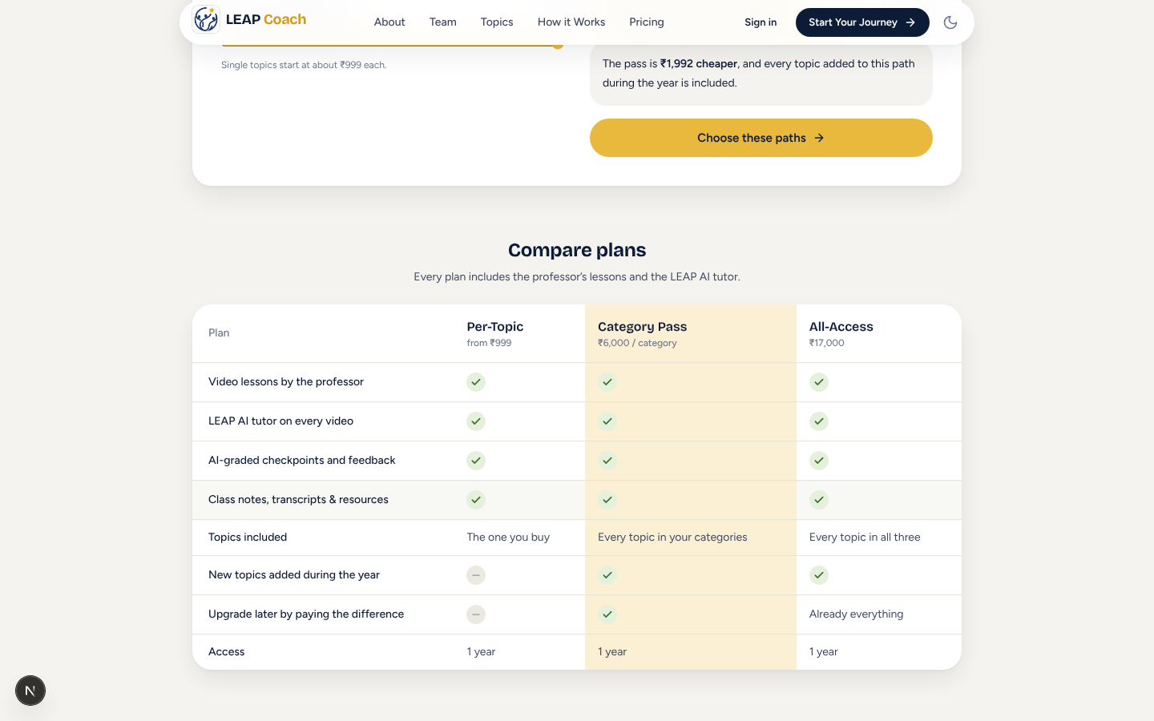
Plan comparison table

Testing
Database changes were tested on PostgreSQL 16 (fresh install, upgrade and access rules for learners, admins and visitors). The app passed 21 automated browser checks and a production build.

