**PRACTICAL QUESTIONS- 10** DEC **2020**

***Submitted By-Sakshi***

***Roll No- 88001***

Q1.To demonstrate the results of logical expressions.

Program

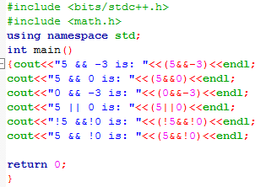

Output

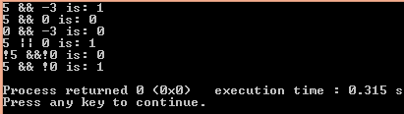

Q.2 To demonstrate the results of relational expressions.

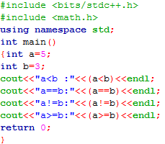

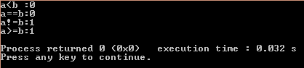

Q.2 WAP to display the grade of a student when she enters her marks.

Program

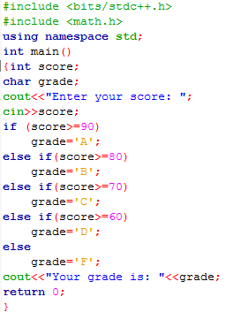

Output

Screenshot (434).png

Q.4 WAP to calculate charges of parking lot.

Program

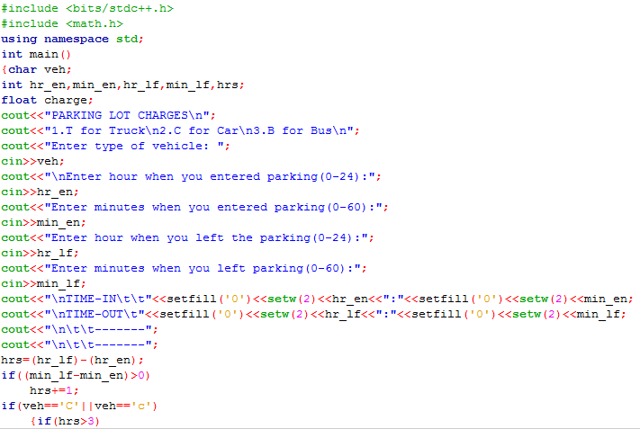

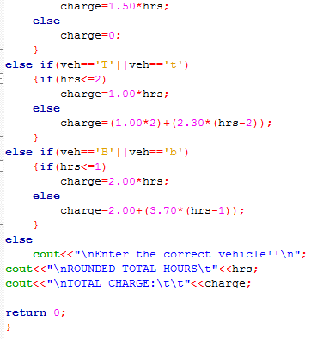

Output

Let’s check out our program through various input and outputs

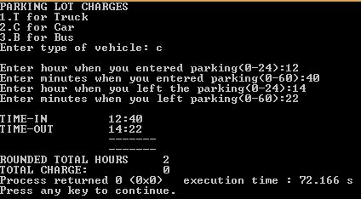

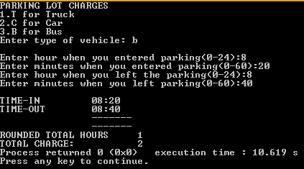

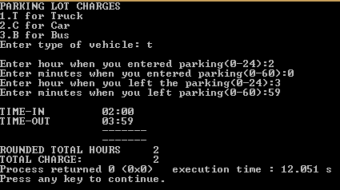

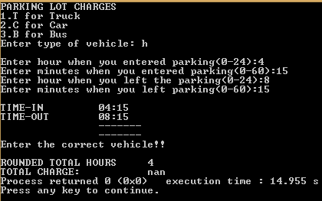

====+===+===+END+===+===+===