Consul UI

The landing page shows the services lists. Services are autometically registered with the consule by consule agent when @EnableDiscoveryClient annotatio is present in the main class and properties related to the consul is present in application.properties file.

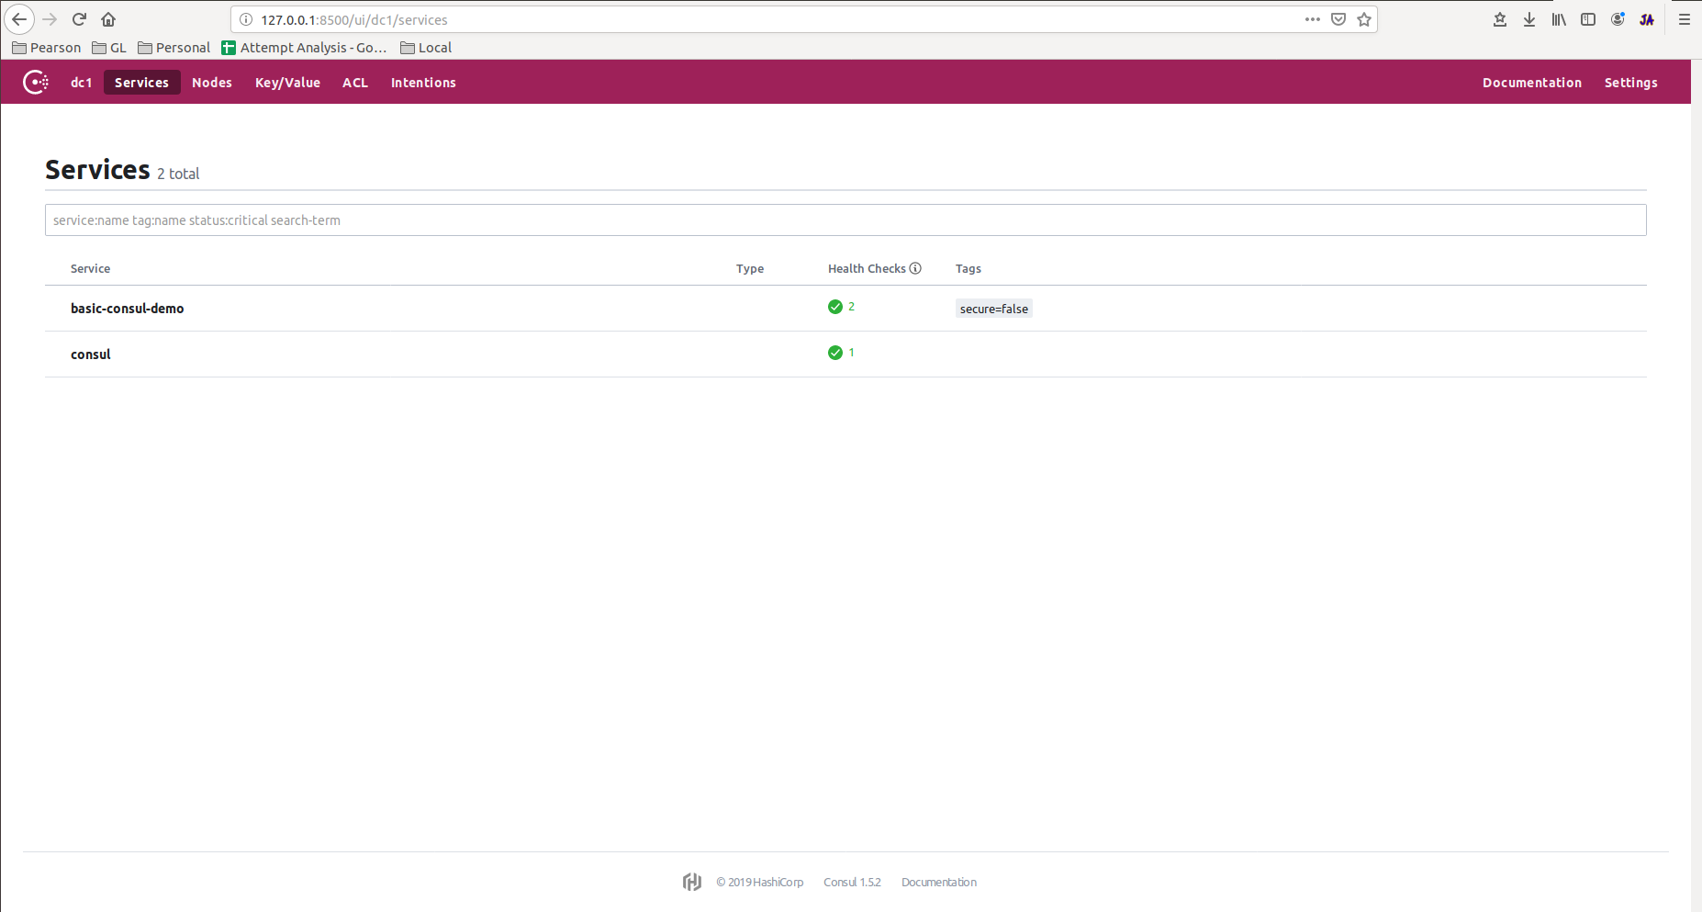

This is the agent self status.

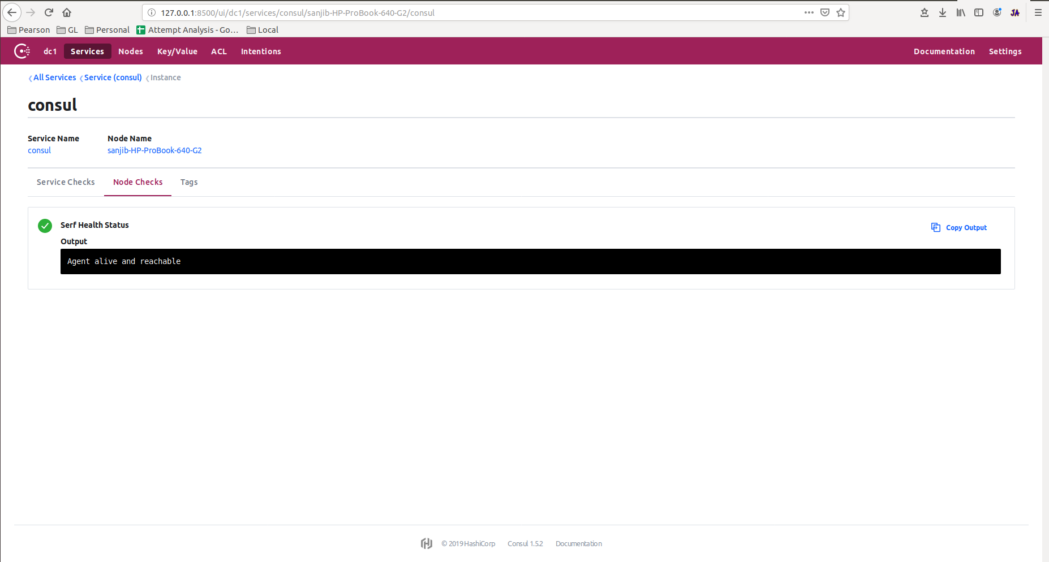

This is showing the status of health api, as well as displaying how services api is calling with their id instead of ip address, like “basic-consul-demo-8080”.

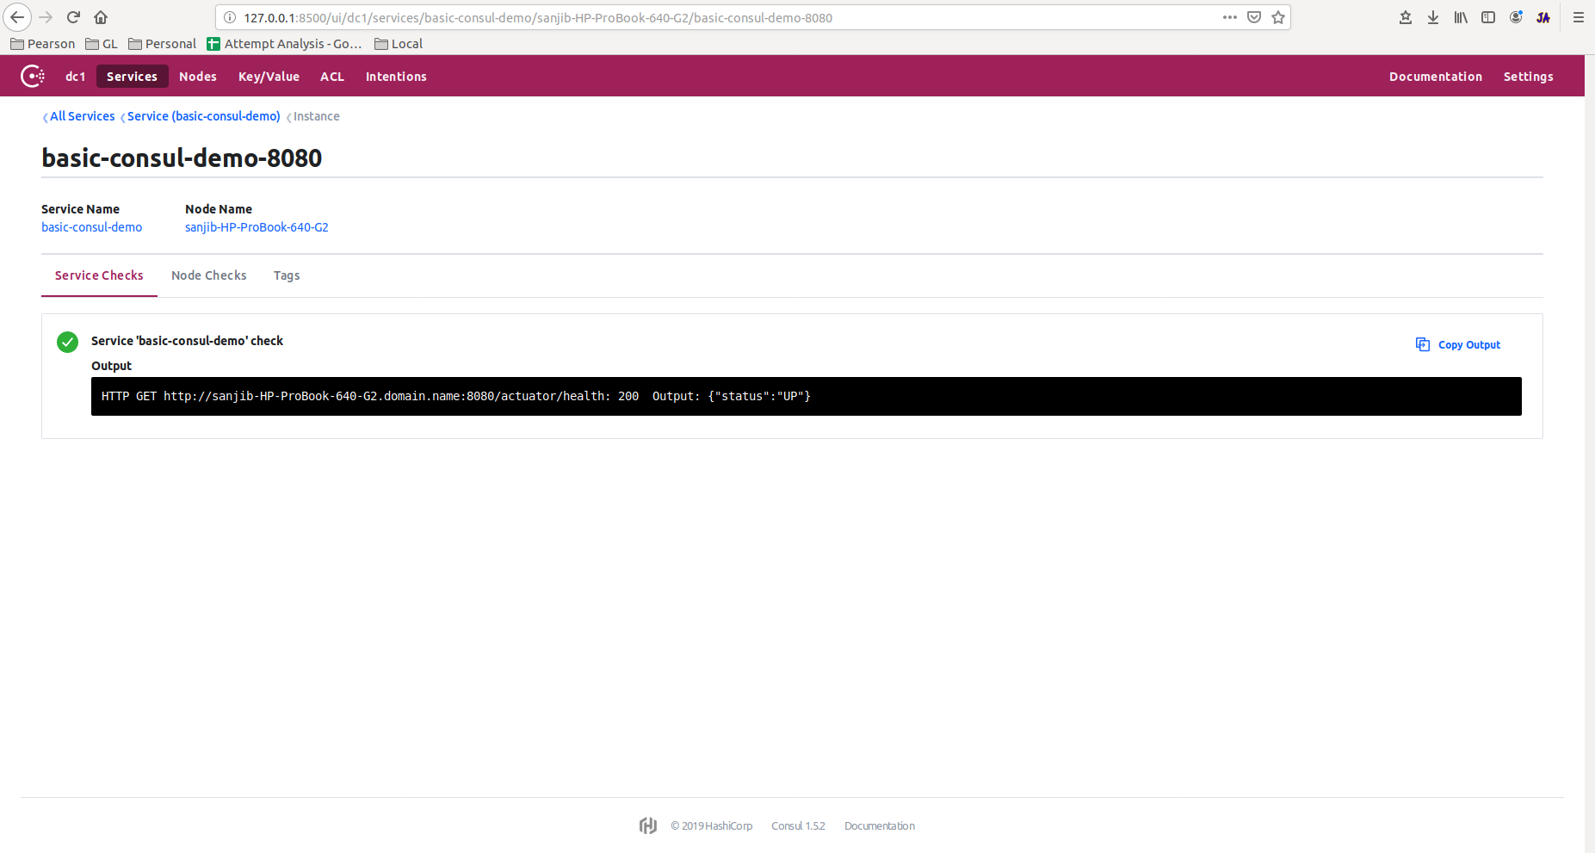

This is showing the node status of the service.

