SCHOOL MANAGEMENT
SYSTEM
Python • Object-Oriented • File-Driven
━━━━━━━━━━━━━━━━━━━━━━━━━━━━━━━━
UNIT 2 PROJECT DOCUMENTATION
Sara Alshmmari

Prepared from the final implemented system, UML design, and executed test evidence.

Table of Contents
Click any section title to jump directly to that section.
1. Executive Summary
2. Objectives and Requirement Coverage
3. System Architecture and Modules
4. UML Design
4.1 Use Case Diagram
4.2 Activity Diagram
4.3 Class Diagram
5. Data Model and Persistence
6. Core Implementation
7. Menu and User Flow
8. Testing and Results
9. Requirements Traceability
10. Conclusion and Future Improvements
Appendix A. Test Evidence Screenshots

1. Executive Summary Back to Contents
School Management System is a menu-driven Python application developed to demonstrate the full set of Unit 2 skills in one working project. The solution combines object-oriented programming, collections, modular code, file persistence, validation, exception handling, and error logging.
- The system manages Students, Courses, Teachers, and the School as the central manager.
- Students can be enrolled in or removed from courses, with both sides of the relationship updated together.
- Data is loaded automatically from JSON files at startup and saved before exit.
- Expected errors are caught without crashing the application and are recorded in logs.txt.
- The implementation is intentionally simple and explainable, matching the project guide’s instruction to use OOP naturally and avoid overengineering.
Final project status: FUNCTIONALLY TESTED AND READY FOR SUBMISSION

2. Objectives and Requirement Coverage Back to Contents
The project was built around the Unit 2 Project Guide. The final solution covers the required building blocks and final readiness criteria as follows:
Requirement | How the Project Meets It
Classes and objects | Student, Course, Teacher, and School are implemented as separate classes.
Collections | Dictionaries store school records by ID/code; lists store course enrollment relationships.
Reusable modules | main.py, student.py, course.py, teacher.py, and school.py separate responsibilities.
Persistent files | students.json, courses.json, and teachers.json preserve data between runs.
Validation | The system checks invalid age/name data, duplicate IDs/codes, missing records, and duplicate enrollment.
Exception handling | ValueError, FileNotFoundError, JSONDecodeError, and KeyError are handled safely.
Logging | Handled errors are appended to logs.txt.
Menu-driven interface | The menu repeats until the user chooses Exit.

3. System Architecture and Modules Back to Contents
The implementation uses a small modular structure. Each Python file has one clear responsibility, while School acts as the central manager that coordinates the model objects and persistent files.
Final project structure
school_managment_system/
├── main.py
├── school.py
├── student.py
├── course.py
├── teacher.py
├── students.json
├── courses.json
├── teachers.json
└── logs.txt

Module / File | Responsibility | Key Interactions
main.py | Text-menu interface and user input | Creates School, loads data, calls operations, catches ValueError, saves on Exit.
school.py | Central business logic and persistence | Stores dictionaries; enrollment/drop logic; JSON save/load; error logging.
student.py | Student model | Validates student data; stores enrolled course codes; enroll/drop/display methods.
course.py | Course model | Stores course data and student IDs; add/remove/display methods.
teacher.py | Teacher model | Stores teacher ID, name, and subject taught.
*.json | Persistent application data | Loaded at startup and overwritten with current state on Save and Exit.
logs.txt | Error audit trail | Receives validation and file-related error messages.

4. UML Design Back to Contents
The following UML overview summarizes the system from three perspectives: user interaction (Use Case), control flow (Activity), and object structure (Class). The diagrams are intentionally aligned with the implemented code rather than introducing unimplemented features.
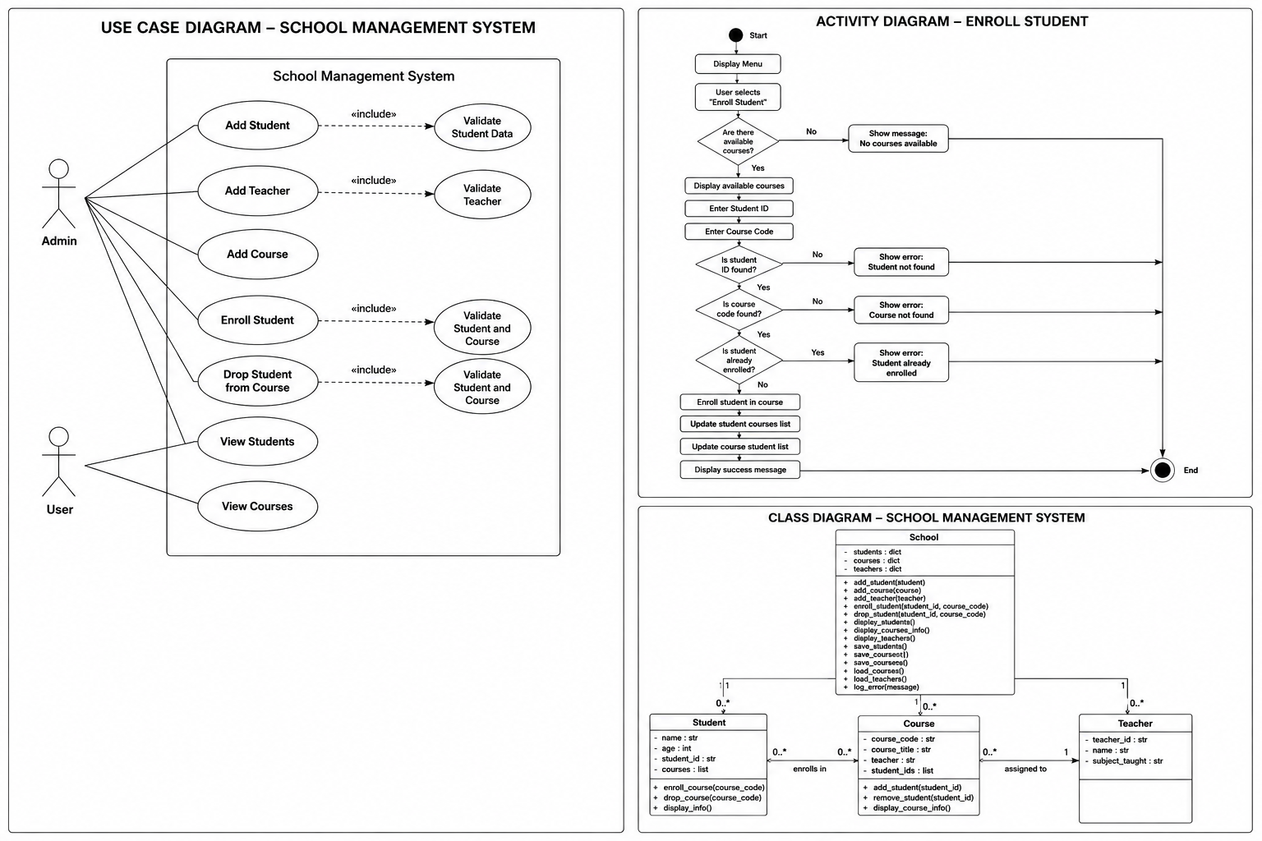
Figure 1. Consolidated UML overview: Use Case, Enroll Student Activity, and Class Diagram.

4.1 Use Case Diagram Back to Contents
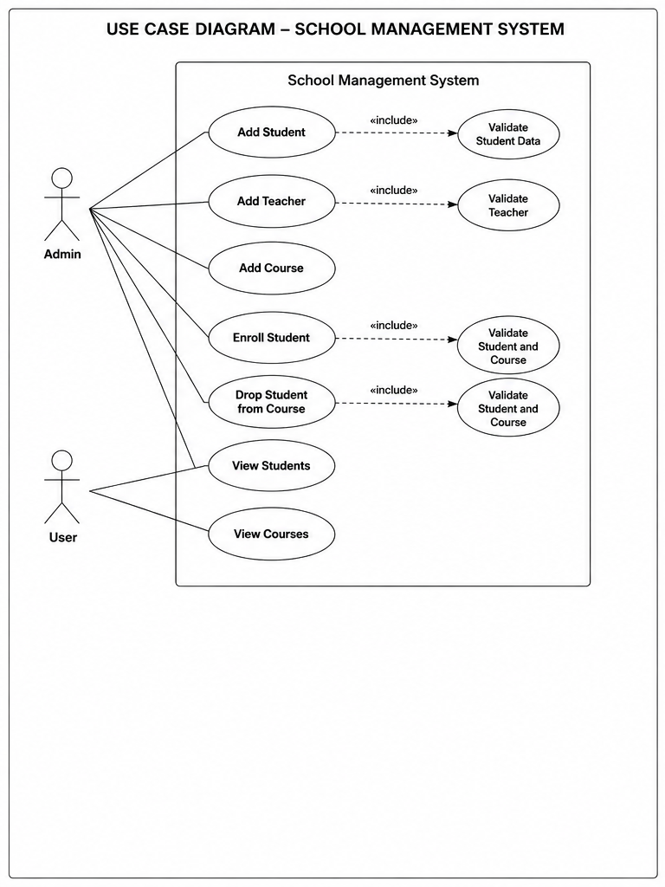
Figure 2. Use Case Diagram.
The Use Case Diagram presents two conceptual actors for documentation purposes: Admin performs record-management operations, while User represents read-only viewing. The current command-line implementation does not include authentication or role-based access control; these actors describe responsibilities rather than enforced permissions.
- Add Student validates student data before storing the object.
- Add Course assigns a teacher ID; in the final implementation the teacher ID is checked before the course is created.
- Enroll Student and Drop Student both validate that the referenced student and course exist before updating enrollment.
- View Students and View Courses provide readable summaries of the current in-memory state.

4.2 Activity Diagram Back to Contents
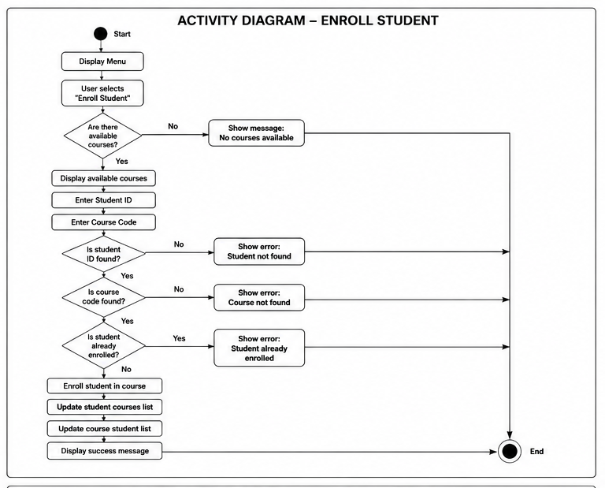
Figure 3. Activity Diagram for enrolling a student.
The Activity Diagram focuses on the most important workflow in the project: enrolling a student in a course. It demonstrates both the successful path and the validation branches that prevent invalid operations.
Stage | Behavior
Course availability | The menu first ensures that at least one course exists.
Input | The user enters a Student ID and Course Code.
Record validation | The system verifies the student exists and then verifies the course exists.
Duplicate prevention | The system checks whether the student is already enrolled.
State update | On success, the course code is added to Student.courses and the student ID is added to Course.student_ids.
Outcome | A success message is displayed; failed conditions display an error and return safely to the menu.

4.3 Class Diagram Back to Contents
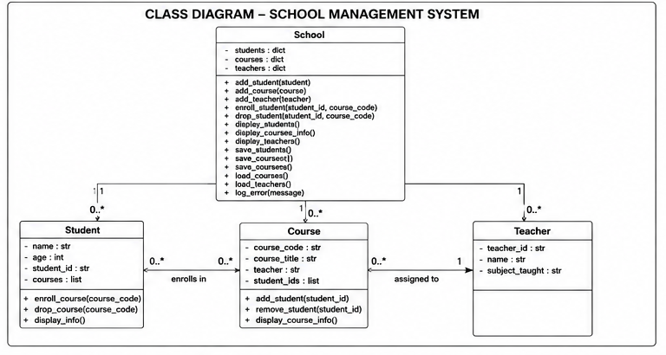
Figure 4. Class Diagram for the four core models.
The Class Diagram reflects the four classes required by the project guide. School is the central manager. Student and Course maintain the two sides of enrollment using lightweight identifiers, while Course stores the assigned teacher ID.
Class | State | Responsibility / Methods
Student | name, age, student_id, courses | enroll_course(), drop_course(), display_info()
Course | course_code, course_title, teacher, student_ids | add_student(), remove_student(), display_course_info()
Teacher | teacher_id, name, subject_taught | Data model used when teachers are added and assigned.
School | students, courses, teachers | Add/display operations, enroll/drop, save/load, and logging.

5. Data Model and Persistence Back to Contents
Persistent state is stored in three JSON files. At startup, School loads each file automatically. At Exit, the current object state is converted into JSON-compatible dictionaries/lists and saved back to disk.
File | Stored Record | Important Fields
students.json | Student | student_id, name, age, courses
courses.json | Course | course_code, course_title, teacher, student_ids
teachers.json | Teacher | teacher_id, name, subject_taught
logs.txt | Error messages | Handled validation and file errors, one message per line
Automatic loading at application startup
school = School()
school.load_students()
school.load_courses()
school.load_teachers()

Persistent save before application exit
elif choice == "8":
school.save_students()
school.save_courses()
school.save_teachers()
print("Exiting program...")
break

Using Path(__file__).parent keeps file operations relative to the project folder instead of depending on the terminal’s current working directory. This makes the save/load behavior more reliable when the program is launched from VS Code or another location.

6. Core Implementation Back to Contents

6.1 Student Input Validation Back to Contents
class Student:
def __init__(self, name, age, student_id):
if not name.strip():
raise ValueError("Name cannot be empty")
elif not name.isalpha():
raise ValueError("Name must contain letters only")
if age <= 0:
raise ValueError("Age must be greater than 0")
self.name = name
self.age = age
self.student_id = student_id
self.courses = []

Student validates its own basic state. A non-numeric age is caught earlier when main.py converts the input using int(age), while empty/invalid names and non-positive ages are rejected by the constructor.

6.2 Record Management and Duplicate Protection Back to Contents
def add_student(self, student):
if student.student_id in self.students:
raise ValueError("Duplicate student ID")
self.students[student.student_id] = student
def add_course(self, course):
if course.course_code in self.courses:
raise ValueError("Duplicate course code")
self.courses[course.course_code] = course
def add_teacher(self, teacher):
if teacher.teacher_id in self.teachers:
raise ValueError("Duplicate teacher ID")
self.teachers[teacher.teacher_id] = teacher

Dictionaries provide direct lookups by ID/code and naturally support duplicate checks before a new object is stored.

6.3 Enrollment and Drop Logic Back to Contents
def enroll_student(self, student_id, course_code):
if student_id not in self.students:
raise ValueError("Student not found")
elif course_code not in self.courses:
raise ValueError("Course not found")
student = self.students[student_id]
course = self.courses[course_code]
if course_code in student.courses:
raise ValueError("Student already enrolled in this course")
student.enroll_course(course_code)
course.add_student(student_id)

def drop_student(self, student_id, course_code):
if student_id not in self.students:
raise ValueError("Student not found")
elif course_code not in self.courses:
raise ValueError("Course not found")
student = self.students[student_id]
course = self.courses[course_code]
if course_code not in student.courses:
raise ValueError("Student is not enrolled in this course")
student.drop_course(course_code)
course.remove_student(student_id)

The important design choice is that both objects are updated together. Student.courses stores course codes, and Course.student_ids stores student IDs. This keeps enrollment consistent in both views.

6.4 Teacher Validation When Adding a Course Back to Contents
teacher = input("Enter teacher ID: ")
if teacher not in school.teachers:
raise ValueError("Teacher not found")
course = Course(course_code, course_title, teacher)
school.add_course(course)

The final menu validates that a teacher record exists before assigning its ID to a new course. This connects the Teacher model to course creation without adding unnecessary complexity.

6.5 JSON Loading and File Error Handling Back to Contents
def load_students(self):
file_path = Path(__file__).parent / "students.json"
try:
with open(file_path, "r") as file:
students_data = json.load(file)
for data in students_data:
student = Student(data["name"], data["age"], data["student_id"])
student.courses = data["courses"]
self.students[student.student_id] = student
except FileNotFoundError:
message = "students.json not found"
print(message)
self.log_error(message)
except json.JSONDecodeError:
message = "students.json is corrupted"
print(message)
self.log_error(message)
except KeyError:
message = "students.json has missing fields"
print(message)
self.log_error(message)

The same pattern is used for courses and teachers. Missing files, corrupted JSON, and missing record fields are handled without terminating the menu-driven application.

6.6 Central Error Logging Back to Contents
except ValueError as error:
print(error)
school.log_error(str(error))
# school.py
def log_error(self, message):
with open(Path(__file__).parent / "logs.txt", "a") as file:
file.write(message + "\n")

Expected user and business-rule errors are shown immediately and also appended to logs.txt, creating a simple persistent audit trail of handled failures.

7. Menu and User Flow Back to Contents
main.py owns the text-based interface. It creates one School object, loads existing data, repeatedly displays the menu, and delegates each operation to the relevant model or School method. A final invalid-choice branch improves usability by explicitly rejecting unsupported menu numbers.
Main menu presented to the user
SCHOOL MANAGEMENT SYSTEM
1. Add student
2. Add course
3. Add teacher
4. Enroll student
5. View students
6. View courses
7. Drop course
8. Exit

- Input is collected only in main.py; business logic is delegated to School and the model classes.
- The try/except around menu operations prevents expected ValueError conditions from stopping the application.
- The menu loops until option 8 saves the data and exits.
- An unsupported choice displays: “Invalid choice. Please choose from 1 to 8.”

8. Testing and Results Back to Contents
The system was tested case-by-case from a clean starting state. Tests covered the successful workflow, relationship updates, persistence, input validation, missing records, duplicate operations, missing files, corrupted JSON, and logging. The supplied screenshots in Appendix A provide execution evidence.
ID | Test Case | Input / Action | Expected & Observed Result | Status
T01 | Add Student | Valid name, age, and Student ID | Student added successfully | PASS
T02 | Add Teacher | Valid Teacher ID, name, subject | Teacher added successfully | PASS
T03 | Add Course | Valid code/title and existing Teacher ID | Course added successfully | PASS
T04 | Enroll Student | Existing Student ID + Course Code | Student enrolled; both lists updated | PASS
T05 | View Records | View Students / View Courses | Readable data with enrollment shown | PASS
T06 | Drop Course | Enrolled Student ID + Course Code | Relationship removed from both sides | PASS
T07 | Duplicate Student | Reuse an existing Student ID | Duplicate student ID; menu continues | PASS
T08 | Invalid Age | Enter hello for age | Conversion error handled; menu continues | PASS
T09 | Missing Student | Use unknown Student ID | Student not found | PASS
T10 | Missing Course | Use unknown Course Code | Course not found | PASS
T11 | Duplicate Enrollment | Enroll same student/course twice | Student already enrolled in this course | PASS
T12 | Drop Not Enrolled | Drop relationship a second time | Student is not enrolled in this course | PASS
T13 | Missing Teacher | Add course with unknown Teacher ID | Teacher not found | PASS
T14 | Missing JSON | Temporarily rename students.json | students.json not found; program continues | PASS
T15 | Corrupted JSON | Replace students.json content with invalid JSON | students.json is corrupted; program continues | PASS
T16 | Logging | Review logs.txt after failures | Expected errors are recorded | PASS
T17 | Persistence | Exit, restart, view data | Saved state reloads correctly | PASS

8.1 What the Tests Prove Back to Contents
- Functional correctness: records can be created, viewed, enrolled, dropped, saved, and loaded.
- Data consistency: enrollment and drop update both Student.courses and Course.student_ids.
- Robustness: expected user errors and file errors do not crash the program.
- Persistence: JSON files preserve the latest state after exit and restart.
- Traceability: logs.txt captures handled errors during testing.

9. Requirements Traceability Back to Contents
Guide Requirement | Implementation Evidence | Status
Student model: ID, name, age, enrolled courses | Student class + students.json | Implemented & tested
Course model: code, title, assigned teacher, student IDs | Course class + courses.json | Implemented & tested
Teacher model: ID, name, subject | Teacher class + teachers.json | Implemented & tested
School central manager | School class dictionaries and methods | Implemented
Prevent duplicate IDs | add_student/add_course/add_teacher | Tested
Confirm student and course exist | enroll_student/drop_student | Tested
Prevent duplicate enrollment | enroll_student | Tested
Allow drop course | drop_student | Tested
Load automatically at startup | main.py load_* calls | Tested
Save updated data before exit | main.py option 8 | Tested
Handle non-numeric age | int(age) + ValueError handling | Tested
Handle missing/corrupted files | load_* exception handling | Tested
Log errors to logs.txt | log_error() | Tested
Use classes, functions, collections, modules, menu | Whole project structure | Implemented

10. Conclusion and Future Improvements Back to Contents
The final School Management System demonstrates the complete Unit 2 learning outcomes in one coherent Python application. The project uses clear OOP models, dictionary/list collections, modular files, persistent JSON storage, exception handling, validation, and error logging. The executed test cases confirm that the application handles both normal operations and common failure conditions without crashing.
The solution deliberately remains simple and readable. This matches the project guide’s emphasis on understandable design and avoiding unnecessary overengineering.

Possible Future Improvements Back to Contents
- Add authentication if Admin and User roles need to be enforced rather than modeled conceptually.
- Add a menu option to display teachers or a teacher’s assigned courses.
- Add timestamps to logs.txt entries.
- Add a graphical user interface while keeping the existing model layer.
- Add automated unit tests for the School business logic.

Appendix A. Test Evidence Screenshots Back to Contents
The following screenshots were captured during manual verification of the final behavior. Each figure corresponds to one or more test cases summarized in Section 8.
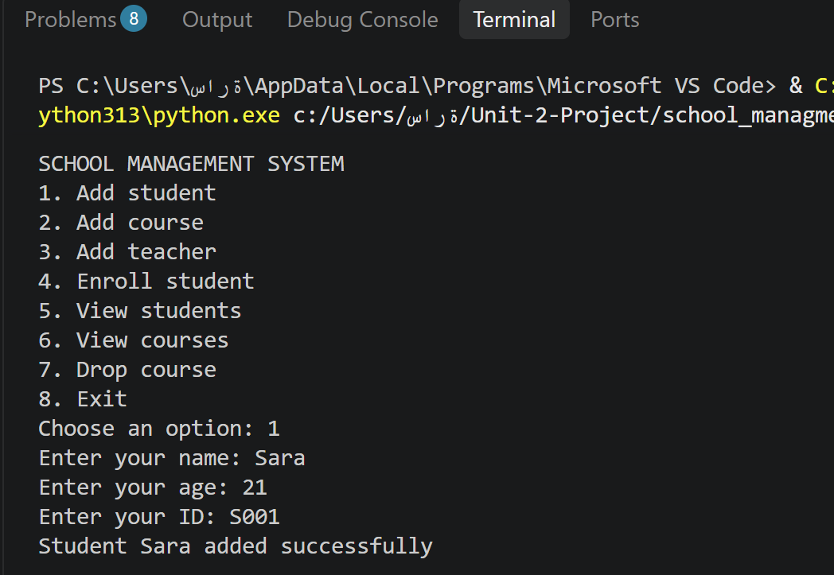
Figure A1. Adding a student successfully.
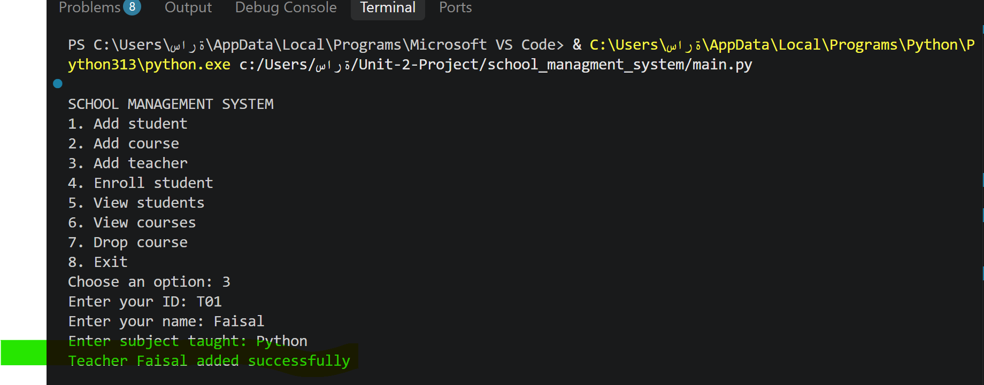
Figure A2. Adding a teacher successfully.

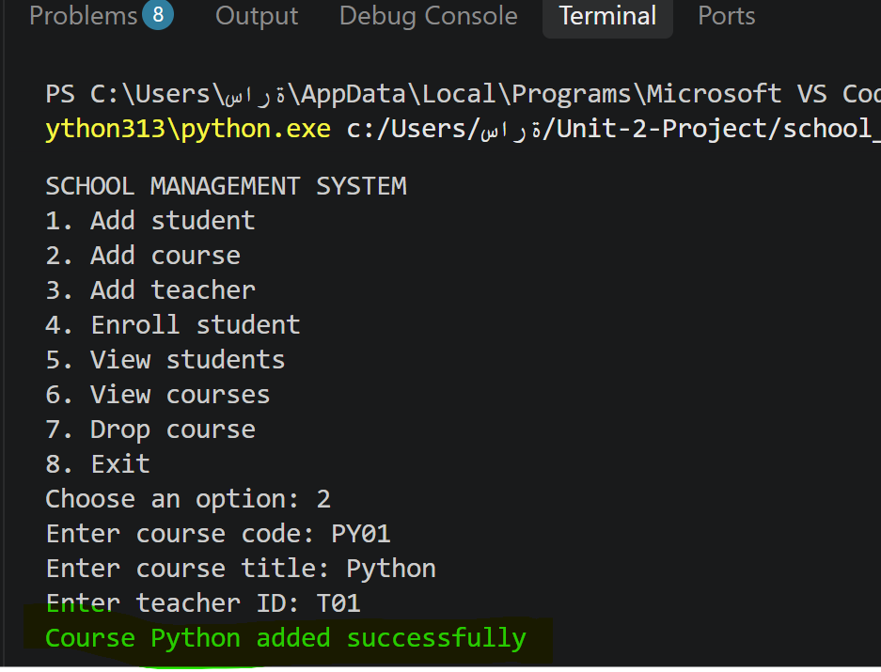
Figure A3. Adding a course successfully.
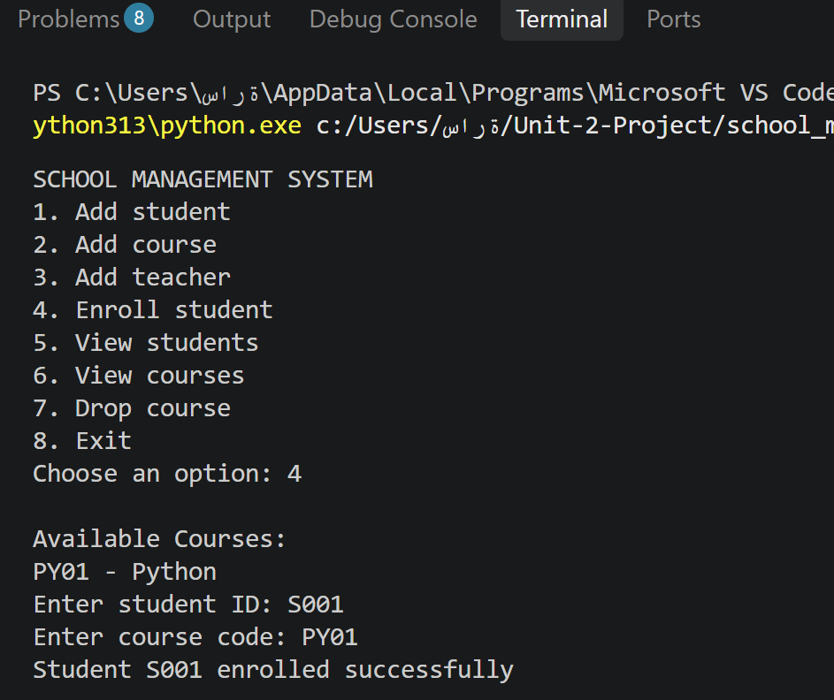
Figure A4. Enrolling a student in an available course.

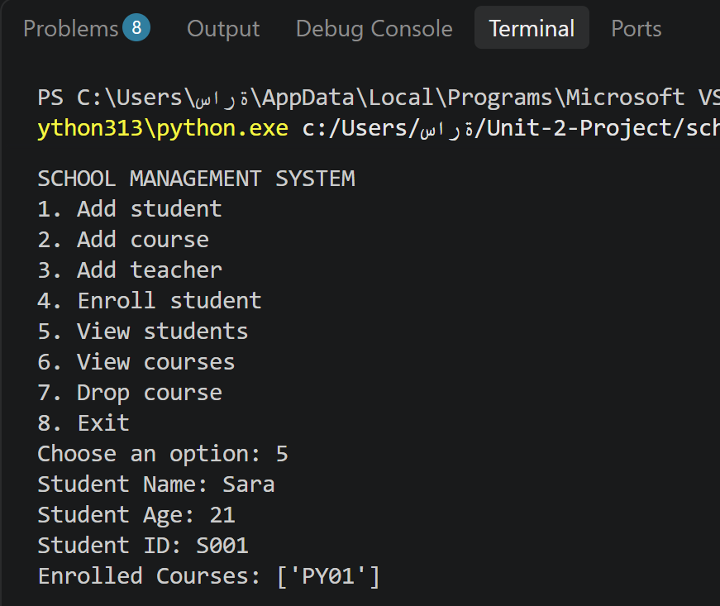
Figure A5. Viewing student information and enrolled courses.
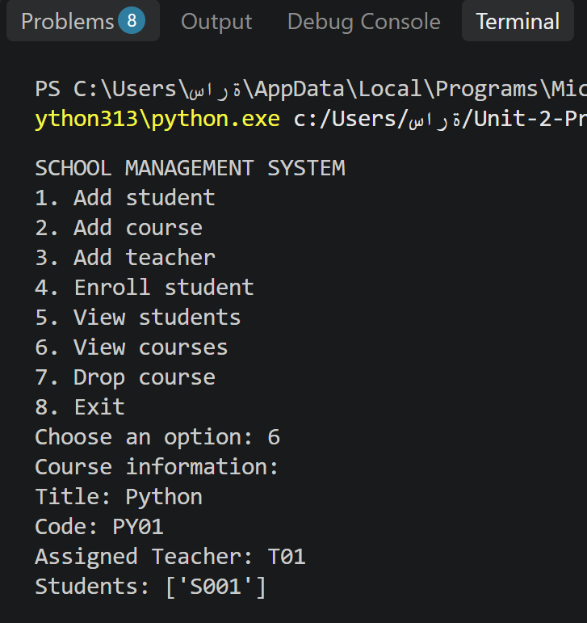
Figure A6. Viewing course information and enrolled student IDs.

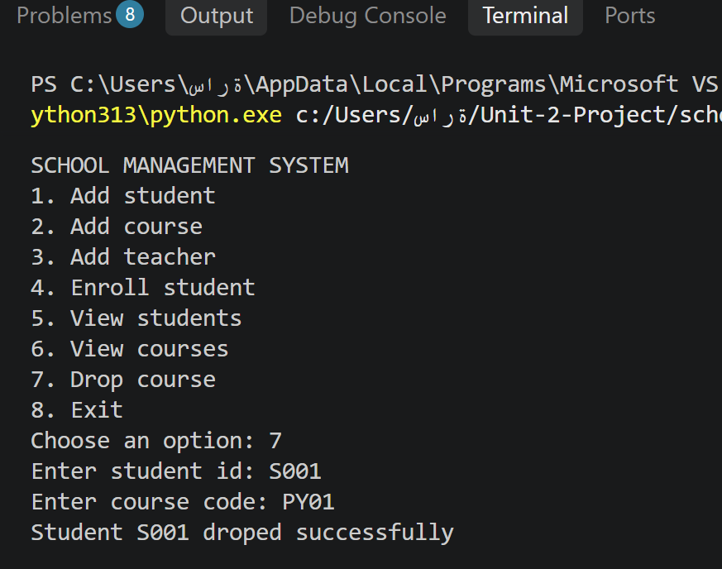
Figure A7. Dropping a student from a course successfully.
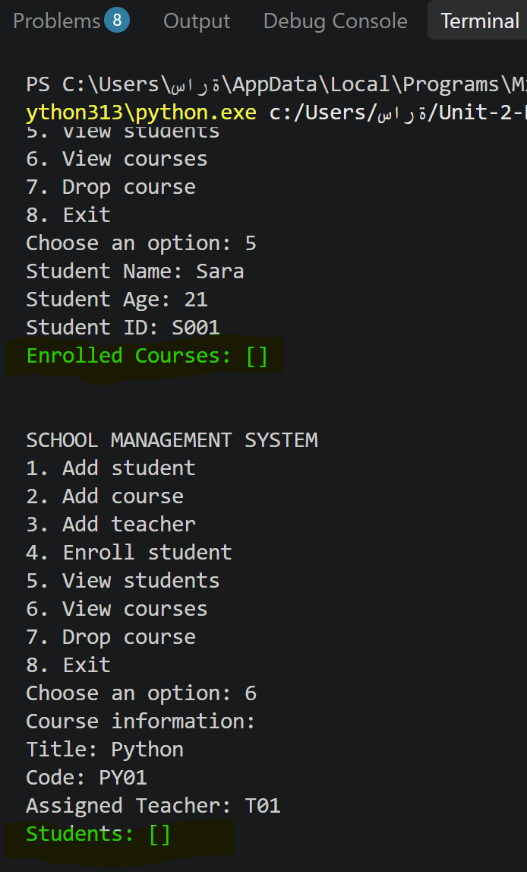
Figure A8. Verifying the relationship after the drop operation.

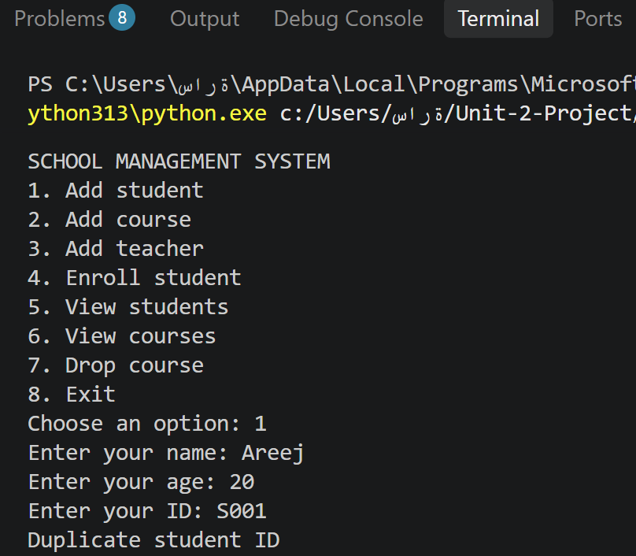
Figure A9. Duplicate Student ID validation.
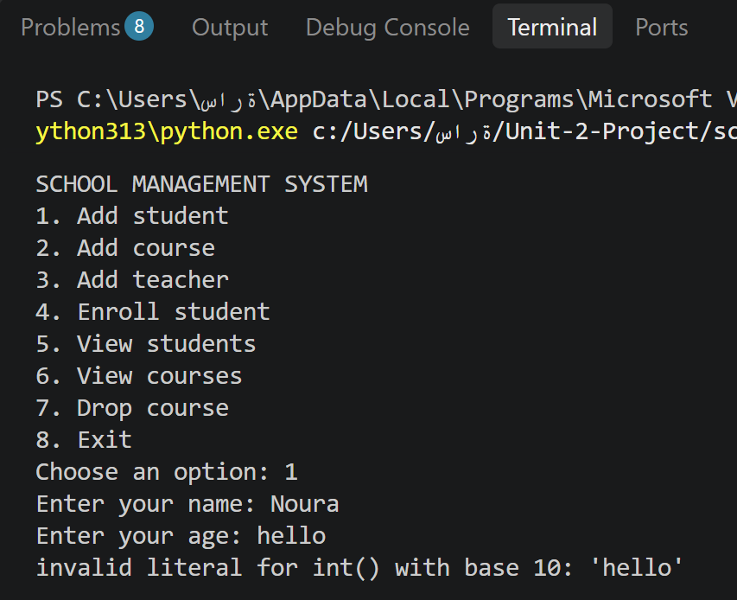
Figure A10. Handling a non-numeric age without crashing.

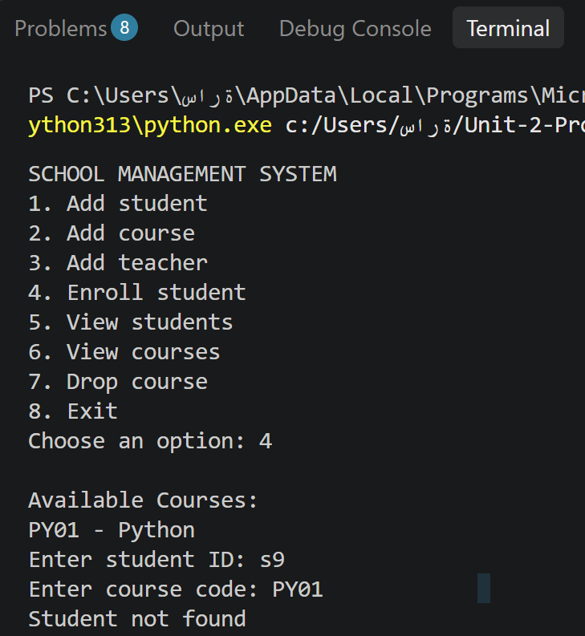
Figure A11. Handling a missing Student ID.
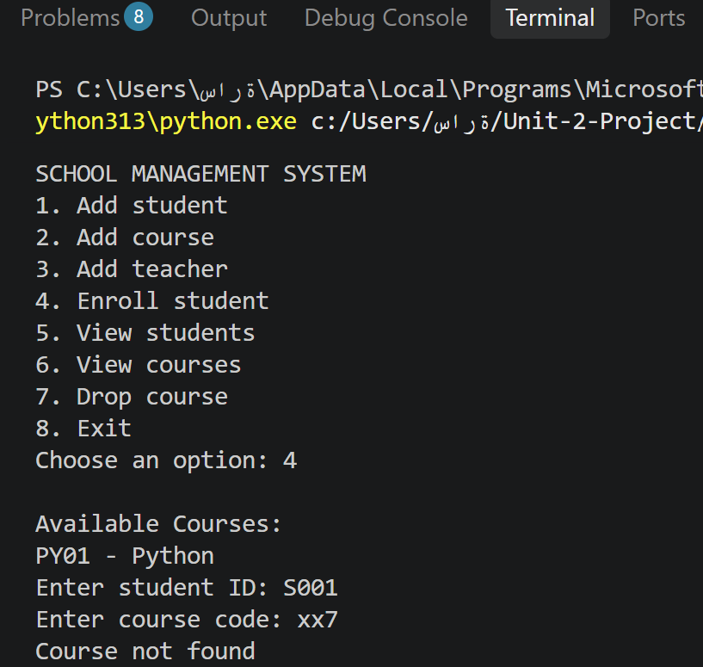
Figure A12. Handling a missing Course Code.

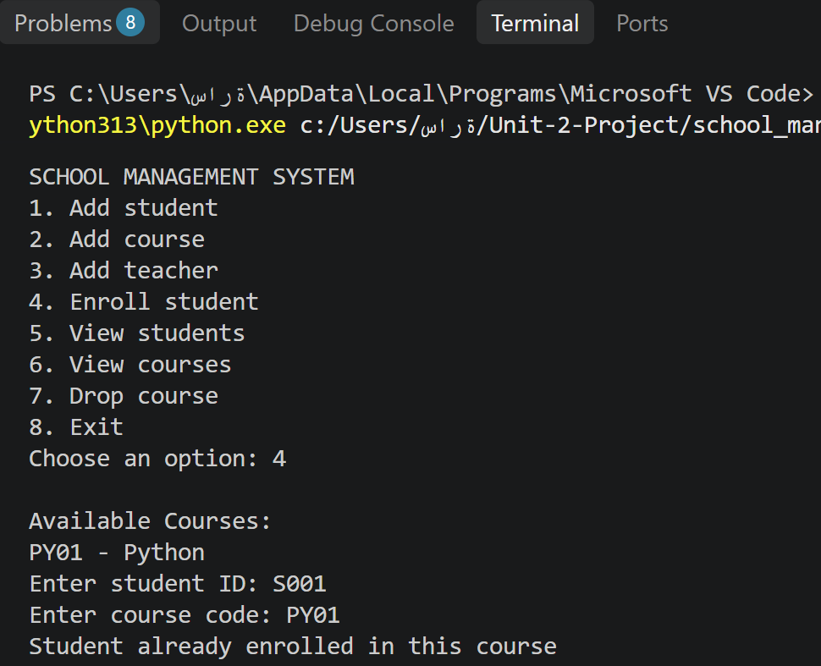
Figure A13. Preventing duplicate enrollment.
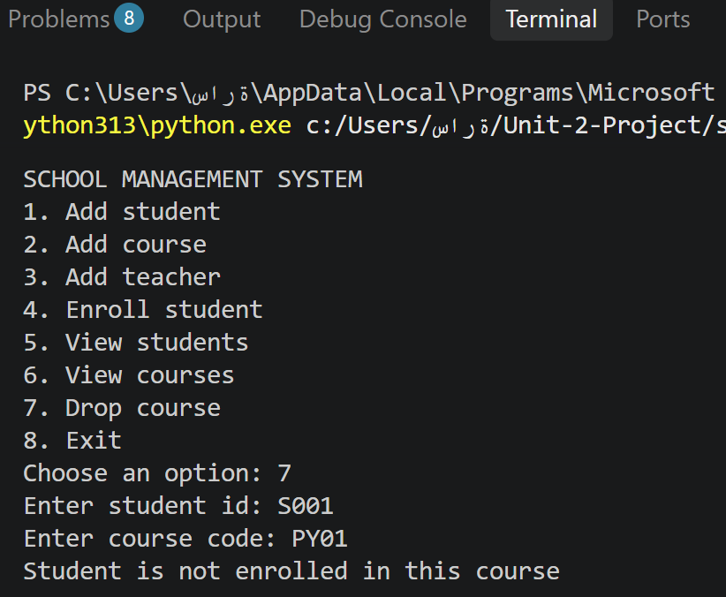
Figure A14. Preventing a second drop when the student is not enrolled.

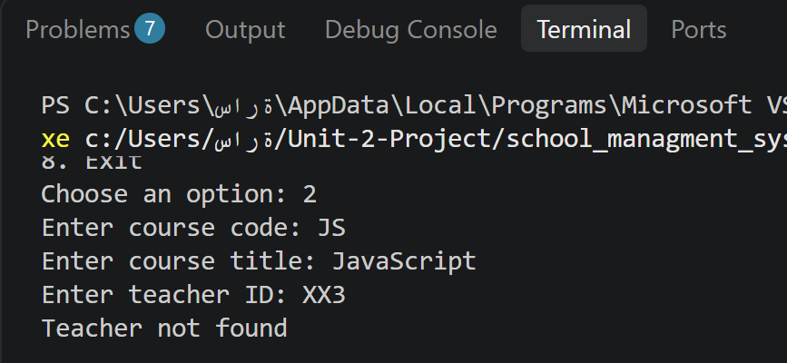
Figure A15. Rejecting a course assignment when the Teacher ID is not found.
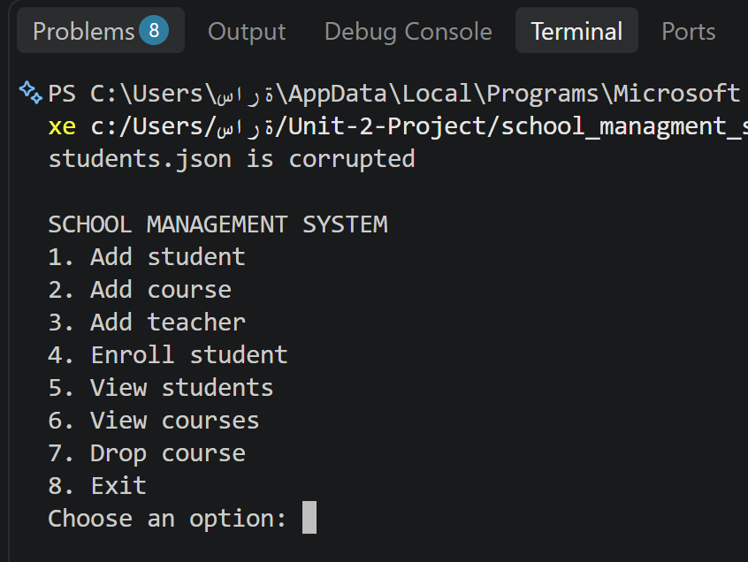
Figure A16. Handling a corrupted students.json file.

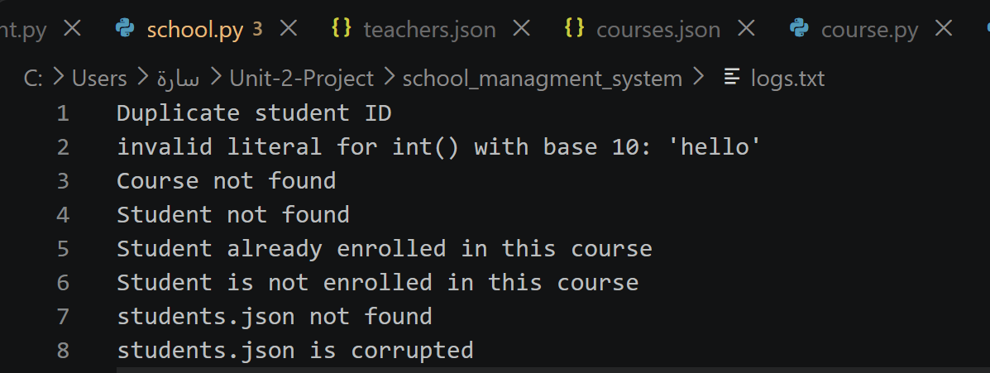
Figure A17. logs.txt containing handled validation and file errors.
End of Documentation

