**MAX imbalance observed across all Days: 2.00 (Count: 12), on Date: 2025-09-01**

**TEMPERATURE PROFILE FOR 865577070464087**

# Date: 2025-09-01



|  |  |
| --- | --- |
| Start BatteryStateOfCharge | 79.50 |
| End BatteryStateOfCharge | 42.78 |
| Most data point of MaxTempCell | batteryBmsTemperature1 |
| Most data point of MinTempCell | batteryBmsTemperature1 |
| **Max imbalance logged** | **2.00 (Count: 12)** |
| Total Records (this date) | 6043 |

**TEMPERATURE PROFILE FOR 865577070464087**

# Date: 2025-09-02

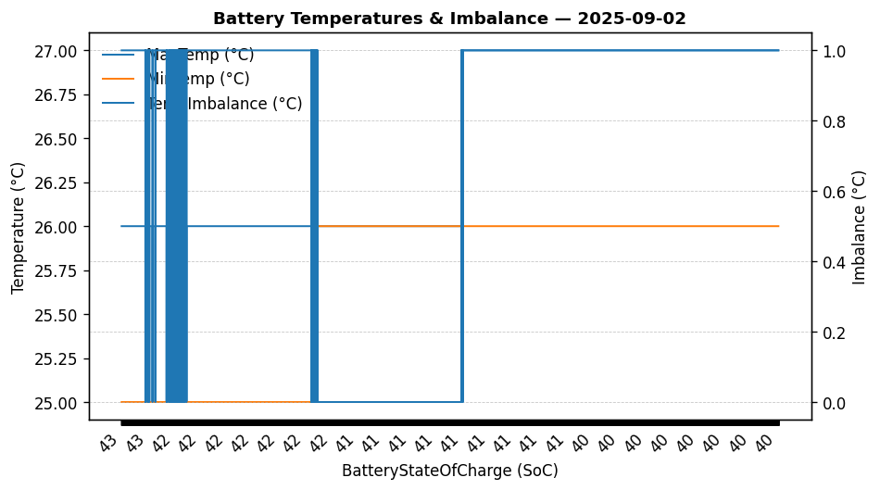

|  |  |
| --- | --- |
| Start BatteryStateOfCharge | 42.78 |
| End BatteryStateOfCharge | 39.80 |
| Most data point of MaxTempCell | batteryBmsTemperature1 |
| Most data point of MinTempCell | batteryBmsTemperature1 |
| **Max imbalance logged** | **1.00 (Count: 9810)** |
| Total Records (this date) | 12724 |

**TEMPERATURE PROFILE FOR 865577070464087**

# Date: 2025-08-28

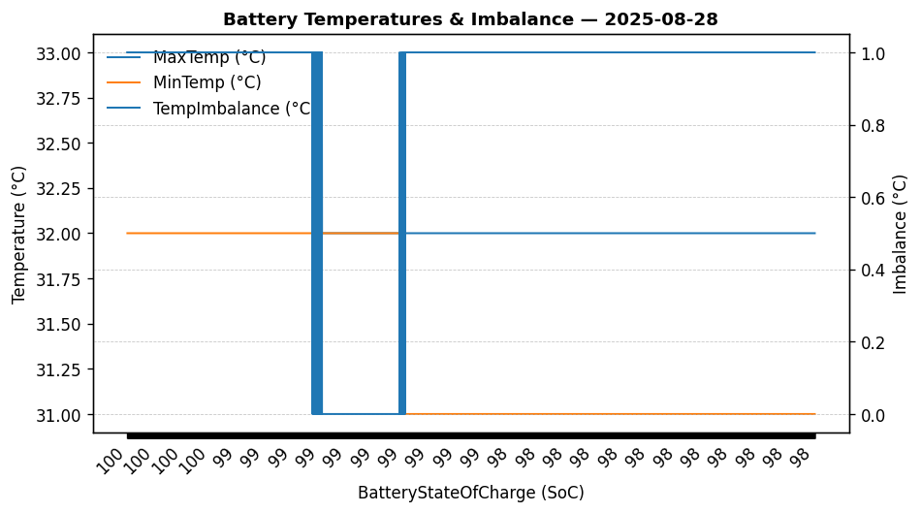

|  |  |
| --- | --- |
| Start BatteryStateOfCharge | 99.99 |
| End BatteryStateOfCharge | 97.52 |
| Most data point of MaxTempCell | batteryBmsTemperature1 |
| Most data point of MinTempCell | batteryBmsTemperature1 |
| **Max imbalance logged** | **1.00 (Count: 4517)** |
| Total Records (this date) | 5155 |

**TEMPERATURE PROFILE FOR 865577070464087**

# Date: 2025-08-29



|  |  |
| --- | --- |
| Start BatteryStateOfCharge | 97.52 |
| End BatteryStateOfCharge | 85.80 |
| Most data point of MaxTempCell | batteryBmsTemperature1 |
| Most data point of MinTempCell | batteryBmsTemperature4 |
| **Max imbalance logged** | **2.00 (Count: 2956)** |
| Total Records (this date) | 12355 |

**TEMPERATURE PROFILE FOR 865577070464087**

# Date: 2025-08-30

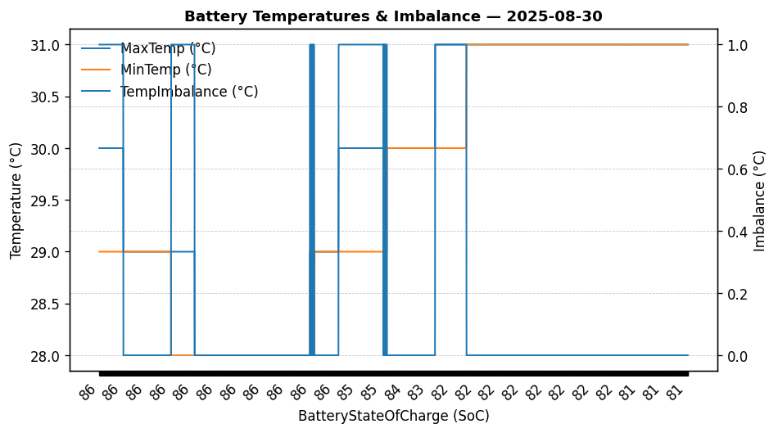

|  |  |
| --- | --- |
| Start BatteryStateOfCharge | 85.80 |
| End BatteryStateOfCharge | 81.30 |
| Most data point of MaxTempCell | batteryBmsTemperature1 |
| Most data point of MinTempCell | batteryBmsTemperature1 |
| **Max imbalance logged** | **1.00 (Count: 635)** |
| Total Records (this date) | 2932 |

**TEMPERATURE PROFILE FOR 865577070464087**

# Date: 2025-08-31



|  |  |
| --- | --- |
| Start BatteryStateOfCharge | 81.30 |
| End BatteryStateOfCharge | 79.58 |
| Most data point of MaxTempCell | batteryBmsTemperature1 |
| Most data point of MinTempCell | batteryBmsTemperature1 |
| **Max imbalance logged** | **1.00 (Count: 2819)** |
| Total Records (this date) | 6529 |