**MAX imbalance observed across all Days: 3.00 (Count: 286), on Date: 2025-08-22**

**TEMPERATURE PROFILE FOR 861409074948697**

# Date: 2025-08-22

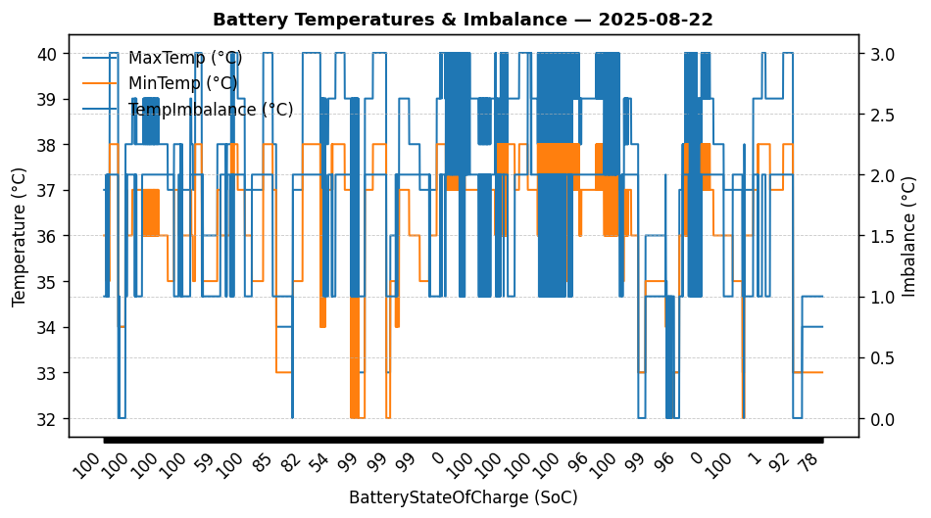

|  |  |
| --- | --- |
| Start BatteryStateOfCharge | 99.72 |
| End BatteryStateOfCharge | 78.35 |
| Most data point of MaxTempCell | battery_bms_temperature_1 |
| Most data point of MinTempCell | battery_bms_temperature_4 |
| **Max imbalance logged** | **3.00 (Count: 286)** |
| Total Records (this date) | 6778 |