**MAX imbalance observed across all Days: 3.00 (Count: 3), on Date: 2025-08-22**

**TEMPERATURE PROFILE FOR 867950075643237**

# Date: 2025-08-22

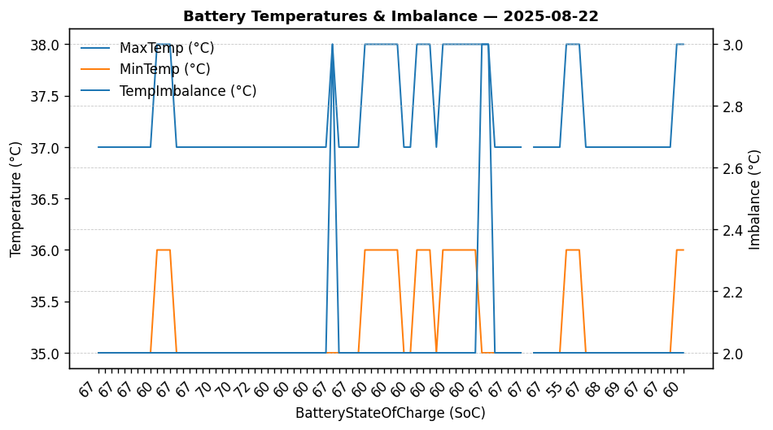

|  |  |
| --- | --- |
| Start BatteryStateOfCharge | 67.38 |
| End BatteryStateOfCharge | 60.20 |
| Most data point of MaxTempCell | battery_bms_temperature_1 |
| Most data point of MinTempCell | battery_bms_temperature_6 |
| **Max imbalance logged** | **3.00 (Count: 3)** |
| Total Records (this date) | 91 |