**MAX imbalance observed across all Days: 2.00 (Count: 114), on Date: 2025-08-22**

**TEMPERATURE PROFILE FOR 866082077995695**

# Date: 2025-08-22

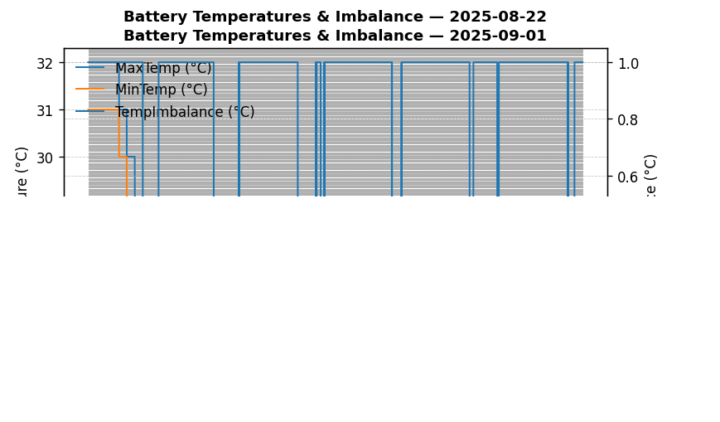

|  |  |
| --- | --- |
| Start BatteryStateOfCharge | 99.90 |
| End BatteryStateOfCharge | 55.86 |
| Most data point of MaxTempCell | batteryBmsTemperature1 |
| Most data point of MinTempCell | batteryBmsTemperature1 |
| **Max imbalance logged** | **2.00 (Count: 114)** |
| Total Records (this date) | 2587 |