**MAX imbalance observed across all Days: 3.00 (Count: 615), on Date: 2025-09-02**

**TEMPERATURE PROFILE FOR 863877071444985**

# Date: 2025-09-01



|  |  |
| --- | --- |
| Start BatteryStateOfCharge | 100.00 |
| End BatteryStateOfCharge | 97.99 |
| Most data point of MaxTempCell | batteryBmsTemperature1 |
| Most data point of MinTempCell | batteryBmsTemperature4 |
| **Max imbalance logged** | **2.00 (Count: 2402)** |
| Total Records (this date) | 11644 |

**TEMPERATURE PROFILE FOR 863877071444985**

# Date: 2025-09-02

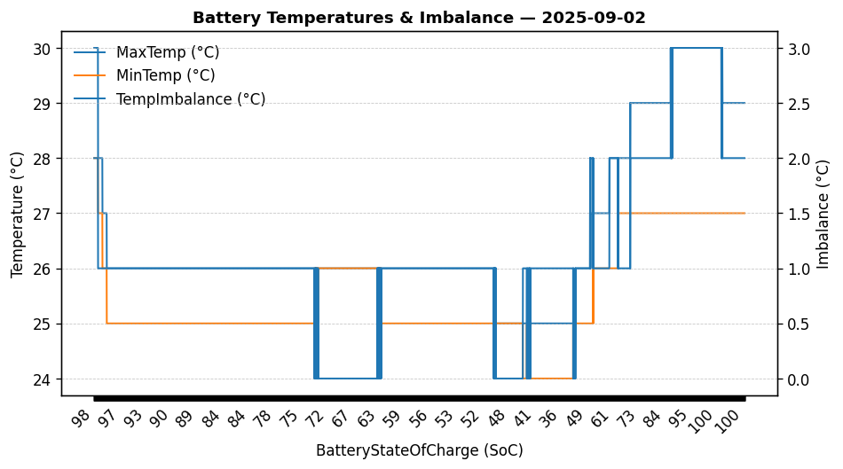

|  |  |
| --- | --- |
| Start BatteryStateOfCharge | 98.00 |
| End BatteryStateOfCharge | 100.00 |
| Most data point of MaxTempCell | batteryBmsTemperature1 |
| Most data point of MinTempCell | batteryBmsTemperature6 |
| **Max imbalance logged** | **3.00 (Count: 615)** |
| Total Records (this date) | 7973 |

**TEMPERATURE PROFILE FOR 863877071444985**

# Date: 2025-08-29

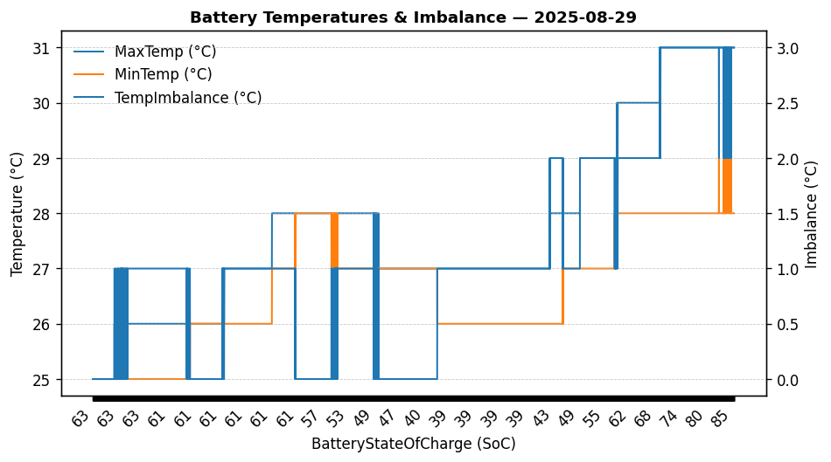

|  |  |
| --- | --- |
| Start BatteryStateOfCharge | 63.49 |
| End BatteryStateOfCharge | 84.79 |
| Most data point of MaxTempCell | batteryBmsTemperature1 |
| Most data point of MinTempCell | batteryBmsTemperature1 |
| **Max imbalance logged** | **3.00 (Count: 546)** |
| Total Records (this date) | 4938 |

**TEMPERATURE PROFILE FOR 863877071444985**

# Date: 2025-08-30

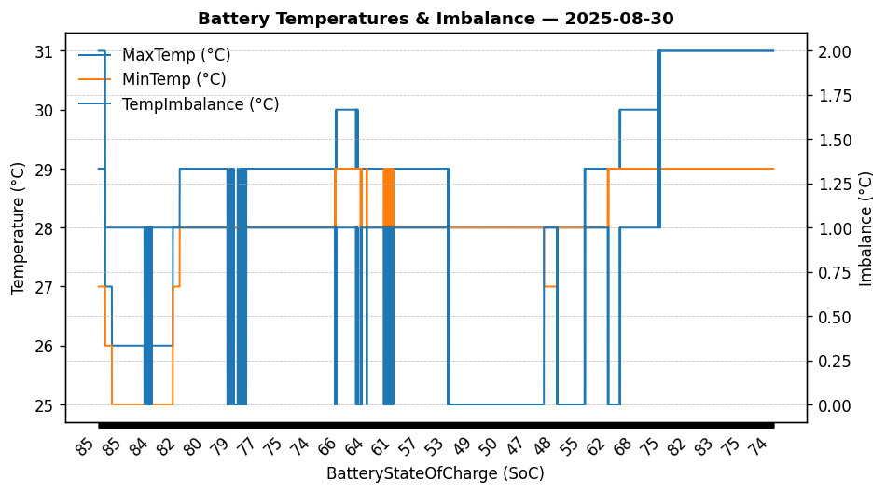

|  |  |
| --- | --- |
| Start BatteryStateOfCharge | 84.80 |
| End BatteryStateOfCharge | 74.34 |
| Most data point of MaxTempCell | batteryBmsTemperature1 |
| Most data point of MinTempCell | batteryBmsTemperature1 |
| **Max imbalance logged** | **2.00 (Count: 961)** |
| Total Records (this date) | 5366 |

**TEMPERATURE PROFILE FOR 863877071444985**

# Date: 2025-08-31

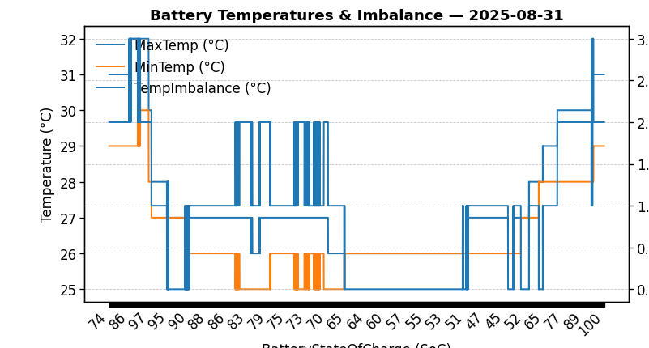

|  |  |
| --- | --- |
| Start BatteryStateOfCharge | 74.37 |
| End BatteryStateOfCharge | 100.00 |
| Most data point of MaxTempCell | batteryBmsTemperature1 |
| Most data point of MinTempCell | batteryBmsTemperature1 |
| **Max imbalance logged** | **3.00 (Count: 175)** |
| Total Records (this date) | 9659 |