**MAX imbalance observed across all Days: 2.00 (Count: 558), on Date: 2025-08-21**

**TEMPERATURE PROFILE FOR 861736078487789**

# Date: 2025-08-21



|  |  |
| --- | --- |
| Start BatteryStateOfCharge | 39.00 |
| End BatteryStateOfCharge | 1.92 |
| Most data point of MaxTempCell | battery_bms_temperature_4 |
| Most data point of MinTempCell | battery_bms_temperature_1 |
| **Max imbalance logged** | **2.00 (Count: 558)** |
| Total Records (this date) | 5119 |

**TEMPERATURE PROFILE FOR 861736078487789**

# Date: 2025-08-22

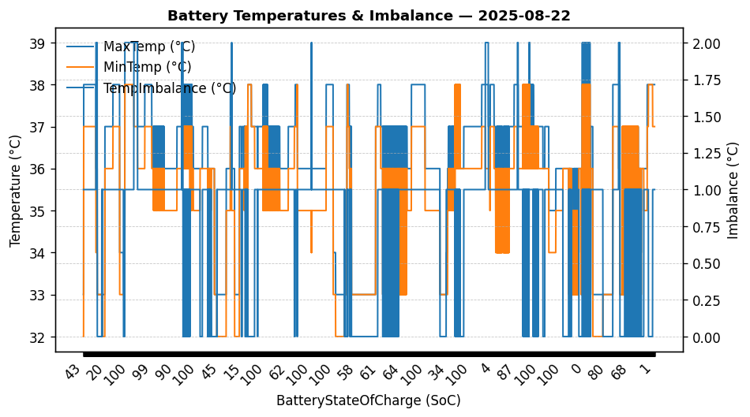

|  |  |
| --- | --- |
| Start BatteryStateOfCharge | 42.86 |
| End BatteryStateOfCharge | 1.30 |
| Most data point of MaxTempCell | battery_bms_temperature_1 |
| Most data point of MinTempCell | battery_bms_temperature_1 |
| **Max imbalance logged** | **2.00 (Count: 141)** |
| Total Records (this date) | 7316 |