**MAX imbalance observed across all Days: 1.00 (Count: 1930), on Date: 2025-08-19**

**TEMPERATURE PROFILE FOR 862942079829404**

# Date: 2025-08-19

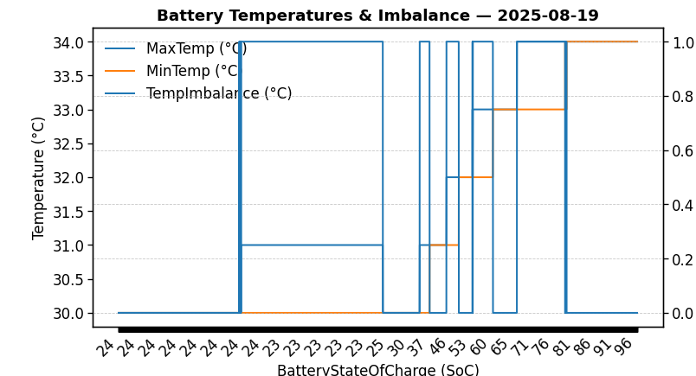

|  |  |
| --- | --- |
| Start BatteryStateOfCharge | 24.50 |
| End BatteryStateOfCharge | 96.05 |
| Most data point of MaxTempCell | batteryBmsTemperature1 |
| Most data point of MinTempCell | batteryBmsTemperature1 |
| **Max imbalance logged** | **1.00 (Count: 1930)** |
| Total Records (this date) | 4282 |

**TEMPERATURE PROFILE FOR 862942079829404**

# Date: 2025-08-20



|  |  |
| --- | --- |
| Start BatteryStateOfCharge | 96.07 |
| End BatteryStateOfCharge | 66.23 |
| Most data point of MaxTempCell | batteryBmsTemperature1 |
| Most data point of MinTempCell | batteryBmsTemperature1 |
| **Max imbalance logged** | **1.00 (Count: 4950)** |
| Total Records (this date) | 13050 |

**TEMPERATURE PROFILE FOR 862942079829404**

# Date: 2025-08-21



|  |  |
| --- | --- |
| Start BatteryStateOfCharge | 66.26 |
| End BatteryStateOfCharge | 99.86 |
| Most data point of MaxTempCell | batteryBmsTemperature1 |
| Most data point of MinTempCell | batteryBmsTemperature1 |
| **Max imbalance logged** | **1.00 (Count: 7964)** |
| Total Records (this date) | 14203 |

**TEMPERATURE PROFILE FOR 862942079829404**

# Date: 2025-08-22

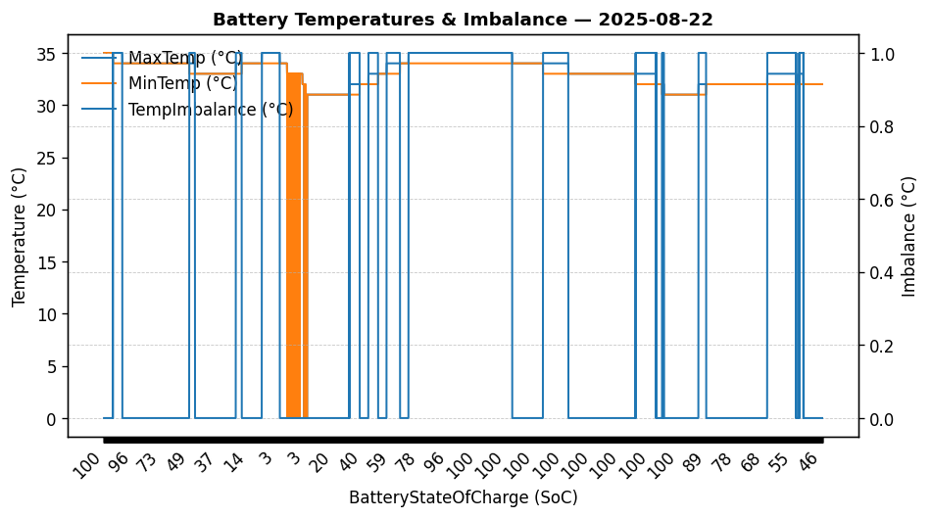

|  |  |
| --- | --- |
| Start BatteryStateOfCharge | 99.86 |
| End BatteryStateOfCharge | 45.43 |
| Most data point of MaxTempCell | batteryBmsTemperature1 |
| Most data point of MinTempCell | batteryBmsTemperature1 |
| **Max imbalance logged** | **1.00 (Count: 2910)** |
| Total Records (this date) | 7928 |