**MAX imbalance observed across all Days: 35.00 (Count: 1), on Date: 2025-09-01**

**TEMPERATURE PROFILE FOR 861409074946568**

# Date: 2025-09-01

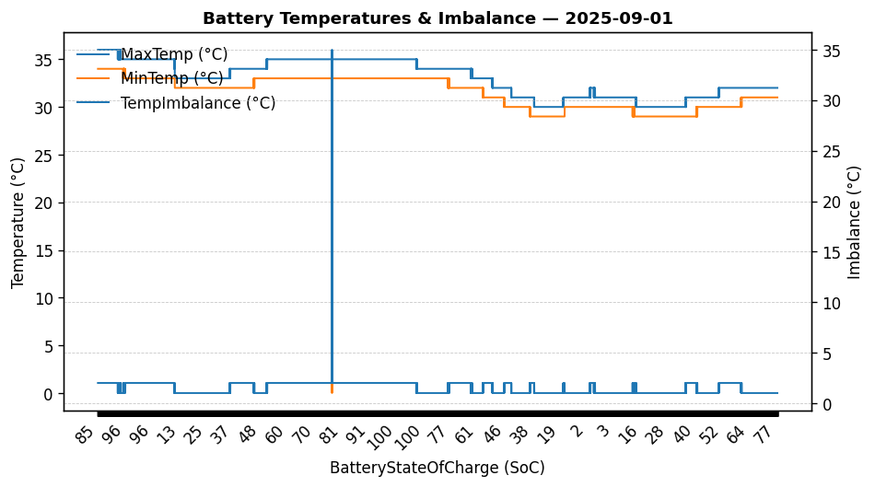

|  |  |
| --- | --- |
| Start BatteryStateOfCharge | 84.81 |
| End BatteryStateOfCharge | 77.26 |
| Most data point of MaxTempCell | batteryBmsTemperature1 |
| Most data point of MinTempCell | batteryBmsTemperature6 |
| **Max imbalance logged** | **35.00 (Count: 1)** |
| Total Records (this date) | 12888 |

**TEMPERATURE PROFILE FOR 861409074946568**

# Date: 2025-09-02

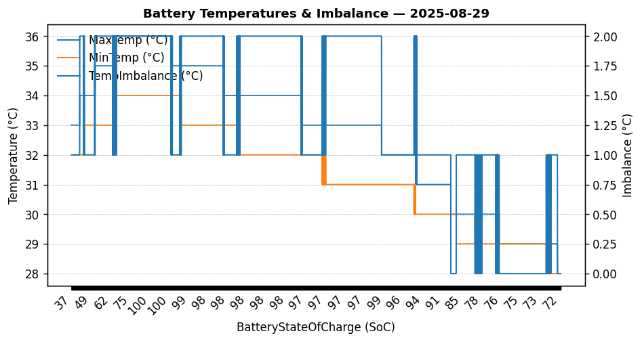

|  |  |
| --- | --- |
| Start BatteryStateOfCharge | 77.28 |
| End BatteryStateOfCharge | 88.07 |
| Most data point of MaxTempCell | batteryBmsTemperature1 |
| Most data point of MinTempCell | batteryBmsTemperature6 |
| **Max imbalance logged** | **3.00 (Count: 768)** |
| Total Records (this date) | 15470 |