**MAX imbalance observed across all Days: 3.00 (Count: 31), on Date: 2025-09-01**

**TEMPERATURE PROFILE FOR 866082077933050**

# Date: 2025-09-01



|  |  |
| --- | --- |
| Start BatteryStateOfCharge | 99.50 |
| End BatteryStateOfCharge | 100.00 |
| Most data point of MaxTempCell | batteryBmsTemperature1 |
| Most data point of MinTempCell | batteryBmsTemperature6 |
| **Max imbalance logged** | **3.00 (Count: 31)** |
| Total Records (this date) | 7214 |

**TEMPERATURE PROFILE FOR 866082077933050**

# Date: 2025-09-02



|  |  |
| --- | --- |
| Start BatteryStateOfCharge | 100.00 |
| End BatteryStateOfCharge | 100.00 |
| Most data point of MaxTempCell | batteryBmsTemperature1 |
| Most data point of MinTempCell | batteryBmsTemperature6 |
| **Max imbalance logged** | **2.00 (Count: 3160)** |
| Total Records (this date) | 11579 |

**TEMPERATURE PROFILE FOR 866082077933050**

# Date: 2025-08-27

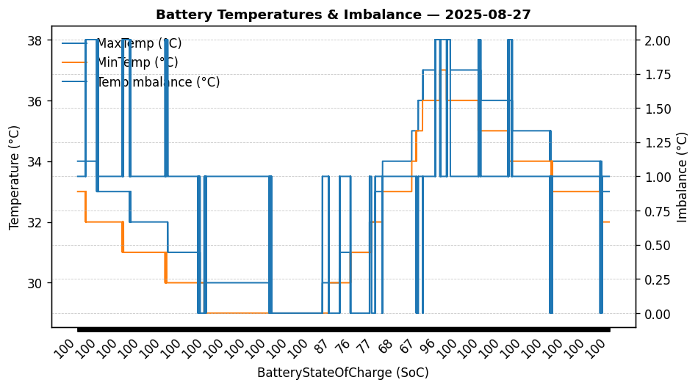

|  |  |
| --- | --- |
| Start BatteryStateOfCharge | 100.00 |
| End BatteryStateOfCharge | 100.00 |
| Most data point of MaxTempCell | batteryBmsTemperature1 |
| Most data point of MinTempCell | batteryBmsTemperature1 |
| **Max imbalance logged** | **2.00 (Count: 740)** |
| Total Records (this date) | 11316 |

**TEMPERATURE PROFILE FOR 866082077933050**

# Date: 2025-08-28

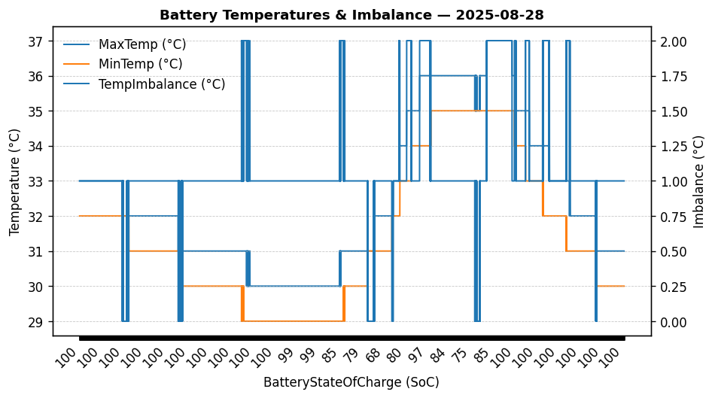

|  |  |
| --- | --- |
| Start BatteryStateOfCharge | 100.00 |
| End BatteryStateOfCharge | 100.00 |
| Most data point of MaxTempCell | batteryBmsTemperature1 |
| Most data point of MinTempCell | batteryBmsTemperature3 |
| **Max imbalance logged** | **2.00 (Count: 1492)** |
| Total Records (this date) | 12349 |

**TEMPERATURE PROFILE FOR 866082077933050**

# Date: 2025-08-29

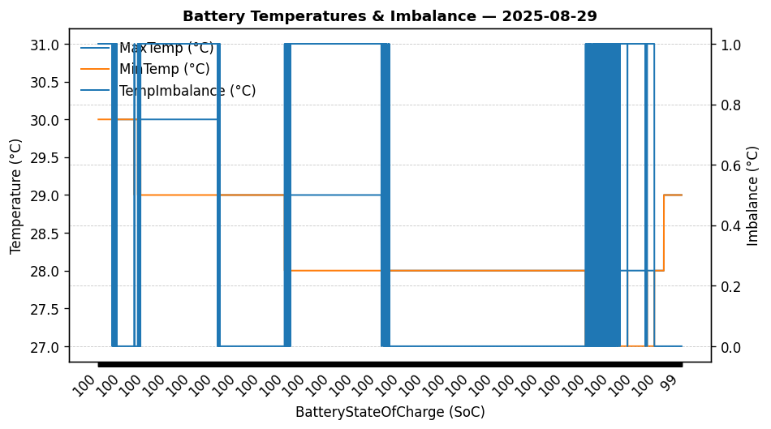

|  |  |
| --- | --- |
| Start BatteryStateOfCharge | 100.00 |
| End BatteryStateOfCharge | 99.40 |
| Most data point of MaxTempCell | batteryBmsTemperature1 |
| Most data point of MinTempCell | batteryBmsTemperature1 |
| **Max imbalance logged** | **1.00 (Count: 2586)** |
| Total Records (this date) | 6234 |

**TEMPERATURE PROFILE FOR 866082077933050**

# Date: 2025-08-30



|  |  |
| --- | --- |
| Start BatteryStateOfCharge | 99.40 |
| End BatteryStateOfCharge | 100.00 |
| Most data point of MaxTempCell | batteryBmsTemperature1 |
| Most data point of MinTempCell | batteryBmsTemperature3 |
| **Max imbalance logged** | **3.00 (Count: 18)** |
| Total Records (this date) | 8494 |

**TEMPERATURE PROFILE FOR 866082077933050**

# Date: 2025-08-31

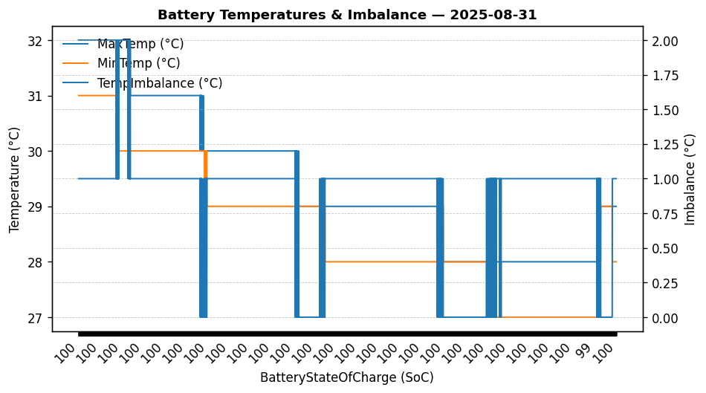

|  |  |
| --- | --- |
| Start BatteryStateOfCharge | 100.00 |
| End BatteryStateOfCharge | 99.50 |
| Most data point of MaxTempCell | batteryBmsTemperature1 |
| Most data point of MinTempCell | batteryBmsTemperature1 |
| **Max imbalance logged** | **2.00 (Count: 170)** |
| Total Records (this date) | 7901 |