**MAX imbalance observed across all Days: 3.00 (Count: 10), on Date: 2025-09-02**

**TEMPERATURE PROFILE FOR 866082077997741**

# Date: 2025-09-01

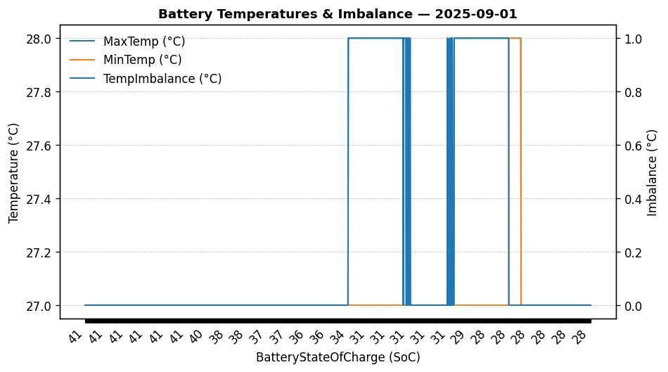

|  |  |
| --- | --- |
| Start BatteryStateOfCharge | 41.00 |
| End BatteryStateOfCharge | 28.00 |
| Most data point of MaxTempCell | batteryBmsTemperature1 |
| Most data point of MinTempCell | batteryBmsTemperature1 |
| **Max imbalance logged** | **1.00 (Count: 363)** |
| Total Records (this date) | 1580 |

**TEMPERATURE PROFILE FOR 866082077997741**

# Date: 2025-09-02



|  |  |
| --- | --- |
| Start BatteryStateOfCharge | 28.00 |
| End BatteryStateOfCharge | 89.04 |
| Most data point of MaxTempCell | batteryBmsTemperature1 |
| Most data point of MinTempCell | batteryBmsTemperature1 |
| **Max imbalance logged** | **3.00 (Count: 10)** |
| Total Records (this date) | 2976 |

**TEMPERATURE PROFILE FOR 866082077997741**

# Date: 2025-08-29



|  |  |
| --- | --- |
| Start BatteryStateOfCharge | 36.93 |
| End BatteryStateOfCharge | 71.50 |
| Most data point of MaxTempCell | batteryBmsTemperature1 |
| Most data point of MinTempCell | batteryBmsTemperature6 |
| **Max imbalance logged** | **2.00 (Count: 4554)** |
| Total Records (this date) | 9166 |

**TEMPERATURE PROFILE FOR 866082077997741**

# Date: 2025-08-30

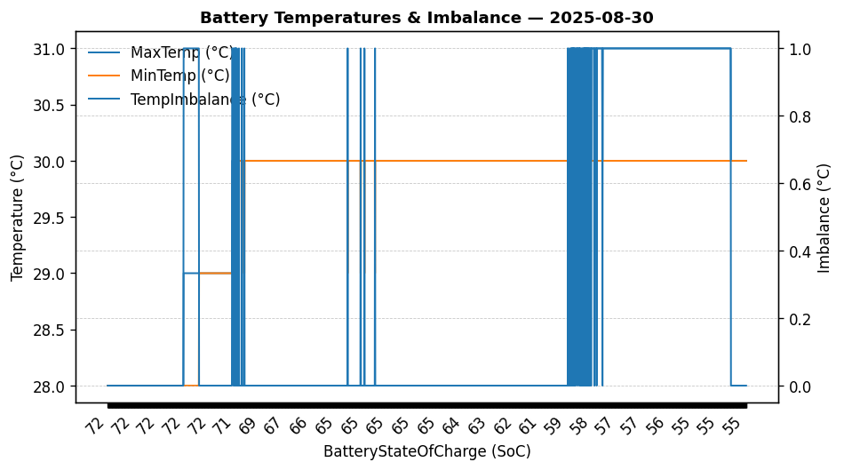

|  |  |
| --- | --- |
| Start BatteryStateOfCharge | 71.50 |
| End BatteryStateOfCharge | 54.60 |
| Most data point of MaxTempCell | batteryBmsTemperature1 |
| Most data point of MinTempCell | batteryBmsTemperature1 |
| **Max imbalance logged** | **1.00 (Count: 631)** |
| Total Records (this date) | 2356 |

**TEMPERATURE PROFILE FOR 866082077997741**

# Date: 2025-08-31

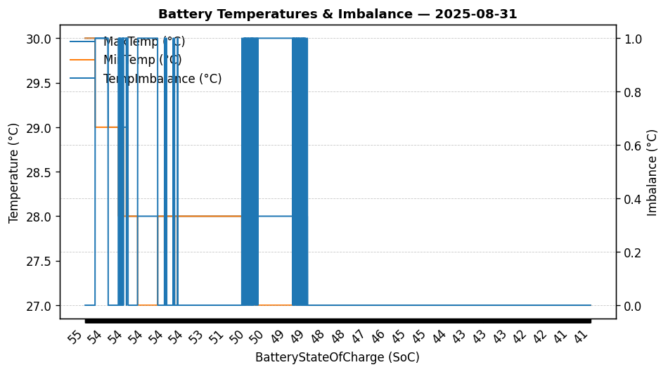

|  |  |
| --- | --- |
| Start BatteryStateOfCharge | 54.60 |
| End BatteryStateOfCharge | 41.00 |
| Most data point of MaxTempCell | batteryBmsTemperature1 |
| Most data point of MinTempCell | batteryBmsTemperature1 |
| **Max imbalance logged** | **1.00 (Count: 535)** |
| Total Records (this date) | 2876 |