**MAX imbalance observed across all Days: 2.00 (Count: 1282), on Date: 2025-08-22**

**TEMPERATURE PROFILE FOR 861409074954463**

# Date: 2025-09-01

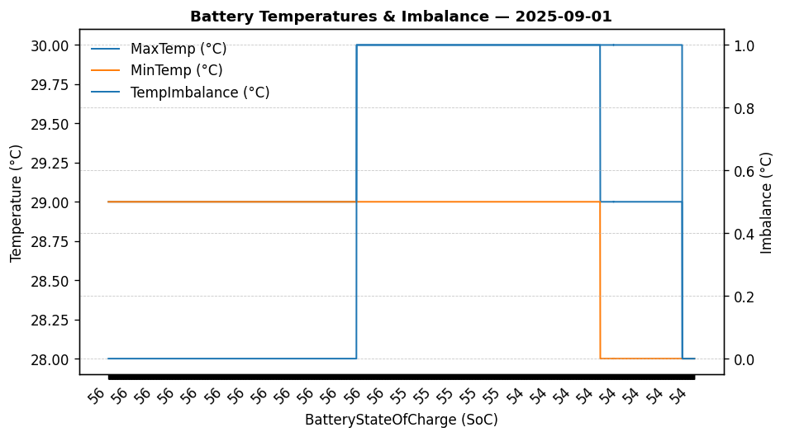

|  |  |
| --- | --- |
| Start BatteryStateOfCharge | 56.30 |
| End BatteryStateOfCharge | 53.90 |
| Most data point of MaxTempCell | batteryBmsTemperature1 |
| Most data point of MinTempCell | batteryBmsTemperature1 |
| **Max imbalance logged** | **1.00 (Count: 1301)** |
| Total Records (this date) | 2343 |

**TEMPERATURE PROFILE FOR 861409074954463**

# Date: 2025-09-02

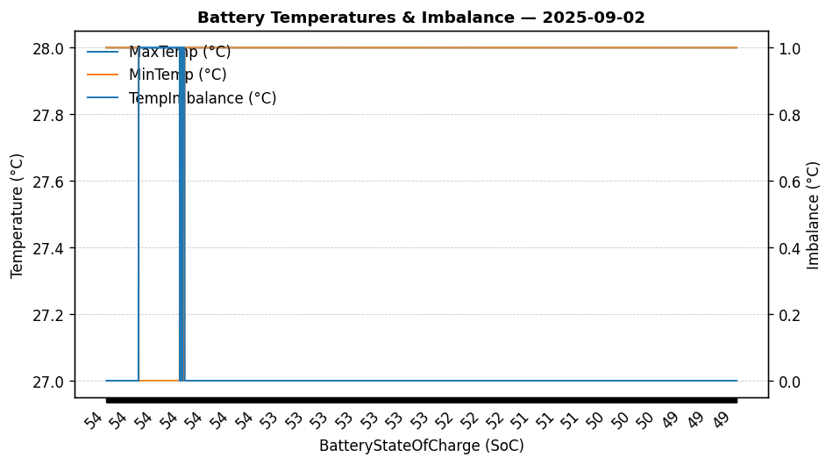

|  |  |
| --- | --- |
| Start BatteryStateOfCharge | 53.90 |
| End BatteryStateOfCharge | 49.38 |
| Most data point of MaxTempCell | batteryBmsTemperature1 |
| Most data point of MinTempCell | batteryBmsTemperature1 |
| **Max imbalance logged** | **1.00 (Count: 159)** |
| Total Records (this date) | 2236 |

**TEMPERATURE PROFILE FOR 861409074954463**

# Date: 2025-08-22

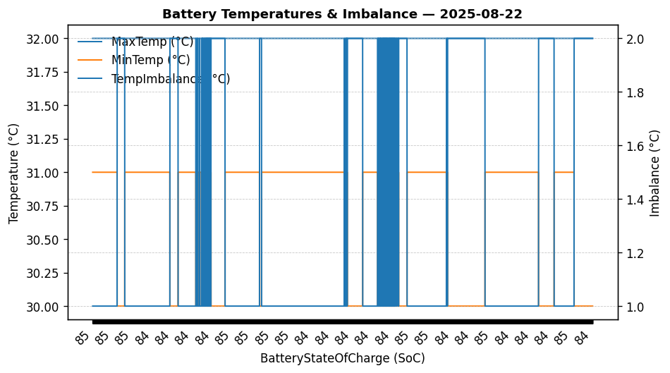

|  |  |
| --- | --- |
| Start BatteryStateOfCharge | 84.75 |
| End BatteryStateOfCharge | 83.56 |
| Most data point of MaxTempCell | battery_bms_temperature_1 |
| Most data point of MinTempCell | battery_bms_temperature_2 |
| **Max imbalance logged** | **2.00 (Count: 1282)** |
| Total Records (this date) | 4407 |

**TEMPERATURE PROFILE FOR 861409074954463**

# Date: 2025-08-27

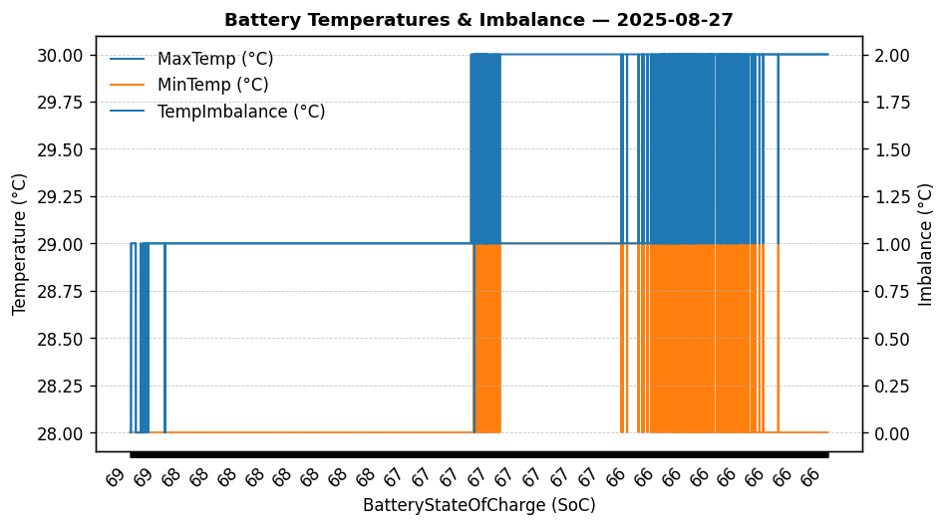

|  |  |
| --- | --- |
| Start BatteryStateOfCharge | 68.60 |
| End BatteryStateOfCharge | 65.69 |
| Most data point of MaxTempCell | batteryBmsTemperature1 |
| Most data point of MinTempCell | batteryBmsTemperature2 |
| **Max imbalance logged** | **2.00 (Count: 1310)** |
| Total Records (this date) | 5999 |

**TEMPERATURE PROFILE FOR 861409074954463**

# Date: 2025-08-28

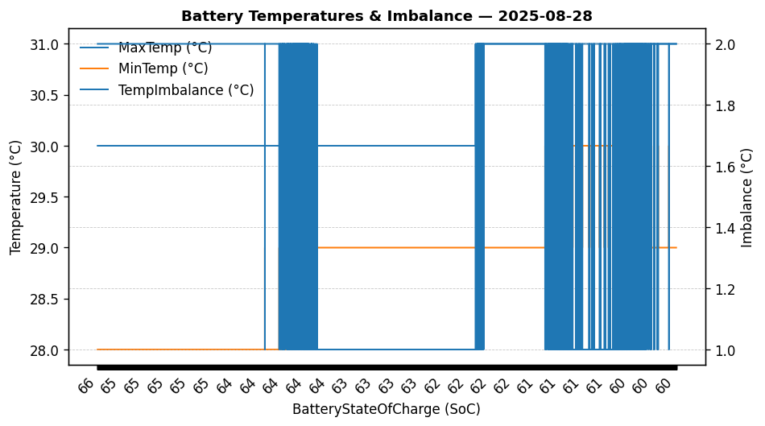

|  |  |
| --- | --- |
| Start BatteryStateOfCharge | 65.69 |
| End BatteryStateOfCharge | 59.96 |
| Most data point of MaxTempCell | batteryBmsTemperature1 |
| Most data point of MinTempCell | batteryBmsTemperature2 |
| **Max imbalance logged** | **2.00 (Count: 7549)** |
| Total Records (this date) | 13498 |

**TEMPERATURE PROFILE FOR 861409074954463**

# Date: 2025-08-29

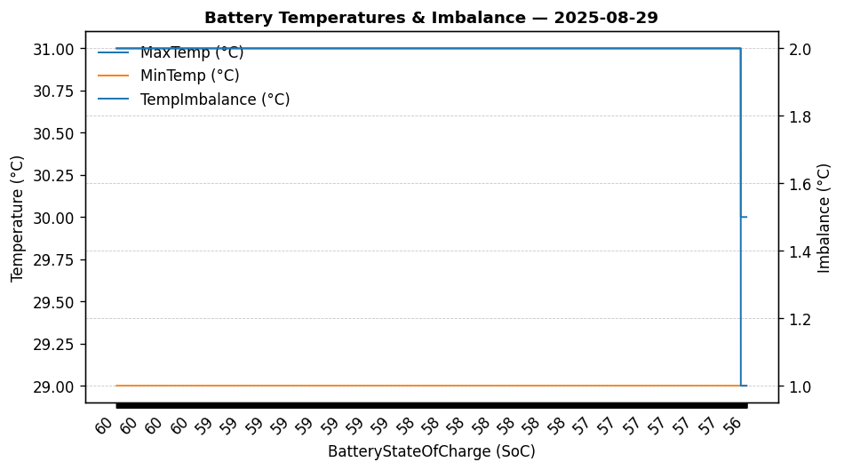

|  |  |
| --- | --- |
| Start BatteryStateOfCharge | 59.96 |
| End BatteryStateOfCharge | 56.35 |
| Most data point of MaxTempCell | batteryBmsTemperature1 |
| Most data point of MinTempCell | batteryBmsTemperature4 |
| **Max imbalance logged** | **2.00 (Count: 9228)** |
| Total Records (this date) | 9313 |