**MAX imbalance observed across all Days: 3.00 (Count: 2), on Date: 2025-08-30**

**TEMPERATURE PROFILE FOR 866082077930882**

# Date: 2025-09-01



|  |  |
| --- | --- |
| Start BatteryStateOfCharge | 72.70 |
| End BatteryStateOfCharge | 67.10 |
| Most data point of MaxTempCell | batteryBmsTemperature1 |
| Most data point of MinTempCell | batteryBmsTemperature1 |
| **Max imbalance logged** | **1.00 (Count: 2799)** |
| Total Records (this date) | 6170 |

**TEMPERATURE PROFILE FOR 866082077930882**

# Date: 2025-09-02

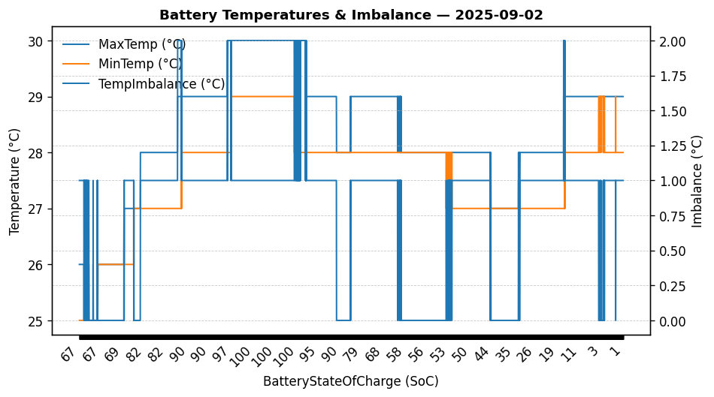

|  |  |
| --- | --- |
| Start BatteryStateOfCharge | 67.10 |
| End BatteryStateOfCharge | 0.69 |
| Most data point of MaxTempCell | batteryBmsTemperature1 |
| Most data point of MinTempCell | batteryBmsTemperature1 |
| **Max imbalance logged** | **2.00 (Count: 193)** |
| Total Records (this date) | 6529 |

**TEMPERATURE PROFILE FOR 866082077930882**

# Date: 2025-09-03

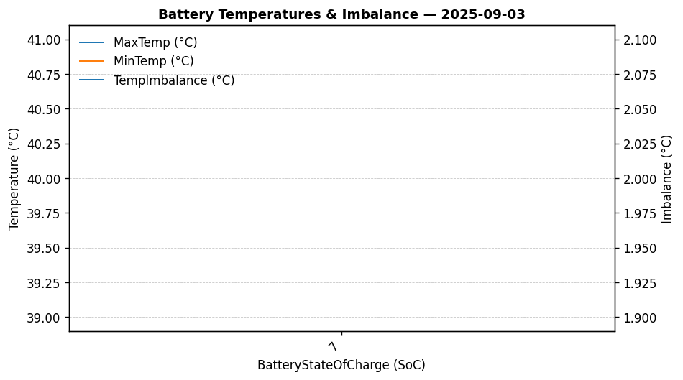

|  |  |
| --- | --- |
| Start BatteryStateOfCharge | 7.48 |
| End BatteryStateOfCharge | 7.48 |
| Most data point of MaxTempCell | battery_bms_temperature_3 |
| Most data point of MinTempCell | battery_bms_temperature_6 |
| **Max imbalance logged** | **2.00 (Count: 1)** |
| Total Records (this date) | 1 |

**TEMPERATURE PROFILE FOR 866082077930882**

# Date: 2025-08-30

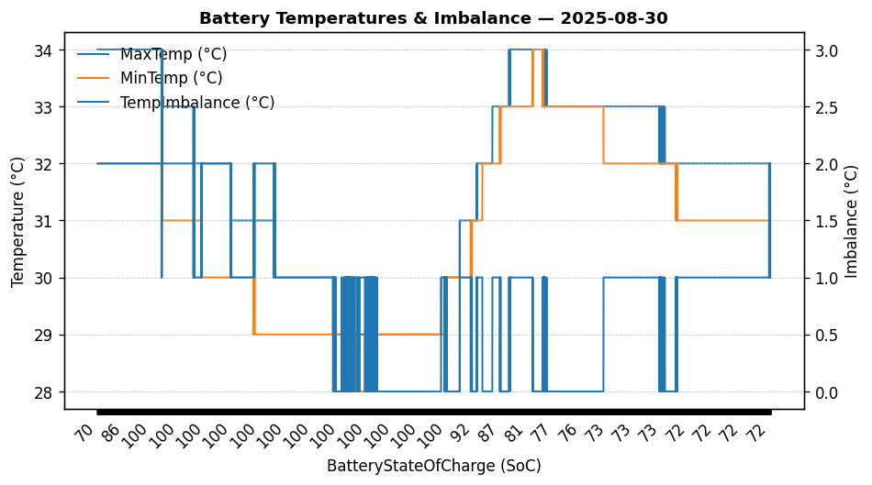

|  |  |
| --- | --- |
| Start BatteryStateOfCharge | 69.90 |
| End BatteryStateOfCharge | 71.82 |
| Most data point of MaxTempCell | batteryBmsTemperature1 |
| Most data point of MinTempCell | batteryBmsTemperature1 |
| **Max imbalance logged** | **3.00 (Count: 2)** |
| Total Records (this date) | 12847 |

**TEMPERATURE PROFILE FOR 866082077930882**

# Date: 2025-08-31

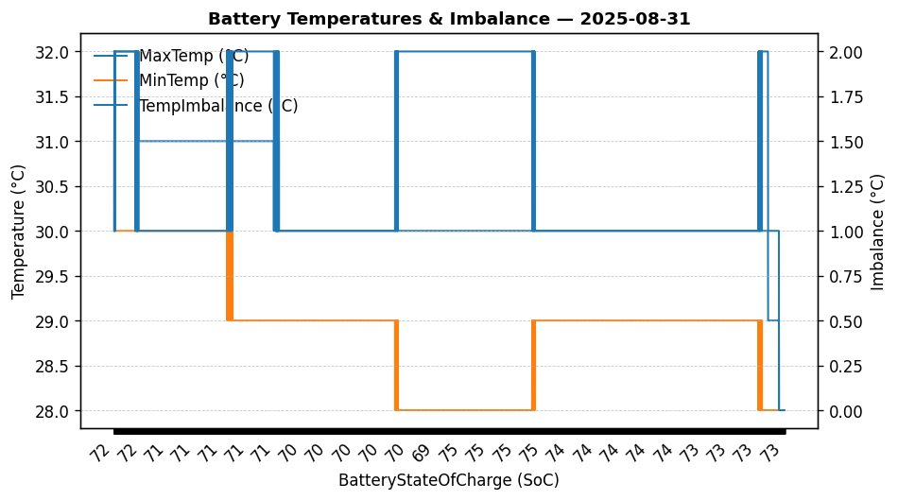

|  |  |
| --- | --- |
| Start BatteryStateOfCharge | 71.82 |
| End BatteryStateOfCharge | 72.70 |
| Most data point of MaxTempCell | batteryBmsTemperature2 |
| Most data point of MinTempCell | batteryBmsTemperature1 |
| **Max imbalance logged** | **2.00 (Count: 4475)** |
| Total Records (this date) | 13988 |