**Dataiku Installation**

**1.Pre-requisite**

1. Installing tar.gz file
2. All the requirements should be full filled <https://doc.dataiku.com/dss/latest/installation/requirements.html>
3. A minimum of 16 GB of RAM is required. If large dataset, please increase the RAM
4. The hard on the maximum number of open files and number of user processes for the Unix user account running DSS should be at least 65536

Note: Running DSS software as root is not supported.

**2. Download**

wget <https://cdn.downloads.dataiku.com/public/dss/7.0.2/dataiku-dss-7.0.2.tar.gz>

**3. Unpack the downloaded archive**

tar -xzf dataiku-dss-7.0.2.tar.gz

**4. Install**

dataiku-dss-7.0.2/installer.sh -d DATA_DIR -p 11000

Launch the installation script and need to make sure that the following packages are installed. If not installed we need to install it

git

nginx

unzip

zip

jdk

python3

Libgfortran

For nginx

Before you install nginx for the first time on a new machine, you need to set up the nginx packages repository. Afterward, you can install and update nginx from the repository.

Install the prerequisites:

sudo yum install yum-utils

To set up the yum repository, create the file named /etc/yum.repos.d/nginx.repo with the following contents:

[nginx-stable]

name=nginx stable repobaseurl=http://nginx.org/packages/centos/$releasever/$basearch/gpgcheck=1enabled=1gpgkey=https://nginx.org/keys/nginx_signing.keymodule_hotfixes=true[nginx-mainline]name=nginx mainline repobaseurl=http://nginx.org/packages/mainline/centos/$releasever/$basearch/gpgcheck=1enabled=0gpgkey=https://nginx.org/keys/nginx_signing.keymodule_hotfixes=true

To install nginx, run the following command:

sudo yum install nginx

**5. Start**

DATA_DIR/bin/dss start

**6. Enter the studio**

Browse to http://<your server address>:11000

Port No - 11000

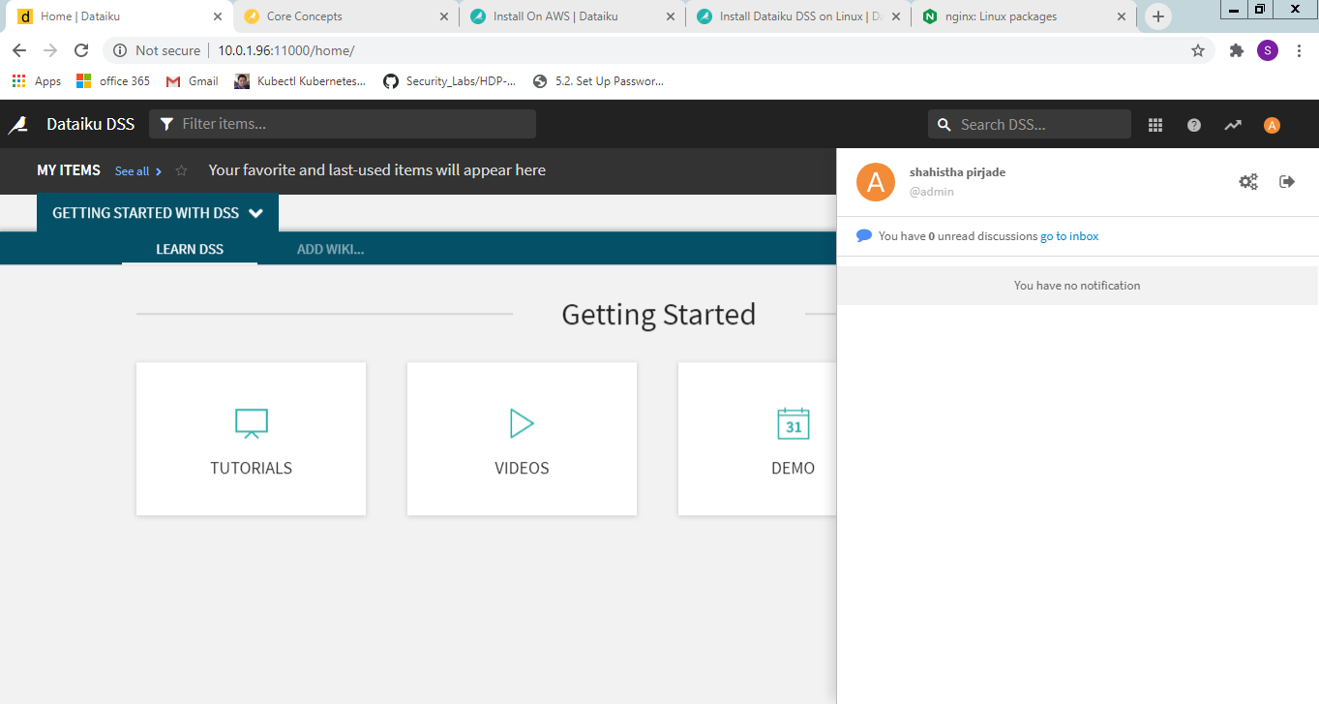

Created a Sample Project

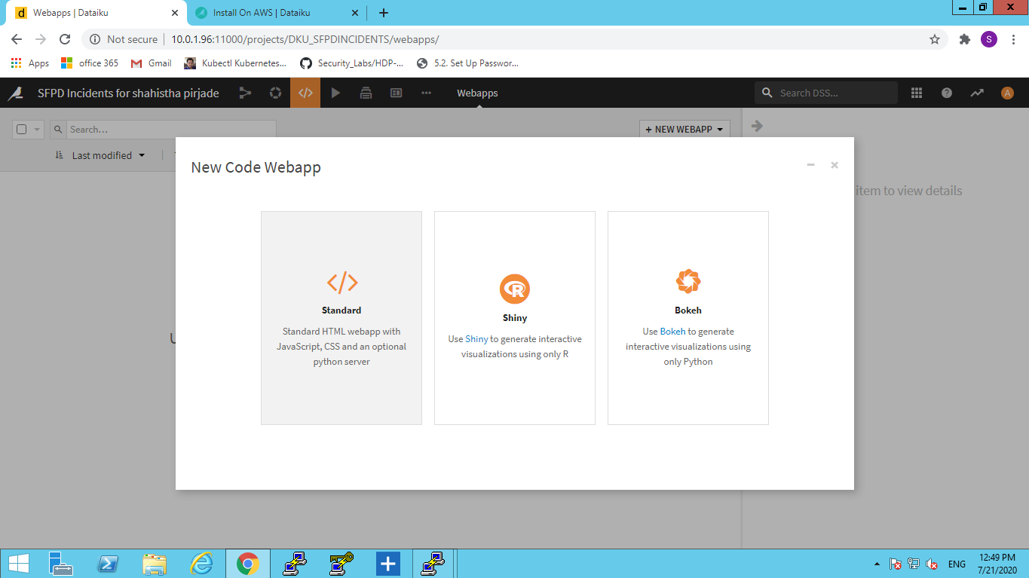

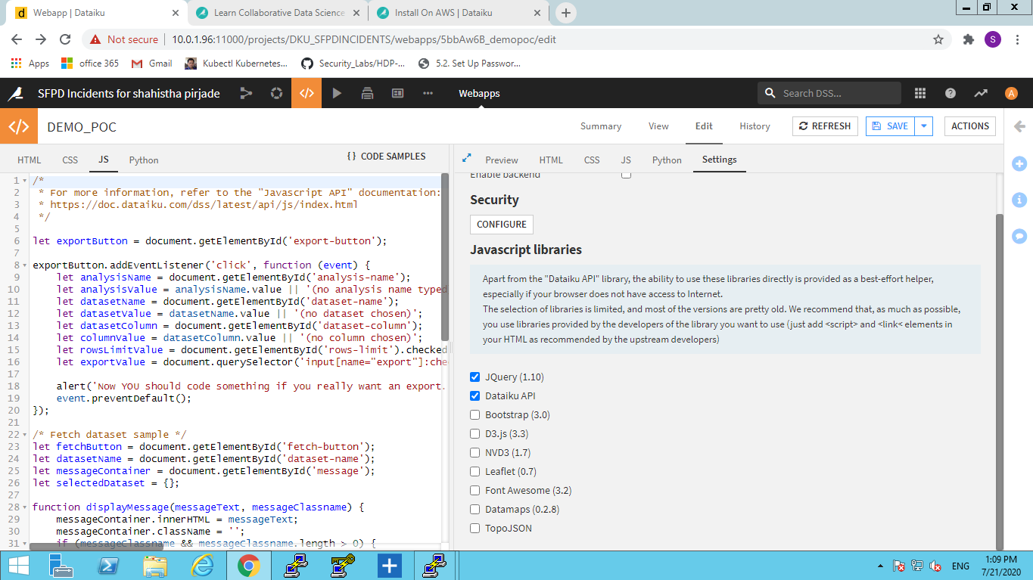

**API key** uRo20C7mgDZYl2yrLCyx2ORM2j9Lff1k

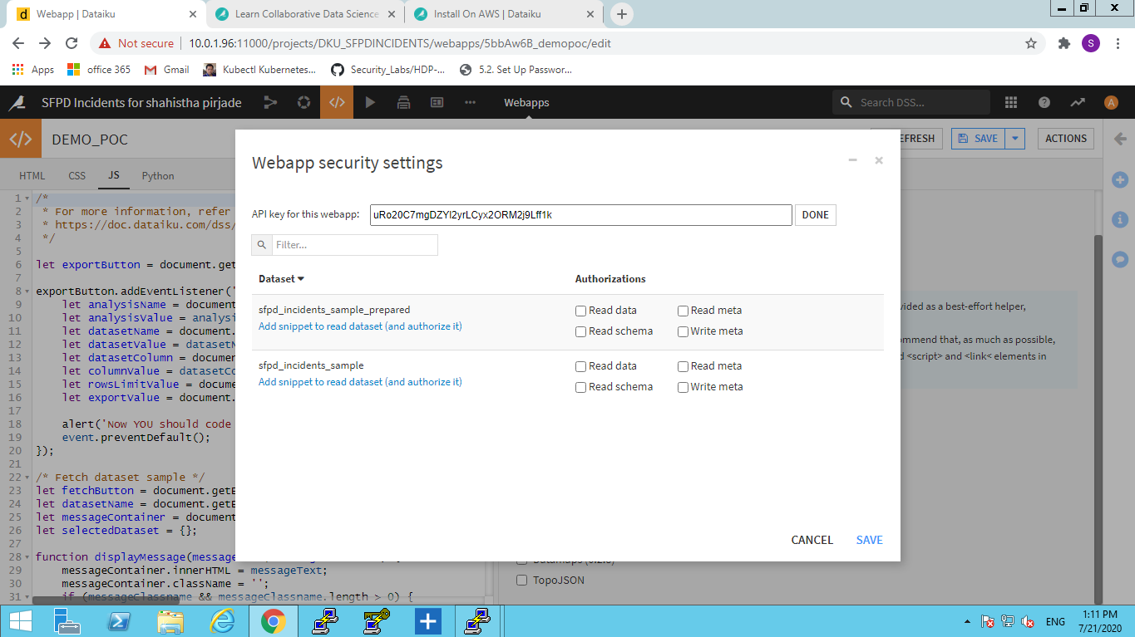

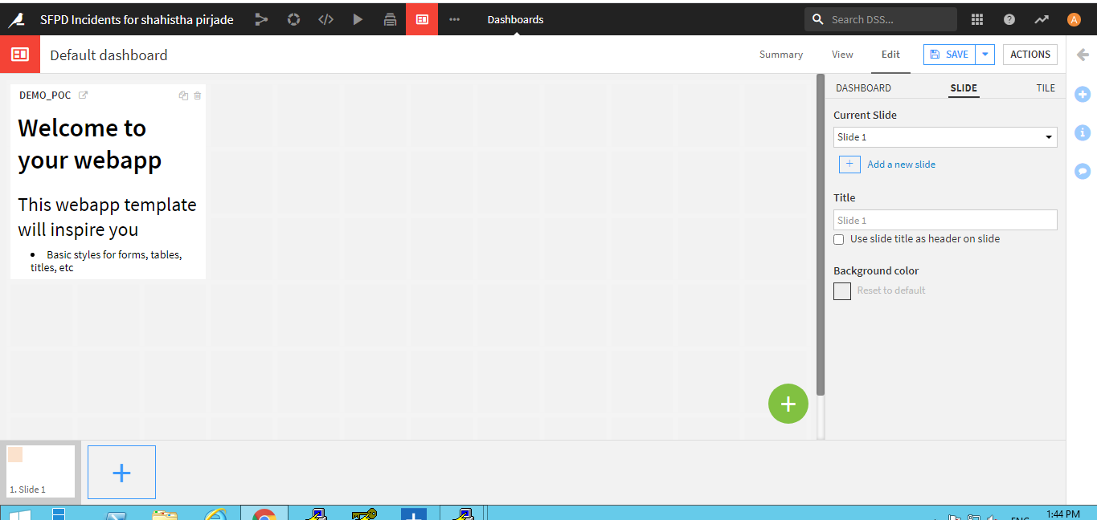

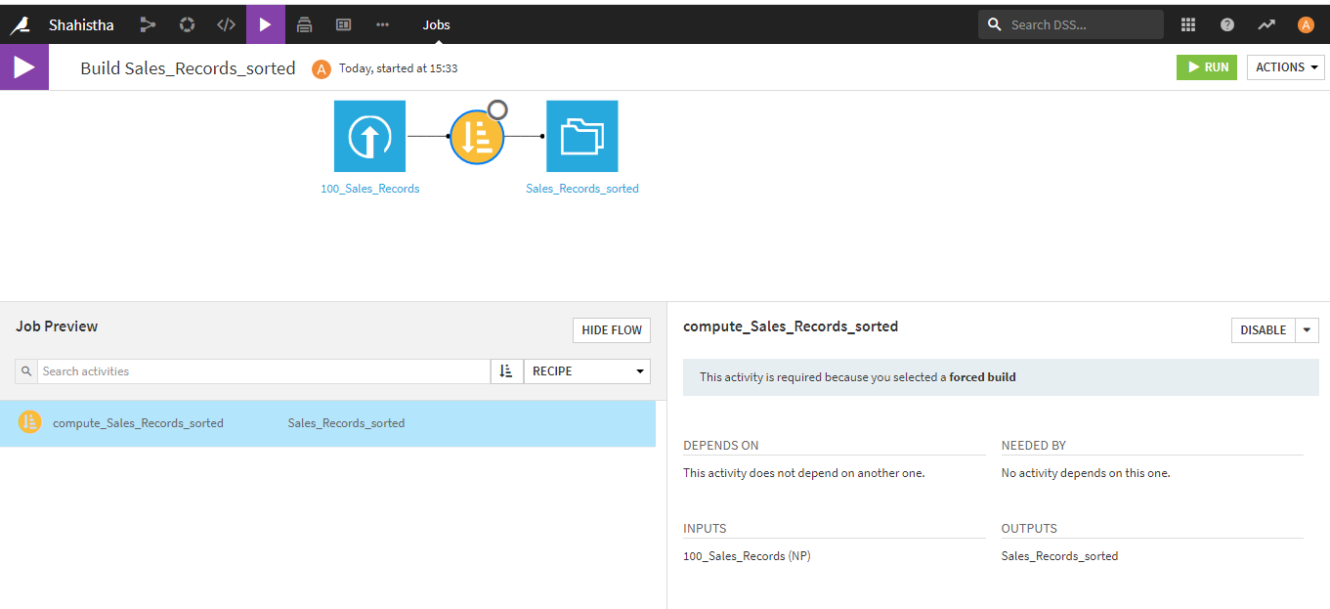

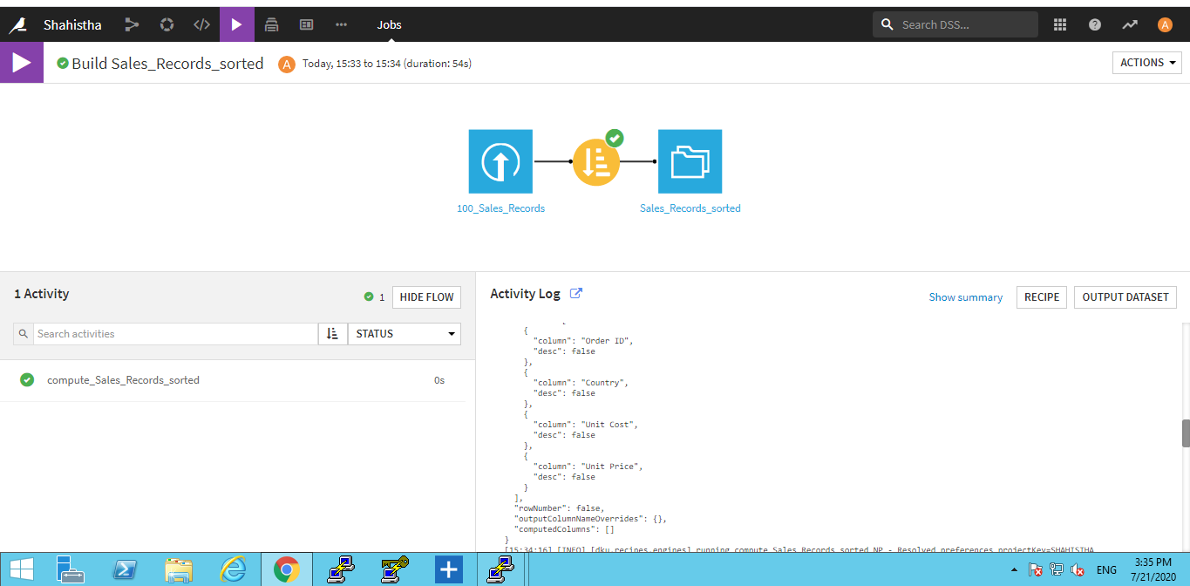

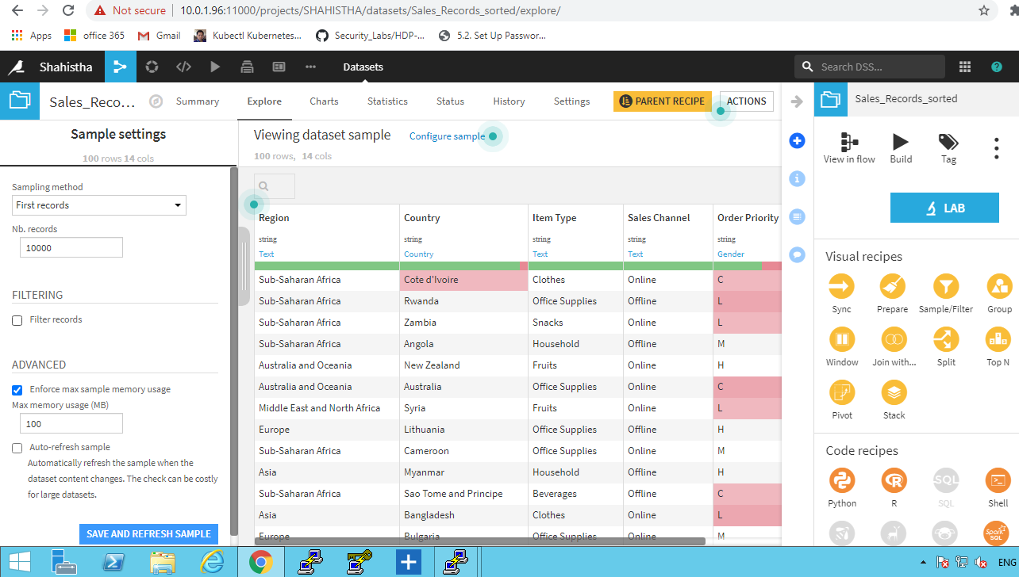



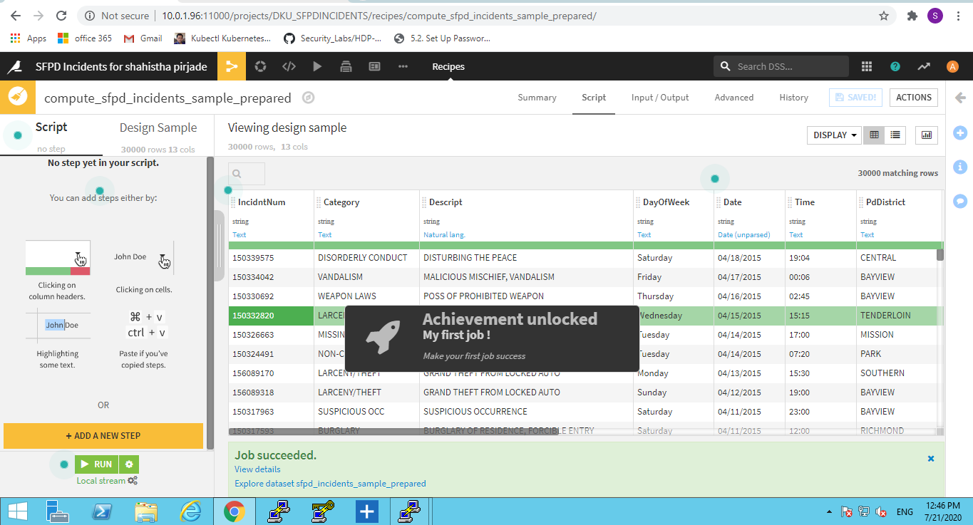

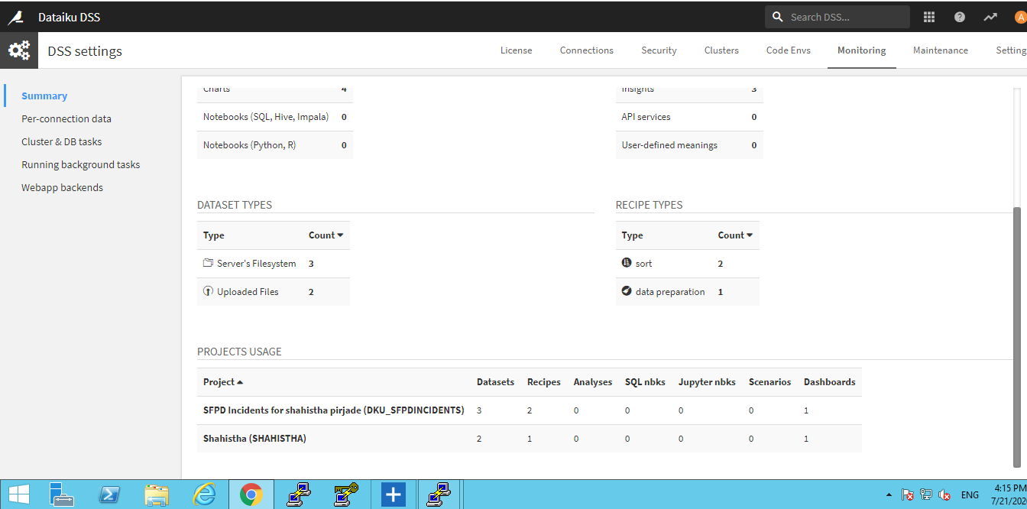

**Note :** We also have DataIKU machine AMI in aws. So we can try with this solution as well. But as it was taking time for approval from their end I tested this on Centos7 instance.