**CS 628 Modern Full-Stack Development**

**HOS01: TypeScript**

January 05, 2023 - Developed by Shingo Kise

School of Technology & Computing (STC)

City University of Seattle (CityU)

**Before You Start**

* This tutorial targets Windows users and MacOS users.
* There might be subtle discrepancies along the steps. Please use your best judgment while going through this cookbook-style tutorial to complete each step.
* For your working directory, use your course number. This tutorial may use a different course number as an example.
* The directory path shown in the screenshots may be different from yours.
* If you are not sure what to do or confused with any steps:
  + Consult the resources listed below.
  + If you cannot solve the problem after a few tries, ask a TA for help.

**Learning Outcomes**

Students will be able to:

* Set up IDE (Integrated Development Environment)
* Getting Familiar with Visual Studio Code
* Learn TypeScript Fundamentals
* Running first TypeScript program.
* Compile TypeScript file and generate JavaScript file

**Resources**

* Visual Studio Code - <https://code.visualstudio.com/>
* TypeScript Documentation - <https://www.typescriptlang.org/docs/handbook/typescript-in-5-minutes.html>
* TypeScript Tutorials | W3Schools.com - <https://www.w3schools.com/typescript/>
* Learning TypeScript - https://www.learningtypescript.com/

**Installation**

There are a few installations that we need to do for this course.

If you do not have them installed on your computer already, please follow the steps below to install them.

1. **Visual Studio Code**

In this course, we will use Visual Studio Code (Integrated Development Environment) to run TypeScript code. Visual Studio Code is a powerful developer tool that can be used with a variety of programming languages including TypeScript.

Go to <https://code.visualstudio.com/> and follow the instructions to install it on your computer.

1. **Node.js**

In order to run TypeScript in Visual Studio Code, you also need to install Node.js.

Go to <https://nodejs.org/en/> and follow the instruction to install Node.js (“Recommend For Most Users” version is recommended)

Node is a platform for running mainly server-side code, which is based on JavaScript. it uses a single-threaded event loop model, which makes everything almost non-blocking. It uses Google’s V8 JavaScript engine, which makes it high-performance and able to handle a large request load.

Node is a first-class runtime environment, which enables interacting with a local file system, accessing relational databases, calling remote systems, etc.

1. **TypeScripit**

Open Terminal on your computer and type the following

1. $ **npm i -g typescript**

- This code will install TypeScript and you will be able to run the command line with ‘tsc’ keyword

2. $ **tsc --version**

If the installation was successful, this code should print out something like Version X.Y.X

**Create a project (Mac Users) *need to write for Windows user**

1. Open Visual Studio Code
2. File > Open Folder..
3. Select the GitHub repository you just cloned.
   * It should be CS142/HOS01-YourGitHubUserName/Module1
4. Click the New File logo and name the file “script.ts”

It would look something like the image below. As you can see, ‘.ts’ creates TypeScript files.

1. Terminal > New Terminal to open Command-Line Interface (CLI)

Keep the Terminal open for the rest of this assignment.

1. In Terminal, type $ **tsc -init** and hit Enter

You should see something like this in Terminal

Also, notice tsconfig.json file is created

**tsconfig.json file**

As mentioned in the textbook, one of the key advantages of TypeScript is the compiler. tsconfig.json file plays an important key during compilation from TypeScript source code to generate JavaScript code. The file provides compiler options required to compile the project, which programmers can specify how compilation should work.

* You do not need to fully understand how tsconfig.json file works for this course, but if you want to know more about it, go to <https://howtodoinjava.com/typescript/tsconfig-json/>

1. Let’s type TypeScript first code!

Type

console.log ( ) allows us to write to the console.

1. Now we need to compile this TypeScript to JavaScript

Type $ **tsc** and press Enter in Terminal

If you pay attention to files, you can see that a JavaScript file (script.js) was automatically created.

We were able to successfully compile a TypeScript source code to JavaScript code.

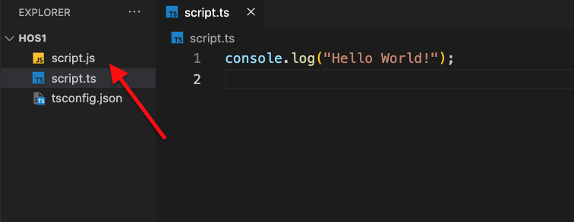

If you look at the JavaScript file, we can observe the same code that we typed in the TypeScript file. We cannot see significant differences in this case, but as the code gets more complex, the compiled file would look significantly different from the source code.

1. Let’s run the JavaScript file

Type $ **node script.js** in Terminal

“node” allows you to execute JavaScript commands from the command line.

In Terminal, we can see that “Hello World” was successfully printed out!



**Let’s Dive into TypeScript**

If you are familiar with JavaScript, you saw that there was no significant difference in the code above. In this section, we will dive deeper into TypeScript code and learn the fundamentals.

Background

TypeScript was created at Microsoft in the early 2010s then released and open-sourced in 2012. TypeScript is a strongly typed programming language that builds on JavaScript and it is often described as “a superset of JavaScript.” TypeScript is a fairly new programming language, and it continues to grow more popular due to its advantages compared to JavaScript.

* + Types
  + extends

**Pushing your work to GitHub**

Run the following commands to push your work to the GitHub repository:

Open the terminal from the VSCode by hitting the control + ~ key and type the following command:

>>> git add .

>>> git commit -m “Submission for Module 1--yourname”

>>> git push