**OUTPUT**

* **ITS MAIN MENU:-**

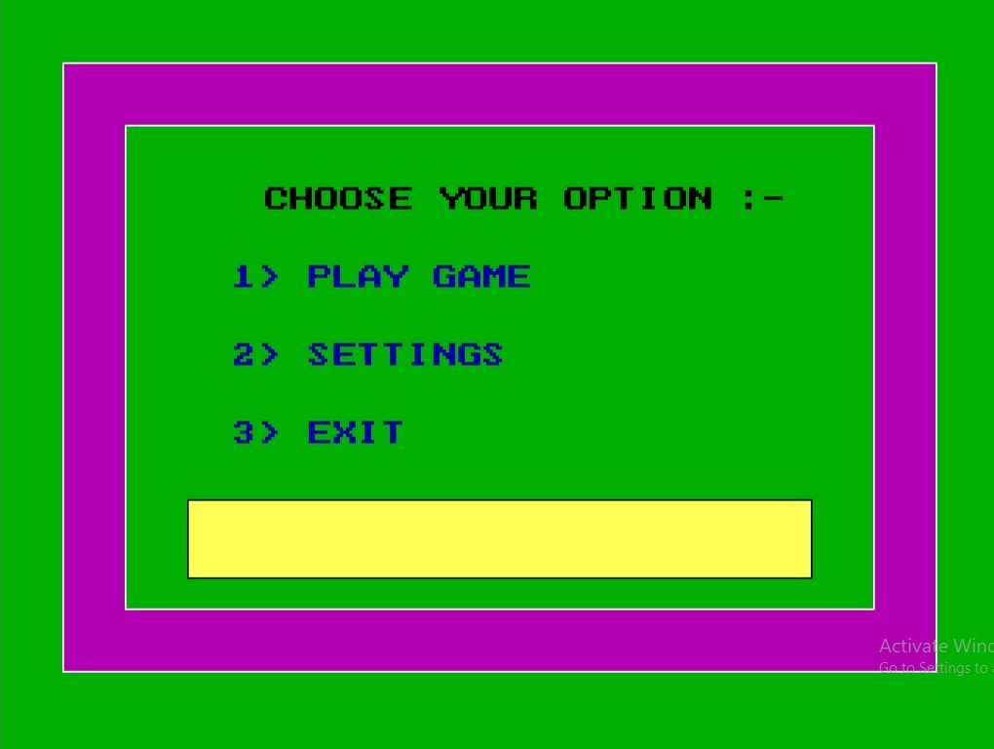

* **IN GAMEPLAY DIFFERENT QUESTION COME AND ITS VALUE ALSO HIGHLIGHTED:-**

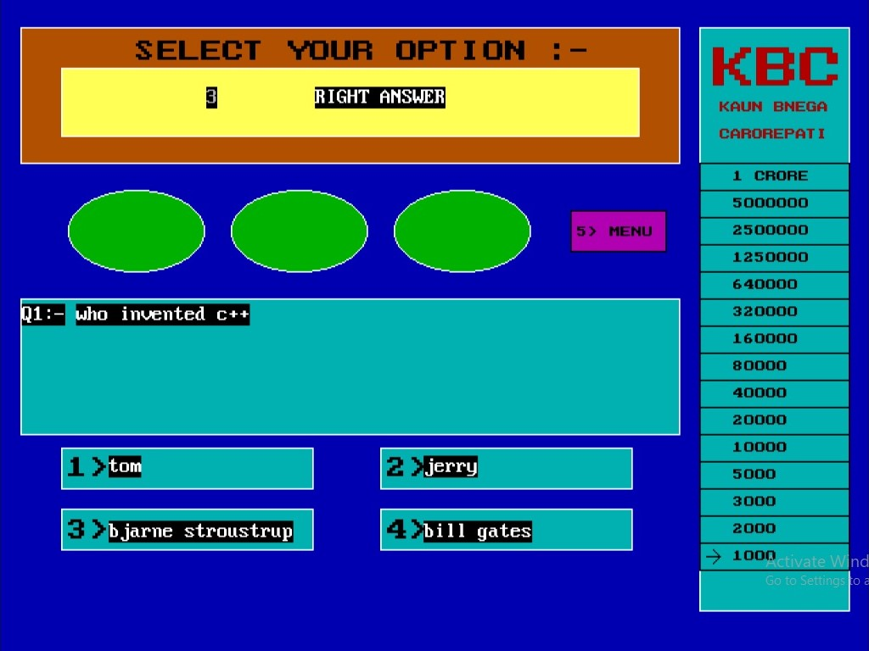

* **IN WRONG ANSWER IT SHOW MESSAGE OF WRONG ANSWER:-**

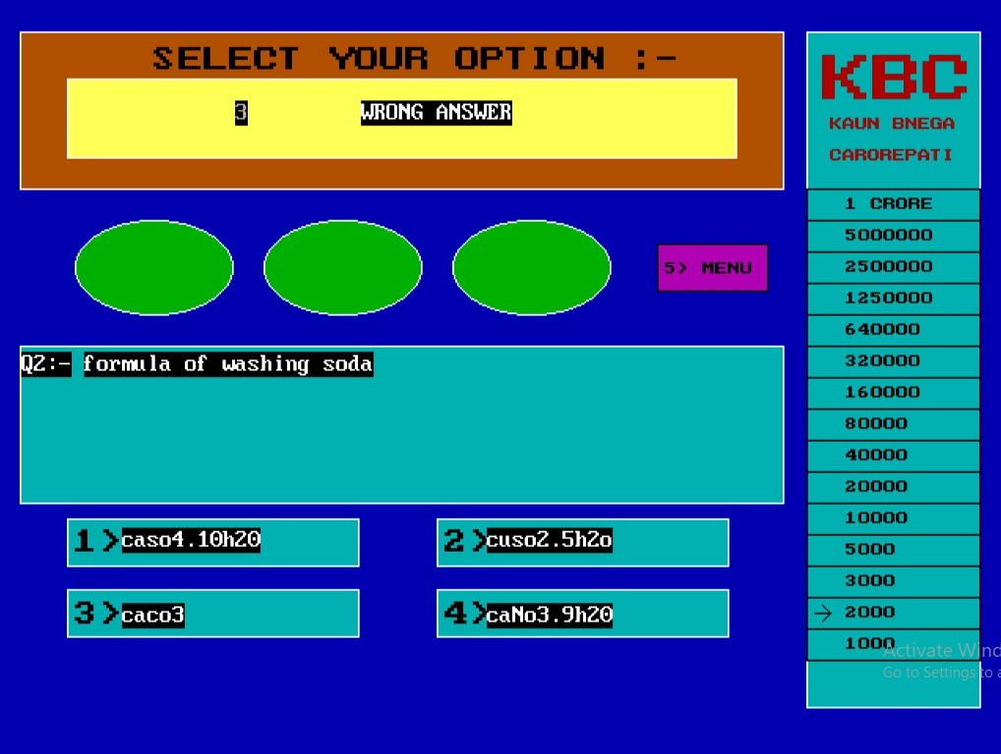

* **IT ALSO TELL HOW MUCH U WIN THE GAME:-**



* **IT ONLY ALLOW USER TO CHANGE SETTINGS WHEN CORRECT PASSWORD IS GIVEN:-**

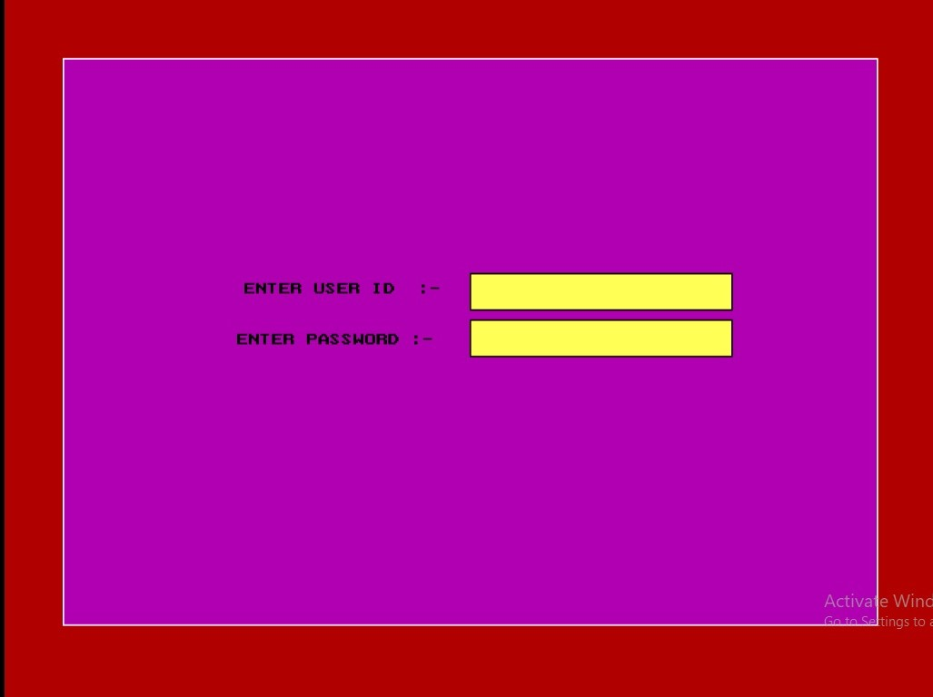

* **YOU CAN ADD OR VIEW THE QUESTIONS AND ALSO GO BACK TO MENU SCREEN:-**

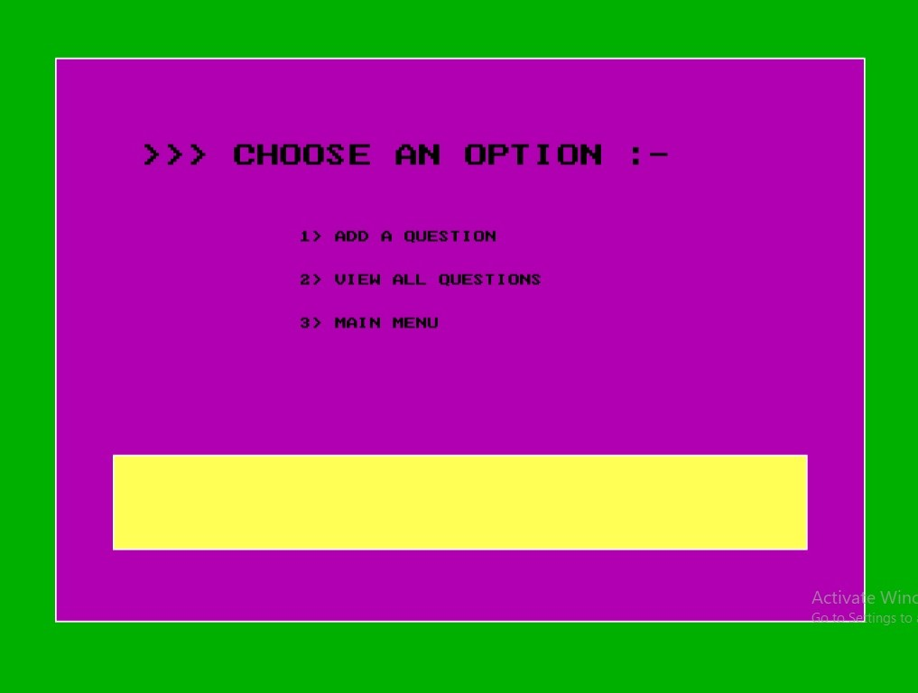

* **YOU CAN ADD QUESTION WITH CORRECT ANSWER IN THIS WAY:-**

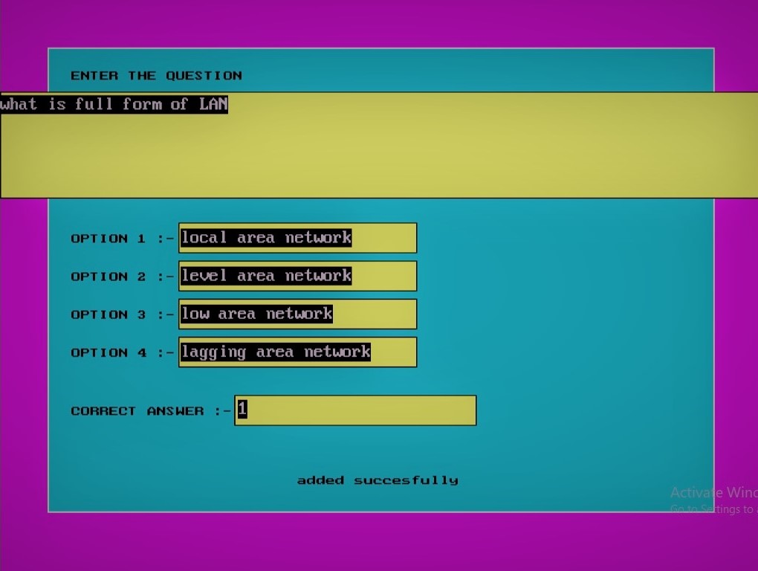

* **YOU CAN VIEW ALL THE QUESTION EXIST IN QUESTION.DAT FILE:-**

