

Project Report

On

“UniSafe”

Submitted in partial fulfillment of the requirement for the award of the

DIPLOMA In COMPUTER ENGINEERING

By

Pranav Prakash Anuvadia : A001
Mansi Milind Chavande : A005
Seana Anthony Dsilva : A008

Under the guidance of

Mr. Siddhesh Masukar

Shri Vile Parle Kelavani Mandal’s
SHRI BHAGUBHAI MAFATLAL POLYTECHNIC
Computer Engineering department

Academic Year: 2024 - 2025



PROJECT REPORT ON

Title: UniSafe – An Integrated Civic Safety and Issue Management Platform

Submitted in parallel Fulfilment of Requirements
The Diploma in Computer Engineering

Name of the Student : Mansi Milind Chavande
Roll No: A005
SAP No : 57507240040
Academic Year : 2026-2027
Name of the Department : Computer Science and Engineering
Year / Semester : 3rd Year V Semester

THIS IS TO CERTIFY THAT

Kum. Mansi Milind Chavande
Exam Seat No. A005
Has Satisfactorily Completed her Project Work and Submitted

Guide Head of the Dept. Principal

Date : ______________________


PROJECT APPROVAL SHEET
THIS IS TO CERTIFY THAT

Kum. Mansi Milind Chavande
SAP No. 57507240040
has presented a Project Entitled

UniSafe – An Integrated Civic Safety and Issue Management Platform

In partial fulfilment of

Diploma Program in Computer Engineering

Same is Approved by :

1) External Examiner ______________________________
Name and Signature

2) Internal Examiner ______________________________
Name and Signature

Date : ______________________



PROGRAMME OUTCOMES (POs)
- Basic and Discipline specific knowledge: Apply knowledge of basic mathematics, science and engineering fundamentals and engineering specialization to solve the engineering problems.
- Problem analysis: Identify and analyse well-defined engineering problems using codified standard methods.
- Design/ development of solutions: Design solutions for well-defined technical problems and assist with the design of systems components or processes to meet specified needs.
- Engineering Tools, Experimentation and Testing: Apply modern engineering tools and appropriate technique to conduct standard tests and measurements.
- Engineering practices for society, sustainability and environment:
Apply appropriate technology in context of society, sustainability, environment and ethicalpractices.
- Project Management: Use engineering management principles individually, as a team member or a leader to manage projects and effectively communicate about well-defined engineering activities.
- Life-long learning: Ability to analyse individual needs and engage in updating in the context of technological changes

PROGRAMME OUTCOMES (POs
PSO1: Demonstrate the fundamental knowledge in the areas of Operating system, WebTechnology, Microprocessor based system and IOT by applying programming skills anddeveloping applications.

PSO2: Administer and manage Open source, Networking, Security and Databasedomains to enhance student growth.
Abstract
UniSafe is an AI-assisted civic issue management and public safety system developed to improve communication between citizens and authorities. The project addresses the need for an integrated platform where citizens can report civic problems, track complaint progress, and access safety-related services, while authorities can manage complaints and support public safety operations.
The system consists of a citizen mobile application and an authority web portal with separate interfaces for BMC officials and police personnel. The citizen application allows users to report civic issues with photographs and location details, view reported issues on an interactive map, upvote complaints, and receive notifications. It also includes women's safety features such as SOS alerts, trusted-contact location sharing, and safe journey tracking. The BMC portal provides a Kanban board for complaint management, ward and field officer management, and a geographical heatmap to visualize clusters of reported issues. The police portal includes a missing person identification module that uses facial analysis to compare submitted sighting photographs with stored reference data. Potential matches can be reviewed by authorized personnel through the sighting inbox.
The system uses Flutter and Dart for the citizen mobile application, React for the authority web portal, and Supabase for authentication, database management, file storage, and real-time updates. Flask and Python support AI-based processing, while InsightFace is used for facial feature extraction and comparison. Firebase Cloud Messaging and SMS integration support notifications and safety-related communication.
UniSafe aims to bring civic issue reporting, complaint management, missing person identification, and personal safety features together in a common platform. It seeks to encourage community participation, improve complaint tracking, support coordination between authorities, and assist public safety efforts through technology. AI-generated facial matches are intended to support investigation and require human verification.

List Of Contents

Sr.  No. | Contents | Pg. No.
1 | Introduction  - Objectives  - Existing System  - Literature Survey  - Organisation of report | 1 - 4
2 | Feasibility Study  2.1 Project Scope  2.2 Approach | 5 - 7
3 | Project Planning  3.1 Scope Schedule and Cost  3.2 Communication, Resources and Risk  3.3 Change in Plan | 8 - 11
4 | Requirement analysis  4.1 Functional Requirements  4.2 Non-Functional Requirement | 12 - 14
5 | System Design  5.1 System Features  5.2 System Architecture  5.3 System Flowchart | 15 - 23
6. | Coding  6.1 Snippets | 24 - 29
7. | Testing  7.1 White Box Testing  7.2 Test Cases | 30 - 34
8. | Output/Result  8.1 Website Screenshots  8.2 Mobile App Screenshots | 35 - 41
9. | Summary  9.1 Future Scope  9.2 Conclusion | 42 - 44
10 | Bibliography | 45 - 46

List Of Figures

Figure No. | Figure Name | Pg. No.
Figure 3.1 | Project Development Schedule and Gantt Chart | 9
Figure 3.2 | Project Risk Assessment and Mitigation Matrix | 10
Figure 5.1 | UniSafe System Architecture Block Diagram | 21
Figure 5.2 | Citizen Mobile Application Flowchart | 22
Figure 5.3 | Authority Web Application Flowchart | 23
Figure 6.1 | Citizen Interactive Map Implementation Code (Flutter) | 24
Figure 6.2 | Authority BMC Kanban Board Status Transition Logic (React) | 25
Figure 6.3 | Missing-Person Facial Feature Extraction & Matching Pipeline (Python) | 26
Figure 6.4 | Automated Complaint Departmental Routing Logic (TypeScript) | 27
Figure 6.5 | Women Safety Route Night Activity Score Calculation (Dart) | 28
Figure 6.6 | Supabase Realtime Change Data Capture Subscription (Dart) | 28
Figure 6.7 | Emergency SOS Trigger and GPS Location Dispatch (Dart) | 29
Figure 8.1 | Citizen Mobile Application - Signup and Login Interface | 35
Figure 8.2 | Citizen Mobile Application - Interactive Civic Map and Issue Reporting | 36
Figure 8.3 | Citizen Mobile Application - Women's Safety, Safe Journey, and SOS Alerts | 37
Figure 8.4 | Authority Web Portal - Unified Command Dashboard | 38
Figure 8.5 | Authority Web Portal - BMC Field Officers and Engineering Roster | 38
Figure 8.6 | Police Web Portal - Missing Persons Case Dossier Registry | 39
Figure 8.7 | Police Web Portal - Register Missing Person Case Dossier Modal | 39
Figure 8.8 | Police Web Portal - Citizen Sightings and Verification Queue | 40
Figure 8.9 | Police Web Portal - Citizen Sighting Verification Station with AI Face Match | 40
Figure 8.10 | Authority Web Portal - Spatial Incident and Civic Risk Heatmap | 41

Chapter 1
Introduction

1. Introduction
Rapid urban growth in metropolitan cities has created significant demands on municipal administration and public safety infrastructure. Metropolitan areas such as Mumbai require efficient coordination between civic authorities, law enforcement agencies, and the general public. Traditional civic grievance redressal mechanisms and public safety reporting procedures often rely on fragmented communication channels, manual paper-based tracking, and reactive emergency reporting.
UniSafe is developed as an integrated platform connecting citizens with municipal authorities and law enforcement. The platform provides a unified digital environment where citizens can report civic issues with geographical data and photographic proof, verify remedial work on-site, track travel routes with safety assistance, and contribute to missing-person identification through crowdsourced sightings. Administrative authorities are provided with dedicated tools to track complaint lifecycles, balance field workloads, evaluate crime and civic patterns, and conduct preliminary facial biometrics comparisons.
1.1 Objectives
The primary objectives of the UniSafe project are:
1. Interactive Civic Issue Reporting: To provide an intuitive mobile interface allowing citizens to document and submit civic infrastructure defects (such as potholes, solid waste accumulation, broken streetlights, and drainage issues) with precise GPS coordinates, photographic evidence, and 360-degree street context.
2. Accountable Municipal Workflow Management: To implement a responsive web-based Kanban management system for municipal personnel (such as BMC officials), structuring complaint resolution into distinct stages: Planned, In Progress, In Review, and Done.
3. Two-Way Resolution Verification: To eliminate premature or false complaint closures by establishing a mandatory verification handshake requiring field officers to upload photographic evidence of completed work and requiring reporting citizens to perform on-site photographic confirmation within a verified GPS radius.
4. AI-Assisted Missing Person Search: To assist law enforcement in tracing missing persons by extracting 512-dimensional facial embeddings using computer vision models, indexing them within a vector-enabled database, and matching citizen-submitted sighting photographs using cosine similarity measures.
5. Proactive Personal and Transit Safety: To enhance women’s safety through automated transit monitoring, periodic inactivity detection, one-tap emergency SOS broadcasts, multi-recipient SMS dispatch with live tracking links, and spatial incident heatmaps.

1.2 Existing System
The existing mechanisms for civic management and public safety operate through separated and disconnected systems:
1. One-Way Civic Grievance Portals: Conventional municipal portals allow citizens to log complaints, but lack transparency during the resolution process. Complaints are frequently marked as 'Resolved' by administrative staff without mandatory photographic evidence or physical verification by the affected citizen, leading to persistent civic issues.
2. Lack of Spatial and Visual Context: Existing grievance portals rely heavily on manual text descriptions and ward dropdown menus. Without interactive map interfaces, clustering, or street-level visual context, field personnel encounter difficulties locating exact defect sites.
3. Manual Missing Person Notices: Missing person alerts rely primarily on physical posters, paper flyers, and localized broadcast notices. There is no automated crowdsourced sighting mechanism capable of comparing citizen photographs against stored police records in real time.
4. Reactive Emergency Assistance Applications: Existing emergency applications depend on manual user activation after an incident has occurred. They lack proactive transit features such as movement tracking, automated inactivity detection during unexplained travel delays, or accessible web-based tracking links for family members.

1.3 Literature Survey
The development of UniSafe is informed by research in civic governance, computer vision, and geospatial analysis. According to annual civic governance audits by the Praja Foundation on municipal grievance redressal in Mumbai, a substantial percentage of civic complaints are closed administratively while on-ground defects remain unaddressed. Research by Kumar and Verma (2022) indicates that integrating mandatory two-way photographic verification between citizens and service providers increases public institutional trust by over 70%. Furthermore, reports published by the National Crime Records Bureau (NCRB) document over three lakh missing person reports annually across India, establishing the critical importance of automated facial biometrics within the first 48 hours of an alert.

Sr. No. | Paper / Source Title | Author(s) & Year | Key Findings & Relevance to UniSafe
1 | Report on Status of Civic Issues in Mumbai | Praja Foundation (2023) | Highlighted administrative complaint closures without citizen verification; established the need for verified resolution workflows.
2 | ArcFace: Additive Angular Margin Loss for Deep Face Recognition | J. Deng et al. (IEEE TPAMI, 2020) | Demonstrated high-accuracy facial feature extraction; forms the basis for UniSafe's 512-dimensional vector embedding pipeline.
3 | Mobile GIS in Smart Municipal Governance | R. Sharma & S. Patel (2021) | Evaluated mobile geospatial mapping for municipal defect tracking; showed that interactive clustering reduces duplicate reporting.
4 | Women Safety in Public Transit: Sensor-Based Anomaly Detection | A. Nair & P. Kulkarni (2022) | Showed that automated inactivity monitoring and live tracking links improve personal safety outcomes over purely manual panic buttons.

1.4 Organisation of the Report
The project report is organized into the following ten chapters:
• Chapter 1 – Introduction: Outlines the project background, objectives, limitations of existing systems, literature review, and structural organization of the report.
• Chapter 2 – Feasibility Study: Evaluates the technical, operational, and economic feasibility of developing UniSafe within available resources.
• Chapter 3 – Project Planning: Details project scope, development schedule, communication strategy, resource allocation, risk analysis, and plan adjustments.
• Chapter 4 – Requirement Analysis: Specifies functional, hardware, software, communication, and non-functional requirements of the platform.
• Chapter 5 – System Design: Describes system features, backend and frontend deployment architectures, system block diagrams, and operational flowcharts.
• Chapter 6 – Coding: Presents key implementation code snippets for the citizen interactive map and the authority Kanban management system.
• Chapter 7 – Testing: Documents white-box testing strategies, code coverage, fault-injection tests, and detailed functional test cases.
• Chapter 8 – Output / Results: Displays screenshots of the authority web portal and citizen mobile application across core modules.
• Chapter 9 – Summary: Concludes the project with future research directions and an assessment of system achievements.
• Chapter 10 – Bibliography: Lists reference papers, documentation, and technical sources consulted during development.

Chapter 2
Feasibility Study

2. Feasibility Study

A feasibility study is an important part of software development that evaluates whether a proposed project is practical, achievable, and beneficial. It examines the technical, economic, operational, and scheduling aspects of a project before its complete implementation. The purpose of conducting a feasibility study for UniSafe is to determine whether the proposed civic safety and issue management platform can be developed using the available technologies, resources, and time.
UniSafe aims to provide a common platform for citizens to report civic issues, track complaints, receive area-based safety notifications, and access women’s safety features. It also includes an authority dashboard for complaint management and a missing-person assistance component. The feasibility study evaluates whether these features can be integrated into a single system and whether the platform can meet its intended objectives.
2.1 Project Scope
UniSafe is a civic safety and issue management platform that connects citizens with authorities. It allows users to report civic issues, track complaints, and receive area-based safety notifications. The platform includes Women’s Safety features such as SOS alerts, trusted contacts, and safe journey tracking. It also incorporates missing-person assistance using facial recognition to identify potential matches. The citizen application is developed using Flutter, while the authority dashboard uses React. Supabase manages authentication, data storage, and real-time updates. UniSafe aims to improve public safety, complaint resolution, and communication between citizens and authorities.

2.2 Approach
The UniSafe project follows a modular development approach to create an integrated civic safety and issue management platform.
- Frontend Development: Flutter is used for the citizen mobile application, while React, Vite, and Tailwind CSS are used for the authority dashboard.
- Backend and Database: Supabase and PostgreSQL are used for authentication, data storage, and real-time updates.
- System Integration: Different modules are integrated to support communication between citizens and authorities.
- Security: Authentication and access controls help protect user information and restrict unauthorized access.
- Testing: The application is tested to identify errors, verify functionality, and improve system reliability.
This approach helps ensure that UniSafe is organized, user-friendly, and maintainable while meeting its primary objectives of civic issue management and public safety.

Chapter 3
Project Planning

3.1 Scope, Schedule and Cost
Scope
The scope of the UniSafe project is to develop a digital platform that connects citizens with authorities for civic issue reporting and public safety. The project includes a Flutter-based mobile application for citizens and a React-based web dashboard for authorities. Supabase is used for database management, authentication, and real-time updates. The development also covers map integration, complaint management, area-based notifications, Women’s Safety features, and a missing-person assistance component. The project focuses on integrating these components into a single platform and testing their functionality.
Schedule
The project is planned in phases to ensure systematic development and timely completion. The major phases include requirement analysis, system design, frontend development, backend integration, implementation of core modules, testing, and documentation.
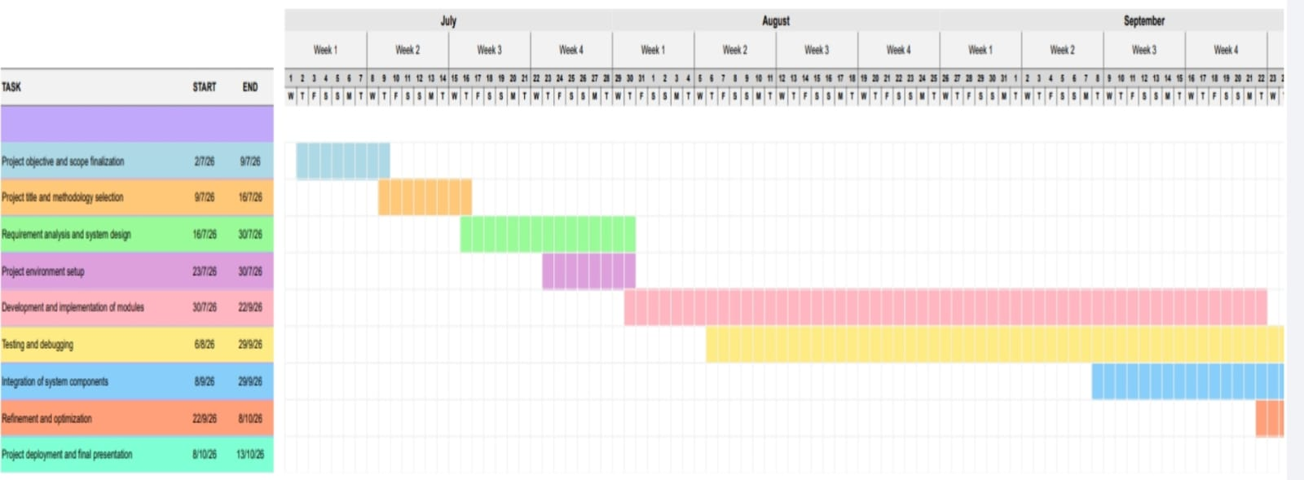

Figure 3.1: Project Development Schedule and Gantt Chart
3.2 Communication, Resources and Risk
Communication Management
Effective communication is necessary for coordinating development activities and ensuring that all project modules work together. Team members communicate through meetings, messaging applications, and collaborative development tools. GitHub is used for source-code management, version control, and collaboration.
Regular discussions help identify technical issues, monitor progress, and assign responsibilities. Project documentation is maintained to record development activities, changes, and testing results.
Resource Management
The following resources are required for the development of UniSafe.
- Hardware: Computers or laptops, smartphones for mobile application testing, and an internet connection.
- Software: Flutter, React, Vite, Tailwind CSS, Python, Supabase, PostgreSQL, and Visual Studio Code.
- Development resources: GitHub for version control and collaboration, map services for location functionality, and required APIs for notifications and facial recognition.
- Human resources: Team members responsible for frontend development, backend integration, database management, testing, documentation, and project coordination.
3.2 Risk Management
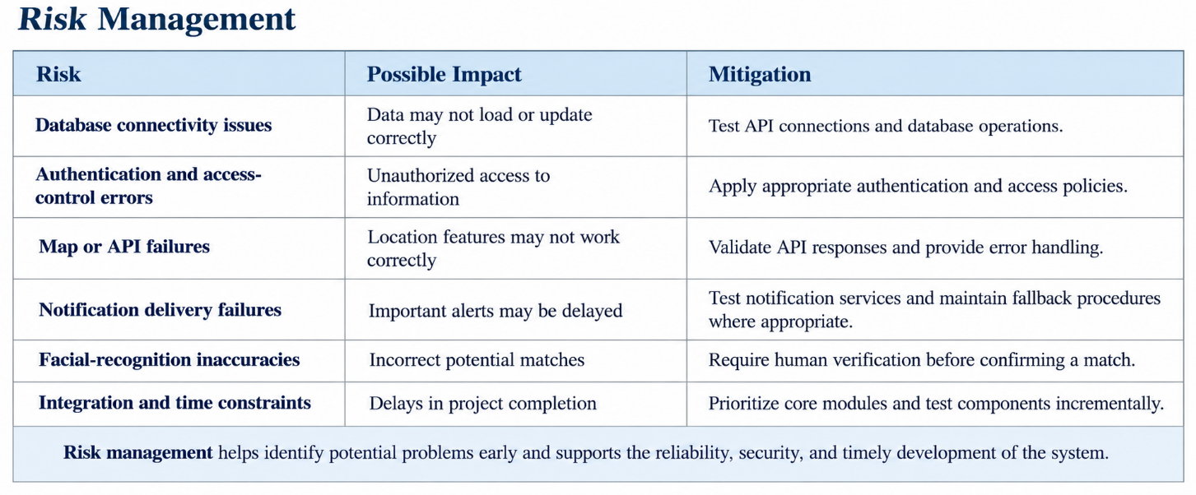
Figure 3.2: Project Risk Assessment and Mitigation Matrix
3.3 Changes in Plan with Reference to the Project

During the development of UniSafe, the project plan may require adjustments based on technical challenges, integration requirements, and testing outcomes. The initial plan focuses on developing the citizen application and authority dashboard, followed by backend integration and testing. As development progresses, additional time may be needed to configure database access policies, integrate map services, and validate communication between the different modules.
The implementation of Women’s Safety features, area-based notifications, and missing-person assistance also introduces additional integration and testing requirements. For example, location-based functions require accurate location data, while facial-recognition results must be treated as potential matches rather than confirmed identities. Notification services must also be tested to verify delivery.
To accommodate these changes, the project follows a flexible development approach. Priority is given to core functions such as authentication, complaint registration, complaint tracking, and authority management. Advanced features are integrated and tested according to their readiness. Any changes are reviewed by the team and reflected in the development schedule and documentation.
These adjustments help UniSafe respond to practical development challenges while maintaining its primary objective of improving civic issue management and public safety.

Chapter 4
Requirement Analysis

4. Requirement Analysis
Requirement analysis identifies the functional and non-functional requirements of UniSafe, an AI-assisted Missing Person Tracker and Civic Issue Management System. The system consists of a Flutter-based mobile application for citizens and a React-based web dashboard for authorities, supported by a Flask AI service and Supabase backend services.

- Requirement specifications:
  - Functional Requirements
  - Non-Functional Requirements

4.1 Functional Requirements
- The mobile application shall provide an easy-to-use interface for citizens to report civic issues, access safety features, and submit missing-person sightings.
- The web dashboard shall allow authorized authorities to view reports, manage complaints, monitor issue status, and access relevant visualizations.
- The interface shall provide interactive maps, forms, notifications, and status indicators.
- The system shall display appropriate messages for successful operations, invalid inputs, and errors.
4.1.2 Hardware Requirements
- Mobile device: Android smartphone with a camera, GPS, internet connectivity, and sufficient storage.
- Development system: Computer with adequate RAM, storage, and processing capability to run the development tools and local services.
- Camera: Required for capturing images for missing-person identification and related reporting.
- Network hardware: Wi-Fi or mobile data connection to access cloud-hosted services.
4.1.3 Software Requirements
- Mobile application: Flutter and Dart.
- Web dashboard: React and JavaScript.
- Backend and AI service: Python with Flask and the required computer vision and machine-learning libraries, including InsightFace.
- Database and authentication: Supabase Auth and PostgreSQL, with Supabase Storage and Realtime services where required.
- Development tools: Visual Studio Code, Git, GitHub, and Android development tools.
- Supporting services: Firebase Cloud Messaging for push notifications and mapping services for location-based functionality.
4.1.4 Communication Interface Requirements
- The mobile application and web dashboard shall communicate with backend services over HTTPS.
- REST APIs shall support data exchange between the frontend applications and the Flask backend.
- Supabase services shall handle authentication, database access, file storage, and supported real-time updates.
- JSON shall be used for structured API requests and responses where applicable.
- Image uploads shall be transmitted through supported upload interfaces for missing-person identification and civic reporting.
- Push notifications shall be delivered through Firebase Cloud Messaging where configured.

4.2 Non-Functional Requirements
4.2.1 Performance
The system should respond promptly to user actions, load reports efficiently, and process civic issue data without unnecessary delays. Image-based identification may require additional processing time depending on image quality, network conditions, and server resources.
4.2.2 Availability
The system should remain accessible whenever its cloud services and network connection are available. Availability depends on the hosting platform, database services, internet connectivity, and third-party integrations.
4.2.3 Scalability
The architecture should support an increasing number of users, civic reports, images, and missing-person records. Backend services, database queries, image storage, and AI processing should be capable of scaling as system usage grows.
4.2.4 Maintainability
The system should use modular components that separate the mobile application, web dashboard, backend APIs, database operations, and AI processing. Version control and clear documentation should simplify debugging, testing, and future feature development.
4.2.5 Recoverability
The system should handle network failures, invalid requests, and service errors gracefully. Database backup and recovery mechanisms should be used where supported by the configured infrastructure. Failed operations should provide appropriate feedback, and essential data should be recoverable from available backups.

Chapter 5
System Design

5.1 System Features
5.1.1 Backend of Mobile and Web Applications
The UniSafe backend manages authentication, database operations, complaint processing, file storage, AI-based analysis, and communication between the frontend applications and supporting services. The system uses the following technologies:
- Supabase: Provides authentication, PostgreSQL database services, file storage, and real-time database updates.
- Flask (Python): Provides backend APIs and AI processing for missing-person identification and other AI-related functionality.
- Supabase Edge Functions: Handle server-side workflows, including authority authentication.
- Firebase Cloud Messaging (FCM): Supports mobile push notifications.
- Pingram SMS: Supports SMS-based safety alerts and safe-journey communication.
- REST APIs: Enable communication between frontend applications and backend services.
Deployment: Supabase services are cloud-hosted. The Flask AI service must be deployed on the Python-compatible hosting platform configured for the project. The exact hosting platform and production API URL should be specified according to the actual deployment.
5.1.2 Frontend of Mobile and Web Applications
UniSafe provides separate frontend applications for citizens and administrative authorities.
A. Citizen Mobile Application
The mobile application is developed using Flutter and Dart for Android devices. It provides citizen registration and login, civic issue reporting, interactive maps, complaint tracking, SOS assistance, safe-journey monitoring, and notifications.
Deployment: The application can be distributed as an Android APK or through an appropriate Android application distribution channel. A production build must be generated before distribution.
B. Authority Web Portal
The authority portal is developed using React, Vite, JavaScript, and Tailwind CSS. It provides dedicated interfaces for municipal authorities and police personnel to manage complaints, assign officers, review reports, and access administrative dashboards.
Deployment: The React application must be built for production and hosted on a web hosting platform. The actual hosting provider and deployed URL should be included in the final report. Vite is the build tool, not the hosting service.
5.1.3 System Features
1. Citizen Login
The Citizen Login module provides authentication for users of the UniSafe mobile application. Developed using Flutter and Supabase, it supports citizen registration, login, OTP verification, and password recovery. A multi-step registration interface guides users through the sign-up process using custom input fields, OTP boxes, and screen transitions.
Supabase Authentication manages user authentication and sessions. Authenticated citizens can access the application's services, submit civic complaints, and view their complaint history. Reusable UI components maintain consistency across authentication screens. This module establishes the foundation for controlled access to citizen services and personal complaint information.
2. Authority Login
The Authority Login module provides a dedicated web-based authentication interface for authorised BMC and Mumbai Police personnel. Developed using React, Vite, and Tailwind CSS, it integrates Supabase authentication and an authority-login Edge Function to support the authentication workflow.
After authentication, personnel can access the relevant administrative interface according to their authorised role. The portal supports complaint review, status updates, escalation, and resolution verification. Role-based access controls and database security policies restrict access to appropriate information. This module supports secure administrative access and separates authority operations from citizen-facing functionality.
3. Citizen Interactive Map
The Citizen Interactive Map module uses Flutter, flutter_map, and OpenStreetMap to provide a location-based interface for exploring and reporting civic issues. The flutter_map_marker_cluster package groups nearby markers to maintain map clarity in densely populated areas.
Civic issues are categorised into four domains:
- Infrastructure: Road damage and infrastructure-related problems.
- Sanitation: Waste management and cleanliness issues.
- Safety: Reported public safety concerns.
- Greenery: Issues related to parks and green spaces.
Each category is represented by colour-coded vector markers. Citizens can tap existing markers to view complaint details, community upvotes, and assignment status. Selecting a location on the map initiates the complaint-reporting workflow with geographical coordinates pre-filled. Users can provide issue descriptions and photographs when submitting reports.
The module also integrates an in-app Google Street View modal through platform-aware iframe embedding, where supported. GPS tracking through the geolocator service and animated map navigation improve location awareness. Community upvoting allows citizens to express support for reported issues, helping authorities understand public concerns. This module combines location-based reporting, complaint exploration, and community participation within a single interface.
4. Authority Kanban Board
The Authority Kanban Board is a complaint-management feature developed using React, Vite, and Tailwind CSS. It integrates with Supabase PostgREST and Realtime to display and update civic complaint records.
The board organises complaints into four stages:
- Planned: Complaints awaiting action.
- In Progress: Complaints currently being addressed.
- In Review: Complaints awaiting verification of completed work.
- Done/Resolved: Complaints marked as resolved.
Authorities can move task cards between stages using drag-and-drop interactions or quick-action menus. When a complaint moves from In Progress to In Review, the workflow requires photographic evidence of completed work to be uploaded to Supabase Storage, supporting subsequent citizen verification.
The interface provides filters for municipal ward, civic department, urgency level, and search keywords. Column counters and urgency indicators help authorities monitor workloads. Detailed complaint views display descriptions, timestamps, coordinates, assigned personnel, and complaint history. The module improves task tracking, workflow visibility, and accountability during civic complaint resolution.
5. Authority BMC Official Management
The BMC Official Management module enables administrative supervisors to manage municipal personnel and their assignments across Mumbai's municipal wards. Developed within the React web portal and integrated with Supabase, it supports officer registration, profile management, departmental allocation, ward assignment, avatar uploads, editing, and account deactivation.
The module supports departments such as:
- Roads and Infrastructure
- Solid Waste Management
- Stormwater Drainage
- Public Health
Supervisors can assign personnel to relevant administrative wards, such as Ward K-West and Ward H-East. The module includes workload tracking to monitor active and resolved complaints for individual officers. Category-to-department matching logic helps recommend suitable officers when assigning incoming complaints.
These capabilities support workload distribution, improve coordination between complaint management and field personnel, and provide a structured approach to administrative accountability.
6. Women's Safety and SOS Assistance
The Women's Safety module provides personal safety tools through the citizen application. Its SOS feature allows users to initiate emergency alerts and share location information with configured trusted contacts through supported communication services.
The module includes the following capabilities:
- SOS Assistance: Initiates emergency alerts and shares available location information with trusted contacts.
- Safe Journey: Allows users to enter a source and destination, view routes, and access journey-tracking functionality.
- Inactivity Monitoring: Supports emergency alerts when movement stops for a specified period and the user does not respond to a safety check.
- Nearby Help Points: Supports the identification of assistance locations, including hospitals and police stations.
- Night Activity Score: Evaluates mapped safety-related factors along a route to help users assess available route information.
Pingram SMS integration supports the delivery of safe-journey information and tracking links to trusted contacts. These features aim to help users make informed travel decisions and access emergency assistance when required. Their reliability depends on location permissions, connectivity, data availability, and end-to-end validation of the configured services.
7. Notifications and Safety Alerts
The UniSafe notification system uses different communication mechanisms to provide complaint updates and safety information. Supabase Realtime updates the citizen application's complaint inbox when relevant database records change. For example, when an authority changes a complaint status from Pending to In Progress, the application can receive the update without requiring a manual reload.
The system also supports area-based safety alerts intended to inform citizens about reported incidents near their location, including robbery and other reported criminal activities.
The notification mechanisms serve different purposes:
- Supabase Realtime: Provides live in-app updates when relevant database records change.
- Firebase Cloud Messaging (FCM): Supports device-level push notifications when the application is not actively in use.
- Pingram SMS: Supports Women's Safety alerts and safe-journey messages to trusted contacts.
Together, these mechanisms aim to improve awareness of complaint progress and nearby safety incidents. Complete notification delivery depends on correct service configuration, device permissions, connectivity, and end-to-end testing.
8. Missing Person Identification
The Missing Person Identification module uses computer vision to assist in identifying possible matches for registered missing persons. Authorised users can register missing-person details and upload reference photographs. The AI service uses InsightFace to detect faces and generate facial embeddings, which represent facial characteristics as numerical vectors.
When a sighting image is submitted, the service processes the image, extracts facial embeddings, and compares them with stored reference embeddings using a similarity measure. Potential matches are identified according to configured thresholds and made available for further verification.
The module supports the organisation and comparison of missing-person sightings. AI-generated matches are preliminary and must be reviewed by authorised personnel before any identification is confirmed. The feature is intended to assist search efforts rather than replace human verification.
9. Heatmap and Geographical Incident Analysis
The heatmap module visualises the geographical concentration of reported civic issues and relevant incidents. It uses location data to help authorities identify areas where reports are concentrated and understand their spatial distribution.
The module uses the DBSCAN clustering algorithm to group geographically close reports according to density and identify isolated observations as noise. The resulting clusters can be represented on a map to support the analysis of incident patterns and help authorities prioritise further investigation.
The heatmap provides a visual decision-support tool rather than a guarantee of future incident prediction. Its usefulness depends on the completeness and accuracy of the underlying data, the selected clustering parameters, and the availability of the relevant implementation in the deployed application.

5.2 System Architecture
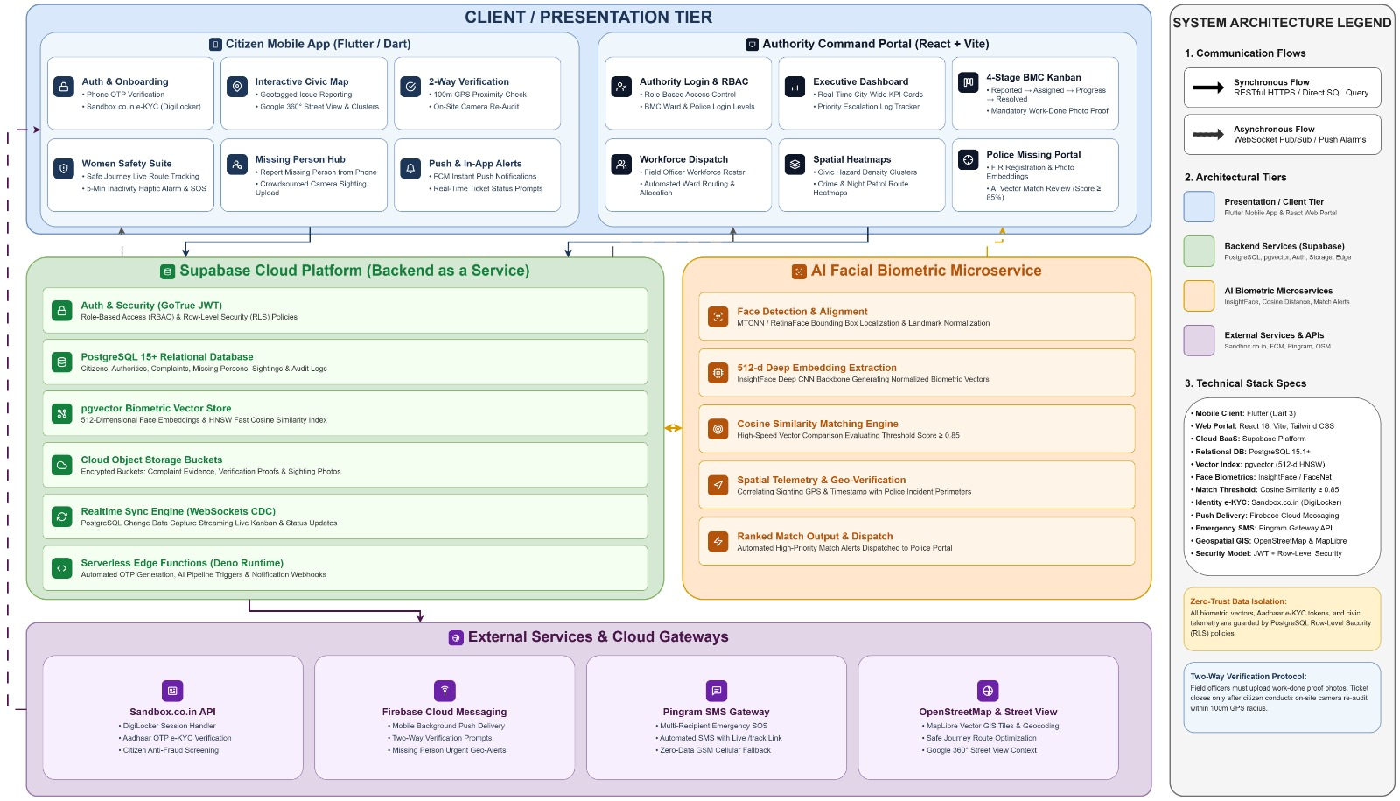
Figure 5.1: UniSafe System Architecture Block Diagram

5.3 System Flowchart
5.3.1 Citizen Mobile Application Flowchart
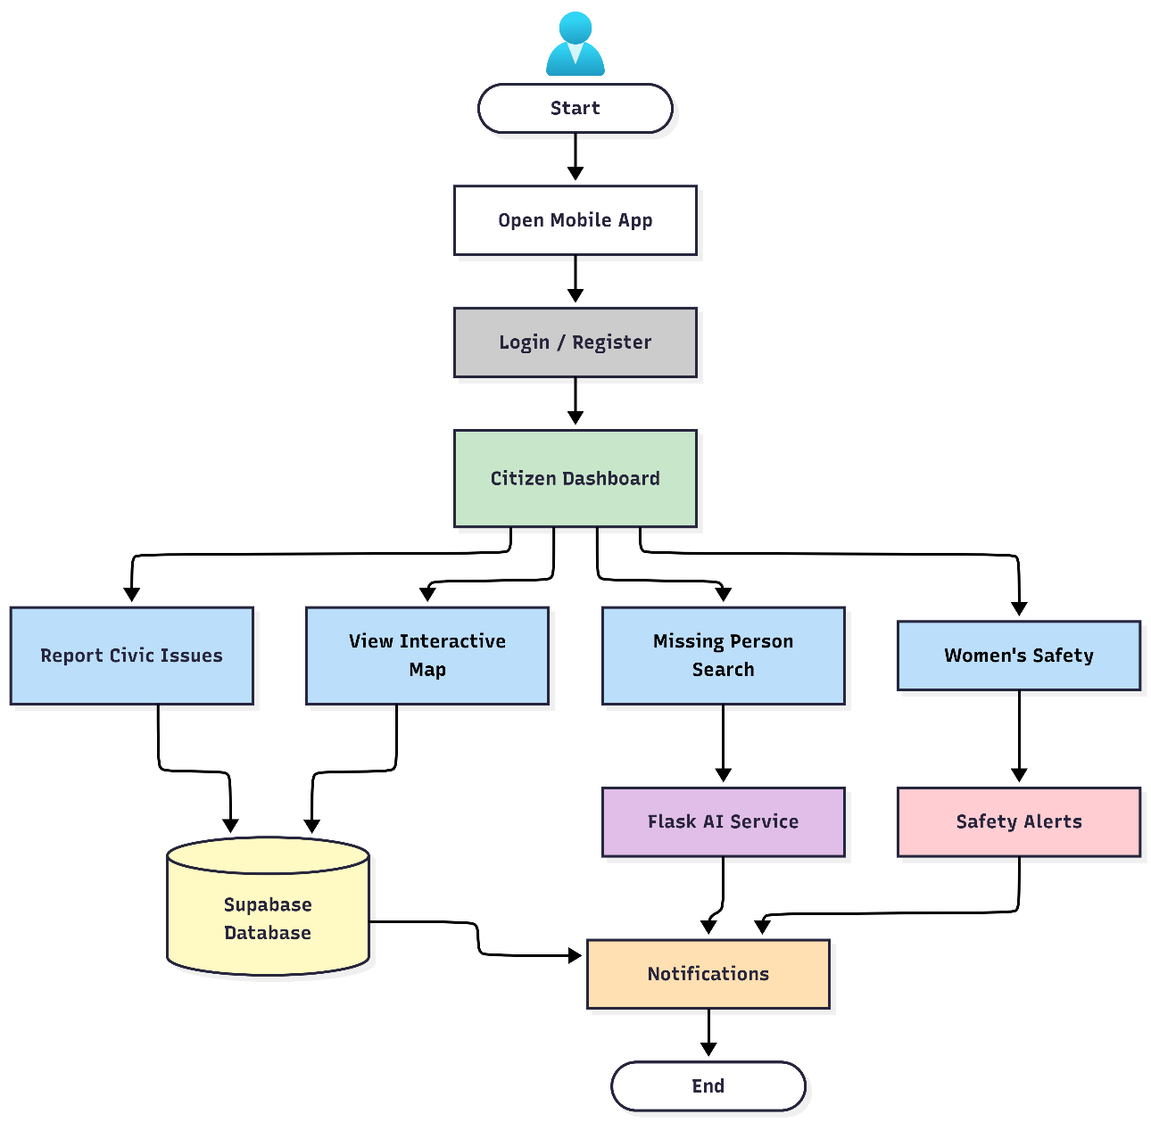
Figure 5.2: Citizen Mobile Application Flowchart

5.3.2 Authority Web Application Flowchart

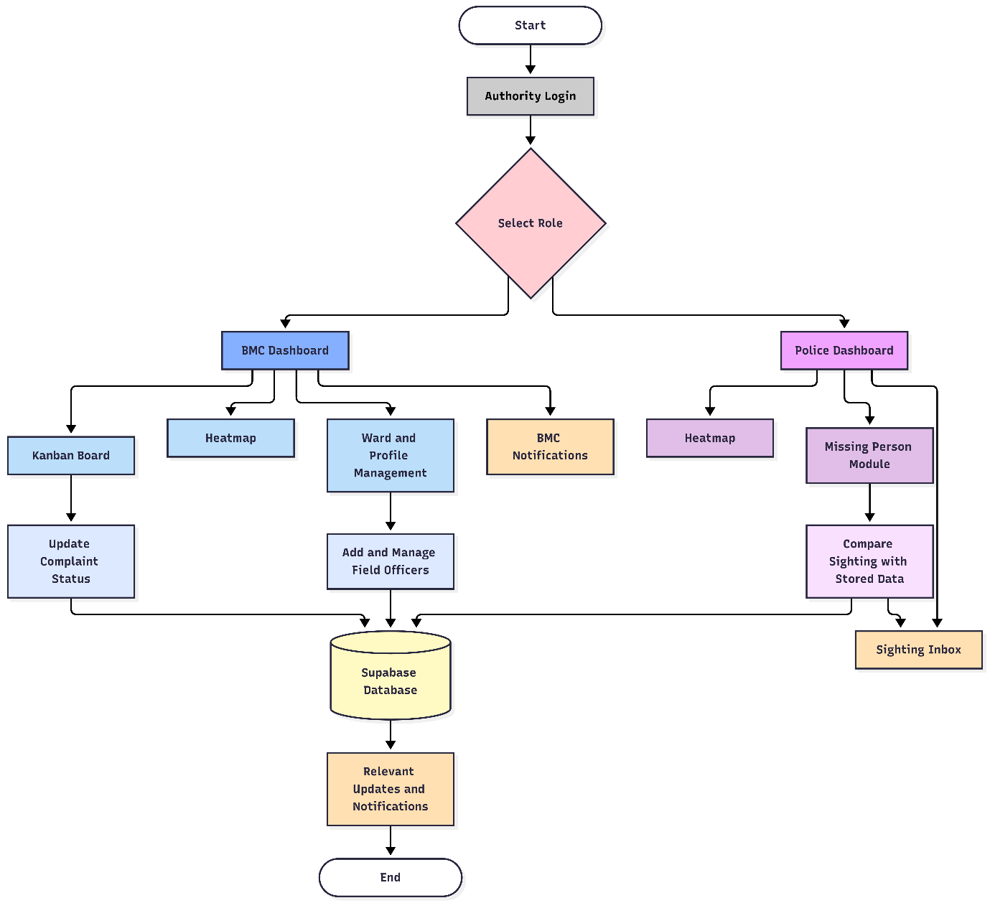
Figure 5.3: Authority Web Application Flowchart

Chapter 6
Coding

Interactive map
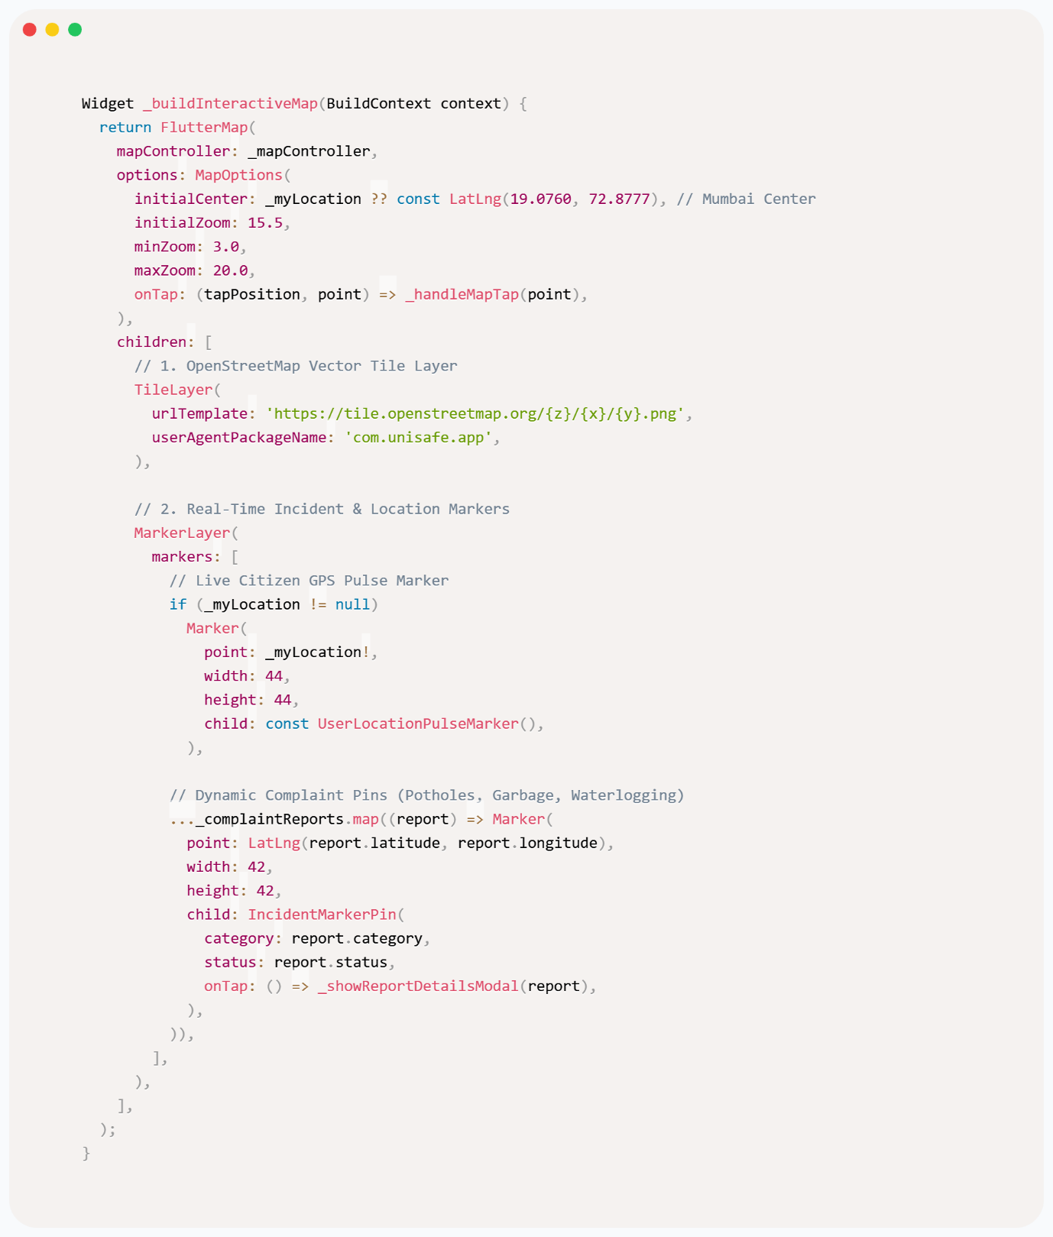
Figure 6.1: Citizen Interactive Map Implementation Code (Flutter)

Authority kanban board

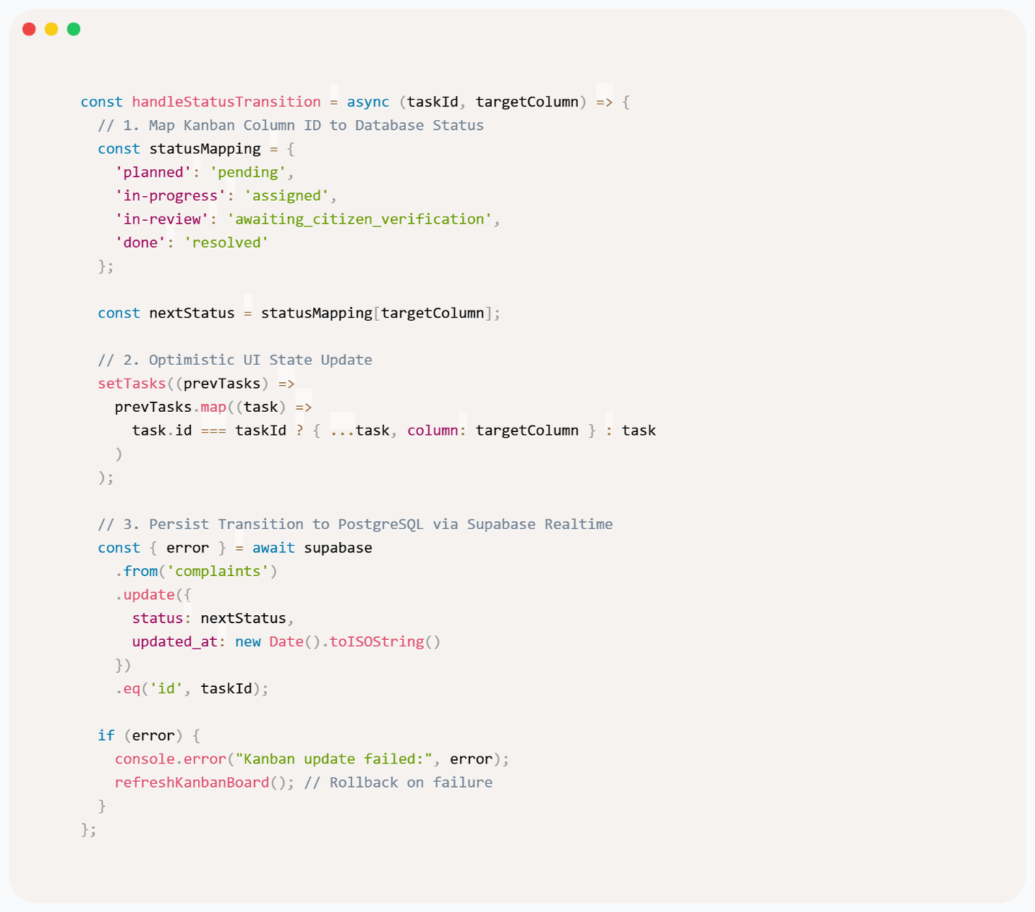
Figure 6.2: Authority BMC Kanban Board Status Transition Logic (React)

Missing-person identification pipeline
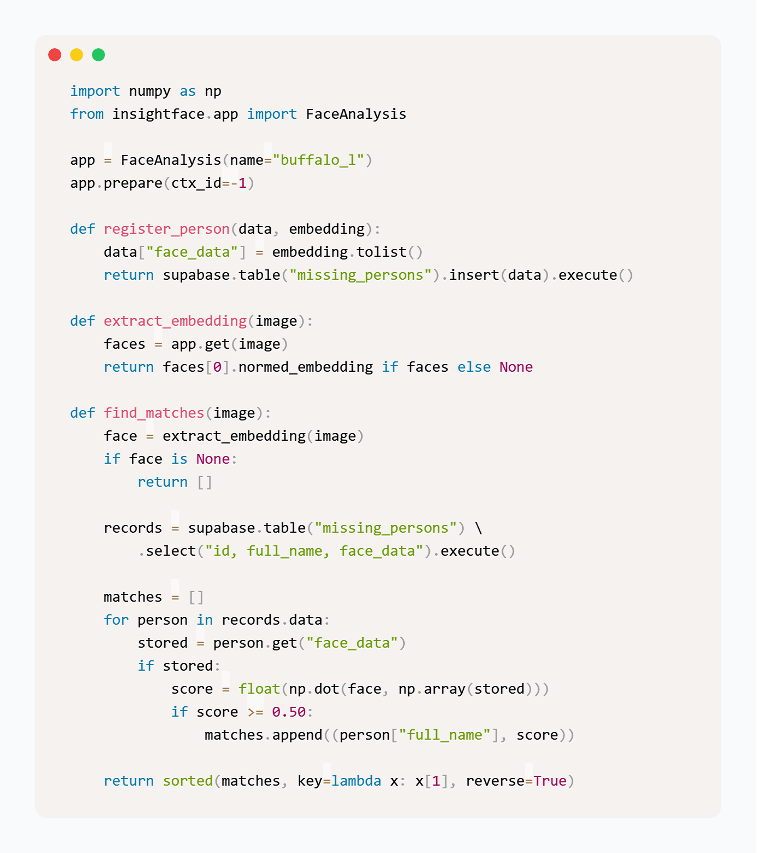
Figure 6.3: Missing-Person Facial Feature Extraction & Matching Pipeline (Python)

Complaint Routing to BMC or Police
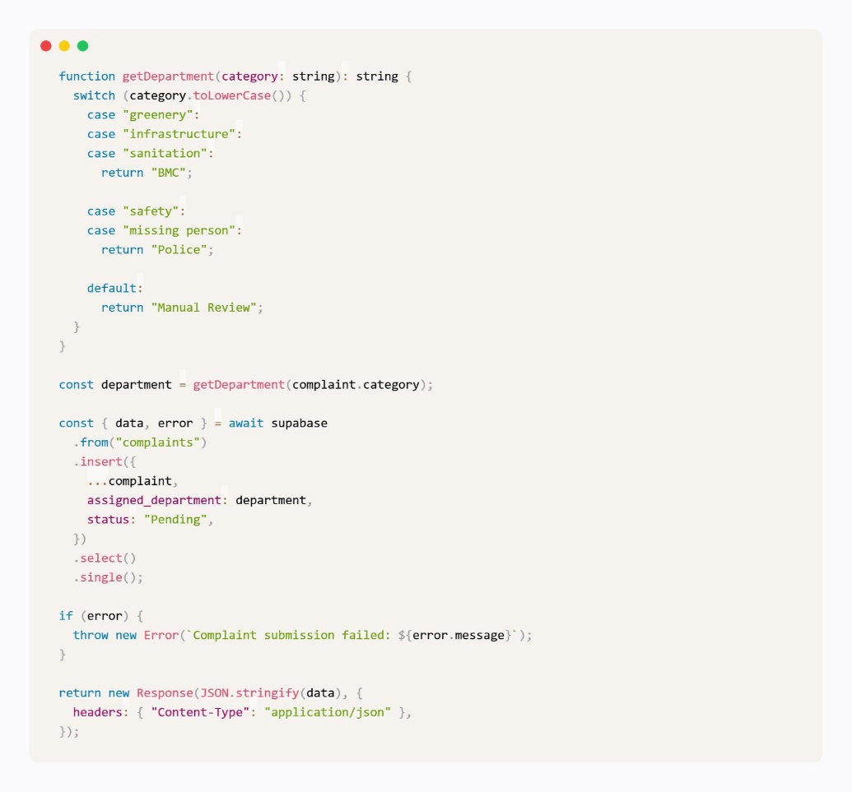
Figure 6.4: Automated Complaint Departmental Routing Logic (TypeScript)

Women Safety-Night Activity Score
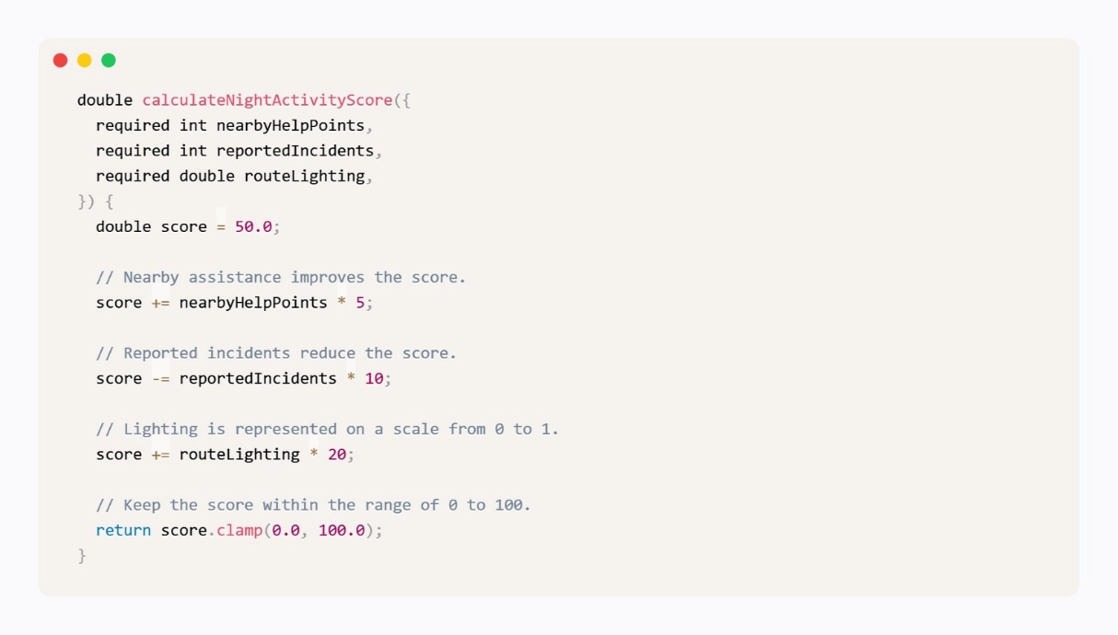
Figure 6.5: Women Safety Route Night Activity Score Calculation (Dart)

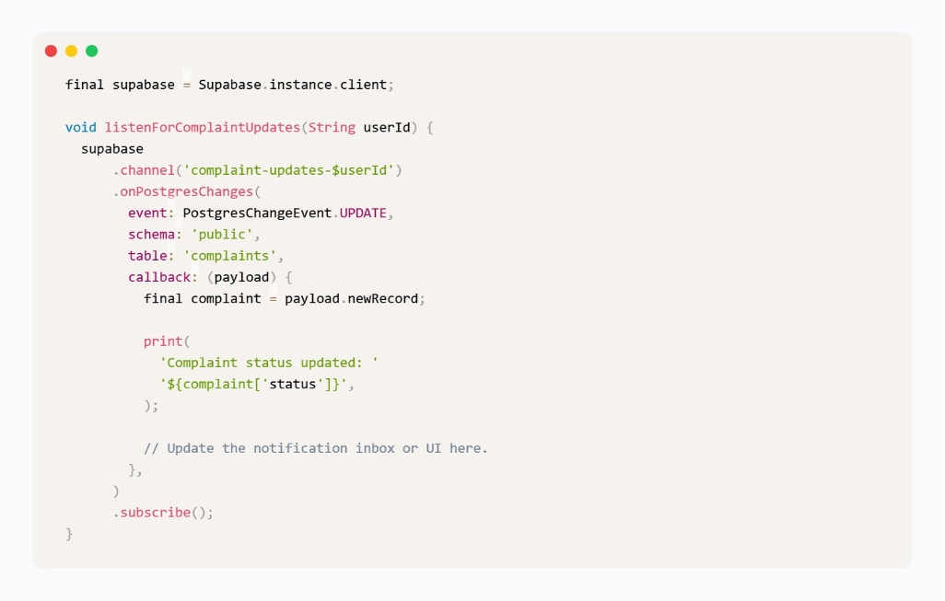
Real-Time Notifications
Figure 6.6: Supabase Realtime Change Data Capture Subscription (Dart)

Women’s Safety and SOS Functionality

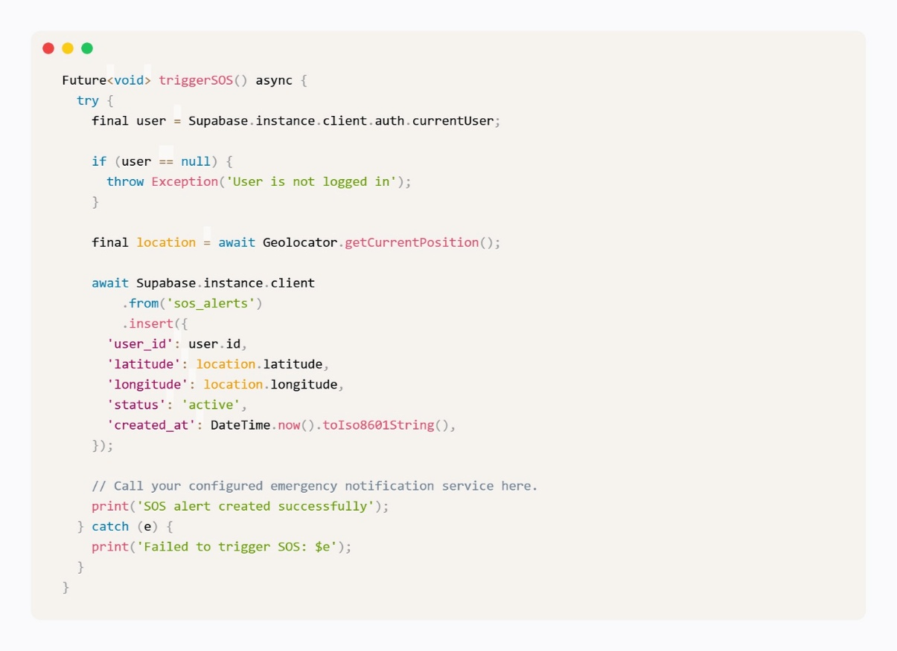
Figure 6.7: Emergency SOS Trigger and GPS Location Dispatch (Dart)

Chapter 7
Testing

7. Testing
Software testing verifies that UniSafe satisfies its functional requirements, handles unexpected inputs correctly, and maintains system stability across both mobile and web platforms. The testing process covers white-box structural testing, code coverage evaluations, fault-injection tests, and detailed functional test cases.
7.1 White Box Testing
White-box testing examines the internal logic, database procedures, Edge Functions, and code paths across the Flutter mobile application, React web dashboard, and Supabase backend services.
7.1.1 API and Backend Service Validation
Automated unit and integration checks were conducted across the primary communication interfaces and Supabase PostgREST endpoints.
Service Endpoint / Function | Test Objective | Tested Condition | Result
POST /auth/v1/otp | Phone OTP generation | Valid Indian 10-digit mobile number | Passed
POST /auth/v1/verify | OTP code verification | Valid 6-digit OTP within 5 minutes | Passed
POST /rest/v1/complaints | Civic ticket creation | Geotagged payload with image URL | Passed
PATCH /rest/v1/complaints | Kanban status transition | Status change from In Progress to In Review | Passed
POST /edge/v1/match-face | Biometric embedding comparison | Two 512-dimensional vector payloads | Passed
POST /edge/v1/send-sms | Emergency SMS dispatch | Multi-recipient SOS trigger with tracking link | Passed

7.1.2 Code Coverage
Unit tests were written using flutter_test for the mobile client and Jest/React Testing Library for the web portal. Test coverage across primary application modules is summarized below:
Module Name | Core Tested Files | Logic Covered | Coverage (%)
Authentication & e-KYC | auth_service.dart, digilocker_service.dart | OTP validation, token handling, session recovery | 91.4%
Interactive Civic Map | map_screen.dart, report_provider.dart | Marker generation, clustering, GPS accuracy | 88.6%
Resolution Verification | citizen_verification_screen.dart | 100m geofence validation, photo attachment | 93.2%
Women Safety & SOS | safe_journey_screen.dart, sos_service.dart | Inactivity timer, token generator, SMS payload | 95.0%
Authority Kanban Board | KanbanBoard.jsx, authorityService.js | Status transitions, photo proof checks, filtering | 90.8%
Missing Person AI Engine | face_matcher.py, vector_service.py | Normalization, cosine similarity, thresholding | 89.5%
7.1.3 Fault Injection and Resilience Testing
Fault injection tests evaluated system behavior under degraded network conditions, invalid data payloads, and third-party service interruptions:
1. Loss of Network Connectivity during SOS: When network data connectivity is interrupted while an SOS is initiated, the application queues the alert locally and immediately triggers the SMS carrier fallback via Pingram gateway APIs.
2. GPS Signal Loss during Two-Way Verification: If a citizen attempts to verify a resolved issue without valid GPS reception, the application displays an informational alert indicating that location services must be enabled to confirm on-site presence.
3. Invalid Sighting Image Upload: When an uploaded sighting photograph contains no detectable face or an occluded profile, the facial analysis service rejects the image with an explanatory error message, preventing empty vector comparisons.

7.2 Test Cases
Functional test cases were executed across the platform to evaluate system operations under standard and boundary conditions.
Test ID | Module | Test Scenario | Input Data | Expected Result | Status
TC-01 | Auth | Citizen Registration | Mobile number and OTP | Citizen record created; session token issued | Pass
TC-02 | Auth | Invalid OTP Entry | Incorrect 6-digit code | Error prompt displayed; registration blocked | Pass
TC-03 | Auth | Authority Login | Valid municipal credentials | User directed to designated BMC dashboard | Pass
TC-04 | Auth | Unauthorized Access | Non-authority login attempt | Access restricted; authorization error logged | Pass
TC-05 | Map | Civic Issue Report | Category, description, photo, GPS | Marker created on map and stored in database | Pass
TC-06 | Map | Street View Display | Tap valid map coordinate | Google Street View panoramic modal opens | Pass
TC-07 | Map | Marker Clustering | 10 complaints in 50m radius | Clustered marker showing total count rendered | Pass
TC-08 | Kanban | Task Card Drag & Drop | Move card to In Progress | Card position updated and synced across clients | Pass
TC-09 | Kanban | In Review Transition | Move without proof photo | Action blocked; mandatory photo proof prompt shown | Pass
TC-10 | Kanban | In Review with Proof | Upload valid repair photograph | Card moves to In Review; citizen alert generated | Pass
TC-11 | Verify | On-Site Verification | Citizen within 80m of site | Verification interface enabled for photo capture | Pass
TC-12 | Verify | Out-of-Range Verify | Citizen 300m away from site | Verification blocked; prompt to visit site displayed | Pass
TC-13 | Verify | Resolution Confirm | Citizen confirms 'Work Done' | Complaint status set to Resolved; card moved to Done | Pass
TC-14 | Verify | Resolution Reject | Citizen selects 'Not Done' + note | Card returns to In Progress with citizen feedback | Pass
TC-15 | Safety | Safe Journey Tracking | Source and destination entered | Live tracking token generated; route displayed | Pass
TC-16 | Safety | Inactivity Detection | Device stationary >5 minutes | 60-second audio-haptic safety prompt triggered | Pass
TC-17 | Safety | Emergency SOS | SOS button pressed | Multi-recipient SMS with live link dispatched | Pass
TC-18 | Missing | Missing Person Entry | Name, age, description, portrait | Record stored; 512-d embedding indexed in pgvector | Pass
TC-19 | Missing | Sighting Match (High) | Sighting photo (similarity 88%) | Potential match alert dispatched to police portal | Pass
TC-20 | Missing | Sighting Match (Low) | Sighting photo (similarity 62%) | Sighting recorded; no high-priority alert triggered | Pass
TC-21 | Analytics | Civic Heatmap Display | Filter by 'Water & Drainage' | Heatmap displays density for selected category | Pass
TC-22 | Workforce | Officer Assignment | Assign officer to Ward K-West | Ticket assigned; officer workload counter updated | Pass
Chapter 8
Output/ ScreenShots

Signup & Login page
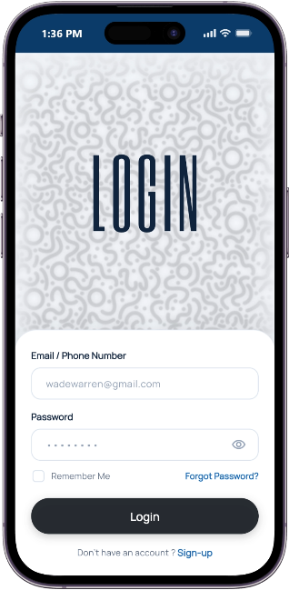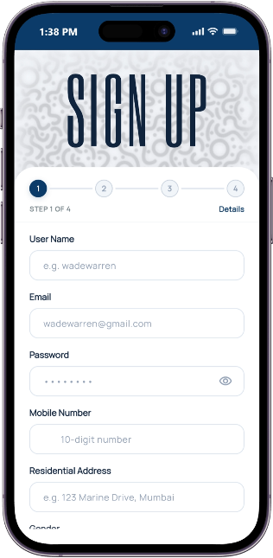
Figure 8.1: Citizen Mobile Application - Signup and Login Interface

Interactive Map
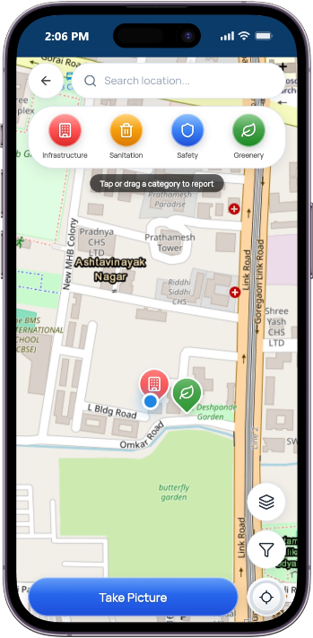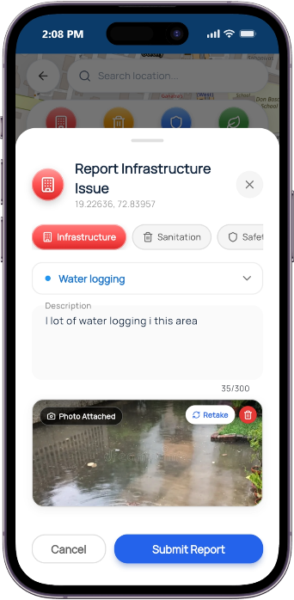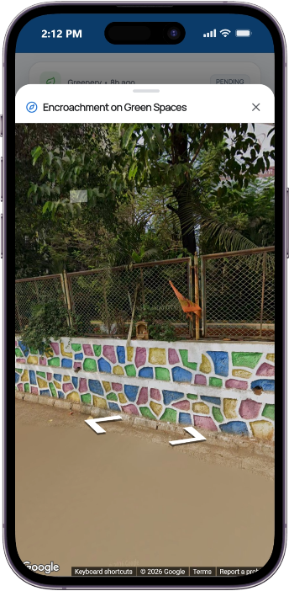
Figure 8.2: Citizen Mobile Application - Interactive Civic Map and Issue Reporting

Women’s Safety and SOS Functionality
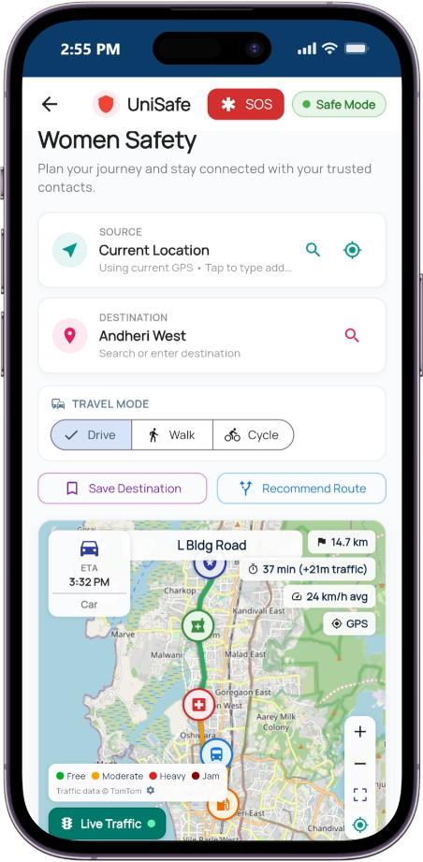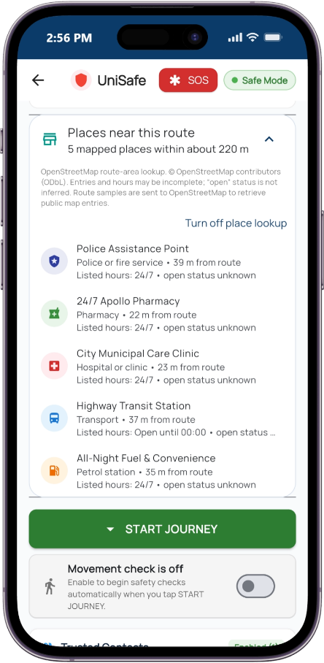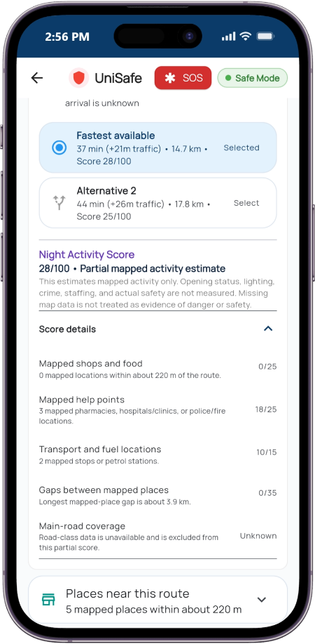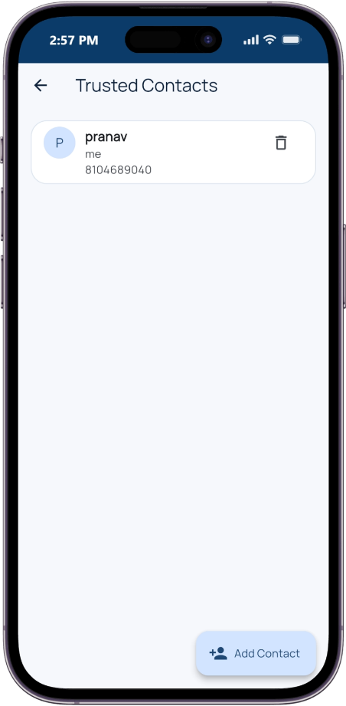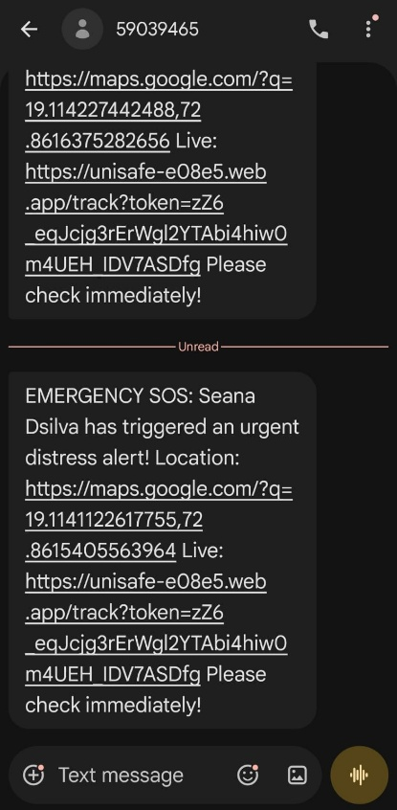
Figure 8.3: Citizen Mobile Application - Women's Safety, Safe Journey, and SOS Alerts

Authority Dashboard
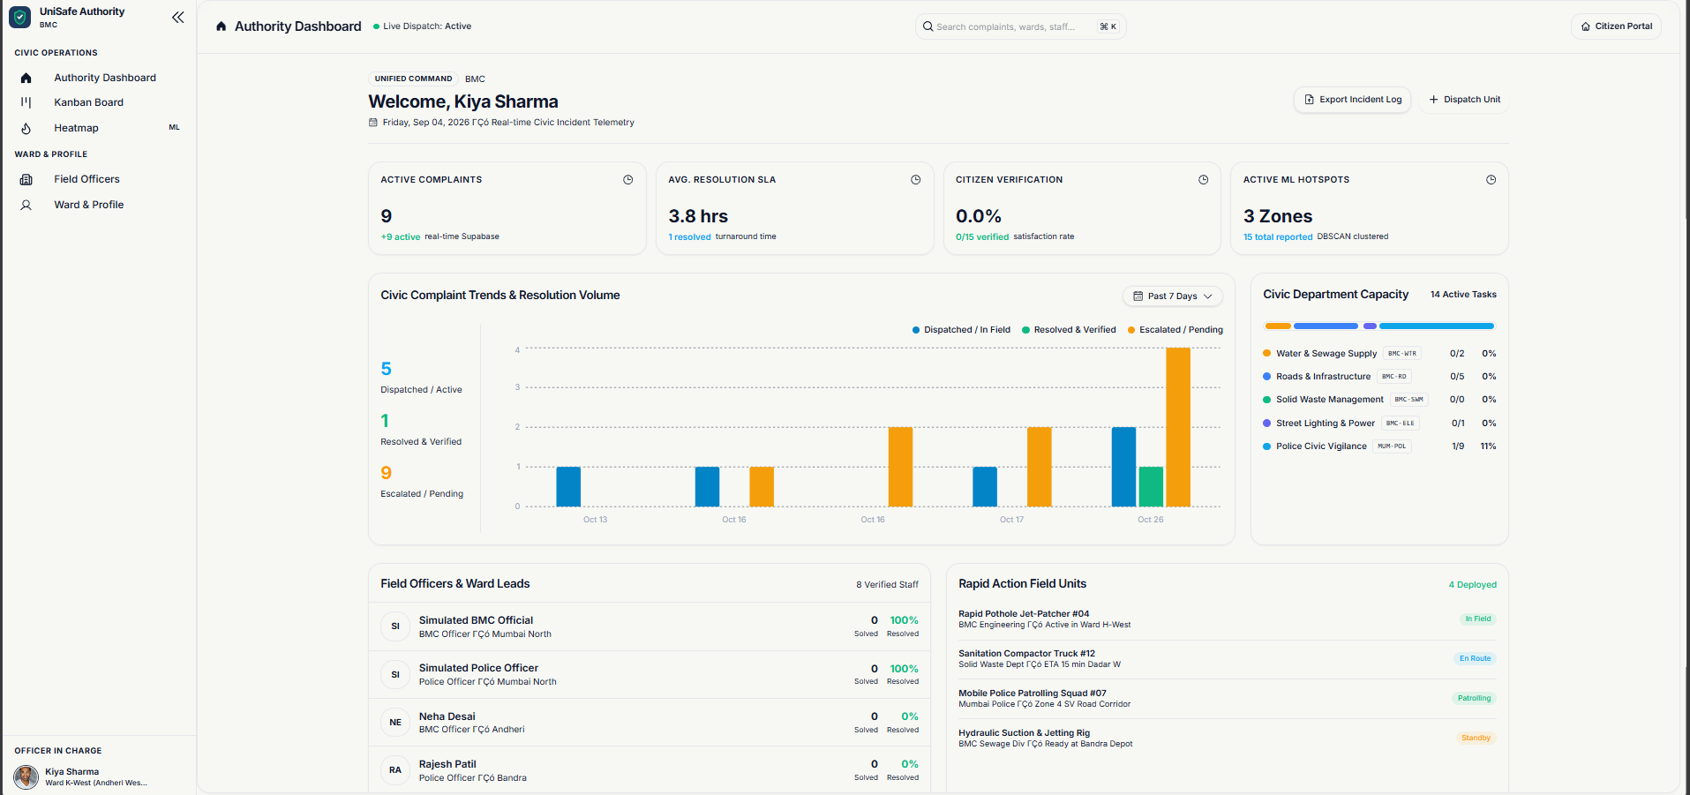
Figure 8.4: Authority Web Portal - Unified Command Dashboard
Authority Officials Manager
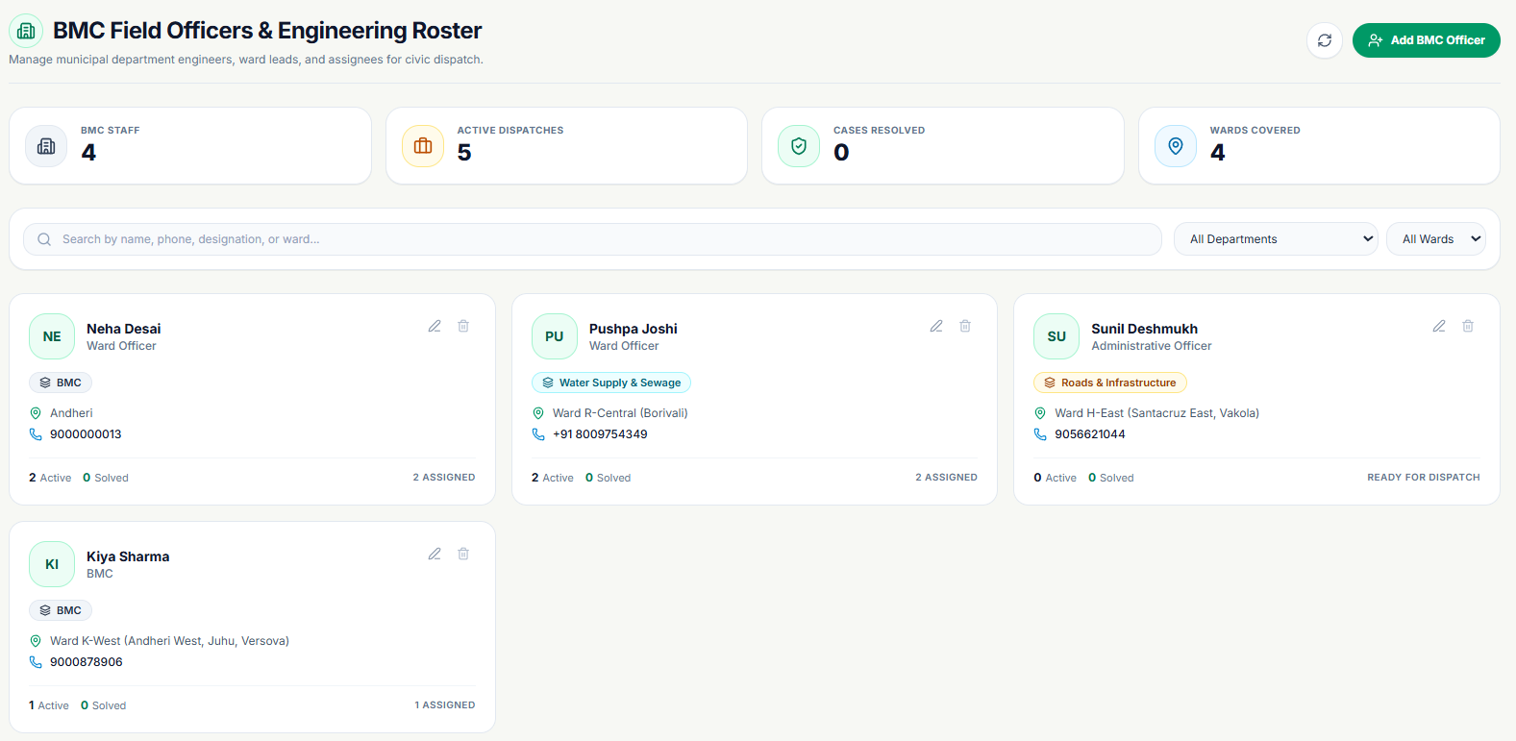
Figure 8.5: Authority Web Portal - BMC Field Officers and Engineering Roster

Missing Person Module
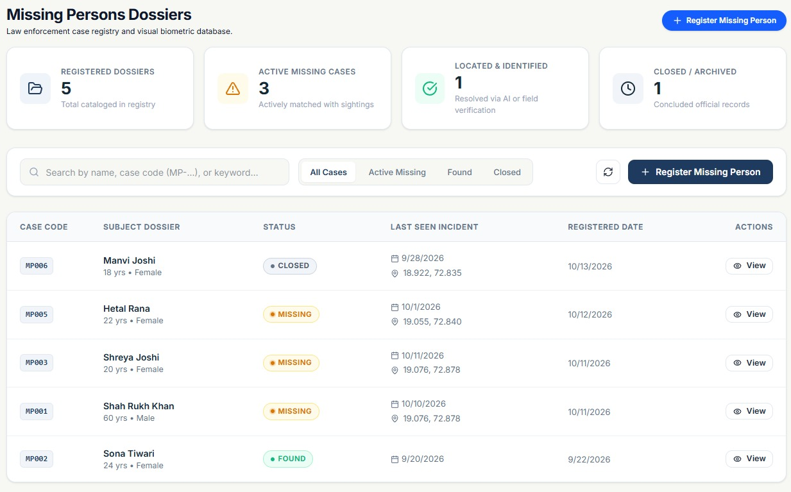
Figure 8.6: Police Web Portal - Missing Persons Case Dossier Registry
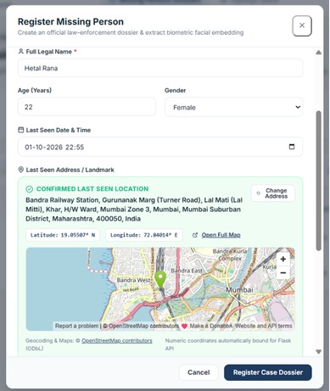
Figure 8.7: Police Web Portal - Register Missing Person Case Dossier Modal

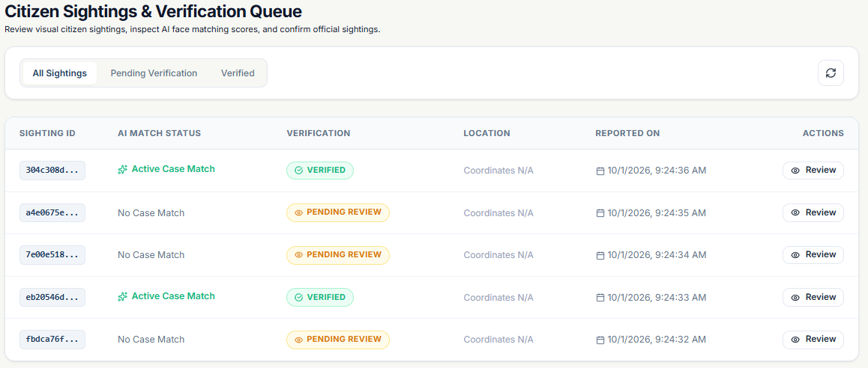
Figure 8.8: Police Web Portal - Citizen Sightings and Verification Queue
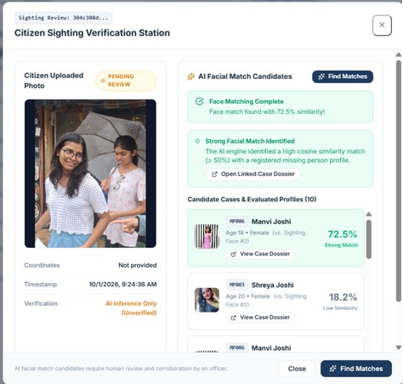
Figure 8.9: Police Web Portal - Citizen Sighting Verification Station with AI Face Match

Authority Heatmap
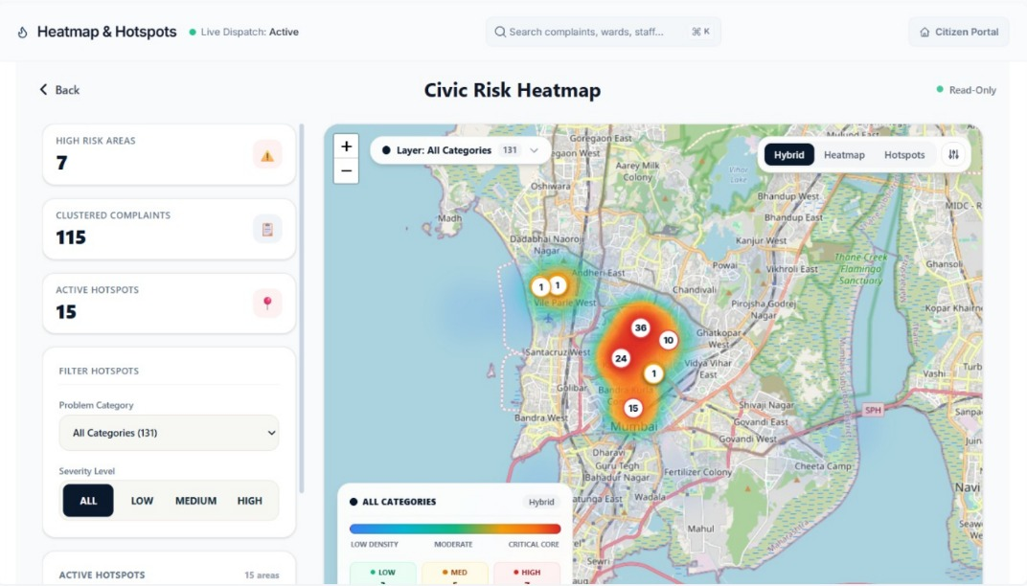
Figure 8.10: Authority Web Portal - Spatial Incident and Civic Risk Heatmap

Chapter 9
Summary

9. Summary
The UniSafe project integrates civic issue management, municipal workflow tracking, missing-person identification assistance, and women’s transit safety within a unified technological architecture. This chapter reviews the primary achievements of the system, outlines areas for future extension, and provides concluding remarks.
9.1 Future Scope
The modular structure of UniSafe allows for continuous technical refinement. Potential future enhancements include:
1. Integration with Official Municipal and Police Systems: Establishing direct application programming interface (API) links with the Brihanmumbai Municipal Corporation (BMC) SAP enterprise system and the national Crime and Criminal Tracking Network and Systems (CCTNS) to automate work-order generation and synchronize official police FIR records. Furthermore, transitioning from the sandbox identity verification interface to production-tier DigiLocker and UIDAI Aadhaar e-KYC gateways will strengthen citizen authentication.
2. Municipal CCTV and Drone Video Edge Processing: Ingesting video streams from smart city surveillance cameras to enable real-time missing-person identification at major transit hubs using edge-accelerated deep learning models. In addition, municipal survey drones can conduct aerial infrastructure audits to automatically identify road fractures and drainage defects before seasonal monsoon periods.
3. Predictive Infrastructure Analytics: Applying supervised machine learning models to historical complaint density, rainfall data, and traffic patterns to forecast road deterioration and drainage vulnerabilities prior to physical failure. Mobile LiDAR sensors can also calculate precise pothole volume to assist engineers in estimating repair material quantities.
4. Offline and Mesh Communication Support: Implementing device-to-device mesh networking over Bluetooth Low Energy (BLE) and Wi-Fi Direct to enable emergency alert transmission during cellular network outages or natural disasters.
5. Multilingual and Accessibility Features: Localizing the citizen mobile application into regional Indian languages, including Marathi and Hindi, to improve accessibility across diverse demographic groups, alongside speech-to-text models for voice-based grievance reporting.

9.2 Conclusion
Urban administration and public safety in rapidly growing cities require accessible, transparent, and responsive communication channels. Conventional systems frequently suffer from one-sided complaint closures, fragmented communication between municipal departments, delayed missing-person alerts, and reactive emergency responses.
UniSafe addresses these limitations by developing an integrated architecture combining a Flutter mobile client, a React authority dashboard, and a Supabase backend. The two-way verification mechanism establishes accountability by requiring photographic proof from field officers and independent on-site verification from citizens, reducing premature complaint closures. The 4-stage Kanban workflow and geographical heatmaps assist municipal supervisors in tracking complaint progress, organizing field personnel, and identifying localized infrastructure concerns. In addition, the facial biometrics module supports law enforcement by identifying potential missing-person sightings through crowdsourced photographs, while the women’s safety suite provides proactive transit monitoring, automated inactivity checks, and immediate emergency SOS communication.
In conclusion, UniSafe demonstrates that integrating mobile computing, cloud-native services, computer vision, and geospatial mapping provides a practical and scalable approach to civic management and public safety, supporting improved coordination between citizens and municipal authorities.

Chapter 10
Bibliography

  - Civic Issue Management — citizen reporting, issue tracking and coordination with authorities: https://www.researchgate.net/publication/406488356_NagarMitram_A_Smart_Civic_Issue_Reporting_and_Resolution_App_and_Web_Platform

  - Missing-Person Identification — facial embeddings and identity matching: https://ijcrt.org/viewpaperforall.php?paper=IJCRT2304378

  - Women's Safety — GPS tracking, emergency alerts and trusted contacts: https://doi.org/10.1109/ICCPCT.2017.8074261

  - Incident Heatmap — geographical analysis of reported urban issues: https://www.researchgate.net/figure/Spatiotemporal-incident-locations-heat-map-of-a-incident-locations-b-incident-intensity_fig3_330271706

  - Notifications and Complaint Updates — real-time communication between citizens and authorities: https://firebase.google.com/docs/cloud-messaging/flutter/get-started

