FITBUDDY
AI Fitness Plan Generator
PROJECT DOCUMENTATION
A practical technical and user guide for the FitBuddy web application
Built with FastAPI • Python • SQLite • SQLAlchemy • Google Gemini
Prepared from the supplied FitBuddy project source files
September 2026
Educational project documentation

1. Executive Summary
Project overview and purpose

What is FitBuddy?
FitBuddy is a browser-based AI fitness plan generator. A user enters basic profile information—name, age, gender, body weight, fitness goal, and workout intensity. The server sends those details to Google Gemini, receives a seven-day workout plan in Markdown, and stores the user and plan in a local SQLite database.

Core capabilities
- Create a personalized seven-day exercise plan with warm-up, exercise guidance, recovery, and general wellness tips.
- Revise a saved plan using free-text feedback from the user.
- Request a short, general nutrition and recovery tip.
- Persist user profiles, generated plans, and feedback records locally.
- Expose REST-style endpoints and interactive API documentation through FastAPI.

Technology at a glance
The backend uses Python and FastAPI. SQLAlchemy maps application objects to SQLite tables. Google’s GenAI Python SDK connects to Gemini. Jinja2 serves the HTML template, while vanilla JavaScript and CSS power the browser interface.

Scope and intended audience
This document is intended for students, developers, project evaluators, and users who need to understand, install, operate, and extend the supplied educational implementation. FitBuddy is not a medical service or a substitute for professional fitness or nutrition advice.

2. Problem Statement & Objectives
Why the application exists and what it aims to deliver

Problem statement
People starting a fitness routine may find it difficult to organize workouts around a goal and a preferred intensity. Generic plans may not reflect a person’s stated preferences, while building a plan manually requires time and familiarity with exercise programming. FitBuddy demonstrates how a generative AI service can help create a structured starting plan from a small set of user inputs.

Project objectives
- Collect a concise set of user attributes through a simple web form.
- Generate a readable, seven-day workout outline using a language model.
- Keep generated plans available in a local relational database.
- Allow a user to request revisions in natural language.
- Offer a lightweight nutrition and recovery tip feature.
- Provide a clear local development workflow using VS Code and Python.

Success criteria
A successful local run should load the home page, accept valid form data, return a generated plan when a valid Gemini API key is configured, save the plan, allow a revision request, and return a nutrition tip. The /health endpoint should return a small status response.

Non-goals
The current project does not provide user authentication, a professional medical assessment, wearable-device integration, payment processing, a mobile app, or guaranteed medically appropriate exercise prescriptions.

3. System Architecture
How the browser, API, AI provider, and database interact

High-level architecture
FitBuddy follows a compact three-part structure: (1) a browser interface, (2) a FastAPI application layer, and (3) supporting AI and database services. The browser submits form data to the API. The API validates selected fields, reads or writes database records, calls the Gemini model when required, and returns JSON.

Component responsibilities
- Frontend: templates/index.html defines the page; static/style.css controls visual styling; static/app.js submits requests and renders responses.
- API/application: main.py declares routes, dependency injection, input checks, and coordination between database and AI functions.
- Data layer: database.py creates the SQLite engine and session factory; models.py declares ORM tables; crud.py contains database operations; schemas.py defines Pydantic data structures.
- AI layer: services/ai_service.py creates the Gemini client and defines plan generation, revision, and nutrition-tip prompts.

Typical plan-generation flow
- The user completes the profile form and clicks Generate My Plan.
- JavaScript sends the form as multipart form data to POST /generate_plan.
- FastAPI checks age and weight, then creates or updates the user record.
- The AI service sends a prompt to Gemini and receives Markdown text.
- The plan is saved in workout_plans and returned as JSON.
- The browser renders the response and displays its identifiers.

Architecture note
The current implementation performs the AI request synchronously during the HTTP request. Slow model responses therefore keep the request open until Gemini responds or the request fails.

4. Technology Stack & Dependencies
Libraries, frameworks, and their roles

Python and FastAPI
Python 3.10 or newer is recommended by the project README. FastAPI defines HTTP endpoints, dependency injection, and automatic OpenAPI documentation. Uvicorn runs the ASGI application locally.

Persistence and validation
SQLAlchemy 2.x provides ORM models and database sessions. SQLite stores data in the local file fitbuddy.db. Pydantic defines the UserCreate, UserOut, and PlanOut data schemas.

Frontend
Jinja2 renders the HTML template. Plain JavaScript uses fetch and FormData for asynchronous API requests. CSS uses variables, a responsive grid, cards, and a mobile breakpoint. No frontend build tool is required.

Generative AI
The google-genai package supplies the Google GenAI client. The service reads GEMINI_API_KEY (or GOOGLE_API_KEY as a fallback) and uses GEMINI_MODEL, defaulting to gemini-2.5-flash. Model availability and API quotas depend on the provider account and configuration.

Dependencies listed in requirements.txt
- fastapi>=0.115 — API framework
- uvicorn[standard]>=0.30 — development/application server
- sqlalchemy>=2.0 — ORM and database sessions
- jinja2>=3.1 — HTML templates
- python-multipart>=0.0.9 — form parsing
- python-dotenv>=1.0 — load environment variables
- pydantic>=2.7 — data validation
- google-genai>=1.0 — Gemini API client

Reproducibility
The requirements file uses minimum version constraints rather than exact pins. For repeatable deployments, create and maintain a tested lock file or pin known-compatible versions.

5. Project Folder Structure
Purpose of each supplied file
FitBuddy/
├── main.py # FastAPI app and routes
├── database.py # SQLite engine and sessions
├── models.py # SQLAlchemy ORM models
├── schemas.py # Pydantic schemas
├── crud.py # Database CRUD helpers
├── services/
│ ├── __init__.py
│ └── ai_service.py # Gemini prompt functions
├── templates/
│ └── index.html # Main browser page
├── static/
│ ├── app.js # Frontend behavior
│ └── style.css # Page styling
├── .env.example # Environment template
├── .gitignore # Excluded local files
├── requirements.txt # Python dependencies
└── README.md # Quick setup guide

Important generated file
fitbuddy.db is created in the working directory when the application initializes its database tables. It is intentionally excluded from version control by .gitignore. The .env file should be created locally from .env.example and must not be committed.

Module boundaries
The route layer imports the CRUD helpers and AI service. CRUD helpers operate on ORM models and Pydantic input data. The AI service is isolated from the route definitions, making it easier to modify prompts or replace the model provider later.

6. Database Design
Tables, relationships, and persistence behavior

Database engine
The application uses SQLite through the connection string sqlite:///./fitbuddy.db. The engine sets check_same_thread=False to support use with FastAPI request handling. A session factory creates a database session for each request through the get_db dependency.

Entity: users
Fields: id (primary key), name, age, gender, weight, goal, and intensity. The name is indexed and the table stores the latest profile values for a matching name. The current lookup uses the stripped name as a simple identity key; it is not a secure account identifier.

Entity: workout_plans
Fields: id (primary key), user_id (foreign key to users), plan_content (text), and created_at (timestamp). One user can have multiple saved plans. The user-to-plan relationship uses cascade behavior for dependent records.

Entity: feedbacks
Fields: id (primary key), plan_id (foreign key to workout_plans), feedback_text, and created_at. Each feedback row records a revision request associated with a plan.

Relationships
- User 1 → many WorkoutPlan records.
- WorkoutPlan 1 → many Feedback records.

Data lifecycle
A plan request creates or updates the user profile, asks Gemini for plan text, and inserts a workout plan row. A revision updates the existing plan_content and adds a feedback row. Plans can be listed for a user through GET /plans/{user_id}.

Current limitations
There are no migrations, account-level identity controls, retention rules, or backup automation. For a production version, use migrations, explicit user identifiers, database backups, and carefully defined privacy/retention policies.

7. Backend API Reference
Routes available in the current source code

GET /
Renders the main HTML page and supplies the latest user records to the template context.

POST /generate_plan
Accepts form fields: name, age, gender, weight, goal, and intensity. It checks that age is between 13 and 100 and weight is positive, then creates or updates the user, generates a plan, stores it, and returns status, user_id, plan_id, and plan text.

POST /update_plan
Accepts plan_id and feedback. Returns 404 if the plan does not exist. Otherwise it asks Gemini to revise the plan, updates the saved content, stores the feedback, and returns the revised plan and plan_id.

GET /nutrition_tip?user_id={id}
Looks up a user and returns one general AI-generated nutrition/recovery tip. A missing user produces HTTP 404.

GET /users
Returns user records ordered by descending ID.

GET /plans/{user_id}
Returns plans for the specified user, newest first.

GET /health
Returns a small JSON health response containing status=ok and app=FitBuddy. It checks that the route is reachable; it does not verify Gemini credentials or database write capability.

Interactive API documentation
When running locally, FastAPI normally exposes Swagger UI at /docs and an OpenAPI schema at /openapi.json.

8. AI Integration & Prompt Workflow
How Gemini is configured and used

Configuration
The AI module loads environment variables with python-dotenv. It reads GEMINI_API_KEY first, then GOOGLE_API_KEY. The model name comes from GEMINI_MODEL and defaults to gemini-2.5-flash. A client is created only if an API key is present.

Plan generation prompt
The prompt frames the model as a fitness coach and requests a practical seven-day plan. It includes the user’s name, age, gender, weight, goal, and intensity. It asks for a summary, day-by-day content, warm-up, exercises, sets/reps or duration, rest/cool-down, a recovery day, hydration/sleep/nutrition guidance, and a brief safety note. The response is requested in Markdown.

Revision prompt
The revision function supplies the current user profile, the user’s feedback, and the existing plan. It requests a complete revised seven-day plan in Markdown. This allows feedback such as making a day easier or reducing running to be incorporated into a new response.

Nutrition prompt
The nutrition function requests one practical general nutrition and recovery tip, capped at 120 words, and instructs the model not to diagnose or prescribe medication.

Error behavior
If no key is configured, the AI service raises a runtime error with setup guidance. If Gemini returns no text, it raises an empty-response error. Provider errors may propagate through the route; production deployments should translate these into controlled HTTP errors and log details safely.

AI output caveats
Generated text can be inaccurate, inconsistent, or unsuitable for a particular user. The current code does not independently validate exercise recommendations, enforce structured output, or verify the model’s safety note. The model should be treated as a text-generation component, not a clinical authority.

9. Frontend & User Interface
Page structure, interactions, and styling

Main page
The HTML template contains a blue hero banner, a profile form, a hidden result card, a nutrition tip area, and a footer. The form collects name, age, gender, weight in kilograms, primary goal, and workout intensity.

Form options
- Age: numeric field with a browser-side range of 13–100.
- Gender: Male, Female, Other, or Prefer not to say.
- Goal: Weight loss, Muscle gain, General fitness, Strength, or Endurance.
- Intensity: Beginner, Moderate, or High.

Browser behavior
app.js intercepts form submission, disables the generate button while waiting, and sends the form with fetch. On success, it renders the returned plan, stores the plan ID in a hidden form field, shows the user/plan identifiers, and scrolls to the result. Errors are displayed in a status region.

Markdown display
A small md() function converts selected Markdown constructs—headings, bold text, and dash list items—into HTML. It escapes HTML-sensitive characters before conversion. This is intentionally lightweight and does not support the full Markdown specification.

Responsive styling
The CSS uses a two-column grid on wider screens and changes to a single column below 700px. Cards, rounded inputs, status text, and a compact result layout support desktop and mobile browsers.

Usability considerations
The current page has basic status messages and disables buttons during requests. Further improvements could include explicit field-level errors, keyboard/screen-reader testing, a loading indicator, print/export controls, and clearer recovery instructions when the API key is missing.

10. Installation & Environment Setup
Run the application in Visual Studio Code

Prerequisites
- Install Python 3.10 or newer and verify it is available in the terminal.
- Install Visual Studio Code and open the extracted FitBuddy folder.
- Ensure an internet connection is available for package installation and Gemini requests.

Windows PowerShell setup
- Open the FitBuddy folder in VS Code and choose Terminal → New Terminal.
py -m venv .venv
.venv\Scripts\python.exe -m pip install --upgrade pip
.venv\Scripts\python.exe -m pip install -r requirements.txt
Using the virtual environment’s Python executable directly avoids the PowerShell script-execution restriction that can block Activate.ps1. Alternatively, use Command Prompt and run .venv\Scripts\activate.bat.

Configure the Gemini key
- Copy .env.example to a new file named .env in the project root.
- Replace the placeholder with your own Gemini API key; keep the key private.
GEMINI_API_KEY=your_real_key_here
GEMINI_MODEL=gemini-2.5-flash

Start the server
.venv\Scripts\python.exe -m uvicorn main:app --reload --host 127.0.0.1 --port 8000
Open http://127.0.0.1:8000 in a browser. For API testing, open http://127.0.0.1:8000/docs. Keep the terminal open while using the app.

11. How to Use FitBuddy
A walkthrough for end users

Step 1 — Open the application
Start the FastAPI server and visit the local address shown in the setup instructions. The FitBuddy home page should display the Create Your Fitness Plan form.

Step 2 — Enter profile details
Enter a name, age, gender selection, weight in kilograms, a primary fitness goal, and an intensity level. Use accurate information and do not enter unnecessary sensitive details.

Step 3 — Generate the plan
Click Generate My Plan once. The page displays a progress message while the backend contacts Gemini. When successful, the result card shows the generated seven-day plan and the plan/user IDs.

Step 4 — Ask for a revision
In the revision box, describe a specific change, such as “make Day 3 easier” or “replace running with low-impact cardio.” Click Revise Plan. The updated plan replaces the displayed plan and is saved to the existing plan record.

Step 5 — Request a nutrition tip
Click Nutrition Tip after generating a plan. FitBuddy requests one general nutrition/recovery suggestion based on selected profile attributes. It is general information and not an individualized diet prescription.

Step 6 — Use the API endpoints (optional)
The /docs page lets developers inspect endpoints and submit test requests. GET /users lists stored users; GET /plans/{user_id} lists plans associated with a user ID.

If the page appears blank or stuck
- Check the terminal for startup errors and confirm the server reports that it is running.
- Use the exact port printed by Uvicorn; this project’s README uses port 8000.
- Open the browser developer console and inspect the Network tab for failed requests.
- Confirm that .env exists and contains a valid key if AI features fail.

12. Testing & Verification Plan
Suggested checks before demonstrating the project

Startup checks
- Install dependencies without errors in the project virtual environment.
- Start Uvicorn and verify the home page loads successfully.
- Open /docs and confirm that the documented routes are listed.
- Call GET /health and confirm a JSON status response.

Functional tests
- Submit valid profile information and verify that a plan is returned and saved.
- Submit an age below 13 or above 100 and confirm the API rejects it.
- Submit zero or negative weight and confirm the API rejects it.
- Revise an existing plan and verify the returned plan changes and feedback is stored.
- Try a nonexistent plan ID and confirm a 404 response.
- Request a nutrition tip for a valid user and for a nonexistent user.
- Call /users and /plans/{user_id} and check the returned records.

Integration and resilience checks
- Test with a missing API key and confirm the error is understandable.
- Test with a provider-side failure or invalid key and inspect the user-facing message.
- Reload the app and confirm SQLite records remain available.
- Try the interface at desktop and narrow mobile widths.

Acceptance checklist
The project can be considered ready for an educational demonstration when the home page loads, the API is reachable, the configured AI request succeeds, the plan is stored, revision and nutrition flows work, and validation errors are handled without crashing the browser interface.

13. Security, Privacy & Responsible Use
Risks and safeguards to consider

API key security
Keep GEMINI_API_KEY in a local .env file and never place it in frontend JavaScript, HTML, screenshots, public repositories, or shared documentation. The .gitignore excludes .env, virtual environments, Python cache files, and the local database. Rotate a key if it is accidentally exposed.

Personal data
The application stores name, age, gender, weight, fitness goal, intensity, generated plan text, and feedback in a local database. Anyone with access to the project directory may be able to read that database. Use test data for classroom demonstrations when possible.

Missing production controls
- No login, authentication, or authorization is implemented. Routes that list users and plans are not access-controlled.
- No rate limiting, abuse prevention, or quota management is included.
- No formal consent, data deletion UI, retention schedule, or privacy notice is implemented.
- No comprehensive request-size limits or centralized exception handling is included.

Fitness safety
FitBuddy is an educational prototype. AI-generated plans may not account for injuries, chronic conditions, pregnancy, medications, disability, or other individual needs. Users should stop activity that causes pain or concerning symptoms and seek qualified professional guidance when appropriate.

Responsible deployment recommendations
- Add authentication and enforce per-user authorization before exposing data endpoints.
- Use HTTPS, secret management, rate limits, and structured server-side logging with sensitive fields omitted.
- Add explicit privacy and consent notices, deletion/export options, and retention rules.
- Use a qualified review process for fitness-related content and clear emergency/medical disclaimers.

14. Limitations & Future Enhancements
Known constraints and a practical development roadmap

Current implementation limitations
- Profile matching uses a name string, which can collide and does not establish identity.
- Database tables are created at startup with create_all; there is no migration framework.
- AI provider exceptions are not comprehensively translated into user-friendly HTTP responses.
- The frontend Markdown renderer supports only a small subset of Markdown syntax.
- The plan is stored as unstructured text, limiting filtering, scheduling, and progress analytics.
- The app does not track completed workouts, measurements, or adherence over time.
- The model prompt does not receive height, equipment availability, injury history, or schedule constraints.

Suggested roadmap

Phase 1 — Reliability
Add centralized error handling, timeouts, request logging, robust validation, automated tests, and pinned dependencies.

Phase 2 — Product features
Add plan history and detail pages, structured workout-day records, progress tracking, workout completion checklists, and plan export.

Phase 3 — Personalization
Add optional equipment and schedule preferences, accessibility considerations, and more structured AI output. Require careful review before collecting sensitive health details.

Phase 4 — Deployment readiness
Introduce authentication, authorization, database migrations, backups, secure secret storage, monitoring, deployment configuration, and privacy controls.

Potential technical improvements
Use response schemas for API outputs, asynchronous/background handling for slow AI calls, retry policies with limits, and model-output validation. Consider a production database when multi-user access or deployment scale requires it.

15. Conclusion, Glossary & References
Summary and quick reference

Conclusion
FitBuddy demonstrates an end-to-end generative AI web application: a browser form collects preferences, FastAPI coordinates application logic, Gemini generates and revises workout text, and SQLAlchemy/SQLite preserve profiles and plans. The project is compact enough for learning and can serve as a foundation for a more robust application after adding testing, security, privacy, and safety controls.

Glossary
- API: Application Programming Interface; a defined way for software components to communicate.
- CRUD: Create, Read, Update, and Delete database operations.
- Gemini: Google’s generative AI model family accessed here through the GenAI SDK.
- ORM: Object-relational mapper; maps Python objects to database records.
- SQLite: A lightweight relational database stored in a local file.
- FastAPI: Python framework for building HTTP APIs.
- Uvicorn: ASGI server used to run the FastAPI application.
- Environment variable: Configuration value supplied outside application source code.

Project reference files
The documentation is based on the supplied FitBuddy project archive, including README.md, main.py, database.py, models.py, schemas.py, crud.py, services/ai_service.py, templates/index.html, static/app.js, static/style.css, requirements.txt, .env.example, and .gitignore.

Quick links when running locally
- Application: http://127.0.0.1:8000
- API docs: http://127.0.0.1:8000/docs
- Health endpoint: http://127.0.0.1:8000/health
End of documentation.

Appendix A — Website & VS Code Screenshots
The following screenshots document the FitHub AI interface and the local development environment used for the project.
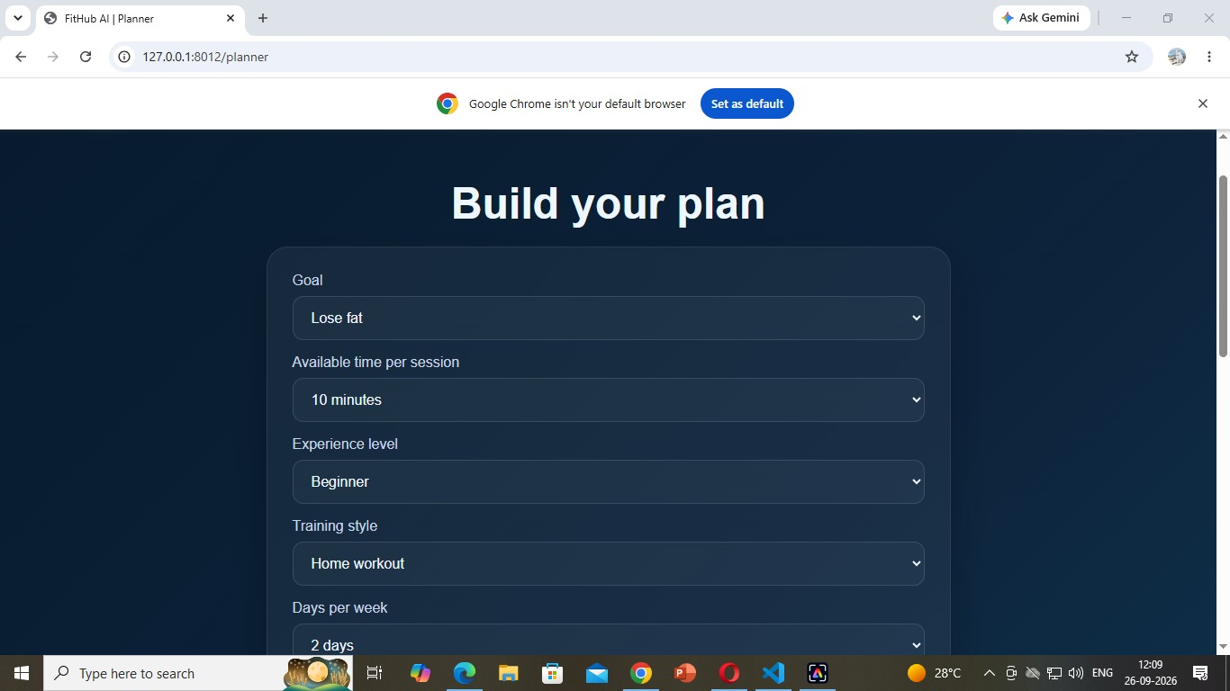
Workout planner form — goal, session duration, experience, training style, and weekly frequency.
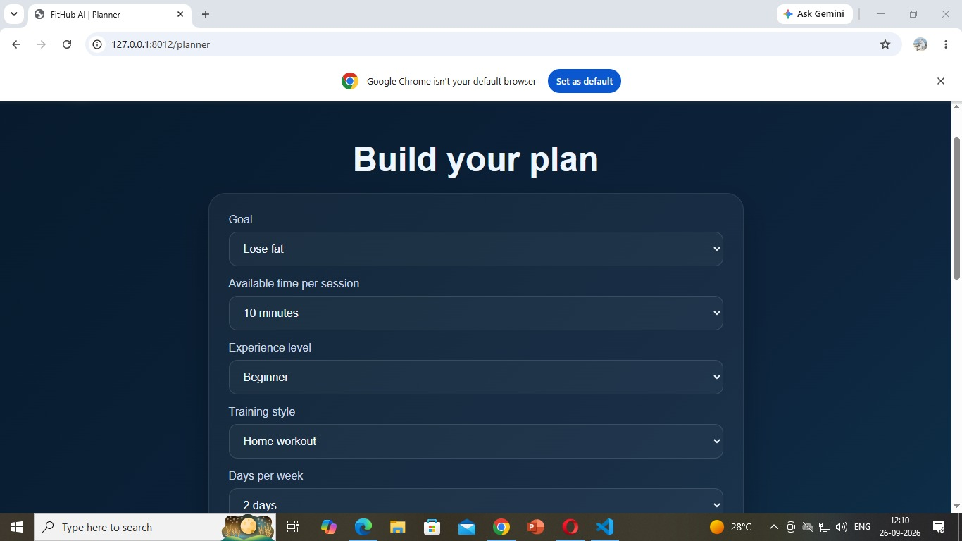
Workout planner form — repeated screenshot showing the selected form settings.

Appendix A — Screenshots (continued)
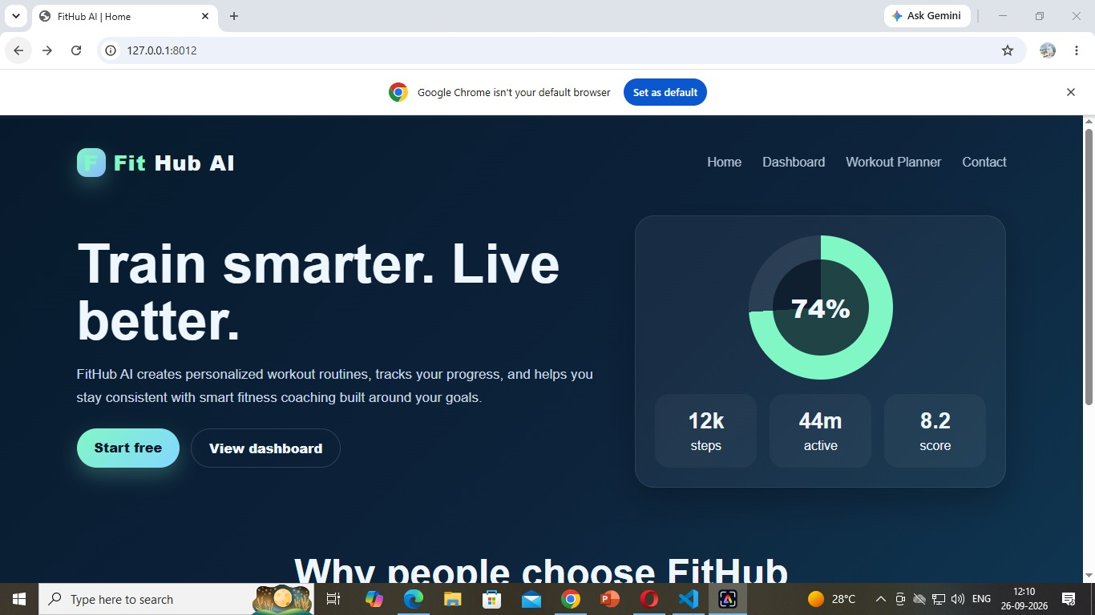
FitHub AI home page — landing page, navigation, and dashboard preview.
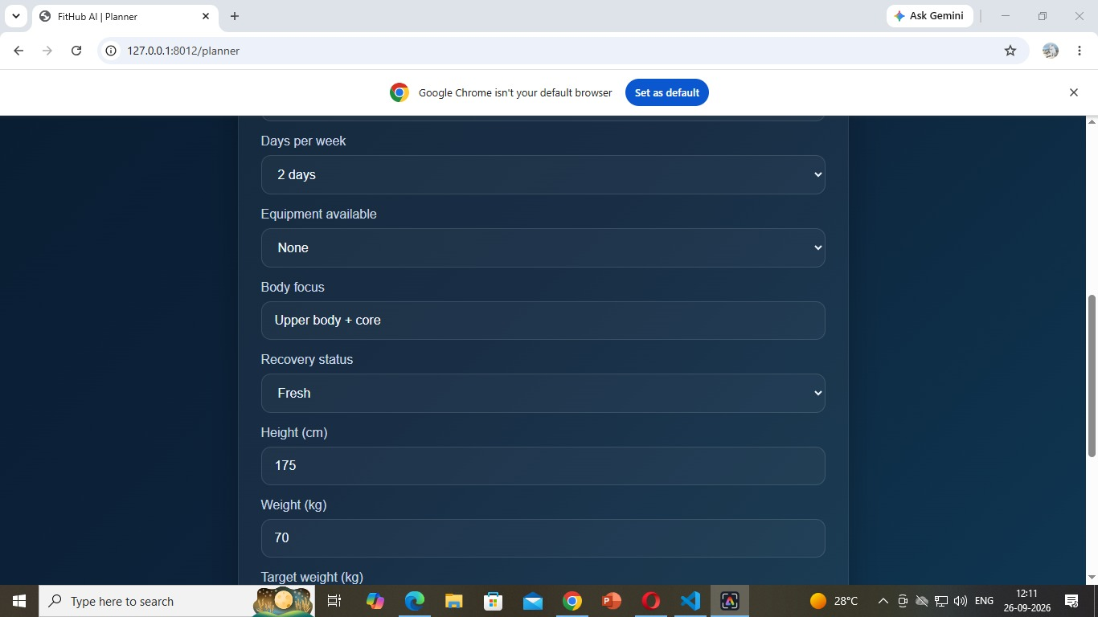
Workout planner form — equipment, body focus, recovery, and body measurements.

Appendix A — Screenshots (continued)
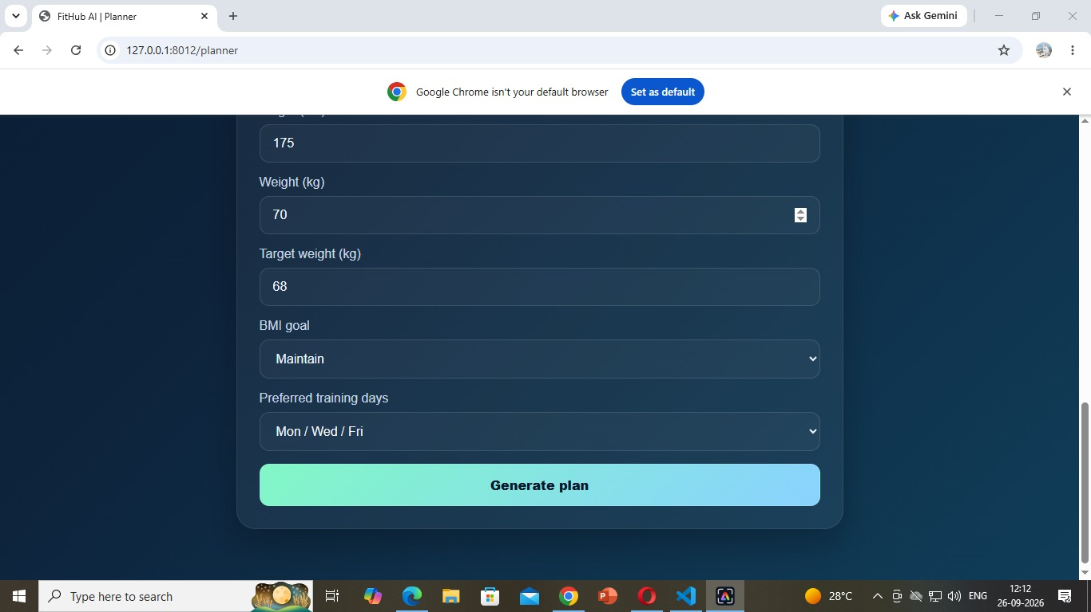
Workout planner form — target weight, BMI goal, preferred training days, and Generate Plan button.
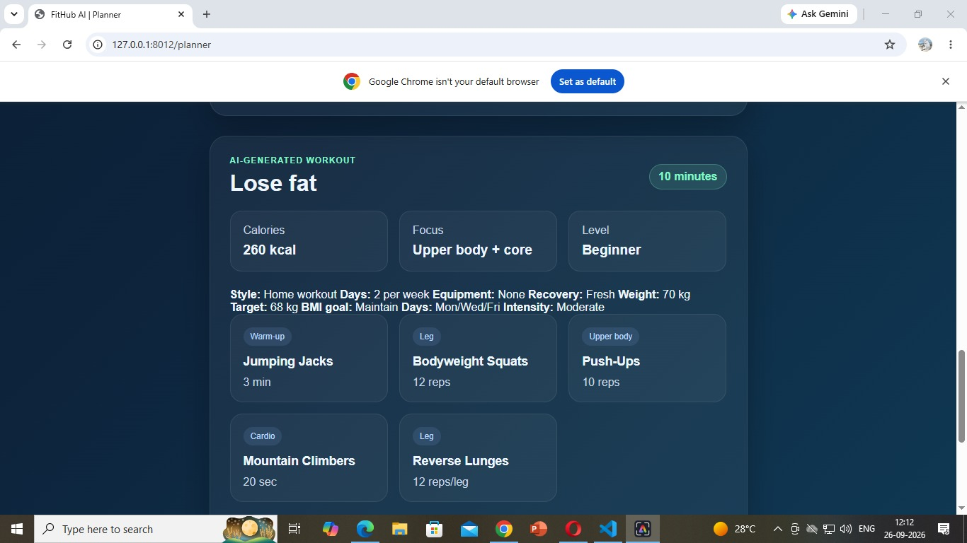
Generated workout result — goal, duration, calorie estimate, focus, level, and exercise cards.

Appendix A — Screenshots (continued)
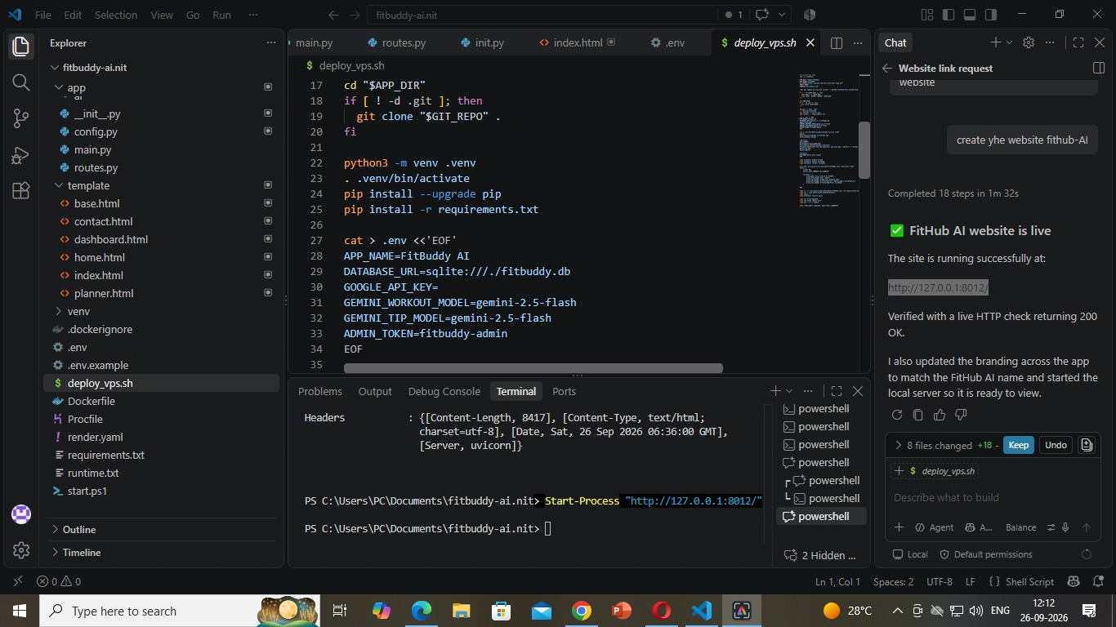
FitHub AI home page — landing page screenshot.
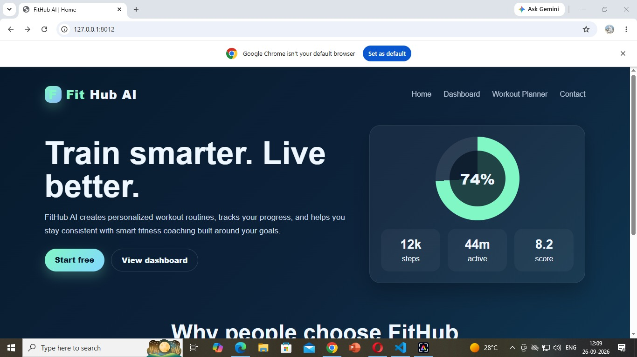
VS Code project workspace — project folders, configuration, and local server status.

