VLSI Practical
4-Bit ALU:

CODE:
library IEEE;
use IEEE.STD_LOGIC_1164.ALL;
use IEEE.STD_LOGIC_ARITH.ALL;
use IEEE.STD_LOGIC_UNSIGNED.ALL;
entity alu_4bit is
Port (
a, b : in STD_LOGIC_VECTOR(3 downto 0);
opcode : in STD_LOGIC_VECTOR(2 downto 0);
y : out STD_LOGIC_VECTOR(4 downto 0)
);
end alu_4bit;
architecture Behavioral of alu_4bit is
signal as, bs, ys : STD_LOGIC_VECTOR(4 downto 0);
begin
as <= '0' & a;
bs <= '0' & b;
process(as, bs, opcode)
begin
case opcode is
when "000" => ys <= as + bs; -- ADD
when "001" => ys <= as - bs; -- SUB
when "010" => ys <= as and bs; -- AND
when "011" => ys <= as nand bs; -- NAND
when "100" => ys <= as xor bs; -- XOR
when "101" => ys <= as xnor bs; -- XNOR
when "110" => ys <= as or bs; -- OR
when others => ys <= '0' & as(3 downto 0); -- Pass A
end case;
end process;
y <= ys;
end Behavioral;

TESTBENCH
library IEEE;
use IEEE.STD_LOGIC_1164.ALL;
use IEEE.STD_LOGIC_ARITH.ALL;
use IEEE.STD_LOGIC_UNSIGNED.ALL;
entity test is
end test;
architecture behavior of test is
-- Component Declaration
component alu_4bit
Port (
a, b : in STD_LOGIC_VECTOR(3 downto 0);
opcode : in STD_LOGIC_VECTOR(2 downto 0);
y : out STD_LOGIC_VECTOR(4 downto 0)
);
end component;
-- Signals for interconnection
signal a_tb, b_tb : STD_LOGIC_VECTOR(3 downto 0);
signal opcode_tb : STD_LOGIC_VECTOR(2 downto 0);
signal y_tb : STD_LOGIC_VECTOR(4 downto 0);
begin
-- Instantiate the Unit Under Test (UUT)
uut: alu_4bit
port map (
a => a_tb,
b => b_tb,
opcode => opcode_tb,
y => y_tb
);
-- Stimulus Process
process
begin
a_tb <= "0101"; b_tb <= "0011"; opcode_tb <= "000"; wait for 10 ns; -- ADD
opcode_tb <= "001"; wait for 10 ns; -- SUB
opcode_tb <= "010"; wait for 10 ns; -- AND
opcode_tb <= "011"; wait for 10 ns; -- NAND
opcode_tb <= "100"; wait for 10 ns; -- XOR
opcode_tb <= "101"; wait for 10 ns; -- XNOR
opcode_tb <= "110"; wait for 10 ns; -- OR
opcode_tb <= "111"; wait for 10 ns; -- Default / Pass A
wait;
end process;
end behavior;

UCF
NET "a<0>" LOC= "p57";
NET "a<1>" LOC= "p52";
NET "a<2>" LOC= "p51";
NET "a<3>" LOC= "p50";
NET "b<0>" LOC= "p43";
NET "b<1>" LOC= "p42";
NET "b<2>" LOC= "p40";
NET "b<3>" LOC= "p39";
NET "opcode<0>" LOC= "p36";
NET "opcode<1>" LOC= "p35";
NET "opcode<2>" LOC= "p34";
NET "y<0>" LOC= "p80";
NET "y<1>" LOC= "p79";
NET "y<2>" LOC= "p78";
NET "y<3>" LOC= "p77";
NET "y<4>" LOC= "p76";

OP
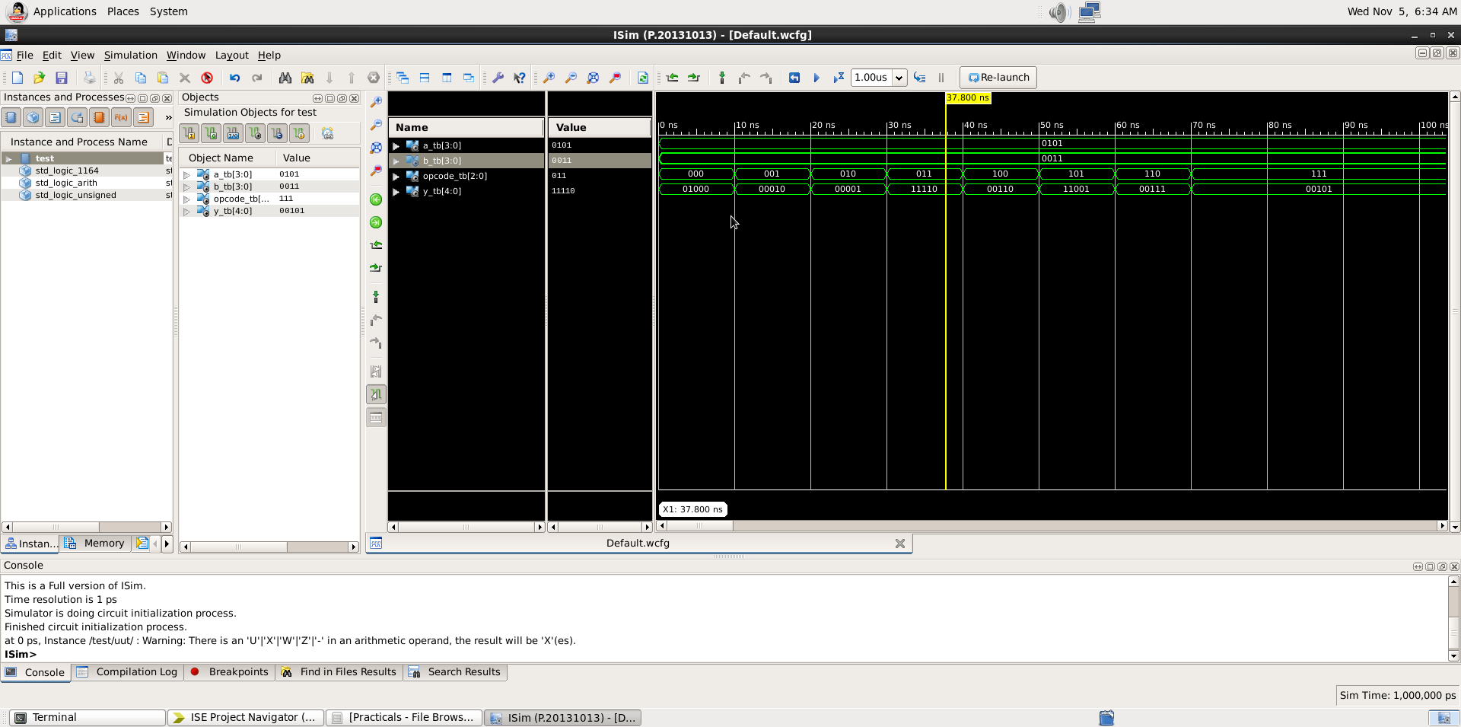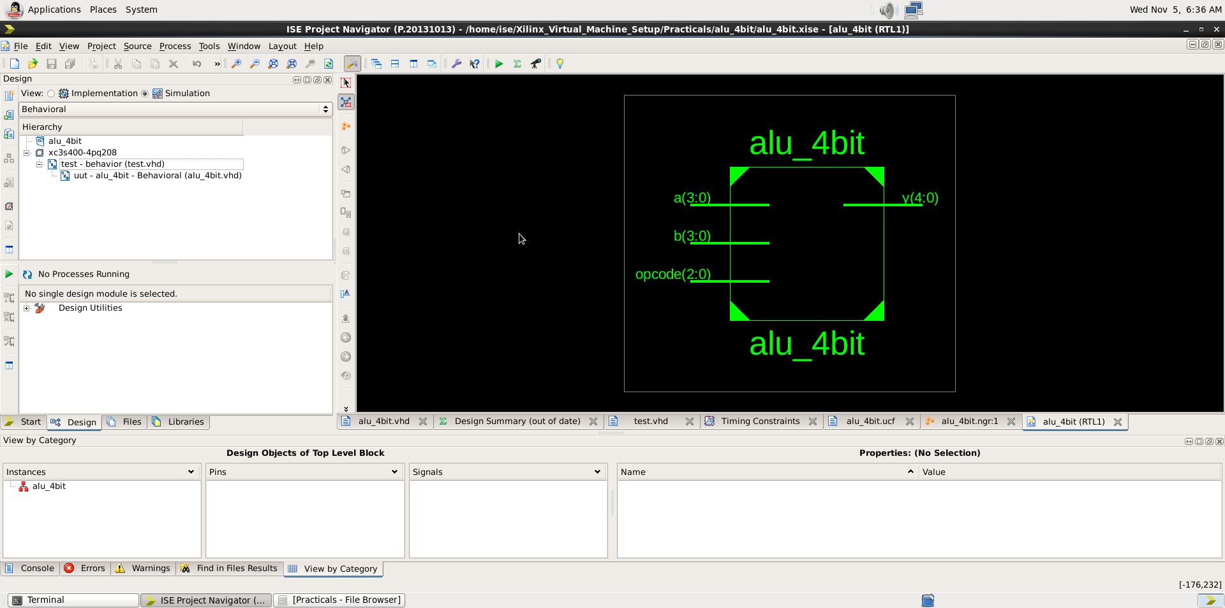

LCD Controller
CODE
library IEEE;
use IEEE.STD_LOGIC_1164.ALL;
use IEEE.NUMERIC_STD.ALL;

entity LCD_CONTROLLER is
port (
clk : in std_logic;
d_out : out std_logic_vector(7 downto 0);
rs, rw, en : out std_logic
);
end LCD_CONTROLLER;

architecture Behavioral of LCD_CONTROLLER is
type state_type is (
s0, s1, s2, s3, s4, s5, s6, s7,
s8, s9, s10, s11, s12, s13, s14, s15
);

signal pr_state, ns_state : state_type := s0;
signal clk_lcd : std_logic_vector(15 downto 0) := (others => '0');
begin

-- Clock Divider
process(clk)
begin
if rising_edge(clk) then
clk_lcd <= std_logic_vector(unsigned(clk_lcd) + 1);
end if;
end process;

-- State Transition Process
process(clk_lcd(15))
begin
if rising_edge(clk_lcd(15)) then
pr_state <= ns_state;
end if;
end process;

-- Output and Next-State Logic
process(pr_state)
begin
case pr_state is
when s0 => d_out <= x"38"; rs <= '0'; rw <= '0'; en <= '1'; ns_state <= s1;
when s1 => d_out <= x"38"; rs <= '0'; rw <= '0'; en <= '0'; ns_state <= s2;
when s2 => d_out <= x"0C"; rs <= '0'; rw <= '0'; en <= '1'; ns_state <= s3;
when s3 => d_out <= x"0C"; rs <= '0'; rw <= '0'; en <= '0'; ns_state <= s4;
when s4 => d_out <= x"06"; rs <= '0'; rw <= '0'; en <= '1'; ns_state <= s5;
when s5 => d_out <= x"06"; rs <= '0'; rw <= '0'; en <= '0'; ns_state <= s6;
when s6 => d_out <= x"01"; rs <= '0'; rw <= '0'; en <= '1'; ns_state <= s7;
when s7 => d_out <= x"01"; rs <= '0'; rw <= '0'; en <= '0'; ns_state <= s8;
when s8 => d_out <= x"53"; rs <= '1'; rw <= '0'; en <= '1'; ns_state <= s9;
when s9 => d_out <= x"53"; rs <= '1'; rw <= '0'; en <= '0'; ns_state <= s10;
when s10 => d_out <= x"49"; rs <= '1'; rw <= '0'; en <= '1'; ns_state <= s11;
when s11 => d_out <= x"49"; rs <= '1'; rw <= '0'; en <= '0'; ns_state <= s12;
when s12 => d_out <= x"54"; rs <= '1'; rw <= '0'; en <= '1'; ns_state <= s13;
when s13 => d_out <= x"54"; rs <= '1'; rw <= '0'; en <= '0'; ns_state <= s14;
when s14 => d_out <= x"53"; rs <= '1'; rw <= '0'; en <= '1'; ns_state <= s15;
when s15 => d_out <= x"53"; rs <= '1'; rw <= '0'; en <= '0'; ns_state <= s15;
end case;
end process;

end Behavioral;

TESTBENCH

library IEEE;
use IEEE.STD_LOGIC_1164.ALL;

entity test is
end test;

architecture Behavioral of test is

-- Component Declaration for the Unit Under Test (UUT)
component LCD_CONTROLLER
port (
clk : in std_logic;
d_out : out std_logic_vector(7 downto 0);
rs, rw, en : out std_logic
);
end component;

-- Testbench Signals
signal clk_tb : std_logic := '0';
signal d_out_tb : std_logic_vector(7 downto 0);
signal rs_tb, rw_tb, en_tb : std_logic;

constant CLK_PERIOD : time := 10 ns;

begin

-- Instantiate the UUT
uut: LCD_CONTROLLER
port map (
clk => clk_tb,
d_out => d_out_tb,
rs => rs_tb,
rw => rw_tb,
en => en_tb
);

-- Clock Generation Process
clk_process : process
begin
while true loop
clk_tb <= '0';
wait for CLK_PERIOD / 2;
clk_tb <= '1';
wait for CLK_PERIOD / 2;
end loop;
end process;

-- Stimulus Process
stim_proc: process
begin
-- Wait sufficient time to observe full FSM sequence
wait for 5 ms;
wait; -- stop simulation
end process;

end Behavioral;

UCF:
NET "clk" LOC = "P181";
NET "d_out<0>" LOC = "P167";
NET "d_out<1>" LOC = "P166";
NET "d_out<2>" LOC = "P165";
NET "d_out<3>" LOC = "P162";
NET "d_out<4>" LOC = "P161";
NET "d_out<5>" LOC = "P156";
NET "d_out<6>" LOC = "P155";
NET "d_out<7>" LOC = "P154";
NET "en" LOC = "P168";
NET "rs" LOC = "P171";
NET "rw" LOC = "P169";

OP
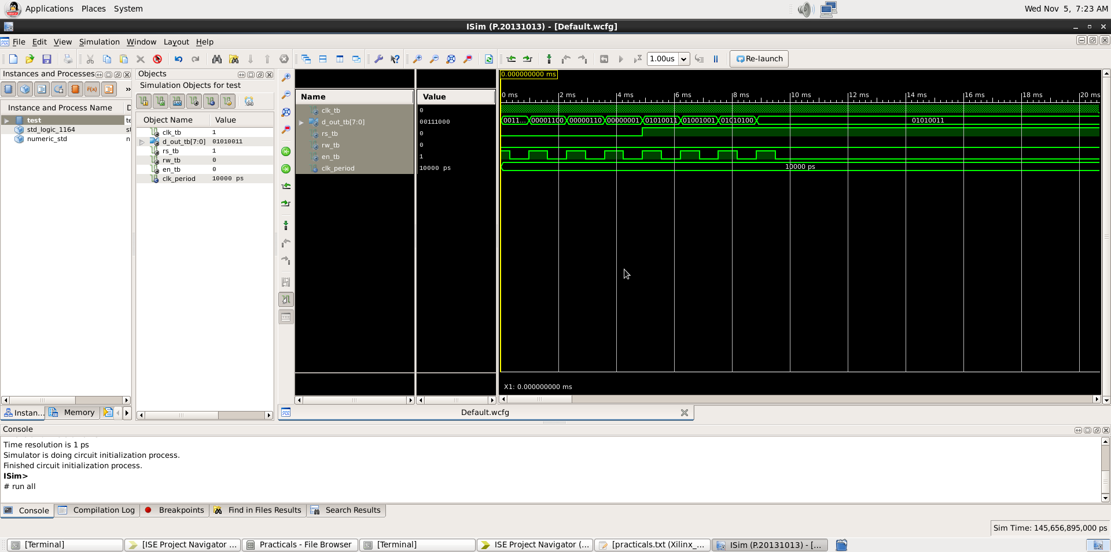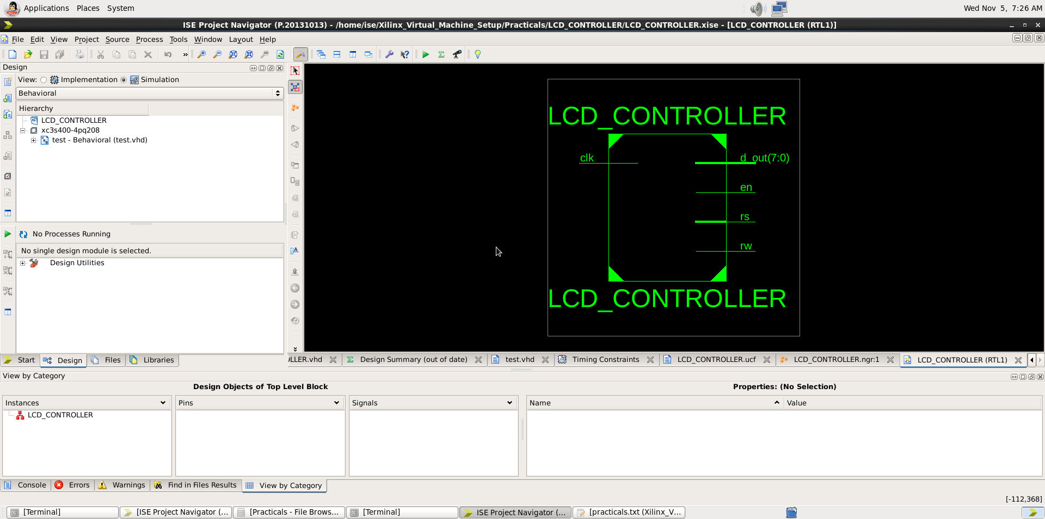

MOD N Counter
CODE
library IEEE;
use IEEE.STD_LOGIC_1164.ALL;
use ieee.std_logic_arith.all;
use ieee.std_logic_unsigned.all;

entity counter is
Port ( clk : in STD_LOGIC;
count : out STD_LOGIC_VECTOR (3 downto 0));
end counter;

architecture Behavioral of counter is
signal s:std_logic_vector(3 downto 0):="0000";
signal s1:std_logic_vector(20 downto 0):=(others=>'0');
signal sclk:std_logic:='0';
begin
process(clk)
begin
if(clk'event and clk='1')then
s1<=s1+1;
end if;
end process;
sclk<=s1(20);

process(sclk)
begin
if(sclk'event and sclk='1')then
s<=s+1;
end if;
end process;
count<=s;
end Behavioral;

TESTBENCH
library IEEE;
use IEEE.STD_LOGIC_1164.ALL;

entity test is
end test;

architecture Behavioral of test is

-- Component Declaration
component counter
Port (
clk : in STD_LOGIC;
count : out STD_LOGIC_VECTOR (3 downto 0)
);
end component;

-- Testbench Signals
signal clk_tb : std_logic := '0';
signal count_tb : std_logic_vector(3 downto 0);

constant CLK_PERIOD : time := 10 ns; -- 100 MHz clock

begin

-- Instantiate the Unit Under Test (UUT)
uut: counter
port map (
clk => clk_tb,
count => count_tb
);

-- Clock generation process
clk_process : process
begin
while true loop
clk_tb <= '0';
wait for CLK_PERIOD / 2;
clk_tb <= '1';
wait for CLK_PERIOD / 2;
end loop;
end process;

-- Simulation process
stim_proc: process
begin
-- Wait long enough to see the counter increment
wait for 200 ms; -- Adjust as needed (since sclk divides by 2^21)
wait;
end process;
end Behavioral;

UCF
NET "clk" LOC="p181";
NET "count<0>" LOC="p80";
NET "count<1>" LOC="p79";
NET "count<2>" LOC="p78";
NET "count<3>" LOC="p77";
OP
