Practical : 1

Write a program to demonstrate status of key on an Applet window such as KeyPressed, KeyReleased, KeyUp, KeyDown.

Program :

KeyEventDemo.java
import java.awt.*;
import java.applet.*;
import java.awt.event.*;
public class KeyEventDemo extends Applet implements KeyListener
{
String msg = "";
public void init()
{
addKeyListener(this);
}
public void keyReleased(KeyEvent k)
{
showStatus("Key Released");
repaint();
}
public void keyTyped(KeyEvent k)
{
showStatus("Key Typed");
repaint();
}
public void keyPressed(KeyEvent k)
{
showStatus("Key Pressed");
repaint();
}
public void paint(Graphics g)
{
g.drawString(msg, 10, 10);
}
}
Exp1.html
<applet code="KeyEventDemo" height="400" width="400">
</applet>

Output :
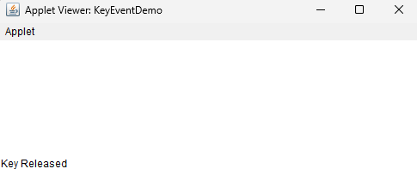
Practical : 2

Write a program to create a frame using AWT. Implement mouseClicked, mouseEntered() and mouseExited() events. Frame should become visible when the mouse enters it.

Program :

import java.awt.*;
import java.awt.event.*;

class Exp2 extends Frame implements MouseListener {

Exp2() {
setTitle("Mouse Event Frame");
setSize(400, 300);
setLayout(new FlowLayout());
add(new Label("Mouse Events: Enter, Exit, Click"));

addMouseListener(this);
setVisible(false); // Frame hidden initially
}

public void mouseEntered(MouseEvent e) {
System.out.println("Mouse Entered");
setVisible(true);
}

public void mouseExited(MouseEvent e) {
System.out.println("Mouse Exited");
setVisible(false);
}

public void mouseClicked(MouseEvent e) {
System.out.println("Mouse Clicked");
}

public void mousePressed(MouseEvent e) {}
public void mouseReleased(MouseEvent e) {}

public static void main(String[] args) {
// Helper frame that stays visible so you can trigger the events
Frame baseFrame = new Frame("Trigger Area");
baseFrame.setSize(300, 200);
baseFrame.setLayout(new FlowLayout());
baseFrame.add(new Label("Move mouse here to show the frame"));
baseFrame.setVisible(true);

// Frame that appears/disappears based on mouse
Exp2 mouseFrame = new Exp2();

// Add mouse listener to the base frame to trigger visibility
baseFrame.addMouseListener(new MouseAdapter() {
public void mouseEntered(MouseEvent e) {
mouseFrame.setVisible(true);
}
});
}
}

Output :
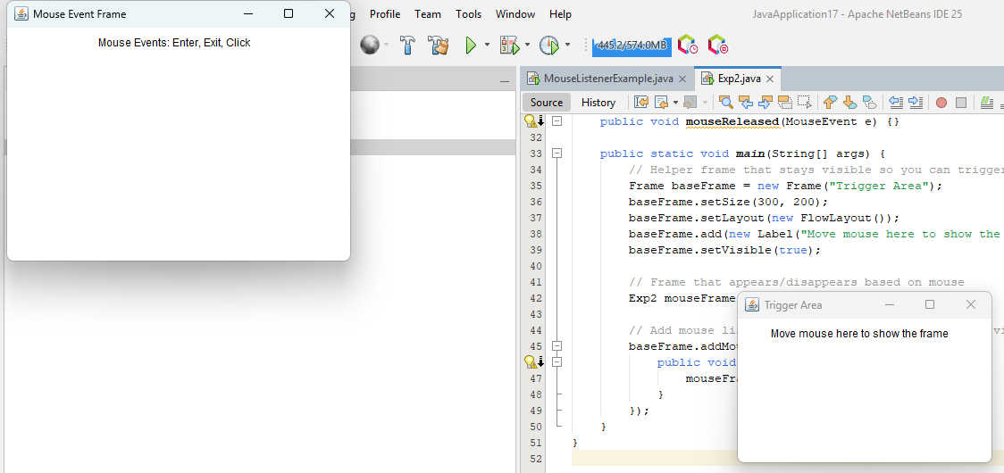

Practical : 3

Develop a GUI which accepts the information regarding the marks for all the subjects of a student in the examination. Display the result for a student in a separate window.

Program :

import javax.swing.*;
import java.awt.*;

public class Exp3 {
public static void main(String[] args) {
SwingUtilities.invokeLater(SimpleMarksWindow::new);
}
}

class SimpleMarksWindow extends JFrame {
JTextField[] markFields = new JTextField[5];
String[] subjects = {"PCS", "CS", "SS", "OOP", "PBL"};

SimpleMarksWindow() {
setTitle("Enter Subject Marks");
setSize(300, 300);
setDefaultCloseOperation(EXIT_ON_CLOSE);
setLocationRelativeTo(null);
setLayout(new GridLayout(6, 2, 10, 10)); ff

for (int i = 0; i < 5; i++) {
add(new JLabel(subjects[i] + ":"));
markFields[i] = new JTextField();
add(markFields[i]);
}

JButton submit = new JButton("Submit");
submit.addActionListener(e -> showResult());
add(submit);
add(new JLabel()); // for grid alignment

setVisible(true);
}

void showResult() {
int total = 0;
boolean pass = true;

for (JTextField field : markFields) {
String input = field.getText().trim();
if (!input.matches("\\d+")) {
JOptionPane.showMessageDialog(this, "Enter valid integer marks.");
return;
}

int mark = Integer.parseInt(input);
if (mark < 0 || mark > 100) {
JOptionPane.showMessageDialog(this, "Marks must be between 0 and 100.");
return;
}

if (mark < 35) pass = false;
total += mark;
}

double percentage = total / 5.0;
String result = pass ? "Pass" : "Fail";

JOptionPane.showMessageDialog(this,
"Total: " + total +
"\nPercentage: " + String.format("%.2f", percentage) + "%" +
"\nResult: " + result);
}
}

Output :
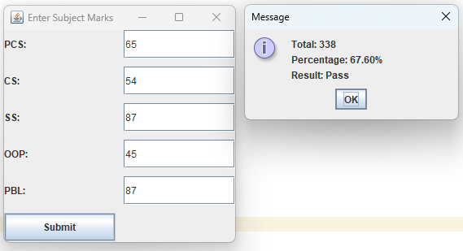

Practical : 4

Write a program to insert and retrieve the data from the database using JDBC.

Program :

StudentDB.java

import java.sql.*;

public class StudentDB {
public static void main(String[] args) {
String url = "jdbc:mysql://localhost:3306/studentdb";
String user = "root";
String password = "root123";

try {
// 1. Load driver and establish connection
Class.forName("com.mysql.cj.jdbc.Driver");
Connection con = DriverManager.getConnection(url, user, password);

// 2. Create table if not exists
Statement stmt = con.createStatement();
stmt.executeUpdate("CREATE TABLE IF NOT EXISTS students (name VARCHAR(50), marks INT)");

// 3. Insert sample data
stmt.executeUpdate("INSERT INTO students VALUES ('Rahul', 85)");
stmt.executeUpdate("INSERT INTO students VALUES ('Priya', 92)");

// 4. Retrieve and display data
ResultSet rs = stmt.executeQuery("SELECT * FROM students");
System.out.println("Student Records:");
while(rs.next()) {
System.out.println(rs.getString("name") + "\t" + rs.getInt("marks"));
}

// 5. Close connection
con.close();
} catch(Exception e) {
System.out.println(e);
}
}
}

MySQL :
SHOW TABLES;
USE studentdb;
CREATE DATABASE StudentDB;
select*from students;

Output :
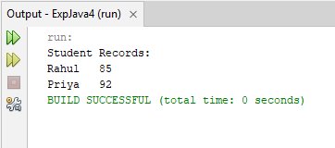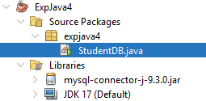
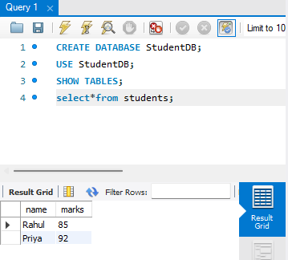

Practical : 5

Write program with suitable example to develop your remote interface, implement your RMI server, implement application that create your server.

Program :

Addition.java (Remote Interface)

import java.rmi.Remote;
import java.rmi.RemoteException;
public interface Addition extends Remote {
int add(int a, int b) throws RemoteException;
}

AdditionImpl.java (Server Implementation)

import java.rmi.server.UnicastRemoteObject;
import java.rmi.RemoteException;
public class AdditionImpl extends UnicastRemoteObject implements Addition {
public AdditionImpl() throws RemoteException {
super();}
public int add(int a, int b) throws RemoteException {
return a + b;}}

AdditionServer.java (RMI Server)

import java.rmi.registry.LocateRegistry;
import java.rmi.registry.Registry;
public class AdditionServer {
public static void main(String[] args) {
try {
AdditionImpl obj = new AdditionImpl();
Registry registry = LocateRegistry.createRegistry(1099);
registry.rebind("AddService", obj);
System.out.println("Addition Server is ready...");
} catch (Exception e) {
e.printStackTrace();
}}}

AdditionClient.java (RMI Client)

import java.rmi.registry.LocateRegistry;
import java.rmi.registry.Registry;
import java.util.Scanner;
public class AdditionClient {
public static void main(String[] args) {
try {
// Getting input from the user
Scanner sc = new Scanner(System.in);
System.out.print("Enter first number: ");
int num1 = sc.nextInt();
System.out.print("Enter second number: ");
int num2 = sc.nextInt();
Registry registry = LocateRegistry.getRegistry("localhost", 1099);
Addition stub = (Addition) registry.lookup("AddService");
int result = stub.add(num1, num2);
System.out.println("Result from Server: " + result);
} catch (Exception e) {
e.printStackTrace();
}
}
}

Output :

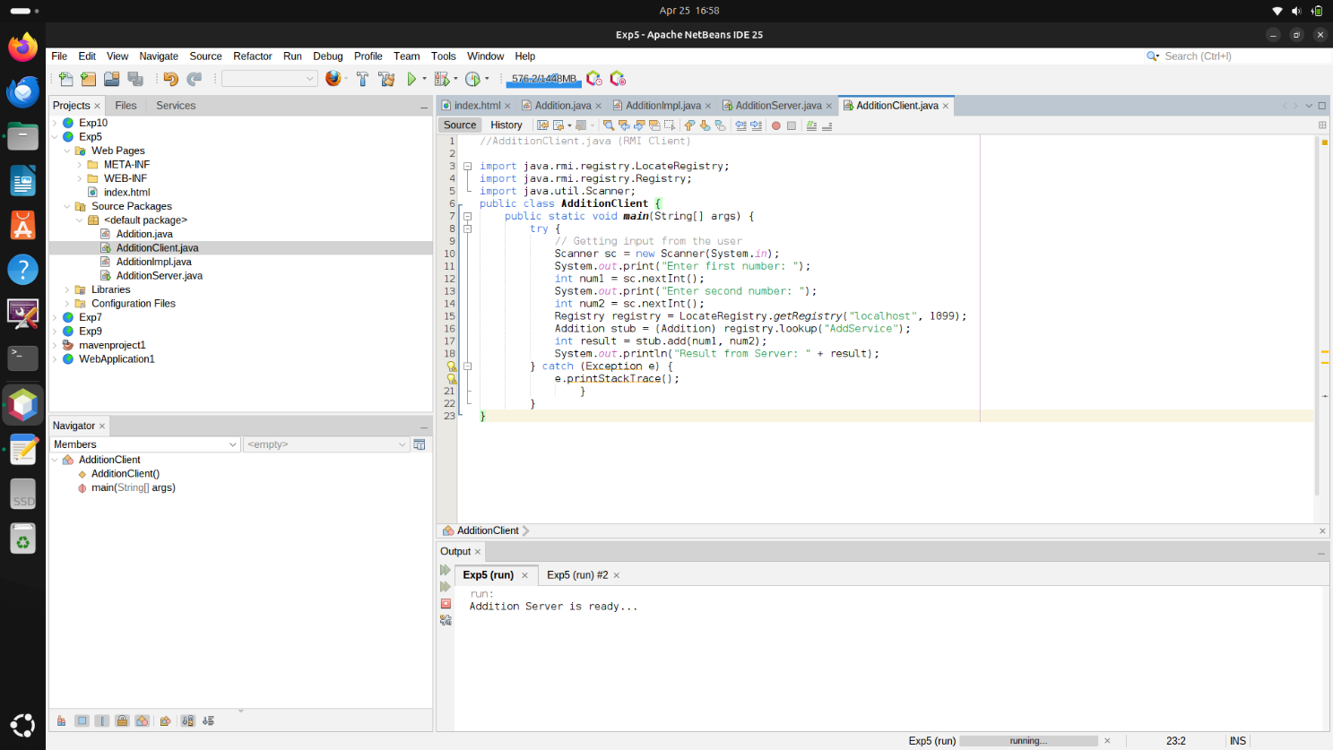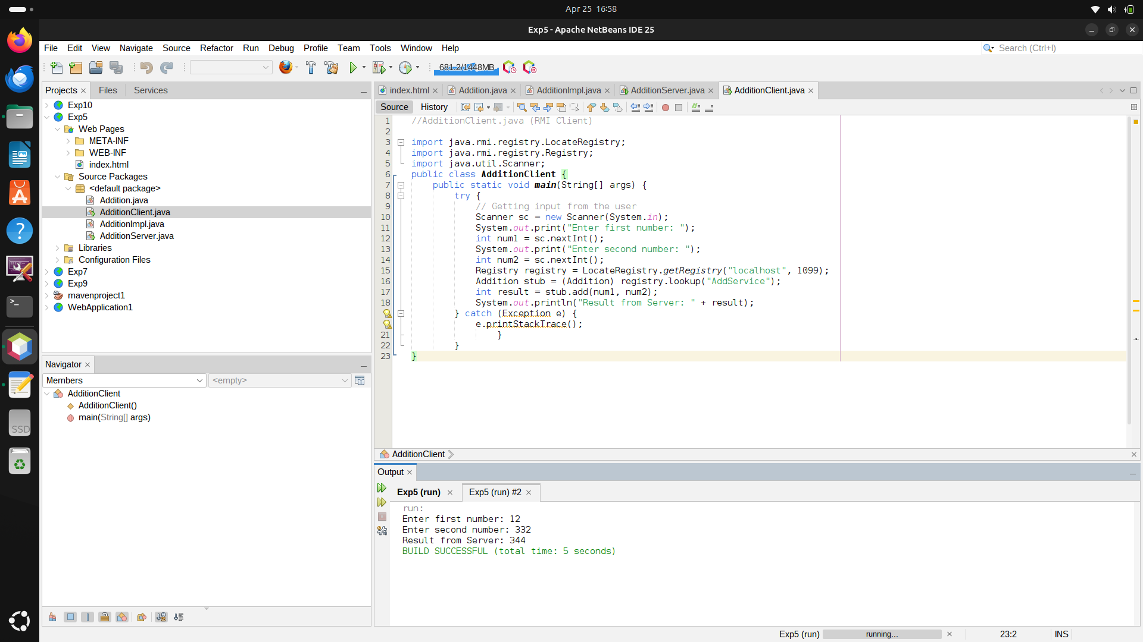

Practical : 6

Write a program to demonstrate the use of InetAddress class and its factory methods.

Program :

import java.net.InetAddress;
public class Exp6 {
public static void main(String[] args) {
try {
// 1. Get Local Host Address
InetAddress localHost = InetAddress.getLocalHost();
System.out.println("Local Host Name : " + localHost.getHostName());
System.out.println("Local Host Address : " + localHost.getHostAddress());

// 2. Get IP Address of a Website (e.g., google.com)
InetAddress google = InetAddress.getByName("www.google.com");
System.out.println("\nGoogle Host Name : " + google.getHostName());
System.out.println("Google IP Address : " + google.getHostAddress());

// 3. Get All IP Addresses Associated with the Domain
InetAddress[] addresses = InetAddress.getAllByName("www.google.com");
System.out.println("\nAll Google IP Addresses:");
for (InetAddress addr : addresses) {
System.out.println("- " + addr.getHostAddress());
}
} catch (Exception e) {
System.out.println("Error occurred: " + e.getMessage());
}
}
}

Output :

Local Host Name : DESKTOP-US539TC
Local Host Address : 26.253.5.171

Google Host Name : www.google.com
Google IP Address : 142.251.220.4

All Google IP Addresses:
- 142.251.220.4
- 2404:6800:4009:80a:0:0:0:2004

Practical : 7

Write a servlet program to send username and password using html forms and authenticate the user.

Program :

MySrv.java

import java.io.IOException;
import java.io.PrintWriter;
import jakarta.servlet.ServletException;
import jakarta.servlet.http.HttpServlet;
import jakarta.servlet.http.HttpServletRequest;
import jakarta.servlet.http.HttpServletResponse;

public class MySrv extends HttpServlet {

protected void doPost(HttpServletRequest request, HttpServletResponse response)
throws ServletException, IOException {

response.setContentType("text/html");
PrintWriter out = response.getWriter();

String username = request.getParameter("uname");
String password = request.getParameter("pwd");

out.println("<!DOCTYPE html>");
out.println("<html><head><title>Login Response</title></head><body>");

if ("shubh".equals(username) && "shubham123".equals(password)) {
out.println("<h1>Welcome " + username + " to the Server!</h1>");
} else {
out.println("<h1>Login failed</h1>");
out.println("<a href='Registration.html'>Click for Home page</a>");
}

out.println("</body></html>");
out.close();
}

protected void doGet(HttpServletRequest request, HttpServletResponse response)
throws ServletException, IOException {
doPost(request, response);
}
}

Registration.html

<!DOCTYPE html>
<html>
<head>
<title>Login Page</title>
</head>
<body bgcolor='#00FFFF'>
<form action='MySrv' method="post">
<center>
<h1><u>Login Page</u></h1>
<h2>
Username: <input type="text" name="uname" />
Password: <input type="password" name="pwd" />
<input type="submit" value="click me" />
</h2>
</center>
</form>
</body>
</html>

web.xml

<?xml version="1.0" encoding="UTF-8"?>
<web-app version="6.1" xmlns="https://jakarta.ee/xml/ns/jakartaee" xmlns:xsi="http://www.w3.org/2001/XMLSchema-instance" xsi:schemaLocation="https://jakarta.ee/xml/ns/jakartaee https://jakarta.ee/xml/ns/jakartaee/web-app_6_1.xsd">
<servlet>
<servlet-name>MySrv</servlet-name>
<servlet-class>MySrv</servlet-class>
</servlet>
<servlet-mapping>
<servlet-name>MySrv</servlet-name>
<url-pattern>/MySrv</url-pattern>
</servlet-mapping>

<welcome-file-list>
<welcome-file>Registration.html</welcome-file>
</welcome-file-list>
</web-app>

Output :
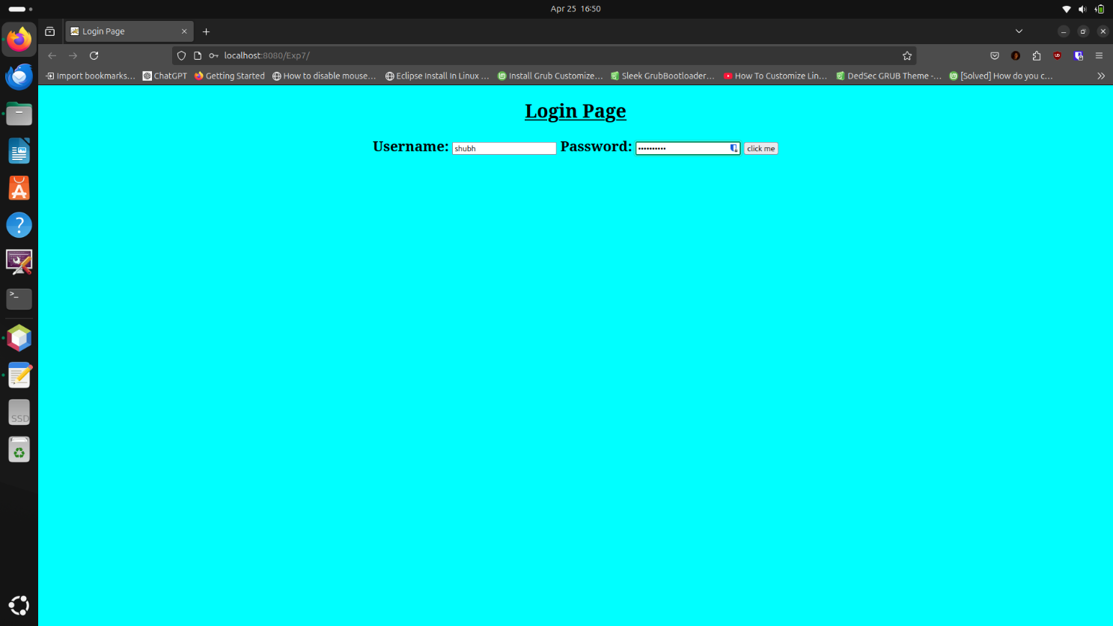
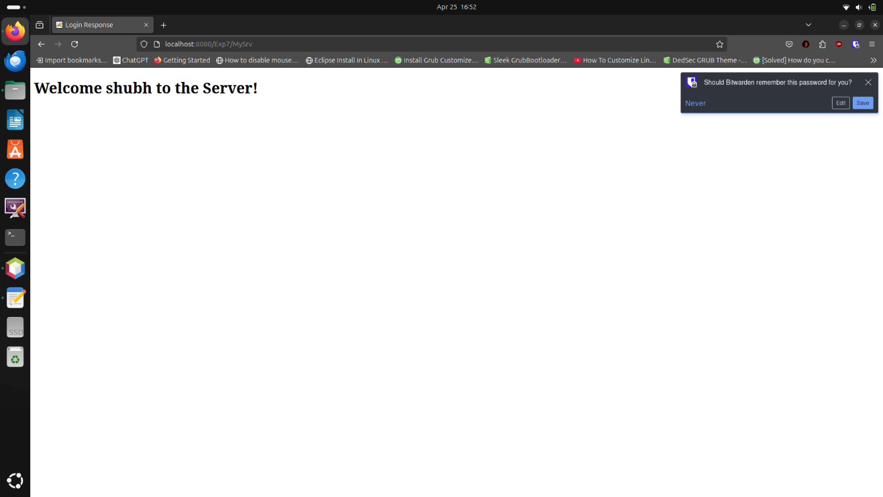
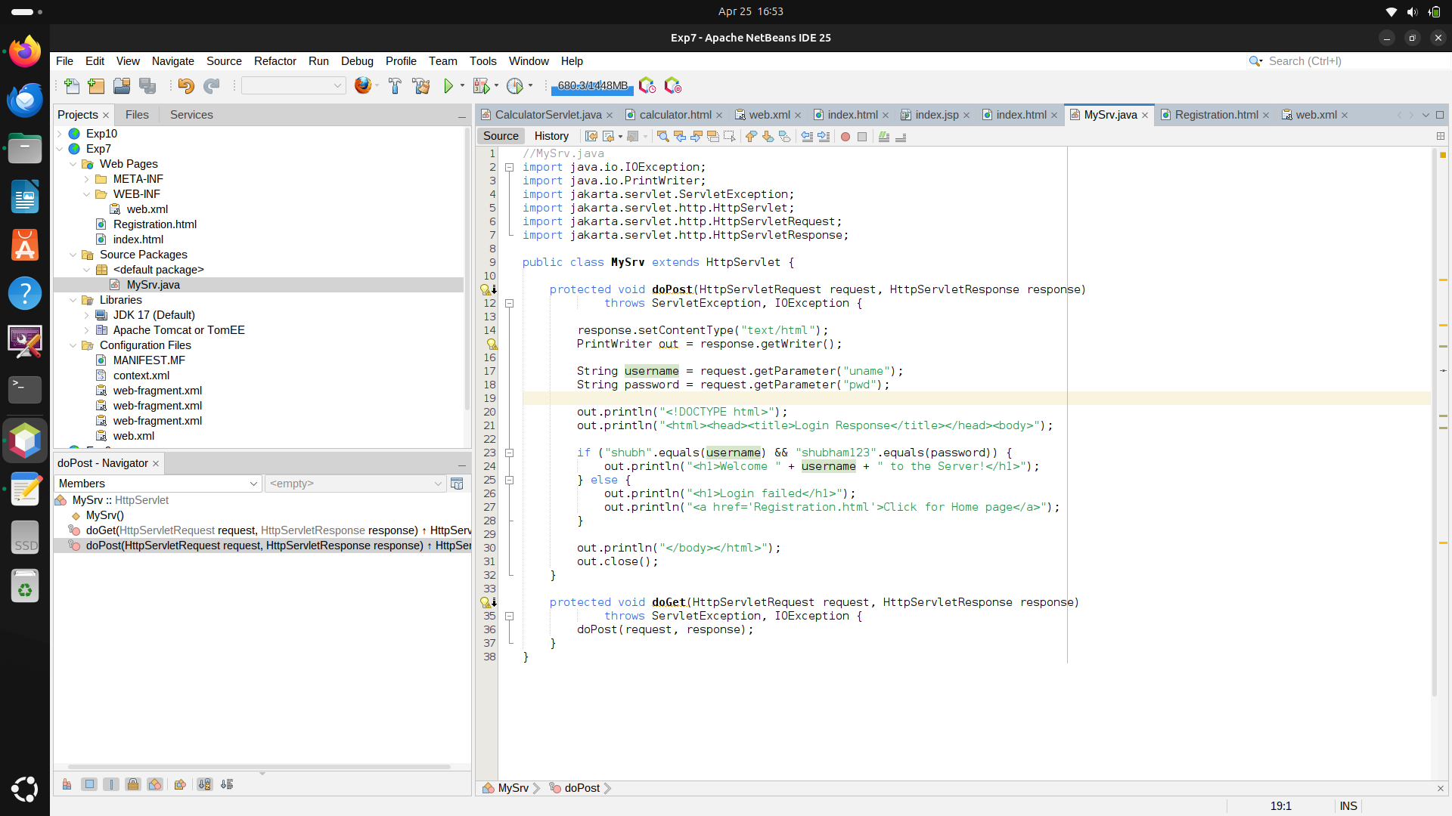

Practical : 8

Write a database application that uses any JDBC driver

Program :

StudentDB.java –
import java.sql.*;

public class JdbcExample {
public static void main(String[] args) {
// Step 1: Define database parameters
String url = "jdbc:mysql://localhost:3306/Exp8"; // Replace 'testdb' with your database name
String user = "root"; // Replace with your DB username
String password = "root123"; // Replace with your DB password

try {
// Step 2: Load and Register the JDBC driver
Class.forName("com.mysql.cj.jdbc.Driver");

// Step 3: Establish the connection
Connection con = DriverManager.getConnection(url, user, password);
System.out.println("Connection established successfully.");

// Step 4: Create a Statement
Statement st = con.createStatement();

// Step 5: Execute a query (creating a table, inserting data, retrieving)
String createTable = "CREATE TABLE IF NOT EXISTS students (id INT, name VARCHAR(50))";
st.executeUpdate(createTable);

String insertData = "INSERT INTO students (id, name) VALUES (1, 'Alice'), (2, 'Bob')";
st.executeUpdate(insertData);

String selectQuery = "SELECT * FROM students";
ResultSet rs = st.executeQuery(selectQuery);

// Step 6: Process the results
System.out.println("Student Data:");
while (rs.next()) {
System.out.println("ID: " + rs.getInt("id") + ", Name: " + rs.getString("name"));
}

// Step 7: Close the connection
con.close();
System.out.println("Connection closed.");

} catch (Exception e) {
e.printStackTrace();
}
}
}

MySQL :
CREATE DATABASE Exp8;
USE Exp8;
SHOW TABLES;
select*from students;

Output :

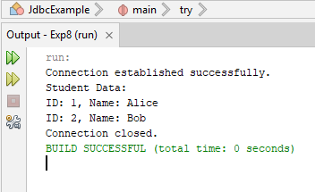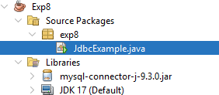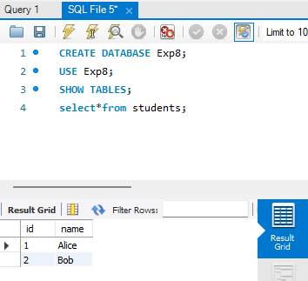

Practical : 9

Write a servlet program to implement simple calculator.

Program :

CalculatorServlet.java

import java.io.*;
import jakarta.servlet.*;
import jakarta.servlet.http.*;
public class CalculatorServlet extends HttpServlet {
public void doPost(HttpServletRequest request, HttpServletResponse response) throws ServletException, IOException {
response.setContentType("text/html");
PrintWriter out = response.getWriter();
// Get parameters from form
int num1 = Integer.parseInt(request.getParameter("num1"));
int num2 = Integer.parseInt(request.getParameter("num2"));
String op = request.getParameter("operation");
double result = 0;
switch (op) {
case "add": result = num1 + num2; break;
case "sub": result = num1 - num2; break;
case "mul": result = num1 * num2; break;
case "div":
if (num2 != 0)
result = (double) num1 / num2;
else
out.println("<h3>Division by zero error!</h3>");
break;
default:
out.println("<h3>Invalid Operation</h3>");
return;
}
out.println("<h2>Result: " + result + "</h2>");
}}

Calculator.html
<!DOCTYPE html>
<html>
<head><title>Simple Calculator</title></head>
<body>
<h2>Simple Calculator</h2>
<form action="CalculatorServlet" method="post">
Number 1: <input type="text" name="num1"><br><br>
Number 2: <input type="text" name="num2"><br><br>
Operation:<br>
<input type="radio" name="operation" value="add" checked> Addition<br>
<input type="radio" name="operation" value="sub"> Subtraction<br>
<input type="radio" name="operation" value="mul"> Multiplication<br>
<input type="radio" name="operation" value="div"> Division<br><br>
<input type="submit" value="Calculate">
</form>
</body>
</html>

web.xml
<?xml version="1.0" encoding="UTF-8"?>
<web-app xmlns="http://java.sun.com/xml/ns/javaee"
xmlns:xsi="http://www.w3.org/2001/XMLSchema-instance"
xsi:schemaLocation="http://java.sun.com/xml/ns/javaee
http://java.sun.com/xml/ns/javaee/web-app_3_0.xsd" version="3.0">
<display-name>SimpleCalculatorApp</display-name>
<servlet>
<servlet-name>CalculatorServlet</servlet-name>
<servlet-class>CalculatorServlet</servlet-class>
</servlet>
<servlet-mapping>
<servlet-name>CalculatorServlet</servlet-name>
<url-pattern>/CalculatorServlet</url-pattern>
</servlet-mapping>
<welcome-file-list>
<welcome-file>calculator.html</welcome-file>
</welcome-file-list>
</web-app>

Output :

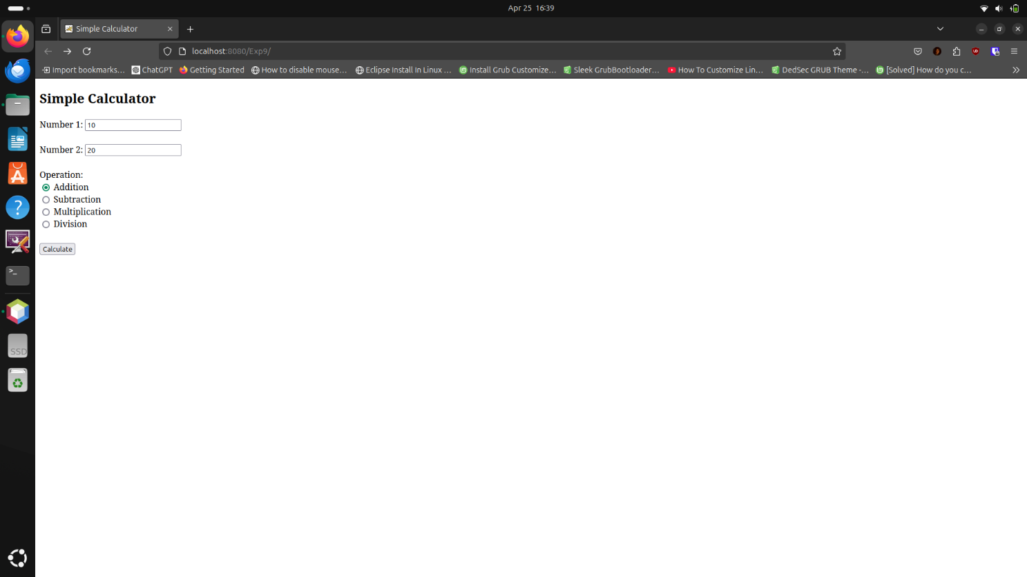
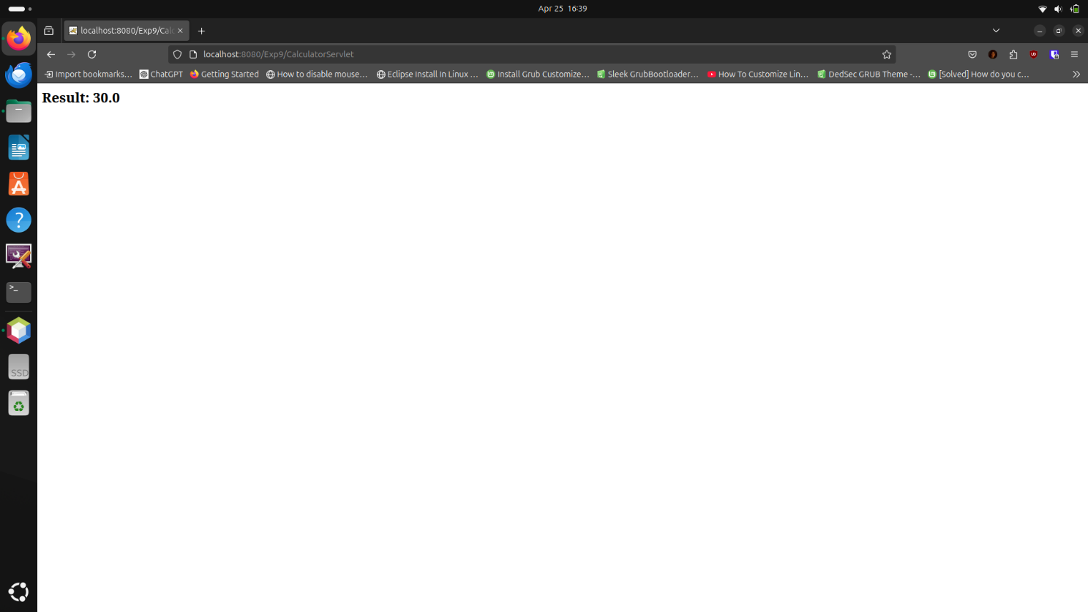

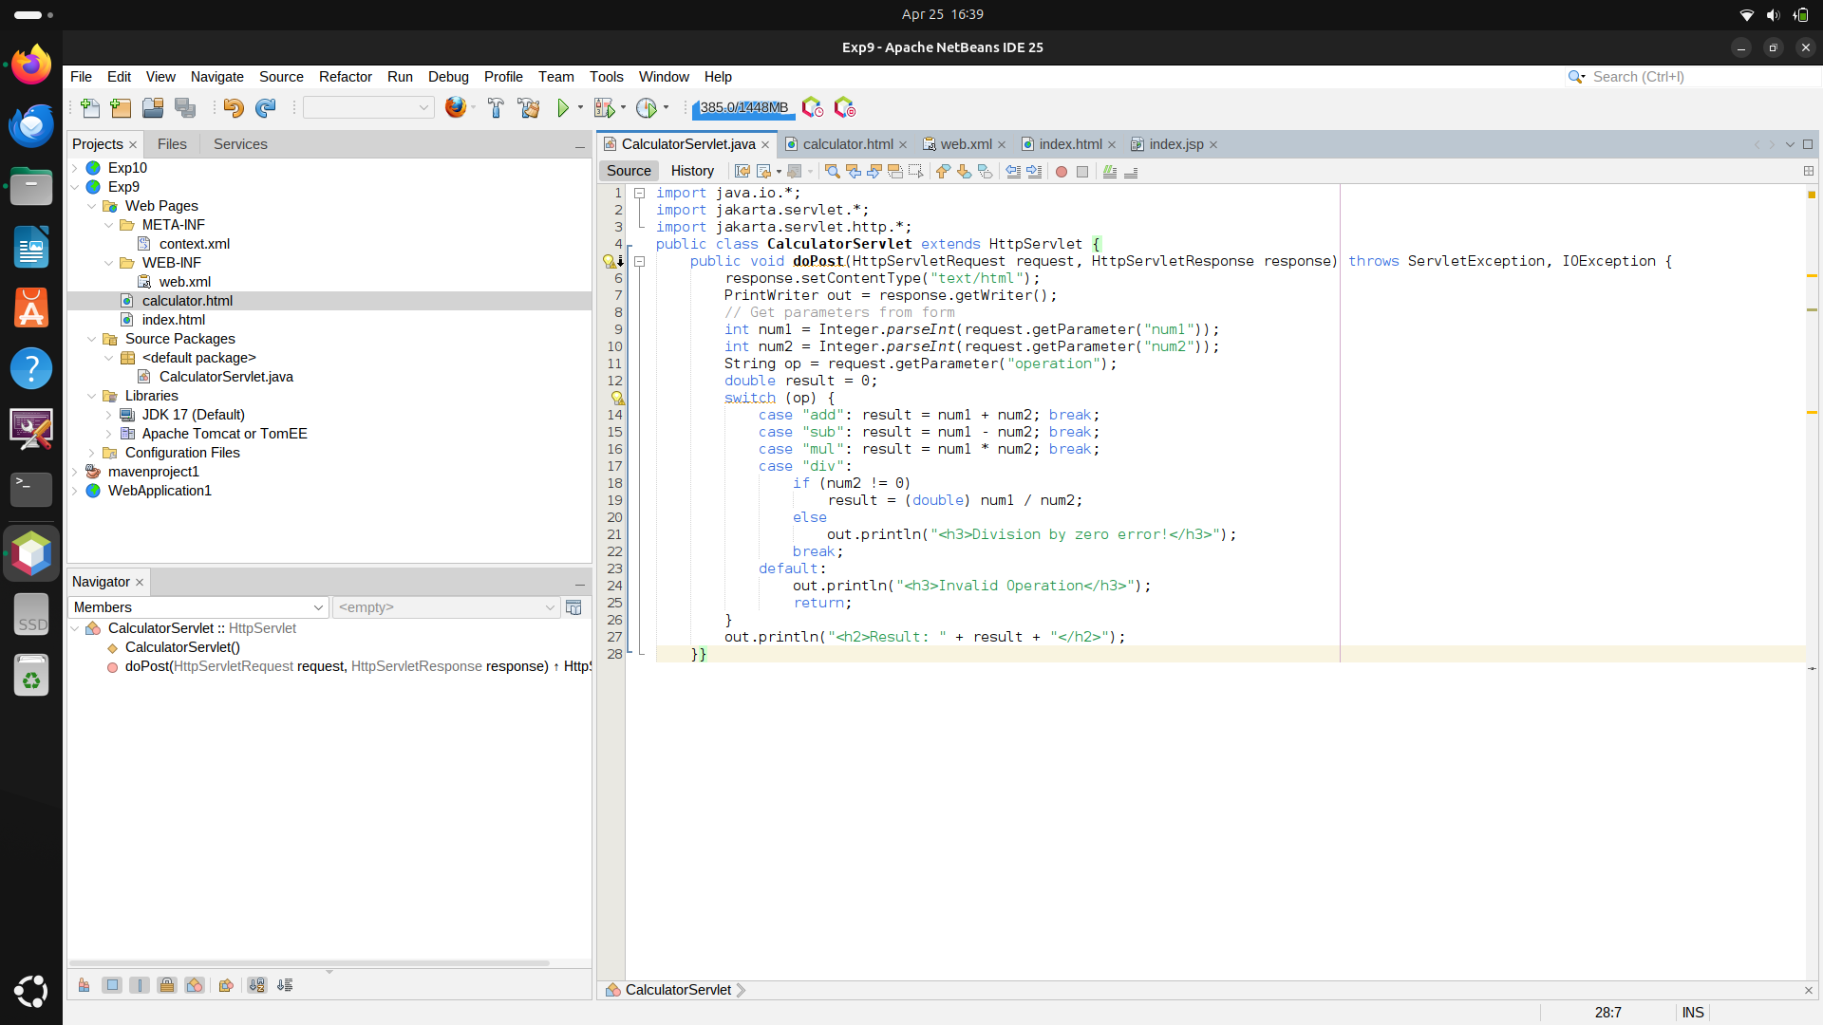

Practical : 10

Write a simple JSP page to display a simple message (It may be a simple HTML page)

Program :

index.jsp

<!DOCTYPE html>
<html>
<head>
<title>Input Page</title>
</head>
<body style="text-align: center; padding-top: 50px;">
<h2>Enter Your Name</h2>
<form action="#">
<input type="text" name="username" placeholder="Your Name" required>
<br><br>
<input type="submit" value="Submit">
</form>
</body>
</html>

Output :

