**1.creating a database product_db1**

**create database product_db1;**

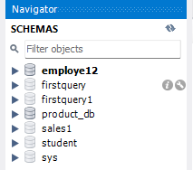

**use product_db;**

**2.CREATE A TABLE WITH THE NAME “PRODUCT” WITH THE FOLLOWING COLUMNS.**

**create table product(product_id int, product varchar(10), quantity int, price int, purchase_cost int, estimated_sale_price float);**

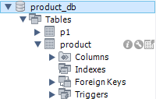

**3.DISPLAY ALL COLUMN NAMES AND THEIR DATATYPE AND SIZE IN PRODUCT.**

**desc product;**

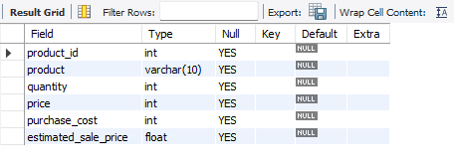

**4.INSERT THE BELOW TWO RECORDS INTO TABLE.**

**--1ST RECORD WITH VALUES**

**-- PRODUCT_ID : 1**

**-- PRODUCT : PAYCARD**

**-- QUANTITY : 2**

**-- PRICE : 300**

**-- PURHASE_COST : 8000**

**-- ESTIMATED_SALES_PRICE : 9000.56**

**--2ND RECORD WITH VALUES**

**-- PRODUCT_ID : 2**

**-- PRODUCT : PAYPOINTS**

**-- QUANTITY : 4**

**-- PRICE : 200**

**-- PURHASE_COST : 7000**

**-- ESTIMATED_SALES_PRICE : 6700.56**

**insert into product values(1,"paycard",2,300,8000,9000.56),**

**(2,"paypoints",4,200,7000,6700.56);**

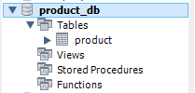

**select *from product;**

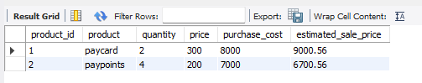

**5. ADD A COLUMN : “LOCATION” TO THE EXISTING PRODUCT TABLE WITH DATA TYPE VARCHAR AND SIZE 50**

**alter table product add column location varchar(50);**

**select *from product;**

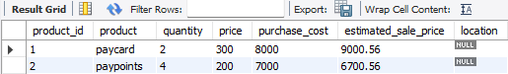

**6.UPDATE THE VALUE OF THE LOCATION**

**-- UPDATE LOCATION AS USA FOR PRODUCT_ID = 1**

**-- UPDATE LOCATION AS INDIA FOR PRODUCT_ID = 2**

**set sql_safe_updates=0;**

**update product set location = "usa" where product_id = 1;**

**update product set location = "India" where product_id = 2;**

**select *from product;**

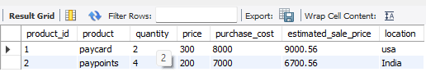

**7.WHAT IS THE VALUE OF LOCATION FOR PRODUCT : “PAYCARD” ?**

**ANSWER:**

**USA**

**8.UPDATE THE PRODUCT COLUMN TO SIZE OF 25**

**alter table product**

**modify column product varchar(25);**

**desc product;**

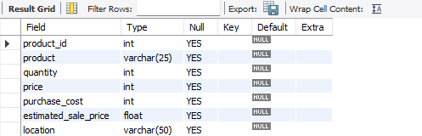

**9.REDUCE THE SIZE OF THE LOCATION FIELD FROM 50 TO 20 AND CHECK IF IT IS POSSIBLE.**

**ANSWER :**

**YES IT IS POSSIBLE**

**alter table product**

**modify column location varchar(20);**

**desc product;**

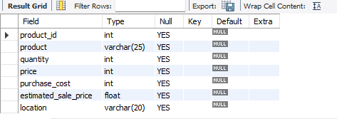

**10. UPDATE THE QUALITY INFORMATION OF “PAYCARD” PRODUCT DETAILS.**

**-- FOR “PAYCARD” PRODUCT,UPDATE THE QUANTITY FROM 2 TO 10**

**update product set quantity=10 where product = "paycard";**

**select *from product;**

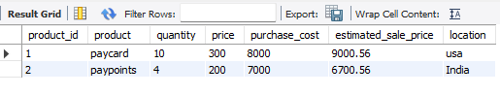

**11. insert one more row/record to the table record with values**

**-- PRODUCT_ID : 4**

**-- PRODUCT : CREDITCARD**

**-- QUANTITY : 2**

**-- PRICE : 500**

**-- PURCHASE_COST : 900**

**-- ESTIMATED_SALES_PRICE : 750**

**-- LOCATION : INDIA**

**insert into product values(4,"creditcard",2,500,900,750,"india");**

**select *from product;**

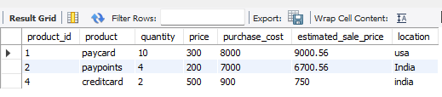

**12.INSERT BELOW TWO ROW/RECORD TO THE TABLE BY USING ONE QUERY RECORD WITH VALUES**

**1) -- PRODUCT_ID : 5**

**-- PRODUCT : DEBITCARD**

**-- QUANTITY : 4**

**-- PRICE : 500**

**-- PURCHASE_COST : 2000**

**-- ESTIMATED_SALES_PRICE : 1850**

**-- LOCATION : UK**

**2)**

**-- PRODUCT_ID : 6**

**-- PRODUCT : BUYBACK**

**-- QUANTITY : 20**

**-- PRICE : 500**

**-- PURCHASE_COST : 10000**

**-- ESTIMATED_SALES_PRICE : 9800.95**

**-- LOCATION : USA**

**insert into product values(5,"debitcard",4,500,2000,1850,"UK"),**

**(6,"buyback",20,500,10000,9800.95,"USA");**

**select *from product;**

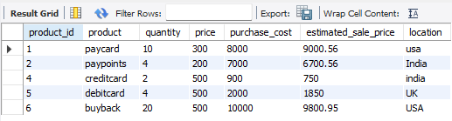

**13.ADD A COLUMN ZIP_CODE TO THE PRODUCT TABLE**

**alter table product add column zip_code int;**

**desc product;**

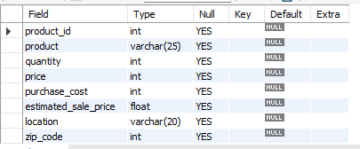

**14.UPDATE ZIP_CODE TO THE PROCUCT TABLE BY SOME RANDOM UNIQUE ZIP CODE TO THE PRODUCT**

**update product set zip_code=143;**

**select *from product;**

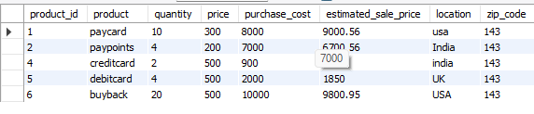

**15. DROP THE COLUMN ZIP_CODE FROM THE TABLE**

**alter table product**

**drop zip_code;**

**select *from product;**

