Hello There!

**What is 12/25 Publishing?**

That's a good question!   
12/25 Publishing is an independent publishing house with a passion for children's books. Please visit Amazon for our latest offering, 'Jeremy Brown and The Unorthodox Crown'

12/25 Publishing Logo.   
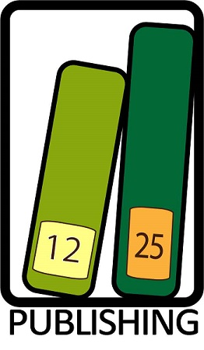

|  |  |
| --- | --- |
| Book Name | Availability |
| Jeremy Brown and The Unorthodox Crown | Available |
| Jeremy Brown, P.I. | Available Soon |
|  |  |

**Please visit the author's site**  [Tara King](http://itstaraking.wordpress.com)