Hexadezimalsystem

# HEX -> DEZ: Stellenwertverfahren

1A16 = 1 * 161 + A * 160 = 16 + 10 * 160 = 16 + 10 = 2610

A116 = A * 161 + 1 * 160 = 10 * 16 + 1 = 16110

10 = 1 * 161 + 0 * 160 = 1610

# DEZ -> HEX: Restwertverfahren

75810 = x16  
758 / 16 = 47 6 6  
47 / 16 = 2 15 F  
2 / 16 = 0 2 2  
x = 2F616

# BIN -> HEX

Die Zahlen 0 – 15 benötigen zur binären Darstellung max. 4 Bit, 1510 = 11112

1011 00112 = x16

|  |  |
| --- | --- |
| 10112 | 00112 |
| 1110 | 310 |
| B16 | 316 |

8 4 2 1 8 4 2 1

x = B316

|  |  |
| --- | --- |
| 00012 | 01112 |
| 110 | 710 |
| 116 | 716 |

101112 = x16

x = 1716

|  |  |
| --- | --- |
| 00102 | 11012 |
| 210 | 1310 |
| 216 | D16 |

10 1101

x = 2D16

# HEX -> BIN

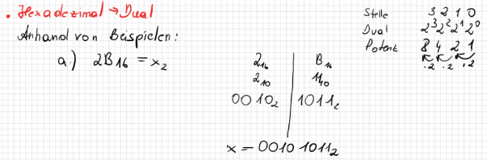Anhand von Beispielen:

|  |  |
| --- | --- |
| 216 | B16 |
| 210 | 1110 |
| 102 | 10112 |

1. 2B16 = x2

x = 10 10112

|  |  |  |
| --- | --- | --- |
| 116 | 016 | 116 |
| 110 | 010 | 110 |
| 00012 | 0000 | 00012 |

1. 10116 = x2

x = 1 0000 0001

# DEZ -> BIN

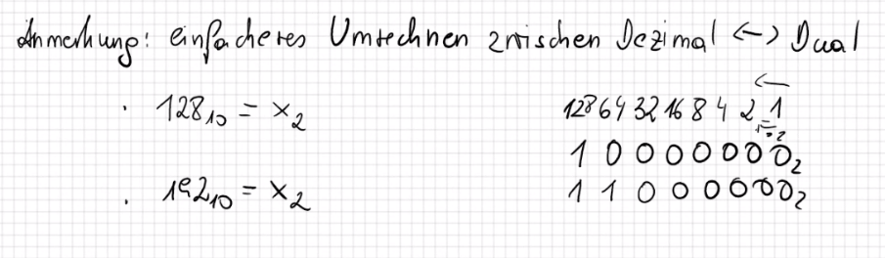

21710 = x2

|  |  |  |  |  |  |  |  |
| --- | --- | --- | --- | --- | --- | --- | --- |
| 128 | 64 | 32 | 16 | 8 | 4 | 2 | 1 |
| 1 | 1 | 0 | 1 | 1 | 0 | 0 | 1 |