**Jede Antwort max. 2 Punkte!**

**a) Please watch this YouTube video:**

<https://www.youtube.com/watch?time_continue=73&v=aEmF3Iylvr4&feature=emb_logo>

**b) Please answer shortly below the following questions:**

1. What could happen if criminals get our passwords? Give one example.

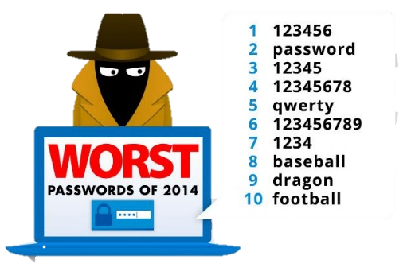 Your answer: If criminals get access to my password, they have full access over the account and can therefore do whatever they want. This can be virus attacks, or them even stealing information or money.

1. How should passwords be?

Your answer: Strong! That means that they should not  
appear in a dictionary, that there should be uppercase and  
lowercase letters and that it should contain special characters and  
numbers.

1. What can be a problem at creating passwords?

Your answer: Remembering it. You should pick passwords that are somewhat rememberable, but still hard to guess. Writing it down is a big risk as others can easily find the piece of paper with all the information they need to get into your account.

1. Which tools have criminals to get passwords?

Your answer: There is lots of ways criminals can get to your passwords. They send you fake emails, that require you to enter your password. Also, they use computers to ‘guess’ the password and try all kinds of words out of dictionaries and wordlists.

1. What makes it easier for them to get your password?

Your answer: Keeping a note with the password next to you PC makes it easy for others to get into you account. Also passwords that are very easy to guess won’t stop a criminal for long.

1. So which kind of password should be created?

Your answer: I kind of answered this at *Question 1* but the password should be unique too. It shouldn’t be used at all accounts you have. If they get the password, they have access to all your accounts if you use only one password.

1. Which words are too easy for passwords? Give three examples!

Your answer: There is lots of obvious passwords:  
- password  
- 1234  
- the name of a family member, a pet, your birthday date, etc

1. Why is the password ***jajwuth*** difficult to guess?  
   Your answer: Because it can’t be found in dictionaries.
2. What can make the password ***jajwuth*** stronger?

Your answer: It can be made stronger by replacing some lowercase letters with their uppercase variation and by adding special characters and numbers.

1. Which persons should know my passwords?

Your answer: Only you yourself! Others might give it away accidentally.