Schaltalgebra

1. !(!E1 ^ E2) ^ !E3 = Q
2. (E1 v E2) ^ (E1 ^ E2) ^ (E2 ^ E3) = Q
3. 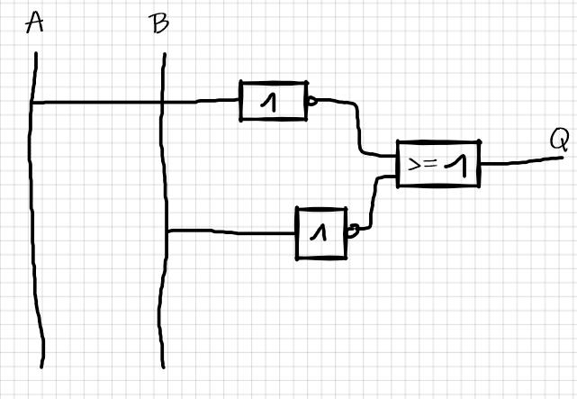

|  |  |  |  |  |  |
| --- | --- | --- | --- | --- | --- |
| A | !A | v | B | !B | Q |
| T | F |  | T | F | F |
| T | F |  | F | T | T |
| F | T |  | T | F | T |
| F | T |  | F | T | T |