Schaltalgebra

1. A ^ B = Q

|  |  |  |  |
| --- | --- | --- | --- |
| A | v | !B | Q |
| T |  | T | T |
| T |  | F | T |
| F |  | T | T |
| F |  | F | F |

1. 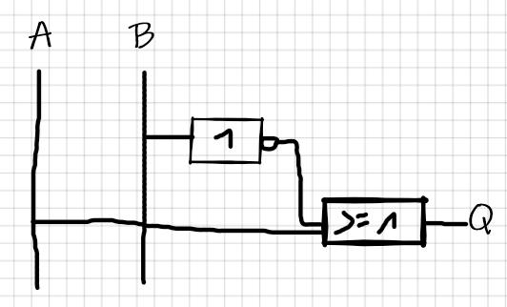

|  |  |  |  |
| --- | --- | --- | --- |
| !A | ^ | B | Q |
| T |  | T | T |
| T |  | F | F |
| F |  | T | F |
| F |  | F | F |

|  |  |  |  |
| --- | --- | --- | --- |
| A | ^ | !B | Q |
| T |  | T | T |
| T |  | F | F |
| F |  | T | F |
| F |  | F | F |

|  |  |  |  |
| --- | --- | --- | --- |
| (!A ^ B) | v | (A ^ !B) | Q |
| T |  | T | T |
| T |  | F | T |
| F |  | T | T |
| F |  | F | F |

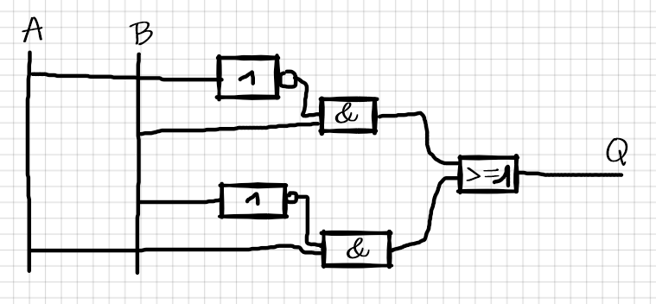

|  |  |  |  |
| --- | --- | --- | --- |
| A | v | B | Q |
| T |  | T | T |
| T |  | F | T |
| F |  | T | T |
| F |  | F | F |

|  |  |  |  |
| --- | --- | --- | --- |
| ( A v B) | ^ | !C | Q |
| T |  | T | T |
| T |  | F | F |
| F |  | T | F |
| F |  | F | F |

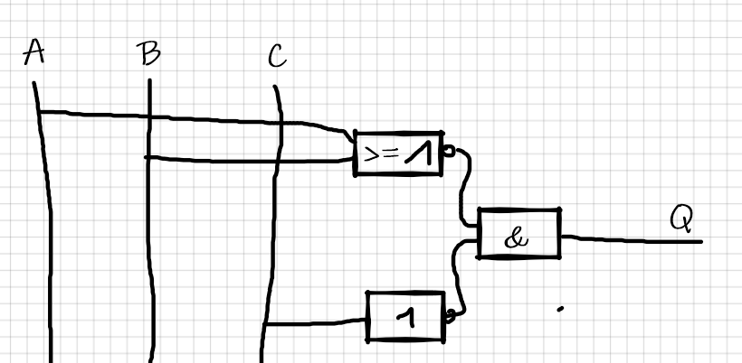

|  |  |  |  |
| --- | --- | --- | --- |
| A | v | B | Q |
| T |  | T | T |
| T |  | F | T |
| F |  | T | T |
| F |  | F | F |

|  |  |  |  |
| --- | --- | --- | --- |
| A | ^ | B | Q |
| T |  | T | T |
| T |  | F | F |
| F |  | T | F |
| F |  | F | F |

|  |  |  |  |
| --- | --- | --- | --- |
| !(A v B) | v | !(A ^ B) | Q |
| T |  | T | T |
| T |  | F | T |
| F |  | T | T |
| F |  | F | F |

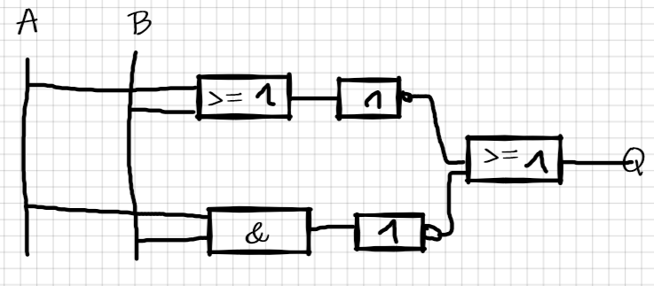

1. !E1 v !E2 = Q