SE 311 PROJECT REPORT

Virus tracking Application

Though Process

In the beginning of the application build, we realized that there were several devices and those devices had different methods to send or receive the data from the same library. As solution, we decided to use an adapter design pattern to solve different kinds of methods to make compatible all devices. In addition, if new device added to the requirements, we can easily adapt it to the application. Second, as we know that there are too many devices to notified. In this manner, we thought that observer design pattern fits to solve the problem. So, device users can know when application updated. In the continuation of the developing process, we thought that database should be singleton pattern because there should be only one database and that database must be accessible to devices from access point. Also, we made a class search engine that has several search methods to show result. So we decided to put in a execute method to have methods in one and easily access and adding methods. Command design pattern solved that problem. While structuring the system, we considered using facade pattern to reduce complexity. In the facade class, we put the all the complex method and declaration of patients and patients conditions. So, the main class looked more simple. Lastly, in the conditions class, we made a condition interface for the implementation of different condition classes such as Fever, MuscleAche and RunnyNose. So we can easily add new type of condition class. As a result, composite pattern occurred.

To sum up, design patterns that we used helped our application more reusable and have more flexible design.

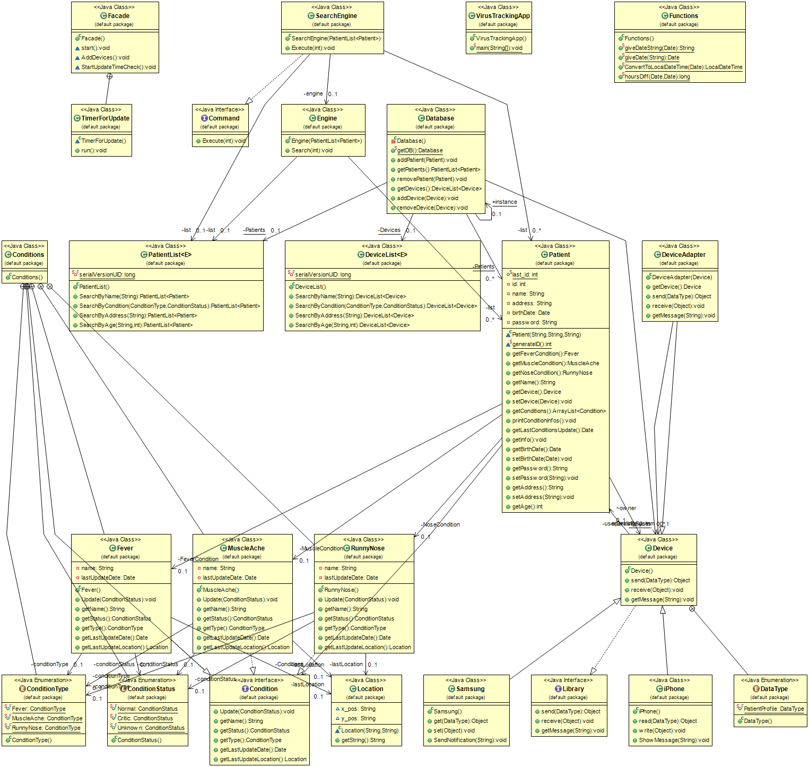UML DIAGRAM

PROJECT CLASSES

Conditions:

Used as a composite pattern. Condition is a interface that contains types of patients condition variables. Several class implements that interface and updates it such as Fever, MuscleAche and RunnyNose.

Database:

Used singleton pattern and adds or removes list of patients and devices.

Device:

Device is a superclass that implements Library interface. Receives and sends data types to the user. And get messages from library.

iPhone and Samsung:

These are subclasses of the device class.

DeviceAdapter:

Used as a adapter between different devices that has different send and get methods of data types.

DeviceList:

Generic type of class that extends arraylist of devices. Contains various search methods in it.

Facade:

Used façade design pattern. It contains various types of methods which were in the main class such as addDevices() adds patients and patients devices other method start() contains execute methods. TimeForUpdate is used to check patient give info or not depending on time. Purpose of the façade class is to reduce complexity of main class.

Funtions:

Contains useful methods which can give date (giveDate(String date)) and converts time (ConvertToLocalDateTime(Date date)) also Calculate method that differences between two time (hoursDiff).

Library:

Library is an interface that sends data types and receives get messages methods.

Location:

Holds the coordinates location.

Patient:

Declare patients various info. Also has set/get methods for patient information.

PatientList:

Generic type class that extends ArrayList patients. Also contains search methods that searches conditions, address, age of patient.

SearchEngine:

Used as a command pattern. Contains search results.

VirusTrackingApp:

Main method of the application.

SCREEN SHOTS

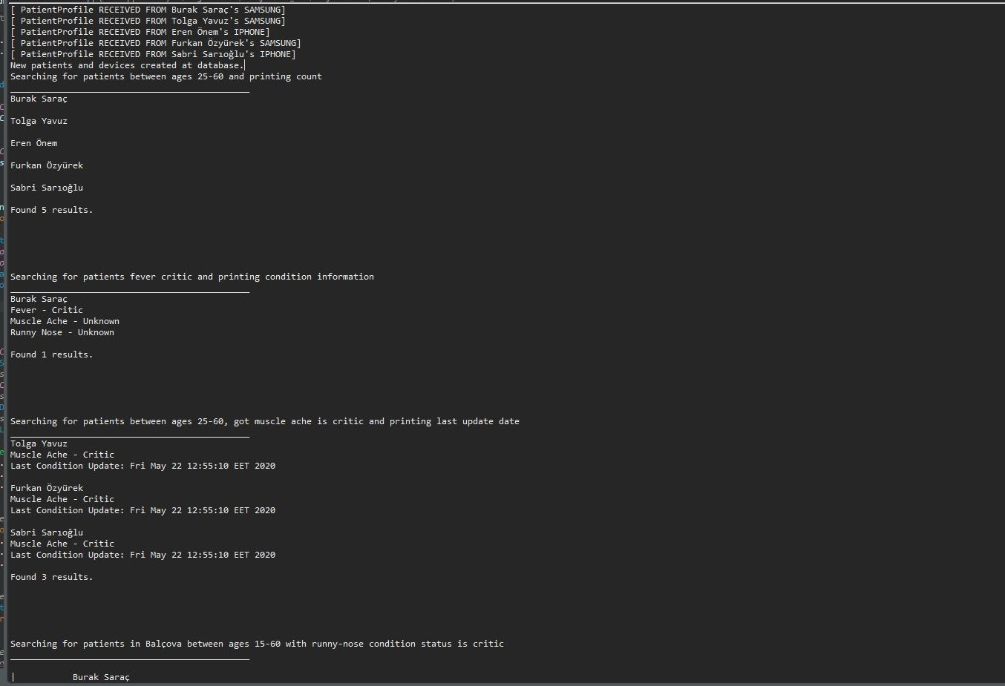

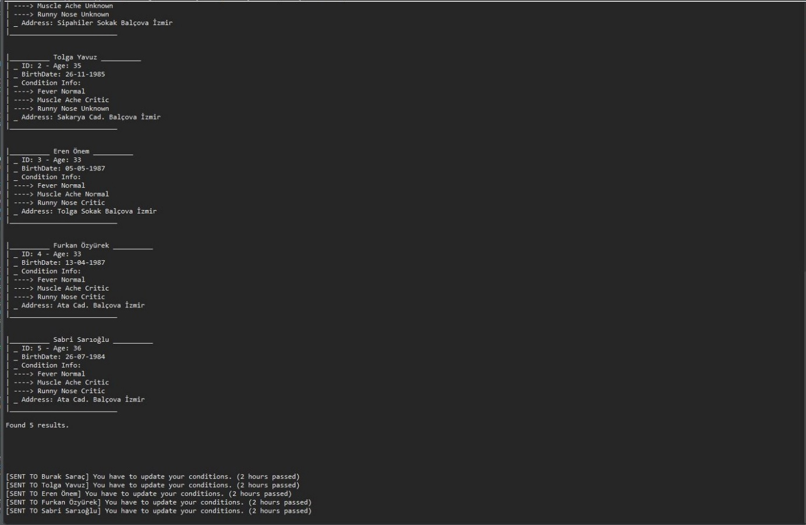

OUTPUT

"C:\Program Files\Java\jdk-9.0.1\bin\java" "-javaagent:C:\Program Files\JetBrains\IntelliJ IDEA Community Edition 2017.3.2\lib\idea_rt.jar=54076:C:\Program Files\JetBrains\IntelliJ IDEA Community Edition 2017.3.2\bin" -Dfile.encoding=UTF-8 -classpath C:\Users\Utku\IdeaProjects\VirusTrackingApp-master\bin VirusTrackingApp

[ PatientProfile RECEIVED FROM Burak Saraç's SAMSUNG]

[ PatientProfile RECEIVED FROM Tolga Yavuz's SAMSUNG]

[ PatientProfile RECEIVED FROM Eren Önem's IPHONE]

[ PatientProfile RECEIVED FROM Furkan Özyürek's SAMSUNG]

[ PatientProfile RECEIVED FROM Sabri Sarýoðlu's IPHONE]

New patients and devices created at database.

Searching for patients between ages 25-60 and printing count

______________________________________________

Burak Saraç

Tolga Yavuz

Eren Önem

Furkan Özyürek

Sabri Sarýoðlu

Found 5 results.

Searching for patients fever critic and printing condition information

______________________________________________

Burak Saraç

Fever - Critic

Muscle Ache - Unknown

Runny Nose - Unknown

Found 1 results.

Searching for patients between ages 25-60, got muscle ache is critic and printing last update date

______________________________________________

Tolga Yavuz

Muscle Ache - Critic

Last Condition Update: Fri May 22 13:24:45 EET 2020

Furkan Özyürek

Muscle Ache - Critic

Last Condition Update: Fri May 22 13:24:45 EET 2020

Sabri Sarýoðlu

Muscle Ache - Critic

Last Condition Update: Fri May 22 13:24:45 EET 2020

Found 3 results.

Searching for patients in Balçova between ages 15-60 with runny-nose condition status is critic

______________________________________________

|__________ Burak Saraç __________

| _ ID: 1 - Age: 34

| _ BirthDate: 11-09-1986

| _ Condition Info:

| ----> Fever Critic

| ----> Muscle Ache Unknown

| ----> Runny Nose Unknown

| _ Address: Sipahiler Sokak Balçova Ýzmir

|___________________________

|__________ Tolga Yavuz __________

| _ ID: 2 - Age: 35

| _ BirthDate: 26-11-1985

| _ Condition Info:

| ----> Fever Normal

| ----> Muscle Ache Critic

| ----> Runny Nose Unknown

| _ Address: Sakarya Cad. Balçova Ýzmir

|___________________________

|__________ Eren Önem __________

| _ ID: 3 - Age: 33

| _ BirthDate: 05-05-1987

| _ Condition Info:

| ----> Fever Normal

| ----> Muscle Ache Normal

| ----> Runny Nose Critic

| _ Address: Tolga Sokak Balçova Ýzmir

|___________________________

|__________ Furkan Özyürek __________

| _ ID: 4 - Age: 33

| _ BirthDate: 13-04-1987

| _ Condition Info:

| ----> Fever Normal

| ----> Muscle Ache Critic

| ----> Runny Nose Critic

| _ Address: Ata Cad. Balçova Ýzmir

|___________________________

|__________ Sabri Sarýoðlu __________

| _ ID: 5 - Age: 36

| _ BirthDate: 26-07-1984

| _ Condition Info:

| ----> Fever Normal

| ----> Muscle Ache Critic

| ----> Runny Nose Critic

| _ Address: Ata Cad. Balçova Ýzmir

|___________________________

Found 5 results.

[SENT TO Burak Saraç] You have to update your conditions. (2 hours passed)

[SENT TO Tolga Yavuz] You have to update your conditions. (2 hours passed)

[SENT TO Eren Önem] You have to update your conditions. (2 hours passed)

[SENT TO Furkan Özyürek] You have to update your conditions. (2 hours passed)[SENT TO Sabri Sarýoðlu] You have to update your conditions. (2 hours passed)