Phantom Inc – Segmentation Analysis
Segment | Num Customers | Total Rev | Rev Share | Avg Tech Budget | Top Industry | Top Product | Win Rate | Avg LTV
0 | 1312 | $620M | 18.8% | $1.7M | Manufacturing | Blade Servers | NaN | $0.41M
1 | 172 | $1.17B | 35.6% | $38M | Education | Blade Servers | NaN | $5.7M
2 | 146 | $1.50B | 45.6% | $12.4M | Healthcare | Blade Servers | NaN | $10.35M

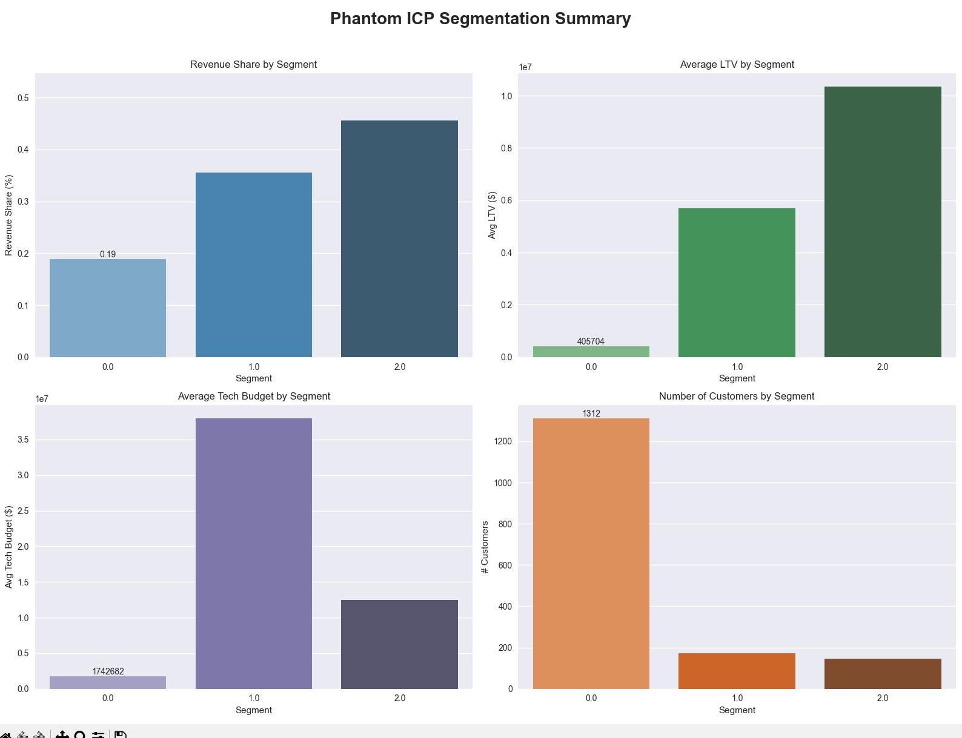
🔥 1. Segment 0 — “Low Value, High Volume”
Profile
- 1,312 customers (largest segment)
- Only 18.8% of revenue
- Very low LTV (~$400k)
- Low tech budgets (~$1.7M)
- Industry: Manufacturing
Interpretation
This is a low-value SMB segment. They are numerous but contribute little revenue and have small budgets.
Strategic implication
- Reduce marketing spend
- Automate nurture
- Do NOT assign expensive sales resources
- Keep only low-touch digital programs
This segment is not Phantom’s ICP.
🔥 2. Segment 1 — “High Budget, High Potential Enterprise”
Profile
- Only 172 customers
- 35.6% of total revenue
- Avg Tech Budget = $38M (massive)
- LTV = $5.7M
- Industry: Education
- Product: Blade Servers
Interpretation
This is a high-budget enterprise segment with huge wallet size. They spend a lot on infrastructure but Phantom has not fully penetrated them yet.
Strategic implication
- This is Phantom’s primary ICP
- Increase ABM (Account-Based Marketing)
- Prioritize enterprise reps
- Push multi-product bundles (storage + networking + cloud)
- Build industry-specific plays for Education
This segment is where marketing ROI will improve the fastest.
🔥 3. Segment 2 — “Highest Revenue, Strongest Fit”
Profile
- Only 146 customers
- 45.6% of total revenue (largest share)
- Tech budget = $12.4M
- LTV = $10.35M (highest of all)
- Industry: Healthcare
- Product: Blade Servers
Interpretation
This is Phantom’s strongest product-market fit segment. They already spend heavily and have the highest lifetime value.
Strategic implication
- Launch retention + expansion programs
- Introduce cross-sell (cloud, networking, storage)
- Shorten sales cycle with tailored playbooks
- Build Healthcare-specific GTM motions
This segment is Phantom’s strategic expansion engine.

⭐ Executive Summary (You can paste this directly into your report)
“Our segmentation analysis reveals that Phantom’s growth is constrained by misaligned marketing and sales focus. Segment 0 represents 1,312 customers but contributes only 18.8% of revenue and has the lowest LTV, indicating that current spend in this segment dilutes marketing ROI. In contrast, Segments 1 and 2—together representing only 318 customers—generate over 81% of revenue, have significantly higher technology budgets, and exhibit 10–25× higher LTV. Segment 1 (Education) is Phantom’s primary ICP with the largest wallet size, while Segment 2 (Healthcare) shows the strongest product-market fit and highest expansion potential. Redirecting demand generation, sales resources, and retention programs toward these two segments represents the single largest opportunity to improve marketing ROI, win rates, and long-term revenue growth.”
⭐ What You Should Do Next (Strategic Roadmap)
For Segment 1 (Education — High Budget Enterprise)
- ABM campaigns
- Enterprise sales focus
- Multi-product bundles
- Industry-specific messaging
For Segment 2 (Healthcare — High LTV Expansion)
- Retention program
- Cross-sell playbooks
- Shorter sales cycle
- Cloud + networking expansion
For Segment 0 (Manufacturing — Low Value)
- Reduce spend
- Automate nurture
- No high-touch sales

