Netflix vs. Blockbuster: Why DVD-by-Mail Won
Section 5 | Group 6
COUGHLIN, HANNAH; LEVIS-FITZGERALD, ROBBIE; MARQUEZ, ALYSSA; UYAROGLU, ZEKI; YANG, ADRIAN; TAMBARAM KAILASAM, SUNDARESAN
Bottom line.
Netflix succeeded because an integrated, mail-based activity system let it charge customers about 31% less per rental than Blockbuster while still covering its costs. Per rental, Netflix collected about $3.05 versus Blockbuster’s estimated $4.44, a $1.39 price gap, yet spent only about $2.92 versus $4.09 (Table A1). That $1.17 (29%) cost advantage funds over 80% of the price gap; the rest is Netflix’s thinner margin ($0.12 vs. $0.35 per rental). Netflix did not simply move rentals online: it designed out the stores, late fees and new-release dependence on which Blockbuster’s economics rested.

Choosing the unit.
We compare one completed rental cycle: one DVD shipped and returned (Netflix) or rented and returned (Blockbuster). It is the one output both firms deliver, so it puts a $20.50 subscription and a $4 store transaction on the same footing. Netflix shipped 13.75M DVDs a month to 2.05M subscribers in June 2004, or 6.7 rentals per subscriber-month and 165M a year; annualized June revenue ($504M) is within 1% of Exhibit 1’s 2004 revenue ($500.6M), so June is representative. For Blockbuster we treat the $4 fee as 90% of revenue because late fees are about 10% of it, giving $4.44 per rental, and divide 2003 revenue ($5.91B; the last full year before Blockbuster Online) by $4.44 to get about 1.33B rentals. We spread each income statement (Exhibits 1 and 3) over those rentals, so every cost is a fully allocated average, not a marginal cost.

Revenue position: Netflix is the low-price option.
Netflix earns $42M a month on 13.75M rentals, or $3.05 each. A subscriber renting 6.7 movies a month would pay about $29.80 at Blockbuster versus $20.50 at Netflix, a 31% saving (still 24% before late fees: 6.7 × $4 = $26.80), with no due dates. This effective price, not a literal $3.05 transaction price, explains why unlimited rental unlocked demand that Netflix’s first per-rental model could not. The flat fee carries a risk: heavy users cost more to ship and handle but pay the same, so retention and inventory utilization are critical.

Cost position: stores vs. warehouses.
The $1.17 gap sits in overhead (Figure A1). Blockbuster spends about $2.30 per rental on SG&A and depreciation, chiefly store occupancy and payroll (about 11 staff and roughly 555 rentals a day in a $300K store), versus $0.91 for Netflix’s SG&A and R&D. Netflix’s figure even includes heavy subscriber acquisition (SG&A nearly doubled in 2004, from $64.9M to $122.6M), so the structural gap is larger than shown. Its $60K converted warehouses are far leaner: one worker re-stuffs 800 DVDs an hour (about 1.5 cents of labor per DVD at an assumed $12/hour), while a store’s $300K buys capacity for only 555 daily rentals, about $540 of capital per daily rental.
Netflix does not win every line. Its cost of revenue is $2.01 per rental versus Blockbuster’s $1.80, because it pays round-trip postage (up to about $0.74 at an assumed $0.37 each way; presort discounts make the true figure lower) on top of library costs, while Blockbuster’s $1.80 includes the cost of its retail goods. Netflix traded a large fixed cost (stores) for a variable one (postage). That trade pays only at scale and with high inventory utilization.

Why Netflix’s activities fit together.
Four reinforcing choices supply that scale and utilization. (1) National inventory: pooling demand lets Netflix serve customers with one-third to one-fifth of a store chain’s inventory, so each DVD earns more rentals. (2) Recommendations: steering subscribers to in-stock catalog titles held new releases below 30% of Netflix rentals (2006) versus over 70% at Blockbuster; catalog titles are cheaper and less scarce. (3) Studio revenue sharing, negotiated within a year of 2000, replaced $18–$20 upfront purchases and delivered about twice the copies for roughly 20% more spend. (4) Distribution and the queue: overnight delivery from regional centers (with the USPS speeding returns) removed the shipping-time penalty, and a queue averaging 50 titles became Netflix’s “biggest switching cost.” Each depends on the others: recommendations need a deep national catalog, and the catalog pays off only when recommendations and the queue keep it rented.

Why Blockbuster could not copy it.
Its economics rested on new releases (75–80% of demand), impulse rentals near the store, and late fees (about $0.44 per rental). The $600M of annual late-fee revenue it later forwent exceeded its entire 2003 operating income of $468M, so dropping fees while still carrying the store base meant moving from profit to roughly a $132M loss, before $60M of implementation cost.

Implications and caveats.
Netflix’s 2004 operating margin was thin ($0.12 per rental, 3.9%). Each subscriber generates about $6.97 of gross profit a month (($3.05 – $2.01) × 6.7), so cutting churn from 6.3% (2002) to 3.6% (2006) stretches expected life from about 16 to 28 months and lifetime gross profit from about $111 to $194. Against the $100–$200 acquisition cost the case cites (for 1999), 2002-level churn barely breaks even while 2006-level churn pays back comfortably, which is why the queue and recommendations were economically central. Key assumptions: (i) the $4 Blockbuster fee, the top of the case’s $3–$4 range. At $3.00 and $3.50 Netflix’s cost gap shrinks to $0.15 and $0.66 per rental, but Netflix stays cheaper on both price and cost (Figure A2), so the direction is robust, the magnitude is not; (ii) all Blockbuster revenue is rental revenue, which overstates its rentals and understates its per-rental cost, making our gap conservative; (iii) $0.37 postage and June 2004 volumes as the 2004 run-rate.

Appendix: Netflix vs. Blockbuster economics per rental
Table A1. Per-rental comparison (one DVD out and back)
Per rental  (one DVD out and back) | Netflix | Blockbuster | Source / assumption
Revenue per rental | $3.05 | $4.44 | NF: $42M ÷ 13.75M DVDs. BB: $4 fee ÷ 0.90 (late fees ≈ 10% of revenue)
Cost of revenue | $2.01 | $1.80 | Exhibit 1 (2004) and Exhibit 3 (2003) ÷ rentals
of which postage (NF) | ≤ $0.74 | – | $0.37 each way, first-class; upper bound (presort discount)
of which handling labor (NF) | ≈ $0.015 | – | 800 DVDs/hour at assumed $12/hour
SG&A, R&D, depreciation | $0.91 | $2.30 | BB mainly store occupancy and payroll; NF includes acquisition marketing
Total cost | $2.92 | $4.09 | Netflix 29% lower ($1.17)
Operating profit | $0.12 | $0.35 | Margin: NF 3.9%, BB 7.9%
Rentals per year | 165M | ≈ 1.33B | NF: 13.75M × 12. BB: $5.91B ÷ $4.44 (upper bound)
Monthly cost at 6.7 rentals | $20.50 | $29.80 | BB $26.80 before late fees (Netflix 24% cheaper)
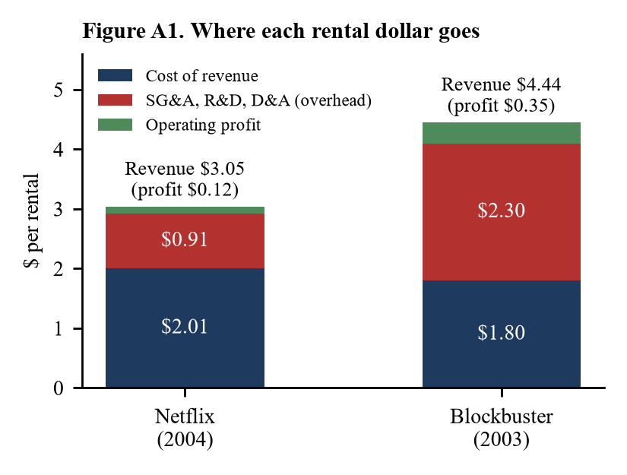 | 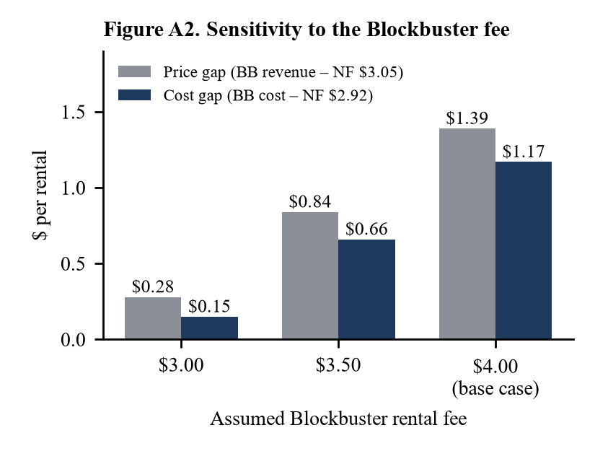
Table A2. Supporting calculations
Calculation | Value | How we got it
BB store rentals per day | ≈ 555 | $900K annual sales ÷ $4.44 ÷ 365; capital per daily rental = $300K ÷ 555 ≈ $540
NF gross profit per subscriber-month | $6.97 | ($3.05 – $2.01) × 6.7 rentals
NF lifetime gross profit per subscriber | $111 → $194 | $6.97 ÷ monthly churn: 6.3% (2002) → 3.6% (2006); life 1 ÷ churn = 16 → 28 months
BB late fees vs. operating income | $600M vs. $468M | Case: ≈ $600M/yr forgone; Exhibit 3 2003 operating income $468.2M → ≈ –$132M
Note: Netflix costs and profit use the 2004 income statement (Exhibit 1) over 165M annualized June rentals; revenue per rental uses the June run-rate ($3.05 vs. $3.03 for 2004 as a whole). Blockbuster uses 2003, its last full year before Blockbuster Online, and assumes all revenue is rental revenue, which overstates rentals and makes the Netflix cost advantage conservative; the fee in Figure A2 is the main sensitivity. Figures may not sum because of rounding.

