**Software Requirement Specification**

**For**

**Boxers Community**

**Prepared by**

|  |
| --- |
| **Student Name :** Hanshvee Aditya Patil |
| **ID:** 21ITUOS100 |
| **Roll No.:** IT111 |

B.Tech(IT)

SEM VI

Faculty of Technology

Dharmsinh Desai University

Nadiad

**Index**

1.Introduction 4

1.1 Purpose 4

1.2 Scope 4

1.3 References 4

1.4 Technologies to be Used 5

1.5 Overview 5

2. Overall Description for Boxers Community 6

2.1 Product Perspective 6

2.2 Product Functions for Boxers Community 7

2.3 User Characteristics for Boxers Community 8

2.4 Constraints for Boxers Community 8

2.5 Operating Environment for Boxers Community 8

3. System Features 8

• SF.1 8

• SF.2 8

• SF.3 8

• SF.4 8

4. Functional Requirements: 9

R.1 Registering a user 9

R.2 Logging in a user 9

R.3 Creating and Sharing Posts 9

R.4 Interacting with Posts 9

R.5 Searching for Boxers or Posts 9

R.6 Admin Tools for Content Moderation 10

R.7 Finding Trainers 10

5.Non-Functional Requirements: 10

NFR.1 Performance Requirements: 10

NFR.2 Safety Requirements: 11

NFR.3 Security Requirements: 11

NFR.4 Software Quality Attributes: 11

NFR.5 Business Rules: 12

6.Navigation: 12

7.Class-Diagram 14

7.1 References 14

8. Use-Case Diagram 15

8.1 References 15

# **1.Introduction**

## **1.1 Purpose**

The purpose of the "Boxers Community" project is to establish a specialised social media platform dedicated to boxing enthusiasts, leveraging the functionalities of the MERN (MongoDB, Express.js, React.js, Node.js) stack. The platform aims to create a vibrant and engaging space where boxers can connect, share experiences, find trainers, and engage in real-time communication.

Utilising MongoDB for flexible data management, Express.js for efficient backend operations, React.js for dynamic user interfaces, and Node.js for real-time communication, "Boxers Community" seeks to redefine social networking within the boxing community. By offering a user-friendly interface and robust features, the platform aims to foster connections, facilitate group interactions, and provide a collaborative environment for boxers to engage in meaningful conversations and collaborations.

## **1.2 Scope**

"Boxers Community" anticipates catering to a diverse boxing community, providing a platform for enthusiasts, amateur boxers, professional fighters, trainers, and boxing aficionados. The platform's scope includes facilitating connections, sharing training insights, discovering trainers, and engaging in real-time conversations related to boxing. As user adoption grows, the platform expects increased user engagement, supporting various discussions and collaborations within the boxing community. "Boxers Community" aims to offer an extensive range of channels, promoting inclusive interactions among users from diverse boxing backgrounds and interests.

## **1.3 References**

**●**   IEEE 830-1998 standard for writing SRS documents.

●  Fundamentals of Software Engineering, 2nd ed. by Rajib Mall.

## **1.4 Technologies to be Used**

The MERN (MongoDB, Express.js, React.js, Node.js) stack is suitable for developing a social media platform due to its versatility, scalability, and robustness.

* MongoDB: A NoSQL database that offers flexibility in managing unstructured data, ideal for handling various types of user-generated content (posts, comments, images, videos).
* Express.js: A backend framework for Node.js, enabling efficient handling of HTTP requests, routing, and middleware integration.
* React.js: A front-end library for building dynamic user interfaces, offering a responsive and interactive user experience.
* Node.js: A server-side JavaScript runtime, facilitating real-time communication and handling concurrent user requests efficiently.

## **1.5 Overview**

The following sections of this SRS document are organized systematically to holistically define the "Boxers Community" project:

* Section 1: Software Description

This section aims to provide a comprehensive portrayal of the software, encompassing various aspects including user proficiency levels, general constraints, and assumed dependencies pertinent to the "Boxers Community" project.

* Section 2: Functional Requirements

Within this section, specific requirements and functionalities expected from the "Boxers Community" software will be articulated. Functional requirements will be elaborated using use cases to ensure a profound and thorough understanding of the system's expected behaviours and capabilities.

* Section 3: Interface Descriptions

This section is dedicated to describing the diverse interfaces and potential scenarios embedded within the "Boxers Community" application. It will offer detailed insights into user interactions, system behaviours, and the overall user experience encapsulated within the community platform designed for boxers.

# **2.** **Overall Description for Boxers Community**

## **2.1 Product Perspective**

The "Boxers Community" is a focused social networking platform tailored for boxing enthusiasts, leveraging the MERN (MongoDB, Express.js, React.js, Node.js) stack. It offers a streamlined set of functionalities targeting the needs of boxers seeking an online space to connect, share experiences, and find relevant resources within the boxing realm.

1. **Registration and Authentication:** Users can effortlessly join the community by registering with essential details such as username, email, password, and boxing experience. Upon registration, users receive a verification message to confirm their accounts.
2. **User Interaction and Content Sharing:** The platform enables users to create, share, and engage with posts related to boxing. They can upload images/videos, add captions, include hashtags, like, and comment within the platform.
3. **Search and Discovery:** Users have access to a search feature facilitating the exploration of specific boxers or posts. They can search using keywords, usernames, or hashtags to discover relevant profiles or content.
4. **Admin Moderation Tools:** Administrators possess tools to moderate user-generated content, ensuring a safe and respectful community. They can manage flagged posts, accounts, and maintain the platform's integrity.
5. **Trainer Discovery:** A dedicated section allows users to find trainers based on various criteria like location, expertise, experience level, specialty, or availability, enabling boxers to connect with suitable trainers.

## **2.2 Product Functions for Boxers Community**

**1. User Registration and Profile Management:**

* + Users can register on the platform by selecting the "Register" button on the homepage.
  + Users can provide necessary details like username, email, password, boxing experience, and profile picture during registration.
  + Upon registration, users receive a confirmation email or message to verify their account.
  + Users can manage and update their profiles, showcasing their interests and expertise in boxing.

**2. Creating Posts and Interacting:**

* + Users have access to a "Create Post" feature from their profile or the homepage.
  + They can upload images/videos, add captions, and include hashtags while sharing posts with their followers.
  + Users can view posts from other users in their news feed and interact by liking and commenting within the platform.

**3. Search and Discovery:**

* + Users can utilize the search bar to find specific boxers or posts by entering keywords, usernames, or hashtags.
  + The search functionality fetches relevant profiles or content based on the provided criteria.

**4. Admin Tools for Content Moderation:**

* + Administrators possess tools to moderate user-generated content, flag inappropriate posts, and manage user accounts to maintain community standards.

**5. Finding Trainers:**

* + Users can access a dedicated "Find Trainers" section either from the homepage or the navigation menu.
  + They can search for trainers based on criteria such as location, expertise, experience level, specialty, or availability, allowing boxers to connect with suitable trainers.

## **2.3 User Characteristics for Boxers Community**

Users engaging with the "Boxers Community" platform should possess familiarity with online communication platforms and social networks. Basic knowledge of functionalities such as creating posts, interacting with content (liking, commenting), searching for specific profiles or posts, and using moderation tools would enhance their experience. Familiarity with similar online community tools tailored for boxers will aid in seamless navigation and engagement within the platform.

## **2.4 Constraints for Boxers Community**

* Backup and Recovery Mechanism: The system lacks a comprehensive backup and recovery mechanism, impacting its availability in case of data loss or system failures.
* Operational Protocols: The system operates within the confines of HTTP/HTTPS protocols for communication and data transfer.
* Financial Transactions: Real-life credit card validation and a complete banking system are not implemented within the platform.

## **2.5 Operating Environment for Boxers Community**

The "Boxers Community" website is optimised to function efficiently across popular browsers. It ensures compatibility with major browsers like Google Chrome, Mozilla Firefox, Safari, and Microsoft Edge. Efforts are made to maintain compatibility with older versions of these browsers for broader accessibility. The platform aims to provide a smooth user experience across different devices and platforms.

# **3. System Features**

Website Authority Control:

* SF.1**:** Ensure users provide genuine and authentic information regarding their profile and content.
* SF.2**:** Provide customer support services managed by platform authority.
* SF.3**:** Implement robust customer information security measures and confirm data integrity.
* SF.4**:** Manage and maintain customer information securely within the system.

# **4. Functional Requirements:**

## **R.1 Registering a user**

R.1.1: Users can select a "Register" button on the platform's homepage.

R.1.2: Users can fill in required details such as username, email, password, boxing experience, and profile picture.

R.1.3: Users receive a confirmation email or message to verify their registration.

## **R.2 Logging in a user**

R.2.1: Users can select a "Login" button on the platform's homepage.

R.2.2: Users can fill in their registered email/username and password to access their accounts.

## **R.3 Creating and Sharing Posts**

R.3.1: Users can access a "Create Post" feature from their profile or the homepage.

R.3.2: Users can upload images/videos, add captions, include hashtags, and share posts with followers.

## **R.4 Interacting with Posts**

R.4.1: Users can view posts from others in their news feed.

R.4.2: Users can like and comment  within the platform.

## **R.5 Searching for Boxers or Posts**

R.5.1: Users can use the search bar to find specific boxers or posts.

R.5.2: Users can enter keywords, usernames, or hashtags to fetch relevant profiles or content.

## **R.6 Admin Tools for Content Moderation**

R.6.1: Admins can access tools to moderate user-generated content, flag inappropriate posts, and manage user accounts.

## **R.7 Finding Trainers**

R.7.1: Users can access a "Find Trainers" section either from the homepage or navigation menu.

R.7.2: Users can search for trainers based on criteria such as location, expertise, experience level, specialty, or availability.

# **5.Non-Functional Requirements:**

## NFR.1 Performance Requirements:

NFR.1.1Security:

The platform must implement state-of-the-art security measures, including encryption protocols, secure sockets layer (SSL), and secure user authentication mechanisms.

Database Optimization:

Optimize the MongoDB database for improved performance, ensuring fast and efficient retrieval of user-generated content such as posts, images, and videos.

NFR.1.2Responsive Website:

The platform's user interface must be responsive, providing an optimal user experience on devices with varying screen sizes, including desktops, tablets, and smartphones.

NFR.1.3Web Scalability:

The system should be designed to scale horizontally to accommodate a growing user base, supporting a minimum of 10,000 concurrent users without significant degradation in performance.

## NFR.2 Safety Requirements:

NFR.2.1 Database Backup:

Conduct automated daily backups of the MongoDB database to prevent data loss in the event of unforeseen circumstances such as virus attacks or system failures.

NFR.2.2 Power Supply Backup:

Ensure the hosting infrastructure has an uninterruptible power supply (UPS) or alternative power source to sustain continuous operation during power supply failures.

## NFR.3 Security Requirements:

NFR.3.1 Secure Database Storage:

Utilize encryption techniques and access controls to ensure secure storage of sensitive user information in the MongoDB database.

NFR.3.2 Access Control:

Implement a robust access control system, restricting unauthorized access to user data. Admins should have elevated privileges, while regular users have read-only access.

NFR.3.3 User Access Constraints:

Define specific access constraints for different user types to maintain data integrity and prevent unauthorized modifications by non-admin users.

## NFR.4 Software Quality Attributes:

NFR.4.1 Multiple Admin Support:

The system should support multiple administrators simultaneously, allowing them to make changes and updates to the platform.

NFR.4.2 Open Source System:

Develop the "Boxers Community" as an open-source system, fostering community contributions, ensuring transparency, and encouraging collaborative development.

NFR.4.3 User-Friendly Database:

Design the MongoDB database with a user-friendly structure, intuitive interfaces, and straightforward navigation for both admins and regular users.

NFR.4.4 Ease of Installation:

Ensure that the platform is easy to download and install, providing clear installation instructions to facilitate a smooth setup process for users.

## NFR.5 Business Rules:

NFR.5.1 Adherence to Rules:

All users, including admins and members, must adhere to established community rules and guidelines, promoting respectful and ethical interactions.

NFR.5.2 Cost and Discount Policies:

Incorporate business rules regarding pricing for premium features, cost calculations for trainers, and discount offers for membership subscriptions.

NFR.5.3 Avoidance of Illegal Activities:

Users should refrain from engaging in any illegal activities or violating legal protocols while using the "Boxers Community" platform. Violation of this rule may lead to account suspension or termination.

# **6.Navigation:**

* Home

Homepage containing an overview of the platform and its features.

"Register" button prominently displayed.

* Login/Register

Separate pages or sections for user registration and login.

Users can access registration fields (username, email, password, boxing experience, profile picture) and submit their details.

Confirmation email/message link for user verification.

* Profile

User-specific area for managing their account.

Access to edit profile details, change settings, and view personal information.

* Create Post

Feature accessible from the user's profile or the homepage.

Options for uploading images/videos, adding captions, and including hashtags.

* News Feed

View posts from other users.

Ability to like and comment on posts within the feed.

* Search

Search bar for finding specific boxers or posts.

Options to enter keywords, usernames, or hashtags for relevant searches.

* Find Trainers

Section to find trainers based on various criteria (location, expertise, experience level, specialty, availability).

Accessible from the homepage or navigation menu.

* Admin Tools

Separate section accessible only to admins.

Tools for content moderation, flagging inappropriate posts, and managing user accounts.

# **7.Class-Diagram**

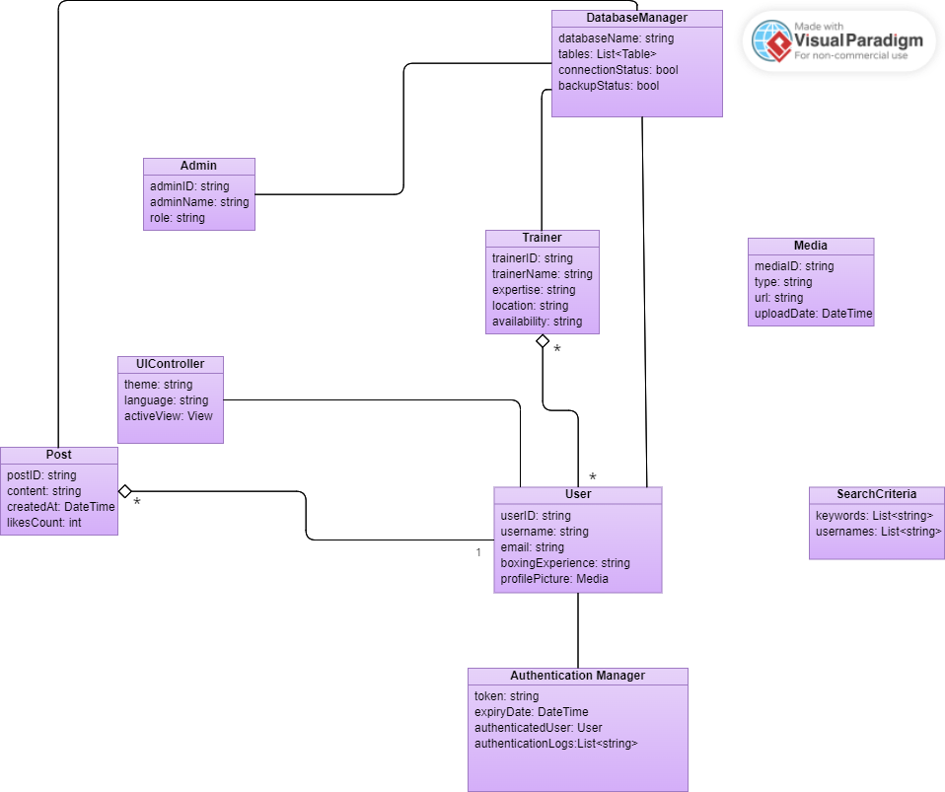

## 7.1 References

**●** [https://online.visual-paradigm.com/w/ltaxjmby/diagrams/#diagram:workspace=ltaxjmby&proj=0&id=5&type=ClassDiagram](https://online.visual-paradigm.com/w/ltaxjmby/diagrams/%23diagram:workspace=ltaxjmby&proj=0&id=5&type=ClassDiagram)

# **8. Use-Case Diagram**

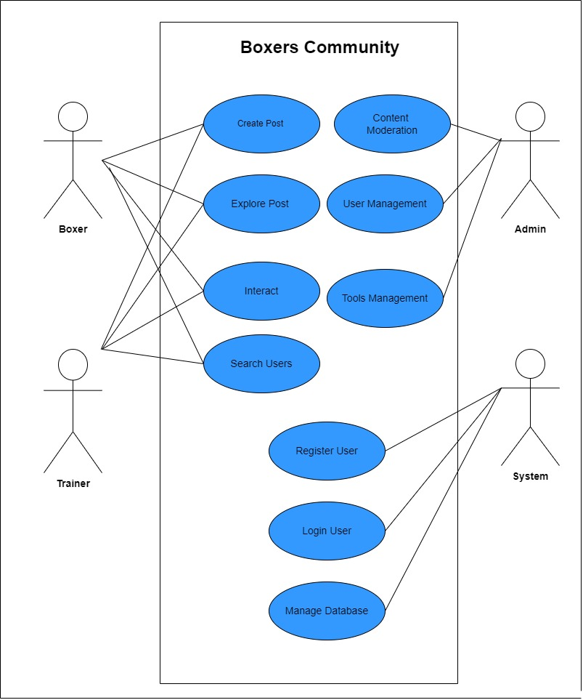

## 8.1 References

* [https://app.diagrams.net/#G1OAMviTSyOWCj51Il0QLIK9617MW-h45K](https://app.diagrams.net/%23G1OAMviTSyOWCj51Il0QLIK9617MW-h45K)