QRServe
Food Track System

Complete User Guide
Step-by-Step Instructions for All Modules
Version 1.0 • April 2026

Table of Contents
QRServe Complete User Guide

1 | Authentication & Account Management  Login, Forgot Password, Reset Password, Change Password | Section 1
2 | Location Master  Manage dining areas and service locations | Section 2
3 | Session Master  Define meal sessions and time slots | Section 3
4 | Cuisine Master  Categorize food types and menu items | Section 4
5 | Configuration Settings  System-level order rules and date settings | Section 5
6 | Company Management  Create and manage company accounts | Section 6
7 | Order Management  Create, view, and manage food orders | Section 7
8 | Override Orders  Modify existing orders for specific date ranges | Section 8
9 | QR Code Management  Generate, send, and download QR codes | Section 9
10 | QR Code Scanner  Scan and validate customer QR codes | Section 10
11 | Reports  Generate and export food request reports | Section 11

Section 1: Authentication & Account Management
Login • Forgot Password • Reset Password • Change Password

Login Screen

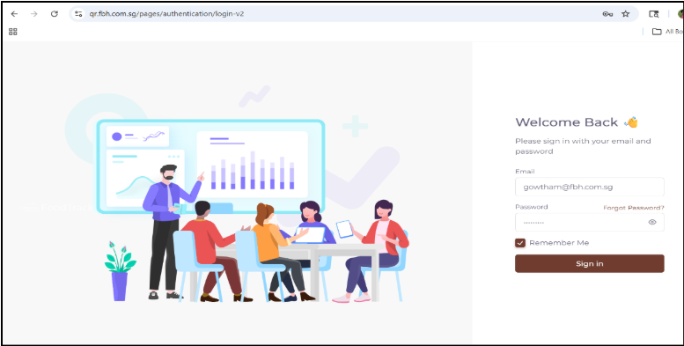
The Login Screen is the main entry point into the QRServe / Food Track system. Only authorized users with registered credentials can access the application.

📌 Access URL: https://qr.fbh.com.sg/login

Screen Layout
Left Panel | Right Panel
Visual branding illustration showing analytics, system usage and teamwork. Provides a modern, user-friendly interface experience. | Login form with Email field, masked Password field, Remember Me checkbox, Forgot Password link, and Sign In button.

Login Fields & Components
Field | Description
Email | Enter your registered email address
Password | Enter your password (masked for security)
Remember Me | Check this to stay logged in for future sessions
Forgot Password? | Click this link to reset your password via email
Sign In Button | Submits your credentials for validation

How to Log In — Step by Step
1 | Open the QRServe URL in your web browser
2 | Enter your registered Email address in the Email field
3 | Enter your Password in the Password field
4 | Optionally check Remember Me to keep your session active
5 | Click the Sign In button
6 | If credentials are valid, you will be redirected to the Dashboard
7 | If credentials are invalid, an error message will be displayed — verify and try again

✅ Success: Valid credentials redirect you to the system Dashboard.

❌ Error: Invalid credentials display an error message. Check your email and password and try again.

Forgot Password Screen

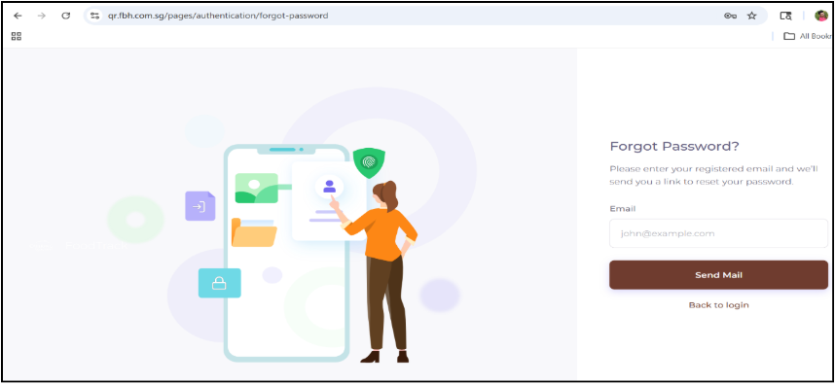
Use this screen when you cannot remember your account password and need to recover access.

How to Reset via Email — Step by Step
1 | Click the Forgot Password? link on the Login Screen
2 | The Forgot Password page will open
3 | Enter your registered Email address in the input field
4 | Click the Send Mail button
5 | The system checks if the email exists in the database
6 | If found, a password reset link is sent to your email
7 | If not found, an error message is displayed
8 | Check your email inbox for the reset link
9 | Click Back to Login to return to the login page at any time

📧 Note: Check your spam/junk folder if you do not receive the reset email within a few minutes.

Reset Password Screen

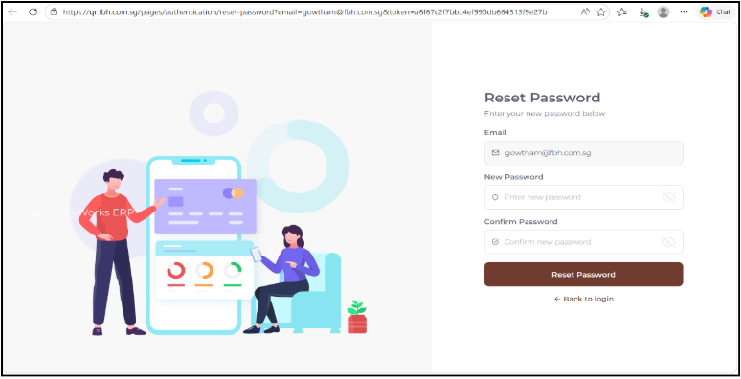
This screen appears when you click the password reset link received in your email. Use it to set a new password for your account.

Reset Password Fields
Field | Description
Email | Your registered email address (read-only, auto-filled)
New Password | Enter your desired new password (masked)
Confirm Password | Re-enter the new password to confirm it matches

How to Reset Your Password — Step by Step
1 | Click the password reset link in your email
2 | The Reset Password page will open with your email pre-filled
3 | Enter your New Password in the first field
4 | Re-enter the same password in the Confirm Password field
5 | Click the Reset Password button
6 | The system validates the passwords match and the reset token is valid
7 | If successful, your password is updated and you are notified
8 | Click Back to Login and sign in with your new password

⚠️ Important: Password reset links expire after a limited time. If the link is expired, repeat the Forgot Password process to get a new link.

Change Password Screen

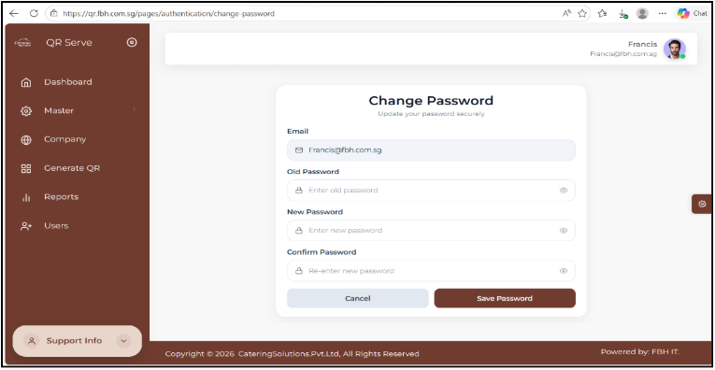
This screen allows logged-in users to update their existing password. Unlike Reset Password, this requires you to know your current password.

Change Password Fields
Field | Description
Email | Your registered email address (read-only, auto-filled)
Old Password | Enter your current/existing password for verification
New Password | Enter the new password you want to set (masked)
Confirm Password | Re-enter the new password to confirm it matches

How to Change Your Password — Step by Step
1 | Navigate to Change Password from your profile or settings menu
2 | Your Email is pre-filled and read-only
3 | Enter your current password in the Old Password field
4 | Enter your desired new password in the New Password field
5 | Re-enter it in the Confirm Password field
6 | Click Save Password to apply the changes
7 | If all validations pass, your password is updated and you are notified
8 | Click Cancel to discard changes and return without saving

🔒 Security Tip: Use a strong password combining uppercase, lowercase, numbers, and special characters.

Dashboard Overview:
Real-time monitoring of orders, QR activity and company performance
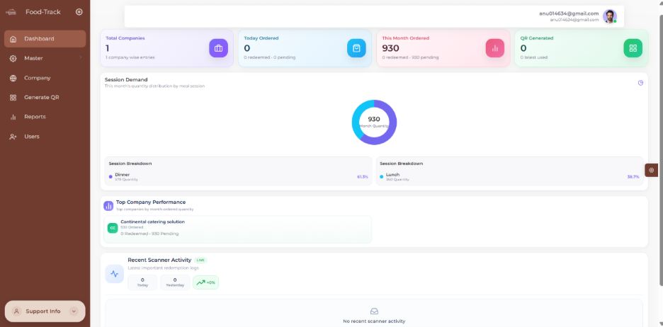

KPI Summary Cards

Total Companies | Today Ordered | This Month Ordered | QR Generated
Total registered companies in the system. | Total orders placed today including Redeemed and Pending counts. | Total monthly orders to help track business volume. | Total QR codes generated to monitor QR activity.

Dashboard Features

Field | Description
Session Demand | Visual donut chart showing order distribution and session-wise split to identify demand trends.
Session Breakdown | Displays quantity and percentage by session. Supports planning and analysis.
Top Company Performance | Shows highest performing company with total, redeemed, and pending orders.
Recent Scanner Activity | Displays QR scan data for today and yesterday with growth percentage.
Real-Time Updates | Dashboard updates dynamically — data reflects backend changes instantly.
Role-Based Visibility | Super Admin: Full access | Admin: Company-specific data | Scanner: Limited access.

Section 2: Location Master
Manage service areas and dining locations

2.1 What is Location Master?

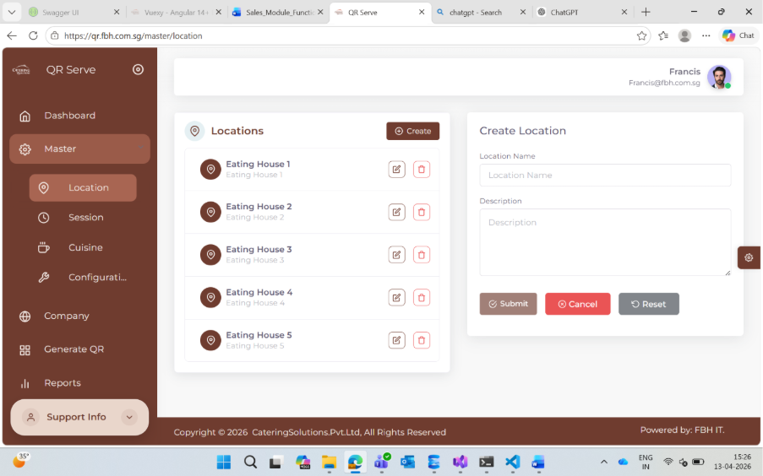
The Location Master screen is used to define and manage different service areas or dining locations within your operation. Examples include Eating House 1, Eating House 2, Cafeteria A, etc.

📌 Access: Menu → Master → Location | URL: https://qr.fbh.com.sg/master/location

Locations are required before:
- Creating sessions
- Generating QR codes
- Placing and organizing orders

2.2 Screen Overview
Left Side — Location List | Right Side — Create / Edit Form
Displays all existing locations. Each entry shows:  - Location Name  - Edit button (pencil icon)  - Delete button (trash icon) | Form with fields:  - Location Name (required)  - Description (optional)  - Submit / Cancel buttons

2.3 How to Create a New Location
1 | Click the Create button on the Location Master screen
2 | Enter a unique Location Name (e.g., Eating House 1) — this field is required
3 | Optionally enter a Description for clarity
4 | Click Submit to save the new location
5 | The new location will immediately appear in the list on the left side

2.4 How to Edit a Location
1 | Find the location you want to edit in the list
2 | Click the Edit (pencil) icon next to that location
3 | The location details will load in the right-side form
4 | Update the Location Name or Description as needed
5 | Click Submit to save your changes

2.5 How to Delete a Location
1 | Find the location you want to delete in the list
2 | Click the Delete (trash) icon next to that location
3 | Confirm the deletion when prompted

⚠️ Warning: Deleting a location may affect any linked QR codes, sessions, or orders. Ensure the location is no longer in use before deleting.

Section 3: Session Master
Define meal sessions and time slots

3.1 What is Session Master?

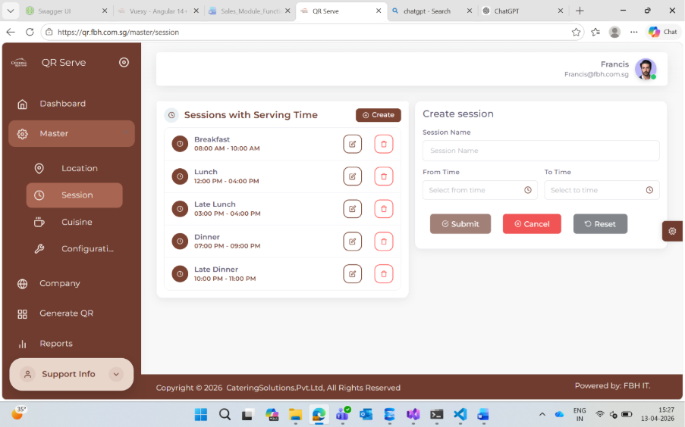
Session Master is used to define different serving time slots — such as Breakfast, Lunch, and Dinner — that control when menu items are available and how orders are organized.

📌 Access: Menu → Master → Session | URL: https://qr.fbh.com.sg/master/session

3.2 Session Form Fields
Field | Description
Session Name | Name of the meal session (e.g., Breakfast, Lunch, Dinner)
From Time | The start time of the session (e.g., 08:00 AM)
To Time | The end time of the session — must be later than From Time

3.3 How to Create a Session
1 | Click the Create button on the Session Master screen
2 | Enter the Session Name (e.g., Breakfast)
3 | Set the From Time using the time picker (e.g., 08:00 AM)
4 | Set the To Time (e.g., 10:00 AM) — must be after From Time
5 | Click Submit to save the session
6 | The new session will appear in the list with the time range displayed

📋 Example Session Schedule: Breakfast: 08:00 AM – 10:00 AM | Lunch: 12:00 PM – 02:00 PM | Dinner: 06:00 PM – 08:00 PM

⚠️ Important Rule: From Time must always be earlier than To Time. Avoid overlapping session times to prevent order conflicts.

3.4 How to Edit / Delete a Session
Editing: Click the Edit (pencil) icon → Update the fields → Click Submit.
Deleting: Click the Delete (trash) icon → Confirm the action.

Section 4: Cuisine Master
Categorize food types and menu items

4.1 What is Cuisine Master?

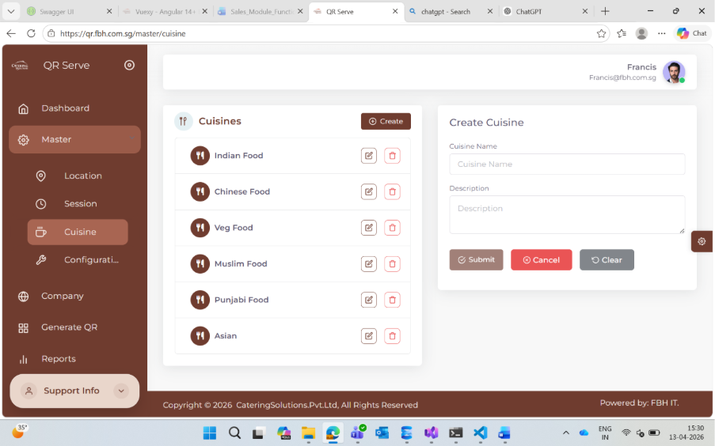
The Cuisine Master screen is used to create and manage different food categories or cuisine types such as Indian Food, Chinese Food, Vegetarian, Western, etc. These categories help organize menu items and improve the ordering experience.

📌 Access: Menu → Master → Cuisine | URL: https://qr.fbh.com.sg/master/cuisine

4.2 Cuisine Form Fields
Field | Description
Cuisine Name | Name of the food category (required) — e.g., Indian Food, Chinese Food
Description | Optional description to clarify the cuisine type

4.3 How to Create, Edit, or Delete a Cuisine
Creating: Click Create → Enter Cuisine Name and optional Description → Click Submit.

Editing: Click the Edit (pencil) icon on a cuisine → Update fields → Click Submit.

Deleting: Click the Delete (trash) icon → Confirm the action.

⚠️ Note: Deleting a cuisine may affect linked menu items. Verify no active items are using this cuisine before deleting.

Section 5: Configuration Settings
System-level order rules and advance booking limits

5.1 What is Configuration?

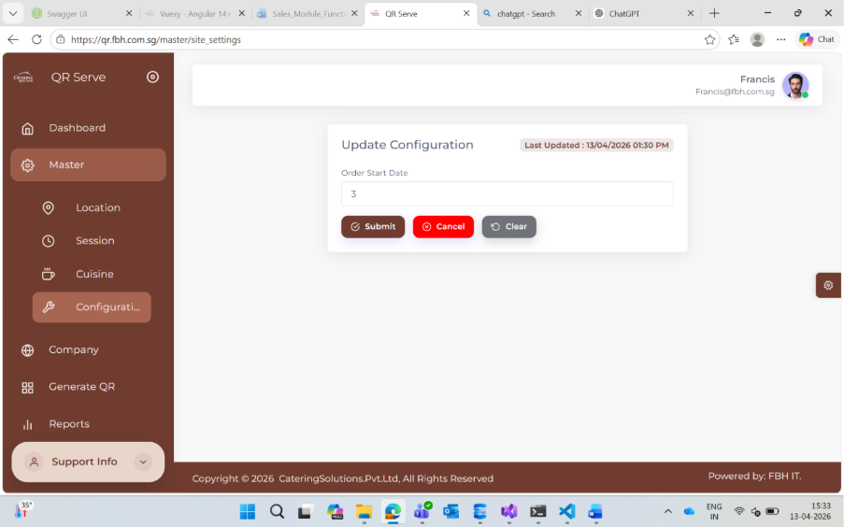
The Configuration screen controls system-wide rules for order creation — specifically, how many days in advance an order can be placed. This setting affects all users globally.

📌 Access: Menu → Master → Configuration | URL: https://qr.fbh.com.sg/master/site_settings

5.2 Order Start Date — How It Works
The Order Start Date field defines the minimum number of days ahead a user must wait before placing an order.

Configuration Value | Earliest Allowed Order Date | Example (Today = 13-Apr)
0 | Today onwards | 13-Apr-2026
1 | Tomorrow onwards | 14-Apr-2026
3 | 3 days from today | 16-Apr-2026
5 | 5 days from today | 18-Apr-2026

5.3 How to Update Configuration
1 | Navigate to Master → Configuration
2 | Enter the desired numeric value in the Order Start Date field
3 | Click Submit to save — changes apply immediately for all users
4 | Click Cancel to discard changes without saving

📌 Best Practice: For catering operations, a value of 2–5 days is recommended to allow proper planning and preparation time.

Section 6: Company Management
Create and manage company accounts

6.1 Company List Screen

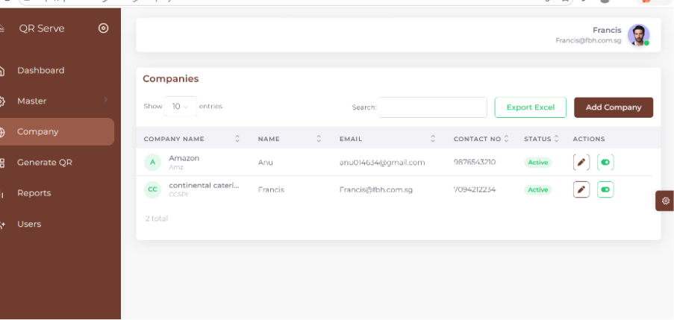
The Company screen allows administrators to view, search, and manage all company accounts registered in the QRServe system. Only users with the Admin role can access this screen.

Available Actions on the Company List
- Search for a company by name or code
- Export company data
- Add a new company using the Add Company button
- Edit an existing company's details
- Activate or deactivate a company using the status toggle

6.2 How to Add a New Company
1 | Click the Add Company button on the Company List screen
2 | A side panel form will slide open on the right side
3 | Fill in all required fields (see field reference below)
4 | Select the appropriate Locations from the available options
5 | Select the required Sessions for the company
6 | Click Save to create the company
7 | The company appears in the Company List
8 | The Set Session Timings form will automatically open next

Add Company Form Fields

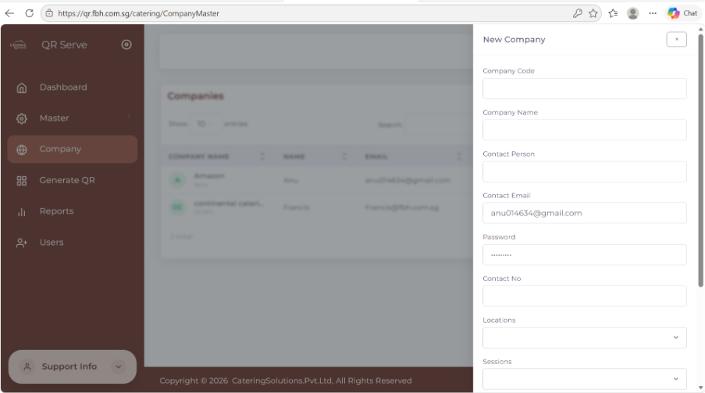
Field | Description
Company Name | Full name of the company (required, must be unique)
Company Code | Short unique identifier code for the company (no duplicates)
Email | Company's email address used for login and QR delivery (must be valid)
Password | Initial login password — share securely with the company user
Locations | Select one or more dining locations assigned to this company
Sessions | Select meal sessions (Breakfast, Lunch, Dinner) for this company

6.3 Set Session Timings

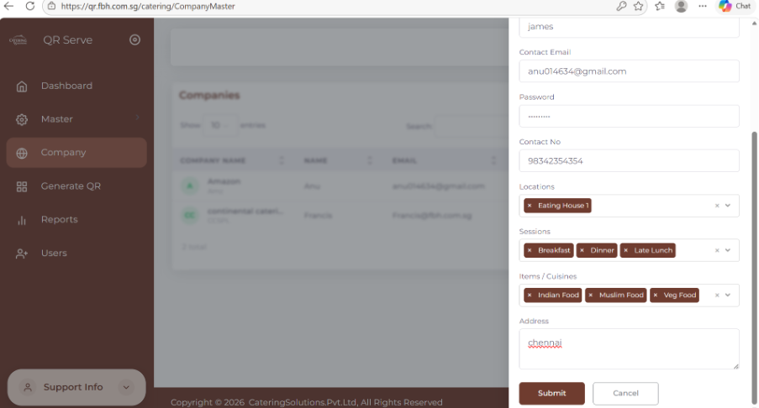

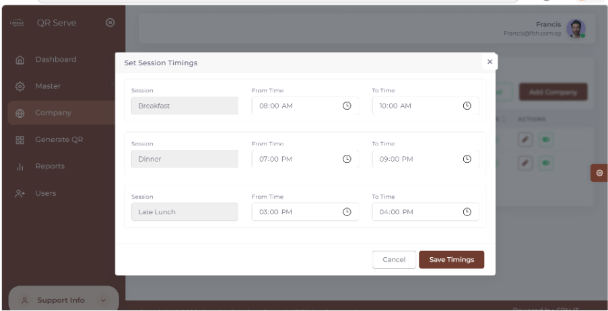
After clicking Save on the Add Company form, the Set Session Timings screen opens automatically. This screen defines the specific meal times for each session assigned to the company.

Field | Description
Session Name | Read-only — shows the session type (e.g., Breakfast, Lunch, Dinner)
From Time | Start time of the session for this company
To Time | End time — must be later than From Time

⚠️ Important: Session timings are critical for QR code validation. The scanner will only accept QR codes during the assigned session time window.

Section 7: Order Management
Create, view, and track food orders

7.1 Order List Screen

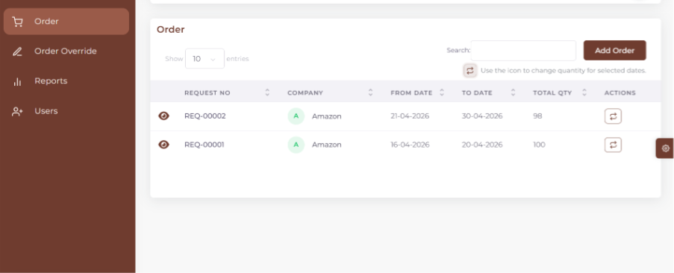
The Order module is used to create and manage food requests for companies. Orders are organized by date range, session (Breakfast, Lunch, Dinner), cuisine, and location-wise quantity.

Order List Columns
Field | Description
Request No | Unique identifier for each order (e.g., REQ-00001)
Company | The company the order belongs to
From Date | The order start date
To Date | The order end date
Total Quantity | Total number of meals ordered across all sessions
Actions | View details or initiate an Override

7.2 How to Create a New Order

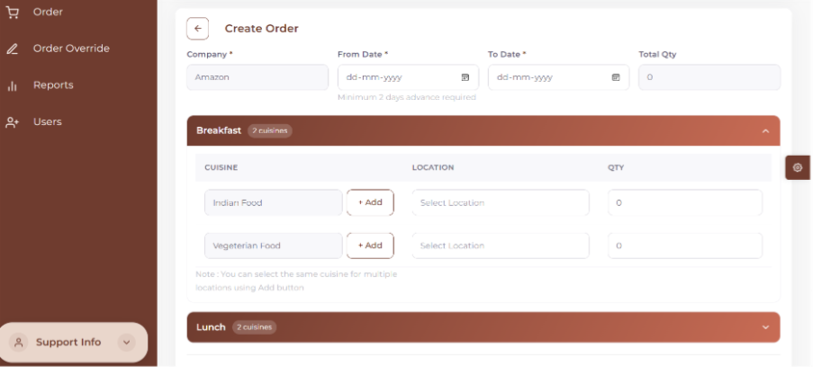
1 | Click the Add Order button on the Order List screen
2 | The order creation form opens
3 | Enter the From Date — must be at least today + configured advance days
4 | The To Date is auto-limited to the end of the selected month
5 | The Company field is auto-filled based on your logged-in account
6 | Expand the session section (e.g., Breakfast or Lunch)
7 | Select a Location from the dropdown
8 | Enter the Quantity for that location
9 | Click + Add to add more locations for the same session
10 | Repeat for additional sessions if needed
11 | Review the auto-calculated Total Quantity at the bottom
12 | Click Save to create the order, or Cancel to discard

Order Validation Rules
Rule | Requirement
From Date | Must be today + configured advance days or later
To Date | Must be equal to or after From Date
Quantity | At least one row with a quantity greater than zero is required
Duplicate Locations | Same location cannot be added twice in the same session
Overlapping Orders | Orders for the same company and date range cannot overlap

7.3 How to View Order Details
1 | In the Order List, find the order you want to inspect
2 | Click the View (eye) icon in the Actions column
3 | A detailed popup will open showing:
4 | Session-wise data breakdown (Breakfast, Lunch, Dinner)
5 | Cuisine type, Location, and Quantity for each entry
6 | Close the popup when done reviewing

Section 8: Override Orders
Modify existing orders for specific date ranges

8.1 What is an Override?
An Override allows you to modify the quantity of an already-saved order for a specific period. This is useful when actual requirements differ from the originally planned quantities — without changing the full original request.

8.2 Override Date Selection
1 | In the Order List, click the Override icon in the Actions column for the desired order
2 | The Override Date Selection popup opens
3 | The Request No is displayed for confirmation
4 | Enter the From Date — must be within the original order range and satisfy the advance days rule
5 | The To Date is auto-calculated (month-end or original request end date, whichever is earlier)
6 | Review the Allowed Request Range shown on screen
7 | Click Open Override to proceed to the Override Entry screen
8 | Click Cancel to close without creating an override

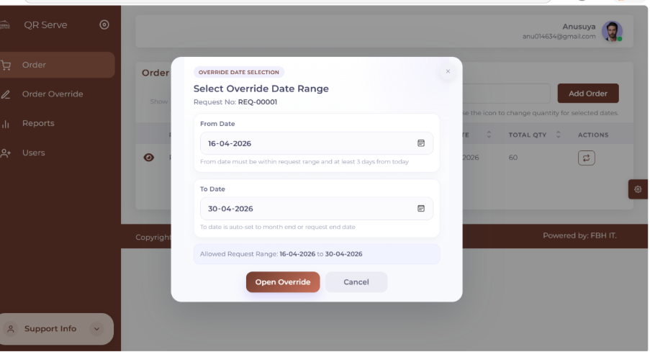

Override Date Selection Fields
Field | Description
Request No | Displays the original order reference number (read-only)
From Date | Start date of the override — must be within allowed range
To Date | Auto-set to month-end or request end date (whichever is earlier)
Allowed Request Range | Shows the valid override window (e.g., 16-04-2026 to 30-04-2026)

8.3 Override Entry Screen
After clicking Open Override, the Override Entry Screen displays the original order quantities for each session and lets you enter modified quantities.

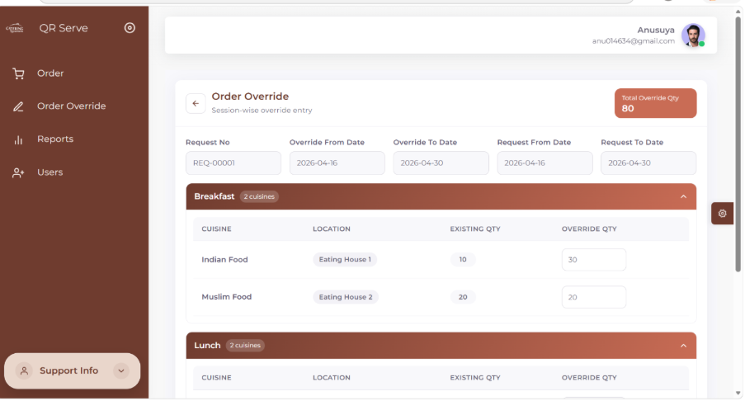

Override Header Information
Field | Description
Request No | The original order being overridden
Override From Date | Start date of the override period
Override To Date | End date (auto-calculated)
Request From/To Date | Original order date range for reference
Total Override Quantity | Auto-calculated sum of all override quantities (read-only)

Entering Override Quantities
For each session (Breakfast, Lunch, Dinner), two columns are shown:
- Existing Quantity — the original order quantity (read-only, for reference only)
- Override Quantity — pre-filled with the existing value; edit this to set the new quantity
- 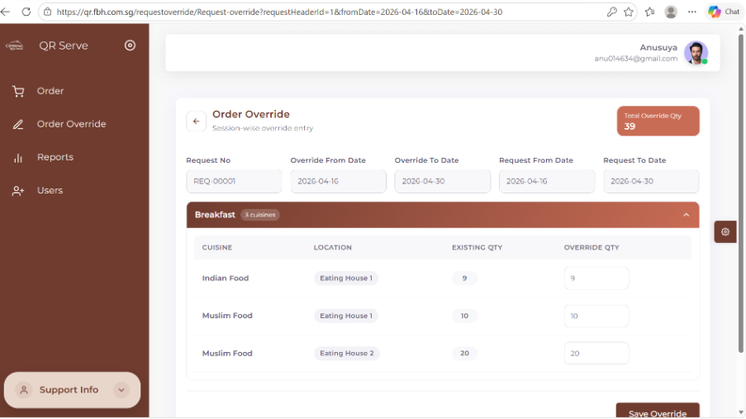
- 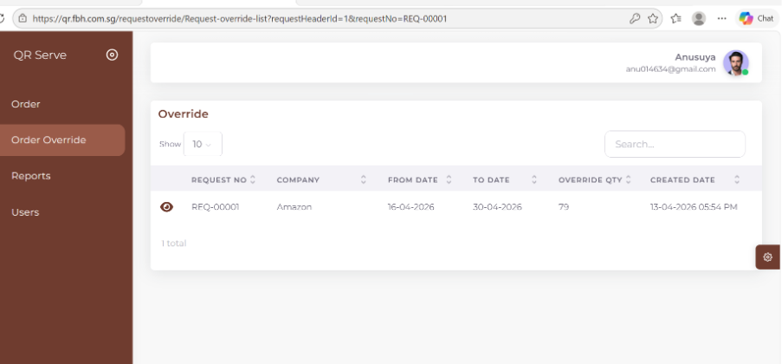

1 | Review the Existing Quantity values shown for each session and location
2 | Edit the Override Quantity fields as needed
3 | The Total Override Quantity updates automatically as you type
4 | Click Save Override to submit the changes
5 | The system saves the override and updates Reports, QR Generation, and the Dashboard

✅ After Saving: The override is linked to the original request. Reports and QR codes will reflect the overridden quantities for the selected date range.

Section 9: QR Code Management
Generate, send, and download QR codes

9.1 QR Screen Overview
The QR Screen displays all generated QR code records and allows users to generate new codes, search existing records, and download QR images.

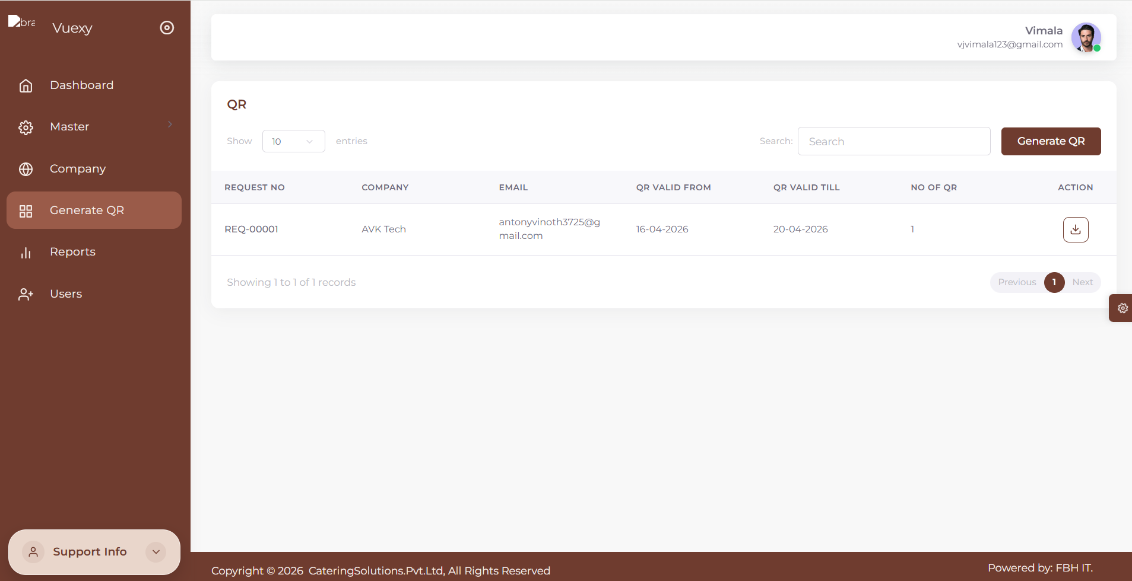

QR List Columns
Field | Description
Request No / Override No | Reference to the original order or override
Company Name | The company the QR codes belong to
Email | Company email used for automatic QR delivery
QR Valid From | Start date of QR code validity
QR Valid To | End date of QR code validity
Number of QR Codes | Total QR images generated for this record
Download Icon | Click to download QR images locally

How to Generate QR Codes

1 | Click the Generate QR button at the top of the QR screen
2 | A new screen opens for QR generation
3 | Select the Request or Override you want to generate QR codes for
4 | The system fetches the associated details (quantity, date range, etc.)
5 | Review the displayed information to confirm correctness
6 | Click Generate to create the QR codes
7 | The QR codes are saved and appear in the QR list
8 | The system automatically emails the QR images to the company's registered email address

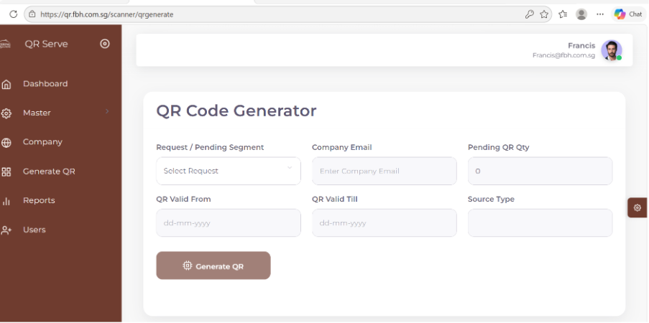

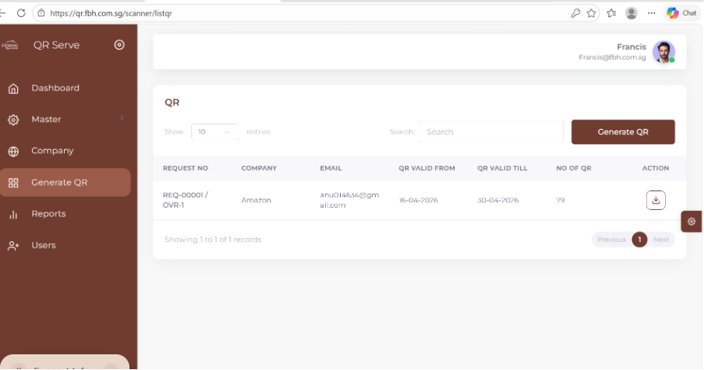

📧 Automatic Email: QR images are automatically sent to the company's registered email after generation — no manual sending required.

⚠️ Duplicate Prevention: Already-generated QR records may be restricted to prevent duplicate QR codes for the same order.

1 | Find the QR record in the QR list
2 | Click the Download icon in the Actions column
3 | The QR images will be downloaded to your local device
4 | Use the downloaded images for printing or distribution

Email Screen
The QR code is automatically sent to the company’s registered email address when QR generation is
Complete for the selected request.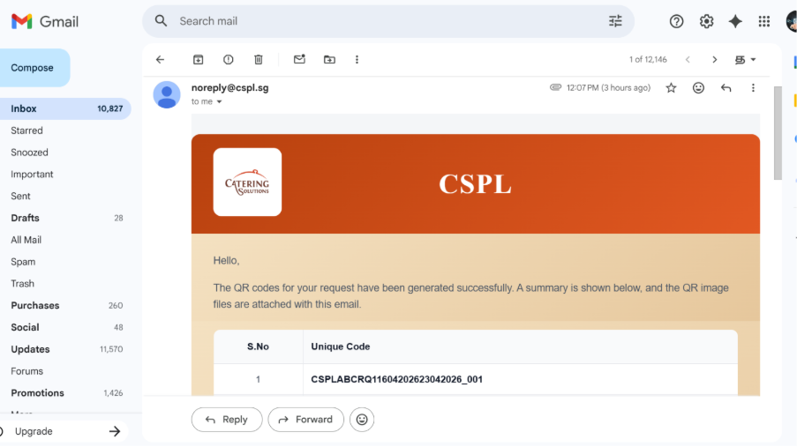

Field | Description
S.No | Displays the serial Number of the QR-Code
Unique Code | Displays the Uique Code of each QR.

📌 Role-Based Visibility: Super Admin sees all users across all organizations. Admin sees only users belonging to their respective company.
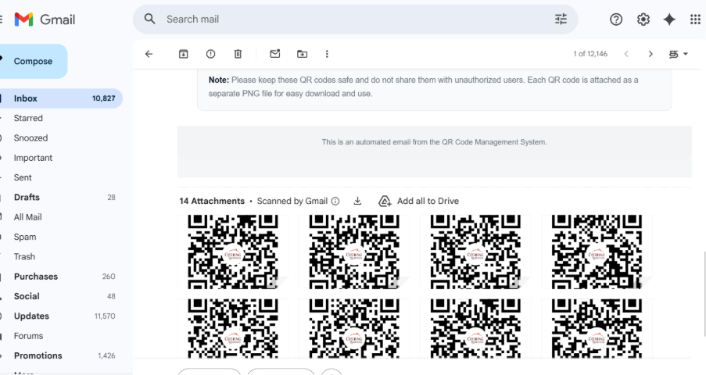

9.3 Downloading QR Codes
1 | Find the QR record in the QR list
2 | Click the Download icon in the Actions column
3 | The QR images will be downloaded to your local device
4 | Use the downloaded images for printing or distribution

Section 10: QR Code Scanner
Scan and validate customer QR codes at the point of service

10.1 What is the QR Scanner?
The QR Scanner is used by staff at food service counters to scan and validate customer QR codes. It verifies that the code is genuine, matches the current session, and has not already been used — allowing food to be issued.

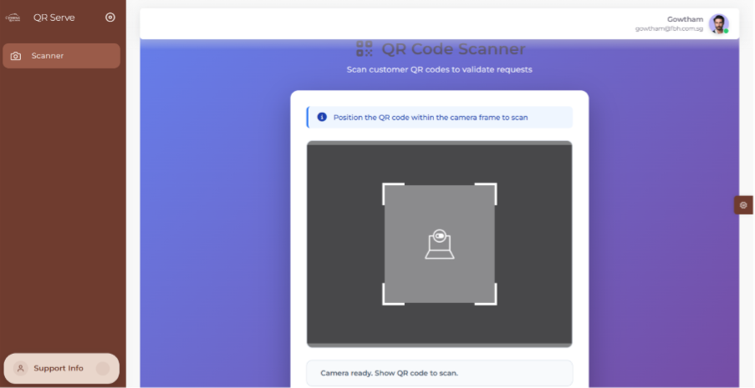

10.2 How to Use the QR Scanner
1 | Open the Scanner screen from the navigation menu
2 | Allow camera access when prompted by the browser
3 | Wait for the status message: 'Camera ready. Show QR code to scan.'
4 | Ask the customer to present their QR code
5 | Hold the QR code in front of the camera within the scanning frame
6 | Keep the QR code steady — the system scans automatically
7 | Wait for the validation result to appear on screen
8 | Issue food if the result is valid; show the error message if invalid

10.3 Scanner Validation Results
✅ Valid QR Code | ❌ Invalid QR Code
- QR code is authentic  - Matches current session  - Within valid date and time  - Food can be issued | - Expired QR code  - Wrong session or time slot  - QR code already used  - Do not issue food

💡 Scanning Tips: Ensure good lighting, hold the QR code steady within the frame, and avoid shadows over the code for best results.

Section 11: Reports
Generate and export food request reports

11.1 Report Screen Overview
The Reports module allows administrators to view, filter, and export company-wise food request data. Reports can be filtered by date range, session, cuisine, and location for detailed analysis.

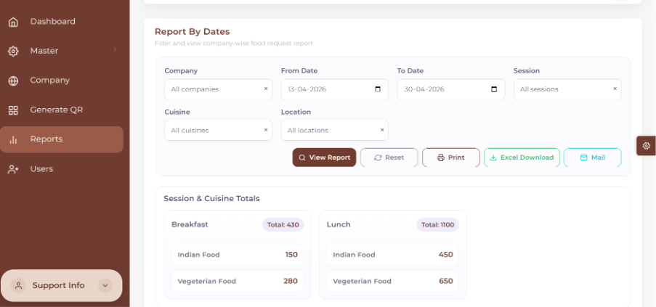

11.2 Available Report Filters
Field | Description
Company | Select a specific company or All Companies for a combined view
From Date | Start date of the reporting period
To Date | End date of the reporting period
Session | Filter by meal session (Breakfast, Lunch, Dinner, or All)
Cuisine | Filter by food category or view all cuisines
Location | Filter by a specific dining location or all locations

11.3 Report Actions

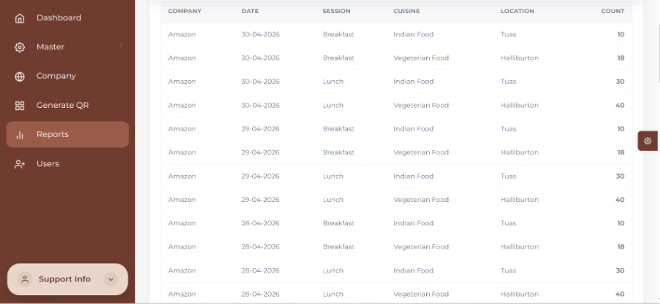
Button | Action
View Report | Loads filtered data into the report view based on selected criteria
Reset | Clears all selected filters and resets the form to default state
Print | Opens a printable version of the current report in the browser
Excel Download | Downloads the filtered report data as a .xlsx Excel file
Mail | Sends the Excel report to the company's registered email address
Print:
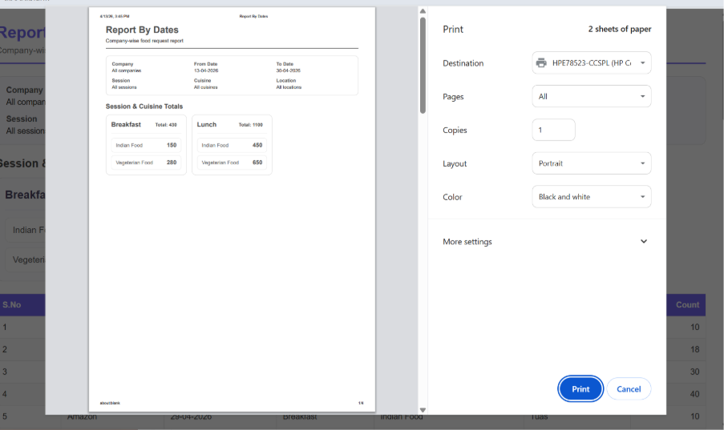
Excel Download :
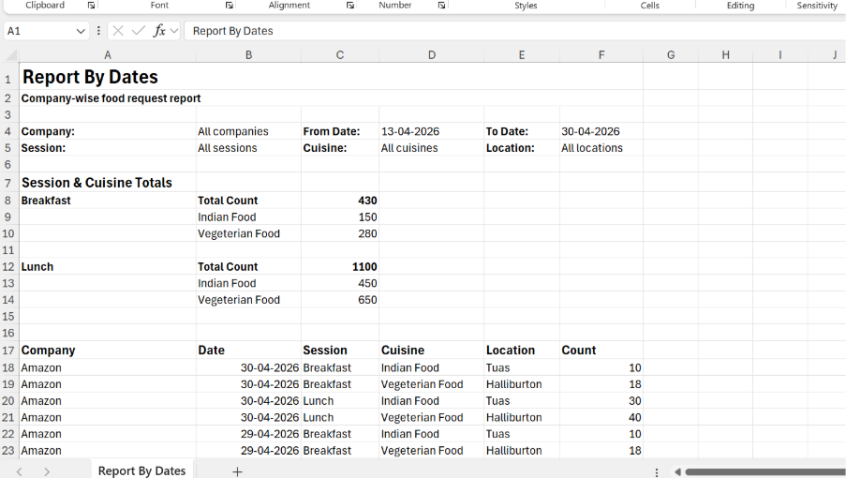
Mail :
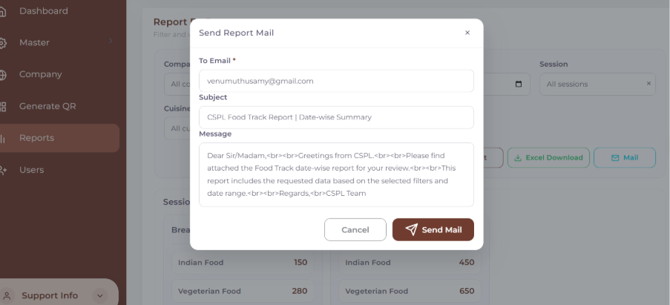

11.4 How to Generate a Report
1 | Navigate to the Reports screen from the navigation menu
2 | Select the Company (or choose All to view all companies)
3 | Set the From Date and To Date for the reporting period
4 | Optionally filter by Session, Cuisine, or Location
5 | Click View Report to load the filtered data
6 | Review the report data displayed on screen
7 | Click Print to print the report, or Excel Download to save a spreadsheet
8 | Click Mail to automatically send the report to the company email
9 | Click Reset to clear all filters and start a new report

User Screen :

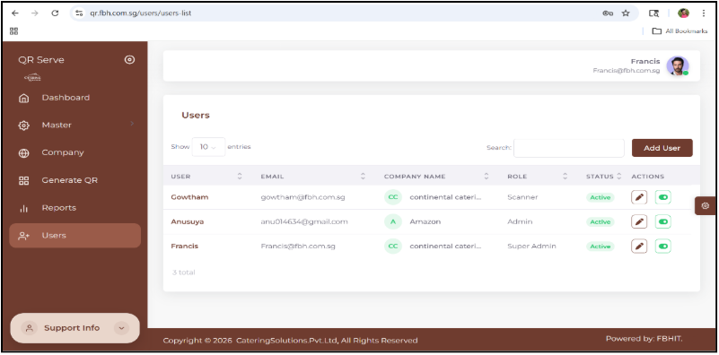

Section | Details
Purpose | Allows administrators to view and manage system users
User List Display | Displays users in a tabular format
Columns | User – Username  Email – Registered email  Company Name – Associated organization  Role – (Super Admin / Admin / Scanner)  Status – Active / Inactive  Actions – Edit, Activate/Deactivate
Role-Based Visibility | Super Admin – Can view all users across organizations  Admin – Can view only users from their company

Create User Screen :

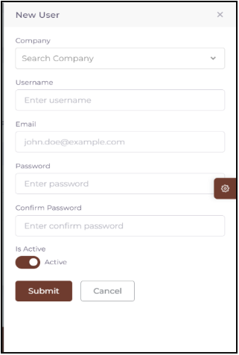

Section | Details
Purpose | Used to create new users
Fields | Company – Dropdown selection  Username – Input field  Email – Input field  Password – Mandatory  Confirm Password – Must match password  Status – Active/Inactive toggle
Validation Rules | All fields are validated  Password & Confirm Password must match
Role-Based Company Access | Super Admin – Can select all companies  Admin – Only their company is auto-bound
Actions | Submit – Saves user after validation  Cancel – Exit without saving

Edit User Screen :

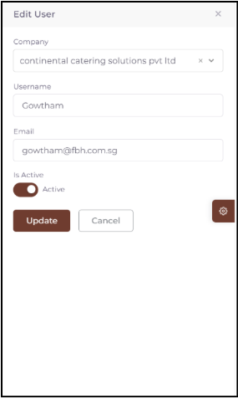

Section | Details
Purpose | Used to update existing user details
Fields | Company – Dropdown  Username – Editable  Email – Displayed  Status – Active/Inactive toggle
Password Handling | Password fields are not shown (handled via Change Password module)
Role-Based Company Access | Super Admin – Can modify all companies  Admin – Restricted to own company
Actions | Update – Saves changes to database  Cancel – Exit without saving

QRServe Food Track System
For technical support or queries, contact your system administrator.
Document Version 1.0 | April 2026 | Confidential — Internal Use Only

